Test Date | Apr. 17 - 18, 2012
Author(S) | Liyuan Zhang, Margot Phelps, GariLynn Billingsley
Approval(s)
Specification Doc. | LIGO-E0900074 | Specification | < 1.0 ppm
Procedure Doc. | LIGO-E1000863 | Avg. ± Error | 0.4 ± 0.1
Conclusion

Discussion and Comment:
With keeping the arrow on barrel at Y+ direction, 4 radial scans outside 120 mm aperture were carried out along X+- and Y+- on two surfaces (S1 and S2), as shown in following Fig.1 and Fig.2. The signal / noise ratio was kept as low as possible to avoid possible coating downgrade caused by dust burning.

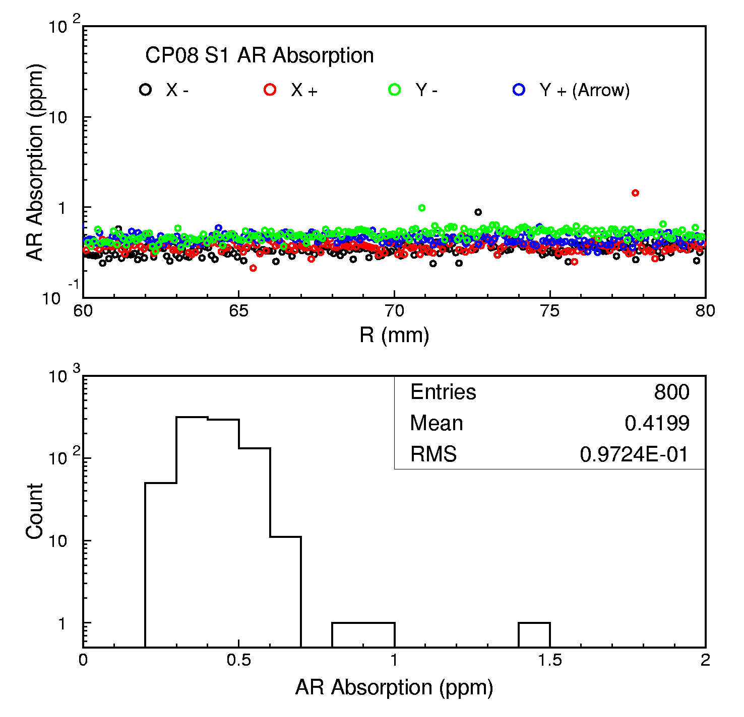
Fig.1 AR coating absorption measurements on CP08 S1 surface along 4 radial directions.

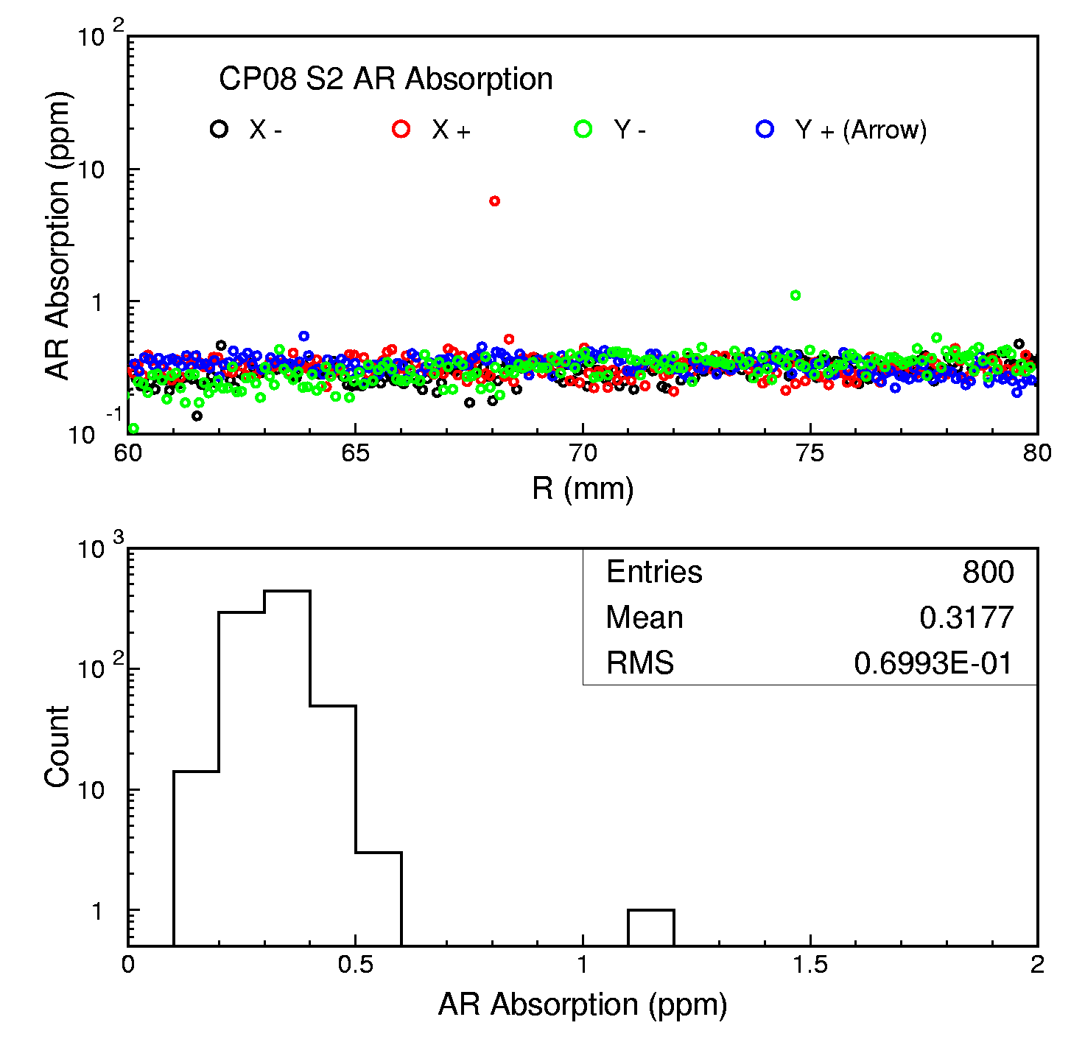

Fig.2 AR coating absorption measurements on CP08 S2 surface along 4 radial directions.

