Test Date | May 10-15, 2012
Author(S) | Liyuan Zhang, Margot Phelps, Patrick Murphy, GariLynn Billingsley
Approval(s) | GariLynn Billingsley
Specification Doc. | LIGO-E0900041 | Specification | 0.013-0.015
Procedure Doc. | LIGO-E1000863 | Mean ± Error* | 0.0148 ± 0.0003
Conclusion | Qualified.
*Error is the calibration error, which is ~2%.
Discussions and Comments:
The scan was done in center of 160 mm in diameter with the beam and step sizes of 1 mm and positioning the arrow on barrel at Y+ direction, as shown in Fig.1. The calibration is done by normalizing the transmitted signal to the signal without mirror and the variation of laser power during scan is monitored and corrected.
The transmission uniformity is quite good. In the histogram, the FWHM (~2.35*RMS) over Mean is about 0.5%, which is dominated by the systematic error.

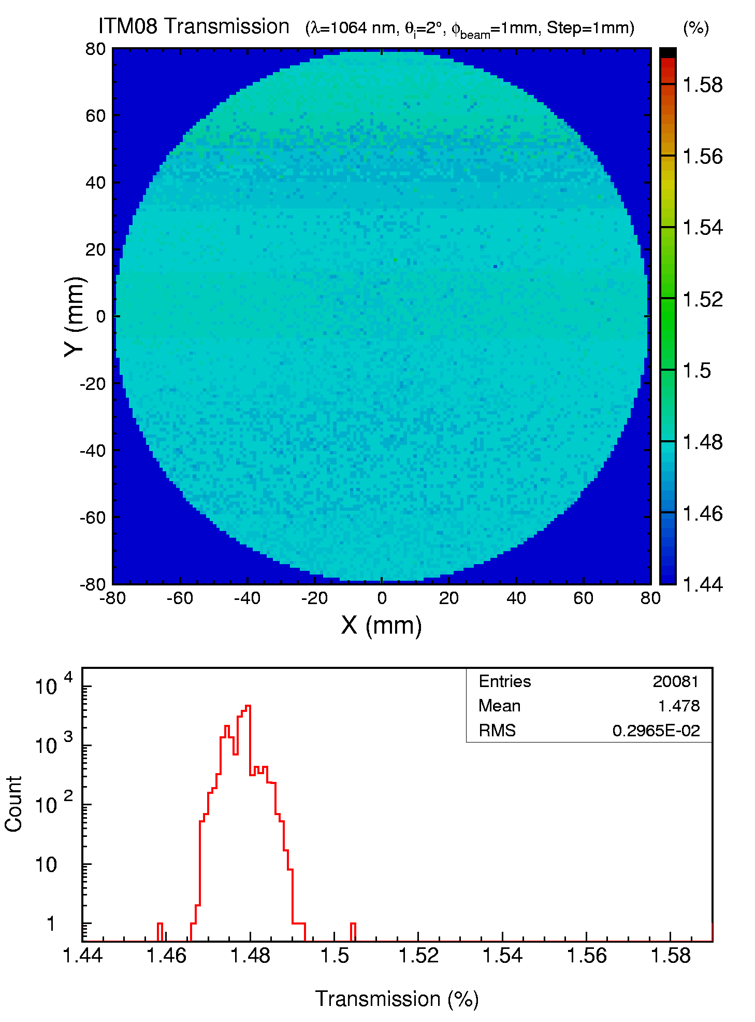
Fig. 1 ITM08 transmission over a 160 mm diameter aperture.

