|  |  |  |
| --- | --- | --- |
| **AUTHOR: Billingsley, G.** | DATE:11/21/12 | Document Change Notice, Release or Approval |
|  |  |  |

# Objective

This document provides guidelines to be used in removing elements that have been bonded to optics using epoxy. Because these repair scenarios are usually unique, this document does not seek to cover all details. Please contact subsystem leads whenever questions arise.

It appears that the Suspensions group prefers to use acetone for removal of epoxy-bonded prisms. This approach is assumed as a baseline. [1]

# Applicable Documents

E1000079 First Contact Application and Removal Procedure  
E1200326 First Contact cleaning of water spots or water-soluble contamination

# Precautions

1. Always work in teams when moving large optics
2. Do not use solvents other than acetone or isopropyl alcohol in the vicinity of first contact
3. Do not use Alpha wipes or other polymers with acetone
4. Do Not use methanol in the presence of first contact™.
5. Do not use Liquinox
6. First Contact has an expiration date of 1 year from the date of purchase.
7. DO NOT use methanol to wipe an optic that has been cleaned with first contact™. See T1000137 for reasons why.

# Materials

# List of required materials:

Acetone; reagent or spectroscopic grade  
Clean room foil or aluminum mixing cups  
Lint-free Berkshire lens wipes, for example 9’’x9’’. VWR part number 52847-1503.   
Cotton swabs, wooden shaft, no glue, for example Puritan 837-WC-NO-GLUE  
100% Cotton balls (caution: “made with 100% cotton” does not guarantee the product is 100%)  
100% Cotton thread (many threads are cotton covered polyester – acquire “100% cotton”)  
Optic and holding fixture as required, e.g. prism bonding v-block  
LED flashlight or similar bright source  
Razor blades

# Preparation – depending on available fixturing

First Contact should be removed if contact with acetone is likely, as in bump stop removal.  
 **Shim prism bonding v-block** to allow about 10mm clearance below the prism to be de-bonded. See figure one for an illustration.  
**Place the optic on the v-block** and locate an aluminum cup underneath the prism.  
Stuff cotton balls* underneath the prism and wet with acetone.

OR

**Secure cotton balls* around the prism** while the optic is horizontal. See figure two for an illustration. Use cotton thread in a slipknot around the circumference of the optic to secure the cotton balls* at each end of the prism. This configuration can be used to remove two prisms at once. Note; the optic should be positions such that the prisms to be removed are below the prisms which stay.  
**Always secure the optic in a vertical** orientation for prism removal.

**Removal of bumper stops** or magnets must be done in horizontal orientation. For ERM or PUM stops there should be enough clearance in the hole to hold the acetone. For CP stops, wind cotton thread around the base of the stop and carefully apply acetone. Minimize the acetone footprint. See figure three for an illustration.

# Application

**Wet** the cotton balls* with acetone.  
**Probe** occasionally with a cotton swab to determine if the prism is loose. It could take several hours to soften the bond.

**Prevent acetone from reaching either face** of the optic by swabbing with Berkshire wipes or cotton swabs. If acetone reaches an optic face see the troubleshooting section.

**Prevent acetone from reaching other prisms**.

# Backup procedure

In the case of a prism, if it does not come off after several hours, rotate the optic in roll until the prism is at the top (for ease and safety of working). Place wipes on the surrounding surfaces and/or have a helper standing by to catch the prism if it should come off unexpectedly.

For each of the top and bottom edges of the prism successively, moisten the edge with a drop of acetone and press a clean, new razor blade into the crack. (It is typically safest and best for visibility to rotate the optic in yaw between each probe so that one is always pulling towards ones body.) The prism may come away at once. Otherwise, look through the prism under various lighting conditions to check for interference fringes or changes in appearance indicating that a small area of the bond has separated. As soon as some small progress has been made, or if no change is observed even after moderate force, rotate the prism back to the bottom and soak for another few hours. Continue as needed, changing the razor blade regularly.

# Clean up

**Scrub the barrel** with acetone and cotton swabs until all visible epoxy is gone.

**Wipe the barrel** with acetone on a Berkshire wipe until there is no streaking when viewed with an LED flashlight or similar bright light source.

**Rub/wipe along** electrical traces on the barrel and face of ERM and CP optics. Avoid rubbing/wiping across electrical traces. Stop if there are signs of scratching.

**Clean up from bumper mount removal** –Use minimal acetone to prevent running.

# Troubleshooting

**Acetone dried on an optical face**:

Dried acetone will leave water spots even in its purest form. Water spots require vigorous scrubbing for complete removal. Use [E1200326](https://dcc.ligo.org/cgi-bin/private/DocDB/ShowDocument?docid=89594) or contact the SUS or COC lead for exceptions. Exceptions will be based on the radius at which the spotting occurs and the beam footprint on the specific optic.

**Alpha wipes or other polymers were used on the optic barrel in the presence of Acetone**.

Alpha wipes degrade into hard, fibrous lumps that stick quite well to optics. Scrub first with cotton swabs, then wipe with Berkshire wipes.

**Alpha wipes and Acetone contacted an optical surface**.

Requires scrubbing under dark field microscope: Contact the COC lead.

**Acetone got onto the first contact**.

Same as Acetone dried on an optical face. Exceptions are more likely since exposure is limited to the edges of the optic.

**Acetone got onto Teflon while in contact with the optic**

Teflon does leave a slight residue when in contact with Acetone. It cleans easily with a few wipes of an acetone soaked Berkshire wipe.



Figure 1

**Top View**

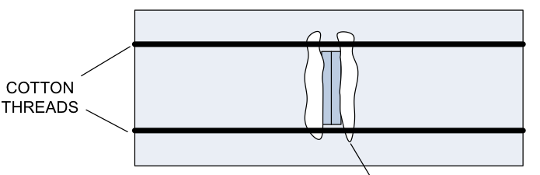

--Cotton

---Prism

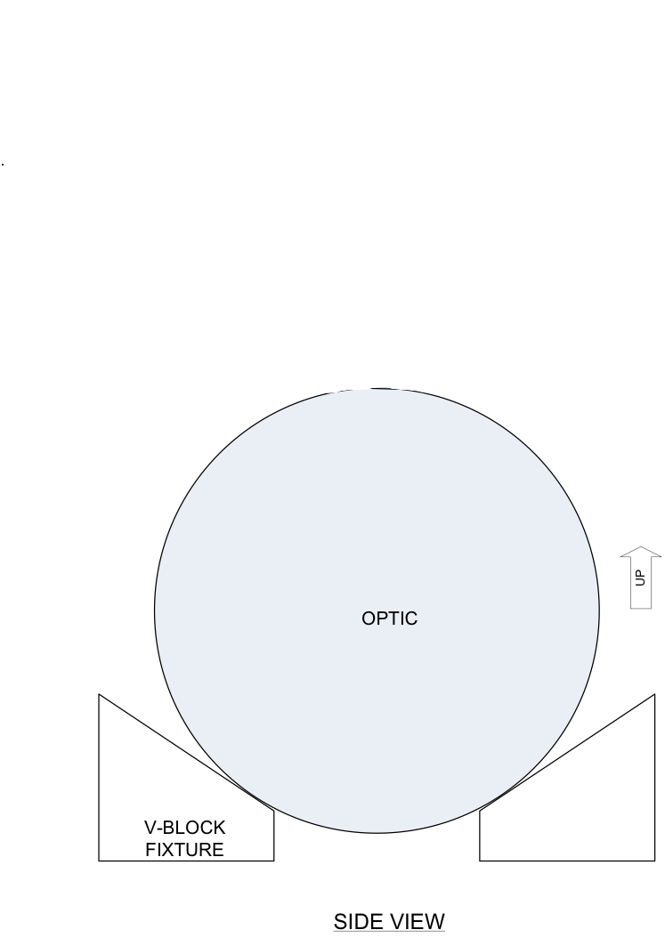

Figure 2



Figure 3

1. T0900369-v1 has been cited as a removal procedure for prisms, this author has no experience with residue or cleaning of the Micro90 referenced therein.