Safety Analysis of Epoxy Curing Oven
11 January, 2013
Richard Abbott, LIGO, Caltech
E13000035-v1

Synopsis

An oven was constructed at Caltech and sent to the LIGO Hanford Observatory (LHO). The oven and a companion control box were designed to provide a thermally controlled environment for the curing of epoxy associated with LIGO optics. The oven derives power from 120VAC via a control box. In the intended application, the oven is set to regulate temperature at approximately 35 degrees C. The oven and its outer insulation can be seen in Figure 1. On the right hand side of the top surface, a cutout is visible. This cutout provides access to a temperature actuated switch which limits the maximum temperature of the oven to approximately 40 degrees C.

Figure 1, Front View of Oven

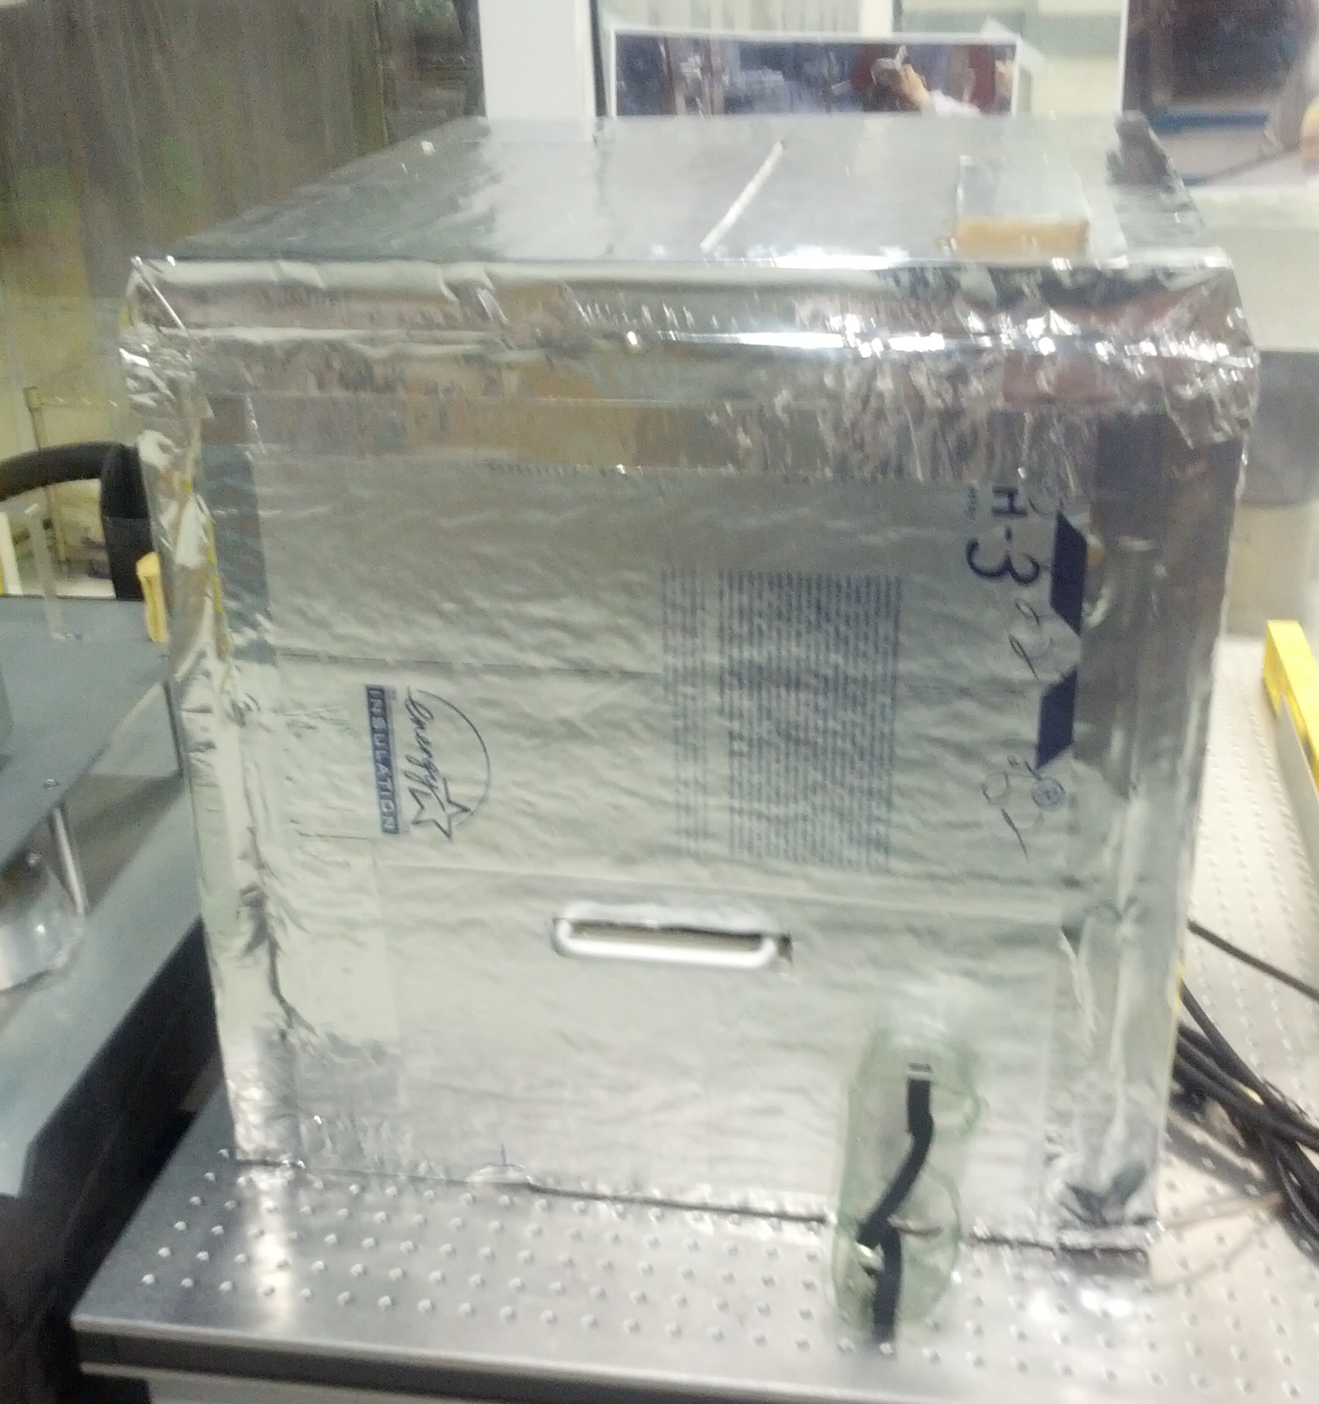

An inspection was conducted by Richard McCarthy upon receipt of the oven at LHO. Richard noted several discrepancies, and communicated them by email. Shown below is a summary of Richard’s observations.

The oven and its associated controller had not been inspected per the LIGO EEIP program.

For conditions wherein the oven must be operated above the thermal cutout setpoint, (40 degrees C.) a technician must bypass the thermal switch. There was insufficient instruction given to adequately inform a technician of the hazards associated with the task.

The insulation on the thermal switch can be easily removed, and should be better labeled to identify the hazardous voltages

Richard inquired as to whether the oven assembly and associated controller had been properly electrically grounded.

Analysis of Existing Design

The following figures provide details of the existing oven and controller.

Figure 2, Top Front View of Controller. Ground wire is bonded to metal box as seen along the rear wall. Fuses seen on the front panel individually protect the oven heater circuit, and the commercial temperature controller
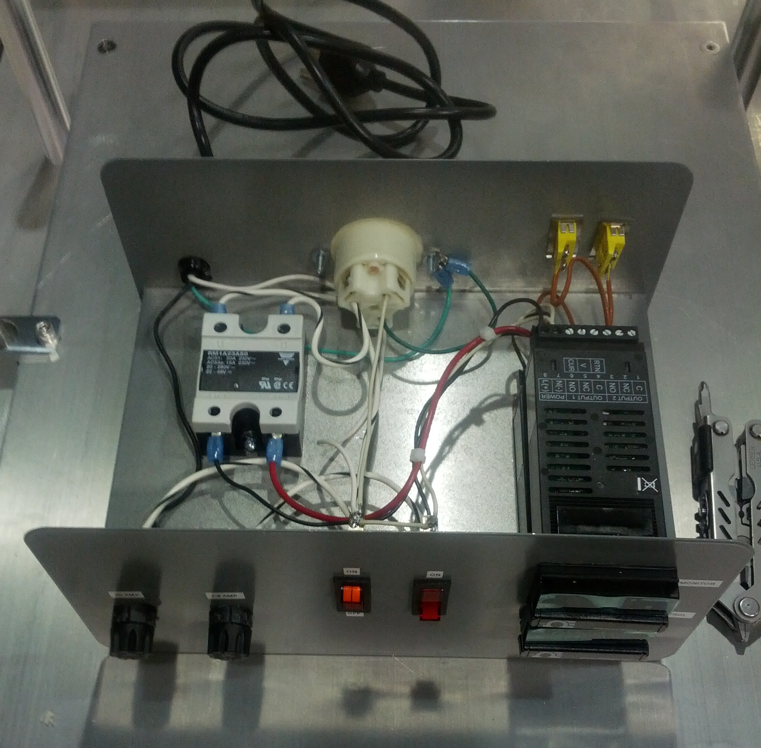

Figure 3, Top Rear View of Controller. UL rated AC plug is provided on the rear wall for the power to the oven heater elements. Yellow thermocouple inputs are visible. AC cord has appropriate strain relief. Overall construction of the control box is reasonable for hand built lab equipment.
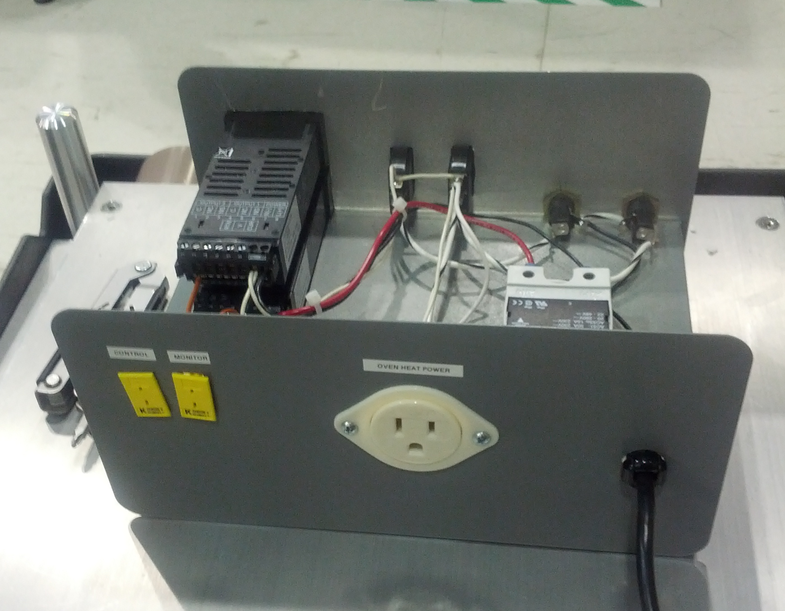

Figure 4, View of insulation cutout revealing the thermal cutoff switch. Spade lugs connect the wires to the thermal switch. Overall insulation seems reasonable in unmodified state.
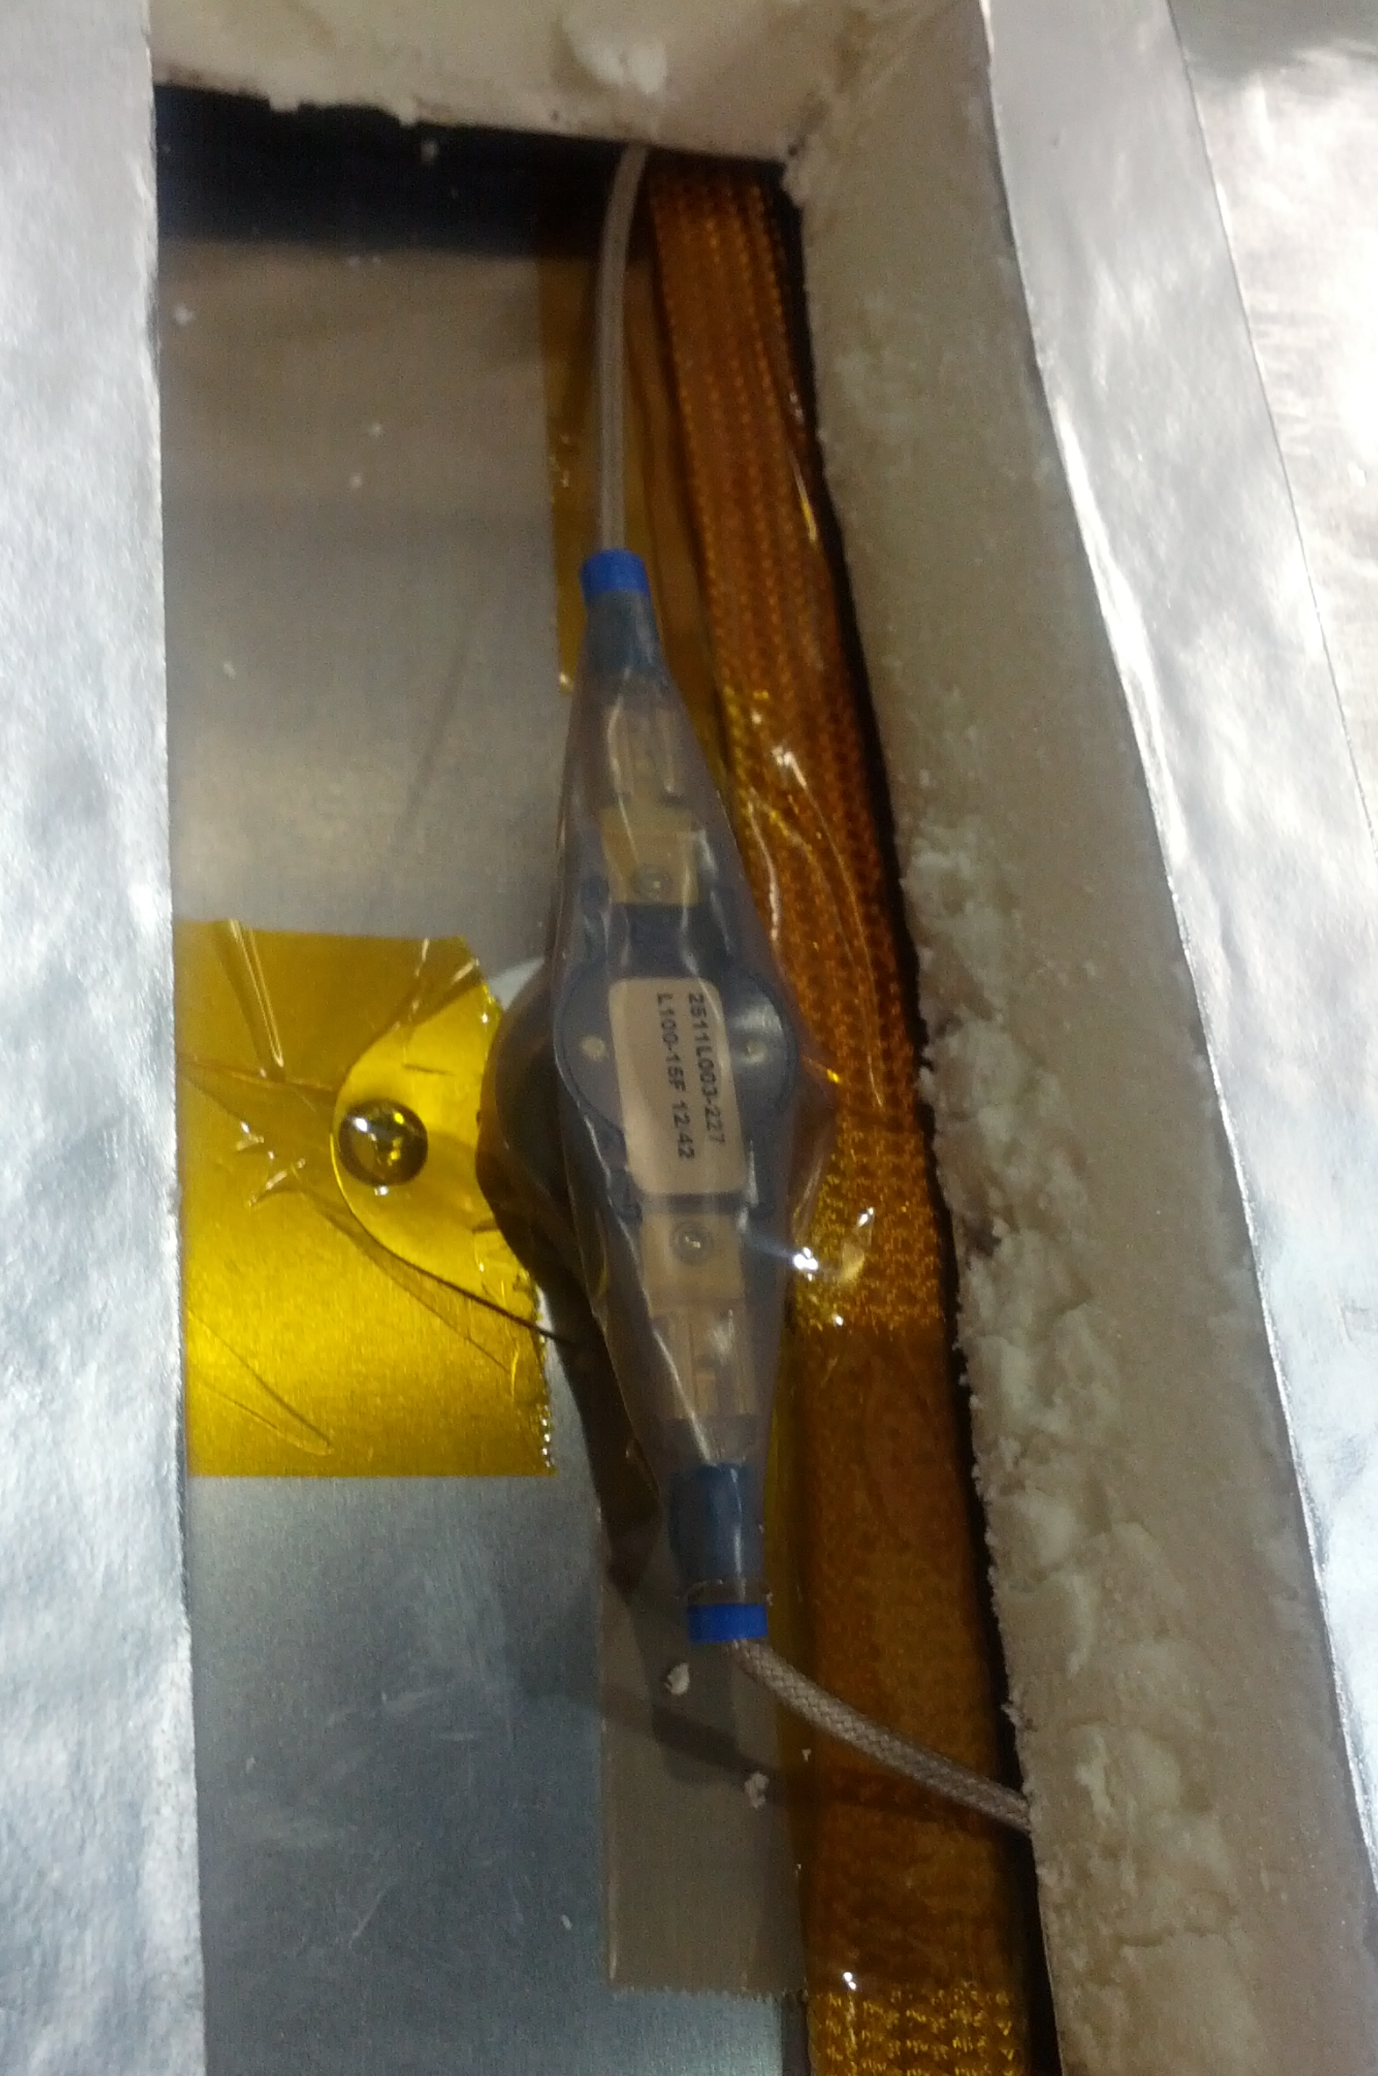

Figure 5, with the oven tilted back, a lug is seen that connects a ground wire to the metal inner wall of the oven. The ground wire terminates on the ground prong of a 3-prong AC plug.
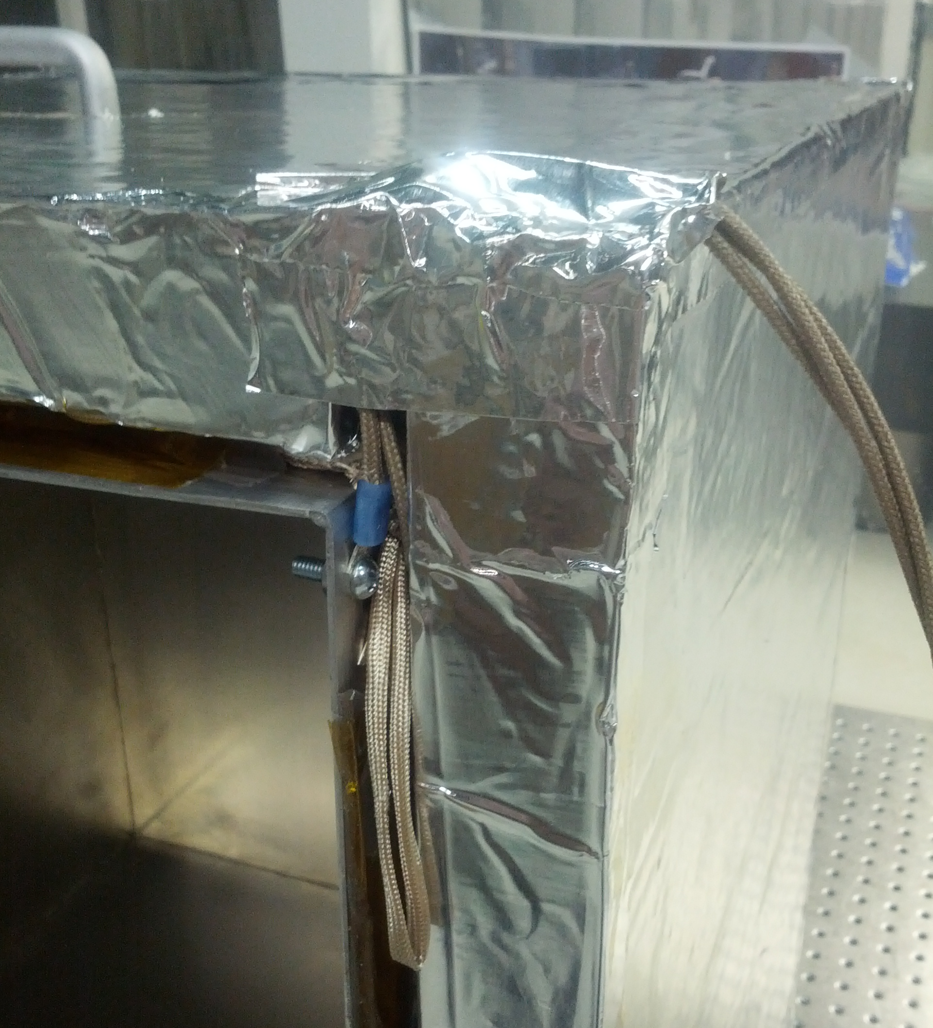

Figure 6 shows the AC plug used to connect the oven to the controller.
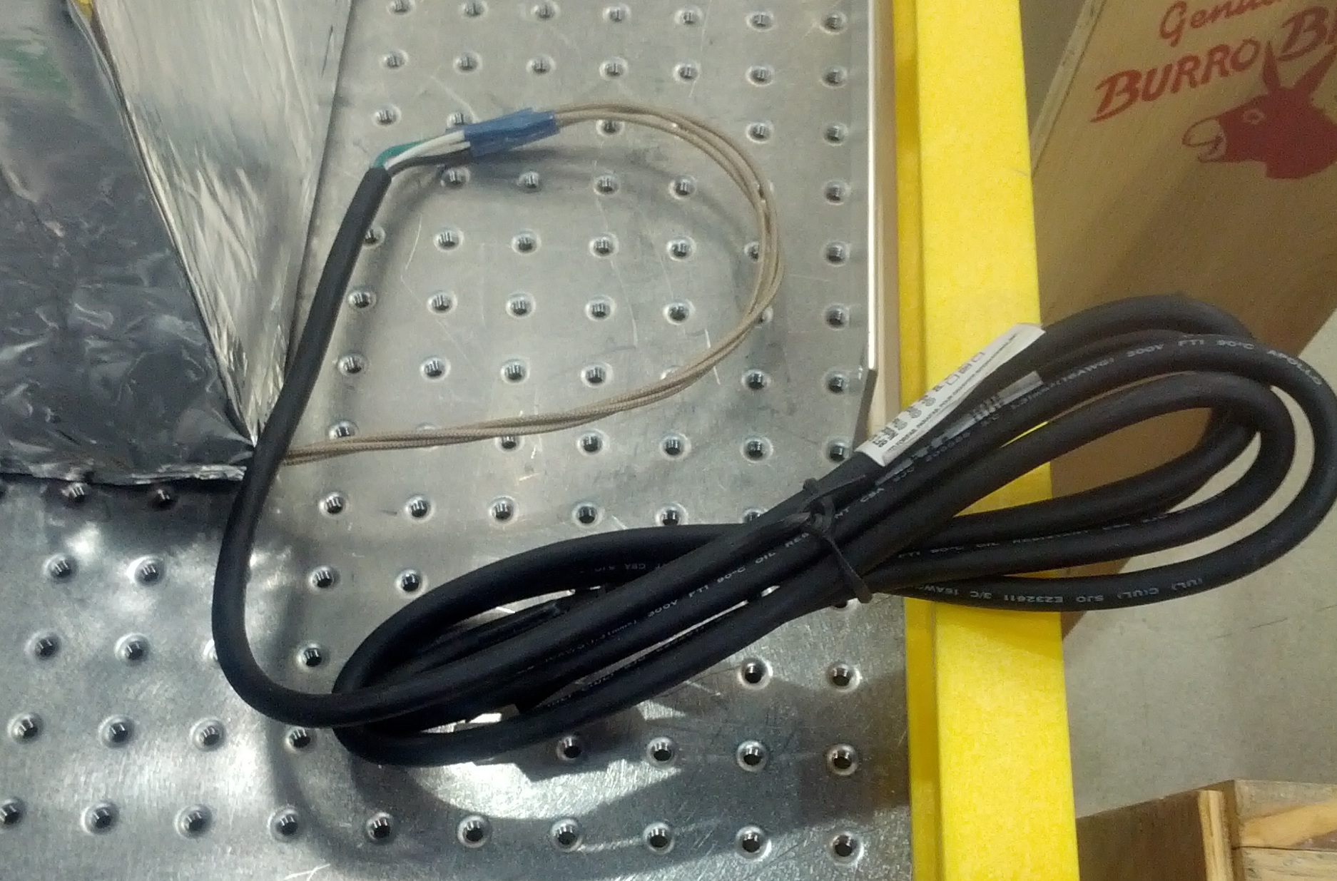

Recommended Safety Actions

LIGO has adopted an Electrical Equipment Inspection Program (EEIP) designed to make personnel aware of electrical hazards in the workplace. A red sticker is used to identify items for which significant electrical personnel hazards exist. A green sticker is used to indicate when there is little or no internal electrical hazard for the device in question. An EEIP evaluation should have been performed on the oven and controller. This would have resulted in a red sticker on each item to warn personnel of the intrinsic electrical hazard.

The thermal cutout switch was provided to limit the oven to 40 degrees C. Better instructions must be provided to warn technicians of the need to fully de-energize the controller and oven prior to bypassing the switch. If the thermal switch is bypassed, and the oven plugged directly into a wall outlet with no controller, the oven will reach an equilibrium temperature of approximately 80 degrees C. With this constraint, there is no fire hazard from a runaway controller.

A label should be present on the removable portion of the insulation used to gain access to the thermal cutout switch. This would serve to caution the user.

No further action is required to ground the components of the oven and controller. Sufficient electrical bonding exists in the design.

The overall construction of the controller and oven are consistent with reasonable engineering practice. No further construction mitigation is required.

Conclusion

An EEIP inspection must be performed on the oven and controller. A red EEIP warning sticker must be applied to the oven and to the controller.

A short procedure must be written detailing the safe manner by which a technician would bypass the thermal cutout switch. This should be added to the overall oven documentation.

The removable insulation cover must be labeled to identify the electrical hazard within.

Personnel involved in the construction of similar devices will be informed of the need to obtain an EEIP inspection prior to sending such devices out for use.

