LIGO Laboratory / LIGO Scientific Collaboration

LIGO-E1300136-v1 LIGO 2/12/2013

TMS Telescope Mirrors & Packaging
for Delivery to Local Coater

Ken Mailand -Virginio Sannibale

Distribution of this document:
LIGO Scientific Collaboration

This is an internal working note
of the LIGO Laboratory.

California Institute of Technology  LIGO Project – MS 18-34  1200 E. California Blvd.  Pasadena, CA 91125  Phone (626) 395-2129  Fax (626) 304-9834  E-mail: info@ligo.caltech.edu | Massachusetts Institute of Technology  LIGO Project – NW22-295  185 Albany St  Cambridge, MA 02139  Phone (617) 253-4824  Fax (617) 253-7014  E-mail: info@ligo.mit.edu
LIGO Hanford Observatory  P.O. Box 159  Richland WA 99352  Phone 509-372-8106  Fax 509-372-8137 | LIGO Livingston Observatory  P.O. Box 940  Livingston, LA 70754  Phone 225-686-3100  Fax 225-686-7189
http://www.ligo.caltech.edu/

TMS Mirror Packaging

Feb 12, 2013

Packaging Primary Mirror
- Remove any previous residues of scotch tape from the PETG container,
- Place 5/6 desiccant bags in the PETG container base before placing the mirror so the bags will be under the mirror as shown in figure 1. The coated side will not be in contact with the bags
- Note the mirror serial number for later use and place it in the container base with the coating facing up
- Take good Care to align the PETG container lid to the Mirror Wedge and then press it down to close the container
- If the lid is properly aligned, then little force is need to get the container properly closed
- Verify that the S/N on the lid correspond to the mirror serial number inscribe on the mirror back
- Secure the lid and base, with two strips of adhesive tape, on two opposite sides.
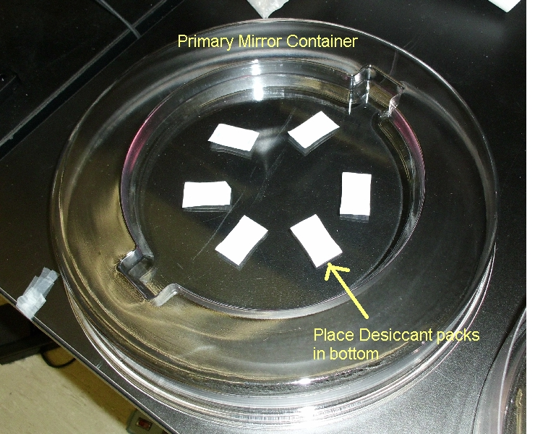
Figure1.

Packaging Secondary Mirror

- Insert the secondary mirror inside the white plastic cylinder sleeve from the coated side as shown in figure 2.
- Stack 3 desiccant bags on the bottom side of the mirror in the white sleeve.
- Insert the assembly inside the cylindrical container in such a way that the coated side is facing up.
- Verify that the container S/N and the mirror S/N match
- Screw the lid on the cylindrical container, and verify that the screw on cap is closed tight. figure 3.

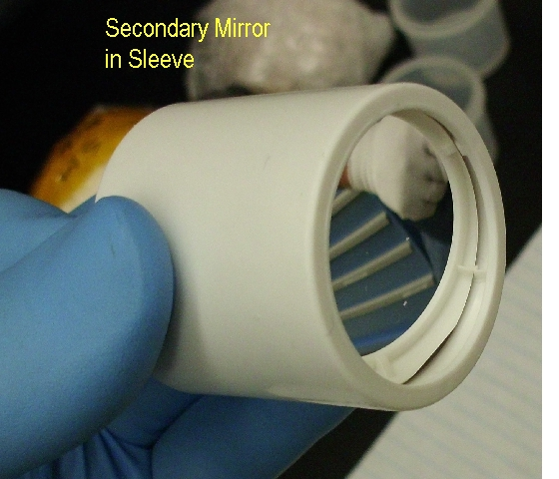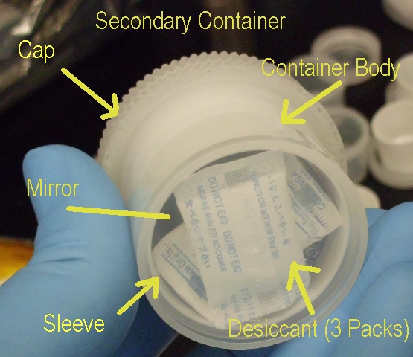

Figure 2 . Figure 3.
Packaging Folding Mirror (F2)

- Insert the F2 mirror inside the white plastic cylinder container, in centering ring, place 3 desiccant bags in recess in base foam, under mirror, reflective surface is in up orientation figure 4.
- Insert the foam ring, with the large hole, inside the cylindrical container, on top the mirror figure 5. ref. coated side is facing up.
- Verify that the container S/N and the mirror S/N match
- Screw the lid on the cylindrical container, and verify that the screw on cap is closed tight. There is some compression in the foam sandwich, and care should be taken to thread the cap on properly, not to cross thread the lead, and completely close the container.
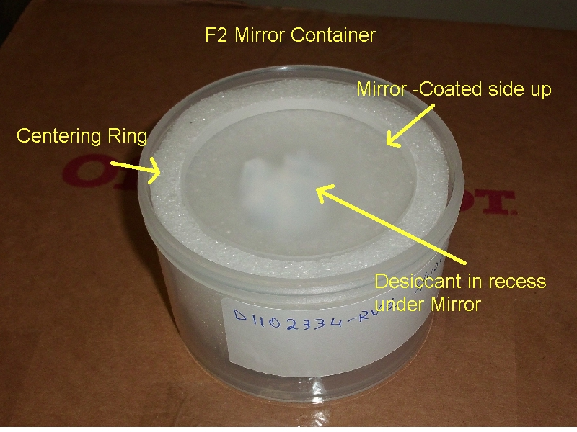
Figure 4.
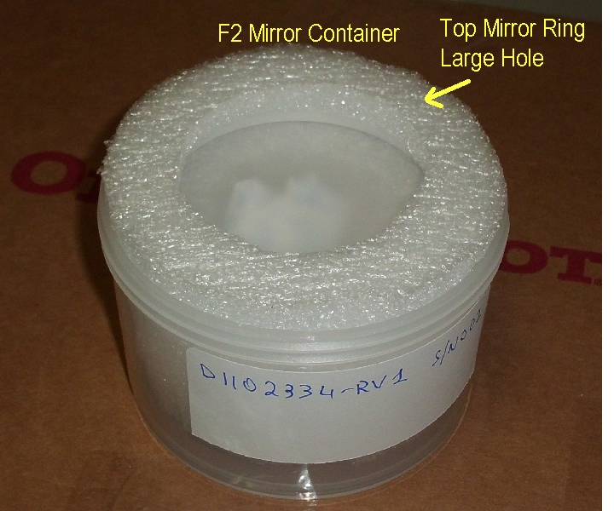
Figure 5.

Mirror Serial Numbers

Secondary Mirrors
S/N Comments Below
002
003 Chipped
004
005
006
007 It was 001 changed into 007

Primary Mirrors
S/N Comments Below
002
003 Coating contaminated practically the entire surface, diffused superficial circular scratches
and straight scratches
004
005
006 Coating contaminated. A couple of small cloudy spots
007 It was 001 changed into 007

Folding Mirror 1
S/N Comments
002
003
004
005
006
008 Serial 001 was changed to 008

