LIGO Laboratory / LIGO Scientific Collaboration

LIGO- E1300146-v2 Advanced LIGO 7/13/2017

TEC Controller Library Documentation

Sheila Dwyer

Distribution of this document:
LIGO Scientific Collaboration

This is an internal working note
of the LIGO Laboratory.

California Institute of Technology  LIGO Project – MS 18-34  1200 E. California Blvd.  Pasadena, CA 91125  Phone (626) 395-2129  Fax (626) 304-9834  E-mail: info@ligo.caltech.edu | Massachusetts Institute of Technology  LIGO Project – NW22-295  185 Albany St  Cambridge, MA 02139  Phone (617) 253-4824  Fax (617) 253-7014  E-mail: info@ligo.mit.edu
LIGO Hanford Observatory  P.O. Box 159  Richland WA 99352  Phone 509-372-8106  Fax 509-372-8137 | LIGO Livingston Observatory  P.O. Box 940  Livingston, LA 70754  Phone 225-686-3100  Fax 225-686-7189
http://www.ligo.caltech.edu/

Library
Title | TECController
Version | 1
TwinCAT version | 2.11.2230
Name space
Author | Sheila Dwyer
Description | Controls the temperature of an SHG oven, using Beckhoff modules EL3692 to measure the temperature using a 10kOhm thermistor (epcos PN: B57861S0103F040), EL3102 to sense the temperature and a TEC from Laird technologies, HOT20, 31, F2A, 0909 and EL4132 for TEC outputs.  The TEC is installed in the SHG with the wider side facing upwards, as shown in the picture. This is because the data sheet indicates that the narrower side should be the cool side.  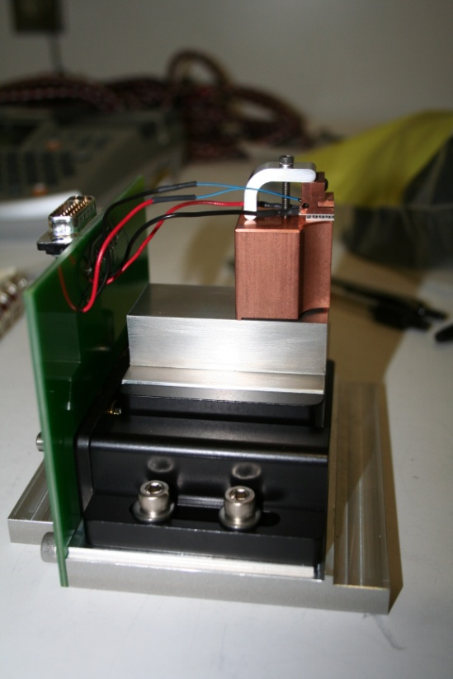  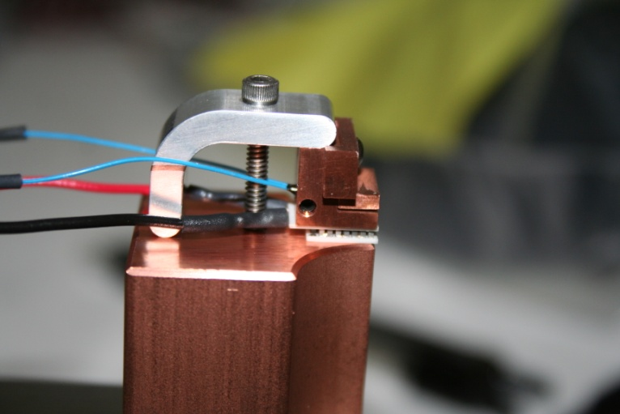  With the unity gain frequency of the servo set to 5Hz, the overshoot is about 20%, so this is a good nominal setting.
Error Codes | TECControllerFB:  0x0001 – Thermistor resistance too high (open)  0x0002 - Thermistor resistance too low (short)  0x0004 - TEC Voltage too high  0x0008 – TEC Current is too high  0x0010 – TEC power dissipated if too high  0x0020 – Integrator limit is exceeded (currently integrator limit is 100V)  0x0040 – Thermistor data invalid  0x0080 – Thermistor measurement error  ThermistorFB:  0x0001 – Thermistor resistance too high (open)  0x0002 - Thermistor resistance too low (short)  0x0004 – Thermistor data invalid  0x0008 – Thermistor measurement error
Library Dependencies | SaveRestore, Error, ReadADC, WriteADC

Hardware Input Type
TYPE ThermStatusStruct:
STRUCT
UnderRange: BOOL;
OverRange: BOOL;
ExtenRange: BOOL;
DataInvalid: BOOL;
RangeInvalid: BOOL;
AutoRangeDis: BOOL;
Error: BOOL;
SteadyState: BOOL;
END_STRUCT
END_TYPE
Type name | ThermStatusStruct
Description | Status information of the EL3692
Element | Name: UnderRange  Type: BOOL  Description: Indicates an under range condition
Element | Name: OverRange  Type: BOOL  Description: Indicates an over range condition
Element | Name: ExtenRange  Type: BOOL  Description: Indicates an extended range condition
Element | Name: DataInvalid  Type: BOOL  Description: Indicates the data is invalid
Element | Name: RangeInvalid  Type: BOOL  Description: Indicates the range is invalid
Element | Name: AutoRangeDis  Type: BOOL  Description: Indicates the auto ranging is disabled
Element | Name: Error  Type: BOOL  Description: Indicates an error condition
Element | Name: SteadyState  Type: BOOL  Description: measurement is in steady state  At last 4 values no more than x/1024 apart

Hardware Input Type
TYPE ThermistorInStruct :
STRUCT
ThermStatus: ThermStatusStruct;
ThermValue: REAL;
END_STRUCT
END_TYPE
Type name | ThermistorInStruct
Description | Hardware inputs for thermistor measurement
Definition | STRUCT
Element | Name: ThermStatus  Type:ThermStatusStruct  Description: Structure of status indicators for resistance measurement module EL3692
Element | Name: ThemValue  Type: REAL  Description: resistance of thermistor in C

Hardware Input Type
TYPE TECControllerInStruct :
STRUCT
ThermStatus: ThermStatusStruct;
ThermValue: REAL;
TECVoltageReadback: INT;
TECCurrentReadback: INT;
END_STRUCT
END_TYPE
Type name | TECControllerInStruct
Description | Hardware inputs
Definition | STRUCT
Element | Name: ThermStatus  Type:ThermStatusStruct  Description: Structure of status indicators for resistance measurement module EL3692
Element | Name: ThemValue  Type: REAL  Description: resistance of thermistor
Element | Name: TECVoltageReadback  Type: INT  Description: readback of voltage across the TEC
Element | Name: TECCurrentReadback  Type: INT  Description: readback of current into the TEC

Hardware Output Type
TYPE ThermControlStruct :
STRUCT
DisableAutoRange: BOOL;
Mode: BYTE;
Range: SINT;
StartConv: BOOL;
END_STRUCT
END_TYPE
Type name | ThermControlStruct
Description | Control information of the EL3692
Definition | STRUCT
Element | Name: DisableAutoRange  Type: BOOL  Description: Disable the auto-ranging feature
Element | Name: Mode  Type: BYTE  Description: measurement mode  0: 4-wire measurement  1: 4-wire measurement, single-shot mode  2: 2-wire measurement  3: 4-wire measurement, single-shot mode
Element | Name: Range  Type: SINT  Description: Measurement range  -1: 10 mΩ - 100 mΩ  0: 100 mΩ - 1 Ω  1: 1 Ω - 10 Ω  2: 10 Ω - 100 Ω  3: 100 Ω - 1 kΩ  4: 1 kΩ - 10 kΩ  5: 10 kΩ - 100 kΩ  6: 100 kΩ - 1 MΩ  7: 1 MΩ - 10 MΩ
Element | Name: StartConv  Type: BOOL  Description: Start a measurement in single shot mode

Hardware Output Type

TYPE ThermistorOutStruct:
STRUCT
ThermControl: ThermControlStruct;
END_STRUCT
END_TYPE
Type name | ThermistorOutStruct
Description | Hardware outputs
Definition | STRUCT
Element | Name: ThermControl  Type: ThermControlStruct  Description: Structure of control bits for EL3692

Hardware Output Type

TYPE TECControllerOutStruct :
STRUCT
ThermControl: ThermControlStruct;
TECVoltageSet: INT;
END_STRUCT
END_TYPE
Type name | TECControllerOutStruct
Description | Hardware outputs
Definition | STRUCT
Element | Name: ThermControl  Type: ThermControlStruct  Description: Structure of control bits for EL3692
Element | Name: TECVoltageSet  Type:INT  Description: voltage sent to the TEC (in units of volts over the TEC, the gain of the controller board is taken out in the code)

User Interface Type
TYPE TECControllerStruct :
STRUCT
Error: ErrorStruct;
ThermistorTemperature: LREAL;
TECVoltageBack: LREAL;
TECCurrentBack: LREAL;
TECVoltsOut: LREAL;
Fault: BOOL;
SetTemp: LREAL:=35;
Servo: BOOL;
UnityGain: LREAL:=5;
ClearInt: BOOL;
OldControlSig: LREAL;
END_STRUCT
END_TYPE
Type name | TECControllerStruct
Description | User interface inputs and outputs for TECController
Definition | STRUCT
Input tags | Name: Error  Type: ErrorStruct  Description: for use by error handler
Input tags | Name: ThermistorTemperature  Type: LREAL  Description: Temperature (in C) measured by thermistor
Input tags | Name: TECVoltageBack  Type:LREAL  Description: Voltage readback, in units of volts over TEC
Output tags | Name: TECCurrentBack  Type:LREAL  Description:TEC Current readback
Output tags | Name: TECVoltsOut  Type:LREAL  Description:Volts sent to TEC, in units of volts over TEC
Output tags | Name: Fault  Type:BOOL  Description: Is there an error condition that required output voltage to go to zero?
Output tags | Name:SetTemp  Type:LREAL  Description: Temperature setting for servo
Output tags | Name:Servo  Type:BOOL  Description: Is the servo on?
Output tags | Name:UnityGain  Type: LREAL  Description: unity gain setting for servo
Output tags | Name:ClearInt  Type:BOOL  Description: Allows the user to clear the integrator, in case the servo gets into a bad state where the integrator value is too high.
Output tags | Name:OldControlSig  Type:LREAL  Description: TECVoltsOut from last cycle in which the servo was on. This is saved so that when the servo is turned on again, it will initialize with the old value.

User Interface Type
TYPE ThermistorStruct:
STRUCT
Error: ErrorStruct;
Temperature: LREAL;
END_STRUCT
END_TYPE
Type name | ThermistorStruct
Description | User interface inputs and outputs for a thermistor readout
Definition | STRUCT
Input tags | Name: Error  Type: ErrorStruct  Description: for use by error handler
Input tags | Name: Temperature  Type: LREAL  Description: Temperature (in C) measured by thermistor

Function Block
FUNCTION_BLOCK ThermistorFB
VAR_INPUT
Request: SaveRestoreEnum;
ThermistorIn: ThermistorINStruct;
END_VAR
VAR_OUTPUT
ThermistorOut: ThermistorOutStruct;
END_VAR
VAR_IN_OUT
ThermistorInit: ThermistorStruct;
Thermistor: ThermistorStruct;
END_VAR
Name | ThermistorFB
Description | Function block to read a thermsitor
Input argument | Name: Request  Type:SaveRestoreEnum  Description: Request for save/restore/safemode or noop.
Input argument | Name: ThermistorIn  Type: ThermistorInStruct  Description: Hardware inputs
Output argument | Name: ThermistorOut  Type: ThermistorOutStruct  Description: Hardware outputs
In/Out argument | Name: Thermistor  Type: ThermistorStruct  Description: User interface
In/Out argument | Name: ThermistorInit  Type: ThermistorStruct  Description: User interface variables to initialize to, if power is lost

Function Block
FUNCTION_BLOCK TECControllerFB
VAR_INPUT
Request: SaveRestoreEnum;
VoltageLimit: LREAL := 2.9;
TECControllerIn: TECControllerINStruct;
END_VAR
VAR_OUTPUT
TECControllerOut: TECControllerOutStruct;
END_VAR
VAR_IN_OUT
TECControllerInit: TECControllerStruct;
TECController: TECControllerStruct;
END_VAR
Name | TECControllerFB
Description | Main temperature controller function block
Input argument | Name: Request  Type:SaveRestoreEnum  Description: Request for save/restore/safemode or noop.
Input argument | Name: VoltageLimit  Type: LREAL  Description: Maximum voltage applied to controller output
Input argument | Name: TECControllerIn  Type: TECControllerInStruct  Description: Hardware inputs
Output argument | Name: TECControllerOut  Type: TECControllerOutStruct  Description: Hardware outputs for TECController
In/Out argument | Name: TECController  Type: TECControllerStruct  Description: User interface
In/Out argument | Name: TECControllerInit  Type: TECControllerStruct  Description: User interface variables to initialize to if power is lost

