LIGO Laboratory / LIGO Scientific Collaboration

LIGO-T1300162-v2 LIGO July 3, 2013

Photon Calibrator:
Optical Follower Servo Design Requirements

Gregorio Téllez, Rick Savage

Distribution of this document:
LIGO Scientific Collaboration

This is an internal working note
of the LIGO Laboratory.

California Institute of Technology  LIGO Project | Massachusetts Institute of Technology  LIGO Project
LIGO Hanford Observatory | LIGO Livingston Observatory
http://www.ligo.caltech.edu/

Introduction
To induce calibrated displacements of the interferometer test masses, the photon calibrator uses a power modulated 2W laser. The laser provokes a small displacement that is proportional to the amount of photons that arrive at each End Test Mass (ETM). Each of the excitations that the Pcal induces can be seen as calibration or excitation lines in the interferometer readout. The Photon Calibrator Design Requirements document, LIGO-T1100044, contains more information on the specifications and means for calibrating the interferometer.
In order to ensure that the calibrated displacement is of a single-tone at a desired frequency, an active controller (servo) can be used to improve the purity of the modulated waveform by means of feedback control. This servo loop used for the Pcal is known as the Optical Follower Servo.
In this document, the design and performance requirements for the Optical Follower Servo (OFS) are described, along with its implementation in aLIGO.

Optical Follower Servo (OFS) Electronic Noise Requirements
The Optical Follower Servo will be used in the Advanced LIGO Photon Calibrator as a means to reduce the relative power noise (RPN) of the laser and achieve maximum sideband to carrier suppression of the modulated output waveform. The following subsections give an overview of these unwanted displacement noise sources and the amount of suppression necessary to achieve the aLIGO requirement.

Relative Power Noise (RPN)
In Section 6 of this document, we show the requirements for RPN for a given interferometer readout configuration. According to our characterization of the aLIGO lasers, given in LIGO-T1300100, for the Zero-Detuning High Power configuration, the RPN of the free-running aLIGO Pcal lasers needs to be suppressed by approximately 20 dB at frequencies below 100Hz.

Carrier to Sideband Suppression
The displacement noise that arises from the Pcal modulation frequencies must not exceed 10% of the design sensitivity as per LIGO-T1100068. This requirement is relaxed at higher modulation frequencies since the amplitudes of the induced noise fall-off as the square of the modulation frequency (1/f²). The maximum harmonic amplitude can be expressed as:
Max. Harmonic = $\frac{0.1*h(f)}{SNR*\sqrt{T}}$
where the SNR is the signal to noise ratio of the specific modulation frequency, T is the measurement time and h(f) is the sensitivity corresponding to the Zero-Detuning High Power Option displayed in Section 7.
The relationship of maximum allowable relative harmonic noise, up to the fourth harmonic (for two interferometer operation modes), is included in Appendix 1: RPN and Harmonic Suppression Requirements. The desired suppression is expected to be realized by our designed OFS. A measurement of relative harmonic displacement for various utilized powers is presented in (LIGO-T1100567).

Block Diagram Representation of OFS
Figure 1 shows the block diagram representation of the Optical Follower Servo. The dashed lines represent laser light in the loop, while solid lines represent electronic signals.
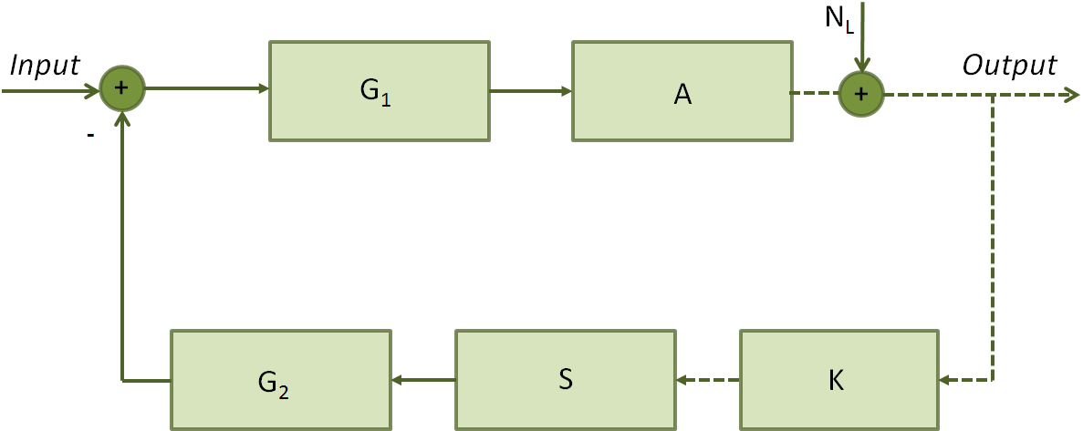
Figure 1: Optical Follower Servo Block Diagram Representation

From Figure 1, the closed loop transfer function of the OFS, neglecting inherent laser noise (N_{L}), can then be stated as:
$$\frac{{AG}_{1}}{1+ {KS{AG}_{1}G}_{2} }$$
where A is the actuator (AOM), S is the sensor (Photodiode), K is the percentage of light power sampled (~1%) and G₁ and G₂ are gain stages in the feedforward and feedback, respectively. The parameters for each of the elements are detailed in Section 4 (Table 1).

System Parameters

Signal Coupling into OFS
The OFS will be AC-coupled with a coupling frequency of 1-Hz. The coupling of the reference excitation is done at the error point of the servo loop and the waveform parameters (amplitude, frequency, and phase) are controlled through the MEDM-Pcal controls.

Gain Parameters
A conservative approximation of the expected gain parameters is given in Table 1.

Parameter | Value | Units
A | 0.5 | W/V
G₁ | 10-100 (20-40) | V/V(dB)
G₂ | ~2(6) | V/V(dB)
K S | 0.5 | V/W
Table 1: Transfer Function Values of Elements in Optical Follower Servo

The product KS, which includes the transimpedance gain of the sensor and the amount of light picked-off, is estimated to be around 0.5V/W. Furthermore, the value of G₂ can be selected such that the product KSG₂ ≈1. If this is the case, then our transfer function becomes
$$\frac{{AG}_{1}}{1+ {AG}_{1} }$$
The servo is then dependent on the variable gain G₁ and the actuator transfer function. Hence, the gain in the feedforward path (G₁) can be adjusted to achieve the desired servo performance.

Servo Bandwidth
The highest frequency that the Pcal will be operated at is expected to be 10 kHz. Our servo bandwidth should be greater than this operating frequency with a suggested gain of 20dB for frequencies up to 100 kHz (UGF of 1MHz).

Actuator (AOM)
The actuator for the OFS is an ISOMET 1205-C-2 series acousto-optic modulator operating at 80MHz RF drive. The nominal modulation bandwidth is approximately 6 MHz, for a spot size (radius) of 156µm and a modulation depth β=0.5.

Open-Loop Implementation
An open-loop implementation of the OFS will be realized as shown in Figure 2. The feedback loop will be broken and the excitation or reference signal will be injected directly to the AOM. The OFS should be able to manage switching between an open and closed-loop configuration depending on the desired operation of the Pcal. Additional connections may be required in the current setup to fulfill both implementation modes of the Pcal.
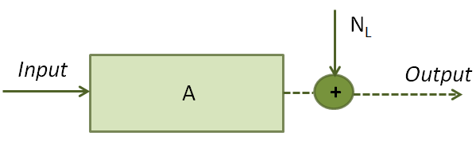
Figure 2: Open-Loop Implementation of OFS.

Test Points
The Optical Follower servo should have test points in order to calculate the servo’s closed loop transfer function and to monitor possible oscillations in the loop. Figure 3 displays the location of those test points on the servo. They are further discussed in the following subsections.
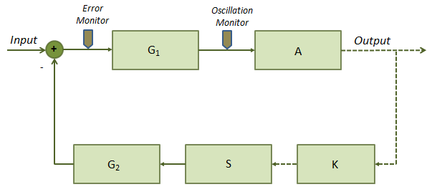
Figure 3: Location of Test Points in the OFS

Error Point Monitor
A monitoring output at the error point allows monitoring the value of the error signal, namely, the difference between the reference input and the feedback signal (ideally zero).

Oscillation Monitor
An oscillation monitor can be included between G₁ and A to monitor the overall performance of the servo. The oscillation monitor is displayed as an output DC value. A bandpass filter, with center frequency at the servo’s unity gain frequency, can be added to look at the band of interest for this readout (~100 kHz).

Other Test Points
A test input is needed in the OFS to perform swept sine measurements and the corresponding closed loop transfer functions.

Summary
The Optical Follower Servo should be capable of reducing the RPN of the free-running Pcal laser by approximately 20dB. A prototype has been built as part of a SURF Project (LIGO-T1100567) and will be further tested and improved to achieve the maximum harmonic suppression and desired relative power noise. The design parameters have been presented and an estimate of RPN has been made to quantify the overall loop gain needed to achieve the desired noise suppression.

Appendix 1: RPN and Harmonic Suppression Requirements
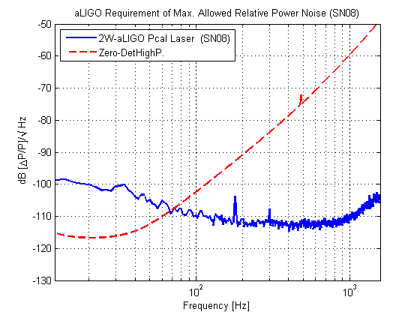
Figure 4: Maximum RPN allowed for aLIGO.

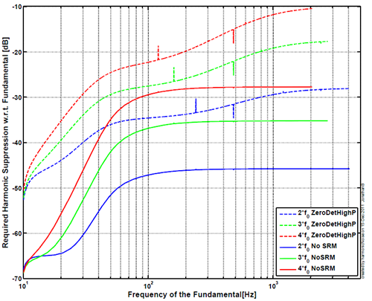
Figure 5: Sideband to Carrier Suppression Needed in aLIGO.

Appendix 2: Advanced LIGO Anticipated Sensitivity Curves.
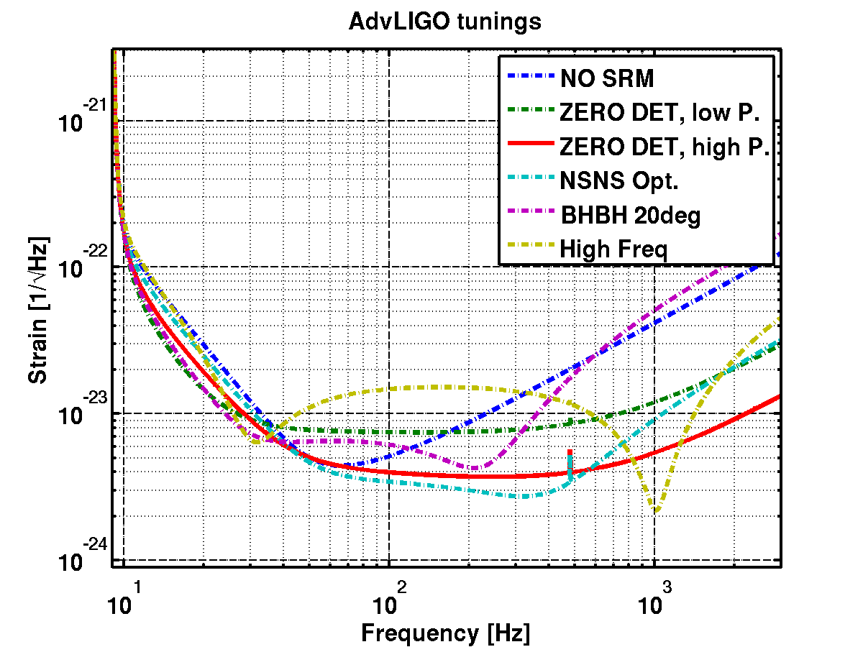
Figure 6: Anticipated Sensitivity Curves for aLIGO (LIGO-T0900288)

