LASER INTERFEROMETER GRAVITATIONAL WAVE OBSERVATORY

-LIGO-

CALIFORNIA INSTITUTE OF TECHNOLOGY

MASSACHUSETTS INSTITUTE OF TECHNOLOGY

Document Type | DCC Number  T1300185-v2 | January 13, 2016
8 Channel Valve Driver Test Plan

B. Abbott

Distribution of this draft:
This is an internal working note of the LIGO Laboratory

California Institute of Technology Massachusetts Institute of Technology
LIGO Project – MS 18-33 LIGO Project – MS 20B-145
Pasadena, CA 91125 Cambridge, MA 01239
Phone (626) 395-2129 Phone (617) 253-4824
Fax (626) 304-9834 Fax (617) 253-7014
E-mail: info@ligo.caltech.edu E-mail: info@ligo.mit.edu

www: http://www.ligo.caltech.edu/

Introduction
The tests described below are required to verify the correct operation of the 8 Channel Valve Driver board (schematic # D020373 Rev v5, PCB # D020373v2).

Test Equipment
Network Analyzer
Power supplies
Multimeter
Valve Driver tester board
25-pin Dsub Breakout Board

Tests

Input Power
Plug a power cord turned to +/- 18V onto the back panel power plug labeled “18V DC IN”, turn on the power, and record the current draw in the table below. The two LEDs on the front panel should come on.

Supply | Nominal Current | Actual | Pass/Fail
+18 V | 0.070 A +/- 10mA
-18 V | 0.070 A +/- 10mA

Continuity check
Each channel’s output is delivered through two wires on the output connector. Using an Ohmmeter, confirm that the DB9 pins shown below are, indeed, connected. They should be a dead short (~ 0.2Ohms)

Channel | Pins on DB9 | Connected?  Y/N | Pins on DB9 | Connected?  Y/N
1 | J1 Pins 1 and 2 |  | J1 pins 6 and 7
2 | J1 Pins 3 and 4 |  | J1 pins 8 and 9
3 | J2 Pins 1 and 2 |  | J3 pins 6 and 7
4 | J2 Pins 3 and 4 |  | J3 pins 8 and 9
5 | J3 Pins 1 and 2 |  | J4 pins 6 and 7
6 | J3 Pins3 and 4 |  | J4 pins 8 and 9
7 | J4 Pins 1 and 2 |  | J6 pins 6 and 7
8 | J4 Pins 3 and 4 |  | J6 pins 8 and 9

Valve Drive Tests
Plug a valve driver tester board into the appropriate 9-pin Dsub connector on the front panel (this is just a 9-pin breakout board with two 80 Ohm resistors, one connected between pins 1 and 6 and the other connected between pins 3 and 8), and a 25-pin adapter board into the “From AI Chassis” 25-pin Dsub on the back panel. Set up a network analyzer to perform a 1Vp-p swept sine measurement from 1Hz to 100KHz. In order to pass the test, the signal should have a low-frequency gain of -9.6dB (+/- 0.5 dB), and a -3dB cutoff frequency of 1.3KHz (+/- 100Hz). It should look line the plot below. Collect the appropriate measurement values, and fill in the next table.

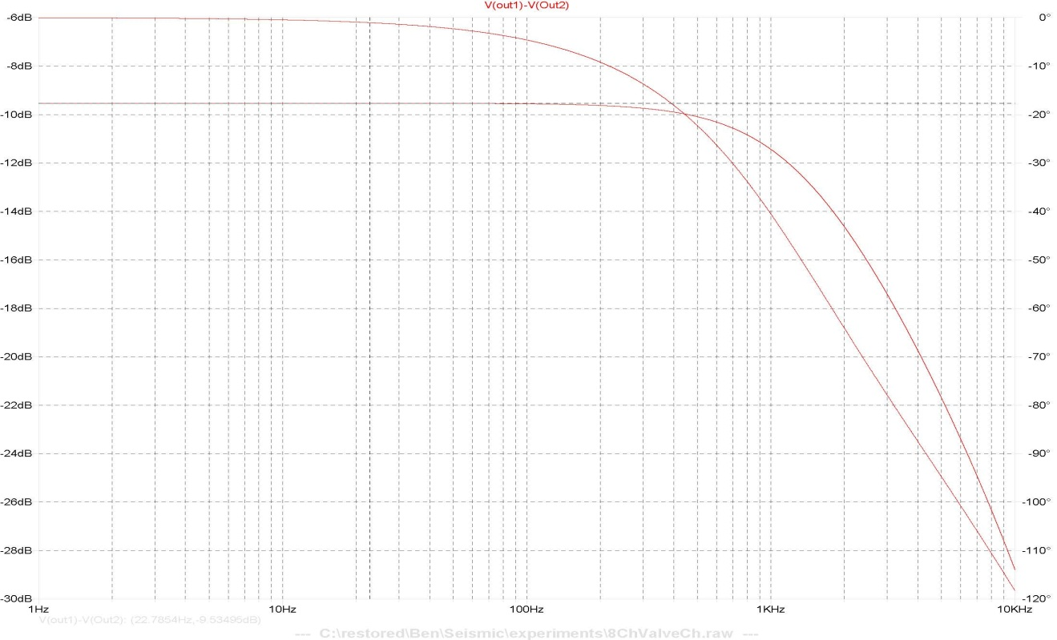

Channel | Input Pins on DB25  (+ / -) | Output pins on DB9  (+ / -) | Gain at 10Hz?  (dB) | Frequency of  -3dB point  (Hz)
1 | J5 Pins 1 / 14 | J1 pins 1 / 6
2 | J5 Pins 2 / 15 | J1 pins 3 / 8
3 | J5 Pins 3 / 16 | J3 pins 1 / 6
4 | J5 Pins 4 / 17 | J3 pins 3 / 8
5 | J5 Pins 5 / 18 | J4 pins 1 / 6
6 | J5 Pins 6 / 19 | J4 pins 3 / 8
7 | J5 Pins 7 / 20 | J6 pins 1 / 6
8 | J5 Pins 8 / 21 | J6 pins 3 / 8

Dynamic Range Measurement
Input a DC level of 10V into the channels above, and verify that the current going through the 80Ohm load is 41mA +/- 3mA), by measuring the voltage drop across the load, and dividing it by the resistance.

Channel | Input Pins on DB25  (+ / -) | Output pins on DB9  (+ / -) | Voltage drop across load (V_{L}) | Current  (V_{L} / 80Ohms)
1 | J5 Pins 1 / 14 | J1 pins 1 / 6
2 | J5 Pins 2 / 15 | J1 pins 3 / 8
3 | J5 Pins 3 / 16 | J3 pins 1 / 6
4 | J5 Pins 4 / 17 | J3 pins 3 / 8
5 | J5 Pins 5 / 18 | J4 pins 1 / 6
6 | J5 Pins 6 / 19 | J4 pins 3 / 8
7 | J5 Pins 7 / 20 | J6 pins 1 / 6
8 | J5 Pins 8 / 21 | J6 pins 3 / 8

