*LIGO Laboratory / LIGO Scientific Collaboration*

LIGO-E1300388-v2 *LIGO* 08/02/13

Install Manifold/Cryo Baf LLO ETM Y Test

Michael Smith, Lisa C. Austin

Distribution of this document:

LIGO Scientific Collaboration

This is an internal working note

of the LIGO Laboratory.

|  |  |
| --- | --- |
| **California Institute of Technology**  **LIGO Project – MS 18-34**  **1200 E. California Blvd.**  **Pasadena, CA 91125**  Phone (626) 395-2129  Fax (626) 304-9834  E-mail: info@ligo.caltech.edu | **Massachusetts Institute of Technology**  **LIGO Project – NW22-295**  **185 Albany St**  **Cambridge, MA 02139**  Phone (617) 253-4824  Fax (617) 253-7014  E-mail: info@ligo.mit.edu |
| **LIGO Hanford Observatory**  **P.O. Box 159**  **Richland WA 99352**  Phone 509-372-8106  Fax 509-372-8137 | **LIGO Livingston Observatory**  **P.O. Box 940**  **Livingston, LA 70754**  Phone 225-686-3100  Fax 225-686-7189 |

http://www.ligo.caltech.edu/

1 Introduction 5

2 Acceptance Tests 5

2.1 Y-Arm Manifold-Cryopump Baffle Alignment Test & Exit Check List 8

**Abstract**

This document presents the data for the LLO ETM Y Manifold/Cryo Baffle Installation Acceptance Test.

# Introduction

This document presents the data for the LLO ETM Y Manifold/Cryo Baffle Installation Acceptance Test.

# Acceptance Tests

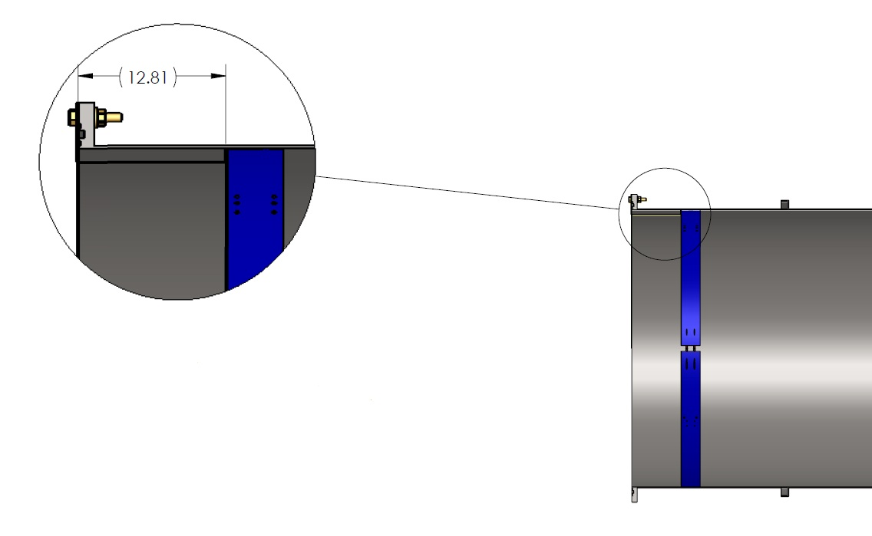

Figure : Manifold Cryopump Baffle placed ~ 12.81” away from Adapter end



Figure : Manifold Cryopump Baffle placed ~ 3.37” away from Adapter end

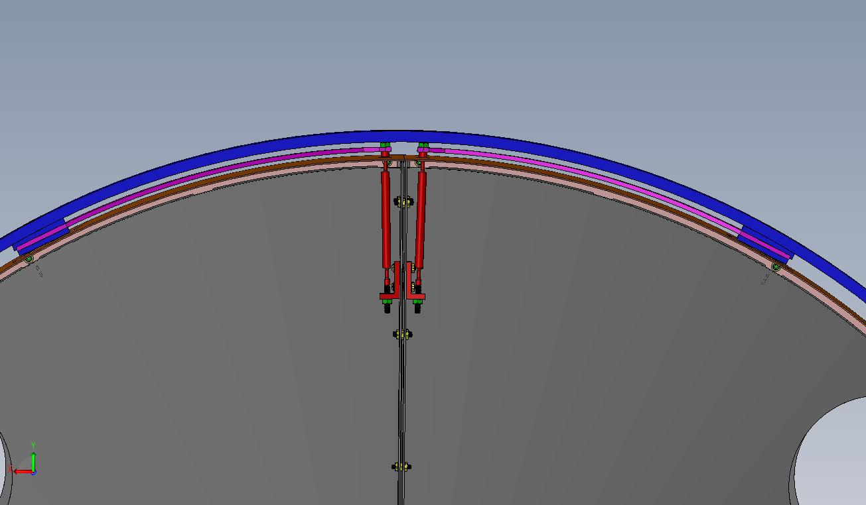

Pendulum Rod

Blade Spring

Figure : Close up of Blade Spring and 2-Wire Pendulum Suspension Mechanism

Fixed Weights

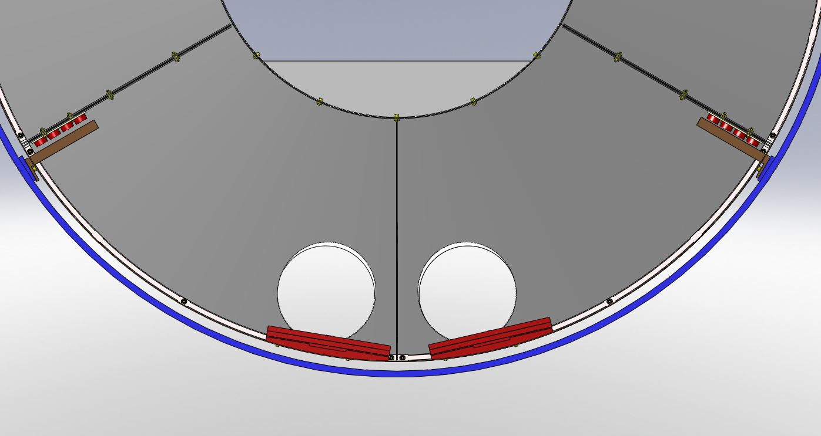

Outer Support Ring

Magnets

Cu Plate

Balance Weights

Figure : Magnet Gap and Balance Weights

## Y-Arm Manifold-Cryopump Baffle Alignment Test & Exit Check List

