LIGO Laboratory / LIGO Scientific Collaboration

LIGO-E1300477-v7 LIGO March 8, 2014

Installation Procedure for Photon Calibrator In-vacuum Periscope Assembly

R. Savage, C. Conley

Distribution of this document:
LIGO Scientific Collaboration

This is an internal working note
of the LIGO Laboratory.

California Institute of Technology  LIGO Project | Massachusetts Institute of Technology  LIGO Project
LIGO Hanford Observatory | LIGO Livingston Observatory
http://www.ligo.caltech.edu/

Introduction
This document provides a step-by-step procedure for installation of the Photon Calibrator (Pcal) Periscope Assembly (LIGO-D1200174, see Figure 1) inside the A7 Adapter at the observatory end stations (see Figure 2 and Figure 3).
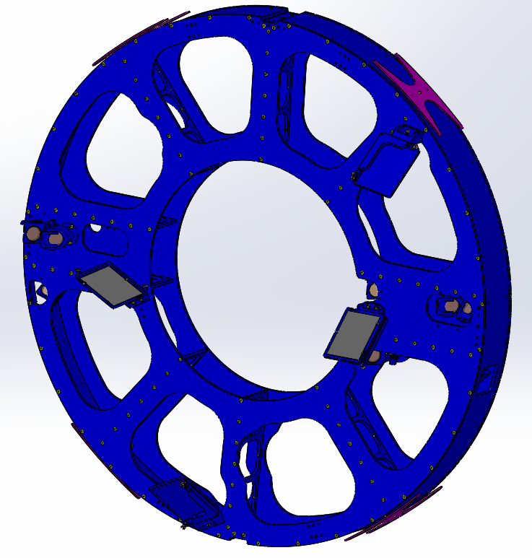
Figure 1: D1200174 aLIGO Pcal Periscope Assembly
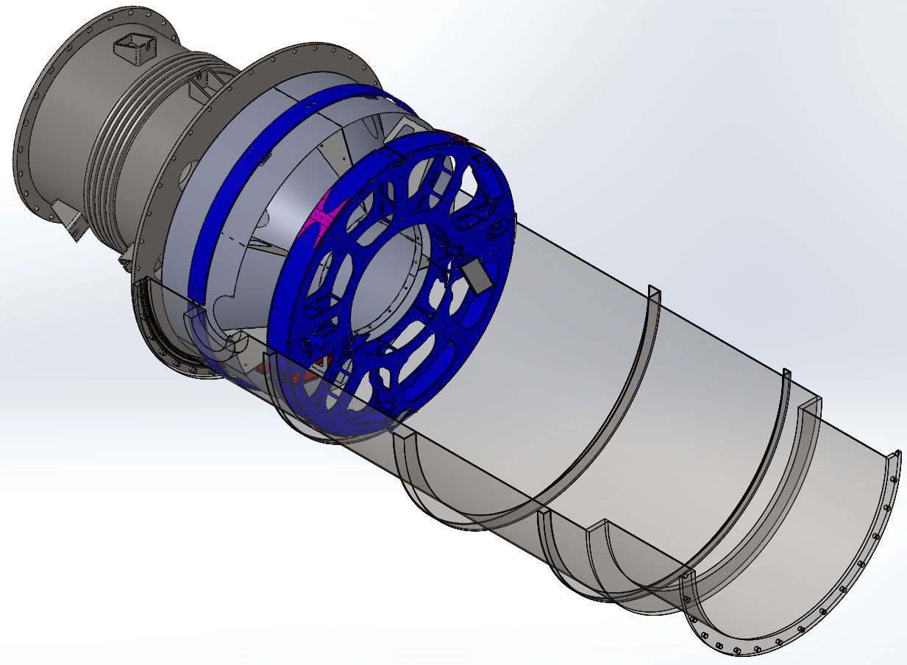
Figure 2: PCal Periscope Assembly and Cryopump/Manifold Baffle Assembly located in the A-7 Adapter
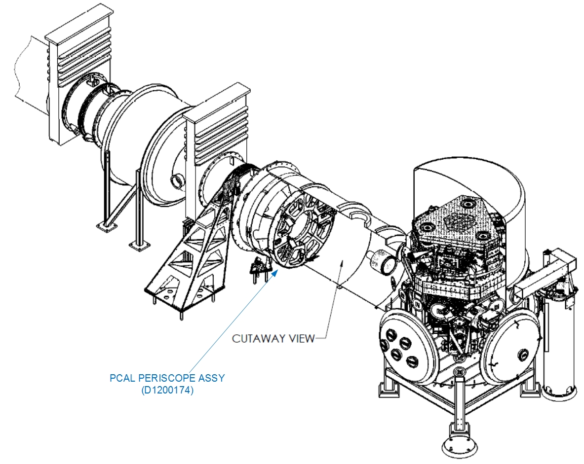
Figure 3: Excerpt from D0901465 aLIGO Systems Layout LLO X-End Station

Procedures

Installation of Installation Entry Pad on A7 Adapter flange
- install Installation Entry Pad Assy (D1300379 see Figure 4) at bottom of A7 adapter flange
- tighten bolts as is done for door installation
- Install Flange Protectors over all un-covered surfaces of A7 adapter flange
- install two 4' long Teflon Installation Highway Strips (D1300493) along floor of A7 Adapter in path of Installation Entry Pad Skids (D1300383)

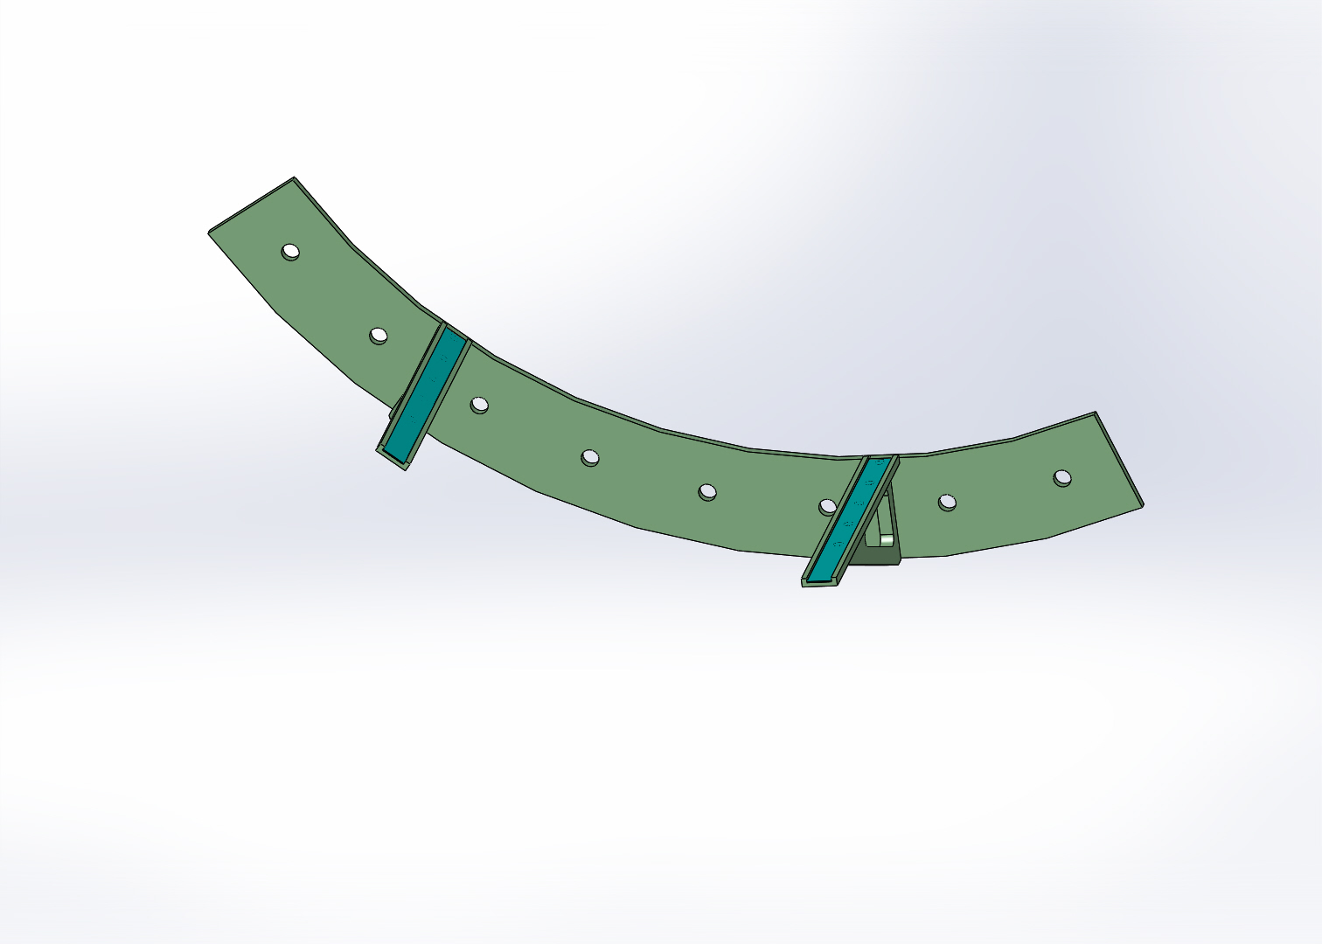
Figure 4: D1300379 aLIGO Pcal Tooling, Periscope Installation Entry Pad Assembly

Transport Periscope Assembly to entrance of A7 adapter
- remove wrapped Class-A periscope assembly (D1200174) from wooden shipping crate outside VEA using an engine hoist, fork lift with boom, or other suitable lifting device connected to lifting eye at top of periscope assembly.
- remove external wrapping, outside layer of two layers of CPstat (aka Ameristat), and move into VEA
- set on four-wheel dolly or some other suitable stand for transfer to VEA crane
- crane into cleanroom stationed over entrance to A7 adapter (A1 spool must be removed prior to this step)
- remove inner layer of CPstat and all UHV-foil wrapping
- install Periscope Stabilizing Slide & Bar (D1300245 & D1300237, see Figure 5) on the Periscope Assembly.
- crane into position on Installation Entry Pad Assy (D1300379). Note that periscope structure should be oriented such that the that eyebolt lifting fixture is on the side closest to the gate valve.
- remove lifting eye from top of Pcal Periscope Assy (D1200174). Be careful when removing the foil that pieces don’t fall into the chamber and that the dowel pins that are retained by the foil don’t fall.
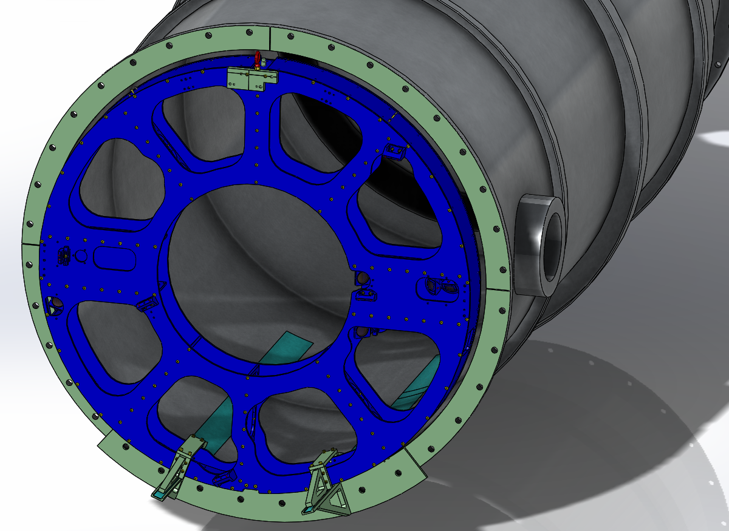
Figure 5: Periscope assembly with Periscope Stabilizing Slides & Bars attached

Moving Periscope Assembly into temporary staging position at BSC end of A7 adapter
- slide periscope Assembly on the Teflon Highway Strips down to the staging position using additional Teflon Highway Strips in “Egyptian-moving” fashion. The staging position is where the center of the periscope assembly (the Jack Screw axis) is 18.8 inches from the inside surface of the reducing step in the A7 adapter diameter (see Figure 6).
- install Support Foot (D1300229) at bottom of Periscope Assembly (Figure 7). Requires 9/16” and 1-1/8” open-end wrenches.
- rotate bottom Jack Screw (D1300228, Figure 7) to put light pressure on bottom Support Foot
- install upper Support Foot
- rotate upper Jack Screw to put light pressure on upper Support Foot, ensuring that jack plates do not rotate relative to the beam tube axis.
- making small adjustments (order one turn of screw) alternately loosen upper Jack Screw and tighten lower Jack Screw to lift Assembly off of Teflon Highway Strips
- remove Teflon Highway Strips
- continue moving Periscope Assebly vertically using Jack Screws until it is centered vertically in the A7 Adapter
- check that Periscope Assembly is vertical and roughly centered (laterally) in the A7 Adapter (roughly equal gap all the way around the diameter)
- tighten upper and lower Jack Screws to secure the Periscope Assembly in the A7 Adapter with approximately equal clearance around the diameter (nominal 3/4"). Check the stability of the Support Feet against moving on the inner surface of the A7 Adapter and increase the pressure on the Jack Screws, if required.
- remove Stabilizing Slides assembly
- rotate Periscope Assembly 90 deg. such that the faces of the Periscope Assembly are parallel to beam tube axis and the exposed face with the mirror bases (D1200726) is oriented as shown in Figure 8
- check tightness of upper and lower Jack Screws; tighten if necessary
- install Rotation Stabilizing Bars between Periscope Assembly and A7 Adapter wall to prevent accidental rotation (see Figure 8)

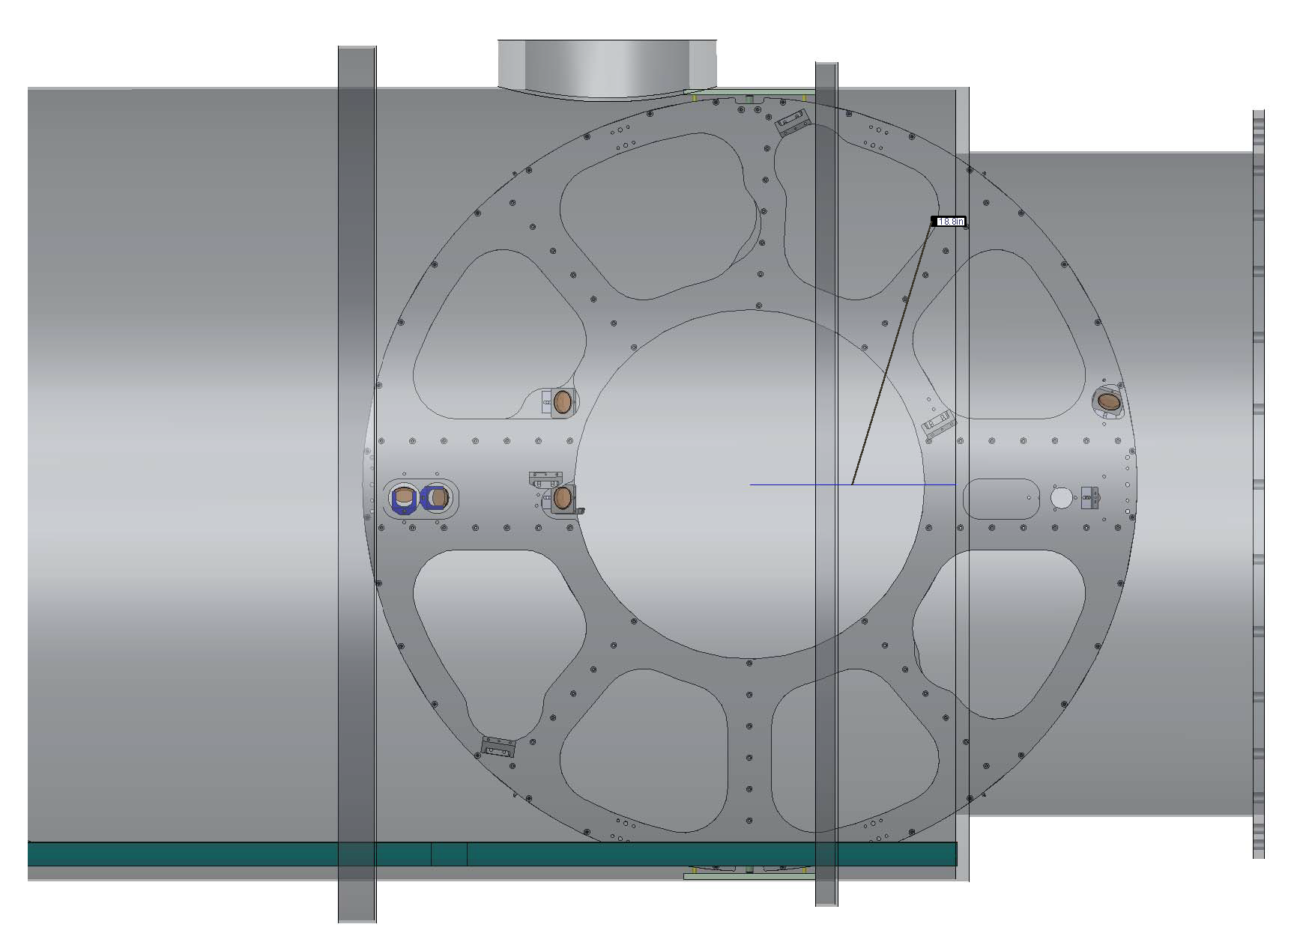
18.8”
Figure 6: Periscope Assembly shown in the staging position inside the A7 Adapter

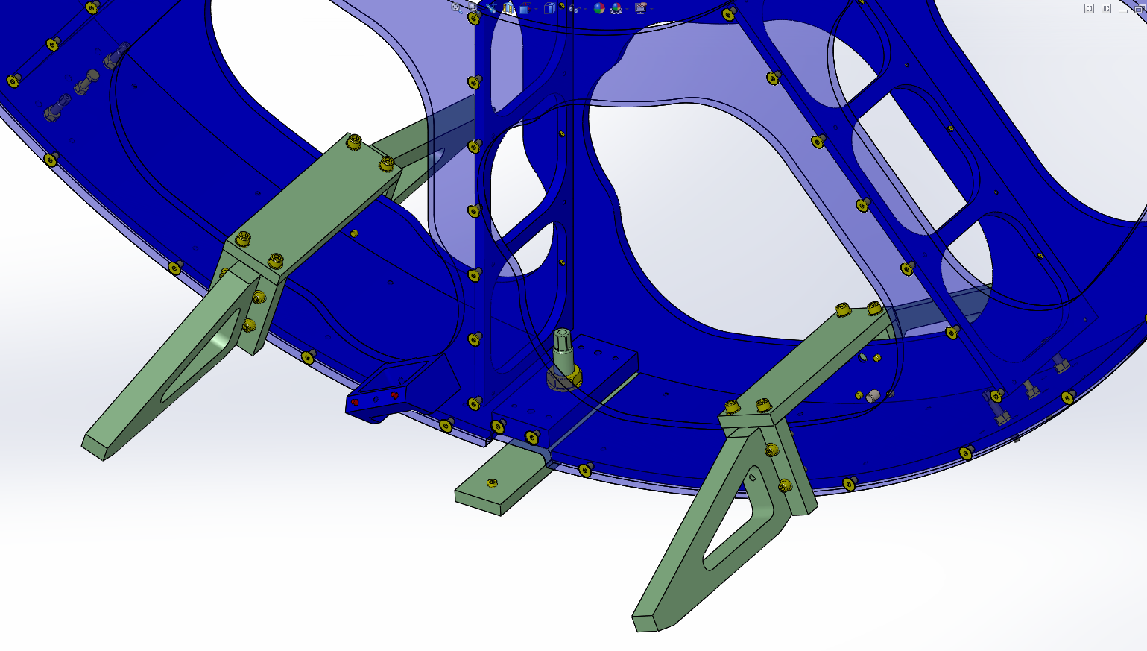
Figure 7: Bottom Support Foot (D1300229) and Jack Screw (D1300228) Assembly.

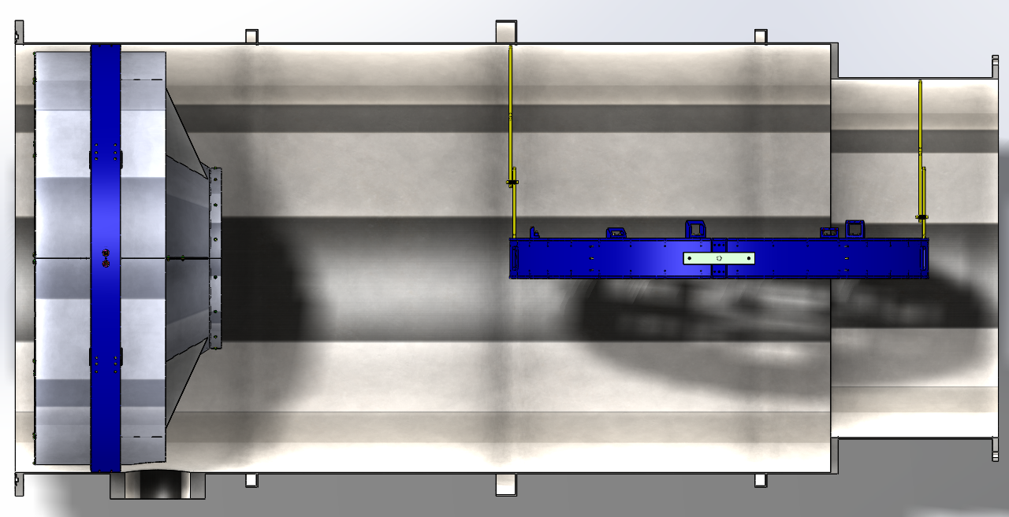
Figure 8 Periscope Assembly in the Staging Location with Rotation Stabilizing Bars installed.

Moving periscope Assembly to final location
- check tightness of upper and lower Jack Screws
- remove Rotation Stabilizing Bars assembly
- install the L2 and L4 mirror mounts (with mirrors) inside the periscope structure

- rotate Periscope Assembly 90 degrees such that the faces of the Periscope Assembly are perpendicular to beam tube axis with D1200726 closest to the ETM location
- install the Periscope Stabilizing Slides assembly
- install Teflon Highway Strips under the Stabilizing Slides
- making small adjustments (order of one turn) loosen lower Jack Screw then tighten upper Jack Screw to lower Periscope Assembly onto the Stabilizing Slides
- remove upper Support Foot; retract upper Jack Screw approximately 1/2"
- remove lower Support Foot; retract lower Jack Screw approximately 1/2"
- slide Periscope Assembly Assembly down the A7 Adapter toward the Manifold/Cryobaffle
- if the periscope assembly will be moved to near the final location without final positioning by IAS at this time, proceed with this sequence. If it will be moved to the final location and set in the final position and orientation with assistance from IAS, skip the rest of this sequence and proceed to Sequence 2.5
- roughly position Periscope Assembly longitudinally such that the face farthest from the ETM is 36 ¾” from the face of the flange at the entrance to the A7 Adapter (final positioning will be achieved with the IAS group using the distance capability of the Total Station and an IAS corner cube reflector mounted to the Periscope Installation Center Target (D1300437))
- leave the periscope structure resting on the stabilizing slides on the Teflon highway strips until final positioning and alignment with assistance from IAS.
- if the A7 adapter will be evacuated before final positioning and alignment of the periscope assembly, install the Periscope Flexures and remove all ClassB hardware (see Sequence 2.5)

Final positioning and alignment of periscope assembly with assistance from IAS
- Note that if the A7 Adapter was evacuated before final positioning and alignment of the periscope assembly, and if all Class B hardware was removed, the Stabilizing Slides assembly and Teflon Highway Strips should be re-installed and the Periscope Flexures should be removed.
- Install the Center Target Assembly (D1300437) with IAS corner cube and retro-reflecting mirror
- with the IAS crew monitoring the longitudinal location of the periscope assembly, move the assembly to the final longitudinal location (see Table 1)
- with assistance from IAS, set the roll orientation of the periscope structure by sliding on the Teflon highway strips
- install the Pcal Periscope Flexures (D1201203) at the four nominal locations; capture Flexures in location by rotating the ¼”-20 flexure retainer screws until they protrude approximately ¼” through the flexures
- rotate flexure adjustment screws so they seat in flexures with light pressure
- with assistance from IAS, roughly align the periscope structure in yaw
- slowly tighten the four lower Flexure Adjustment Screws so that the structure is lifted off of the stabilizing slides and balancing on the two lower flexures (with the stabilizing slides still attached). Make sure that the upper flexures are not limiting the movement of the structure
- bumping the periscope structure by hand and adjusting the four lower flexure adjustment screws, set the transverse position of the structure and the pitch and yaw orientations. Note, set the vertical position approximately 1 mm above the final position
- while monitoring pitch, yaw and position with assistance from IAS, tighten the four upper flexure adjustment screws to seat the upper flexures then move the structure down the required 1 mm to the final transverse location
- remove the stabilizing slides assembly and the Teflon highway strips
- remove the top and bottom jack screws along with their jamb nuts and washers
- check flexure compression using gauge pins and adjust if necessary (nominal non-flexed dimension between flexure center and A7 wall is 0.260”, nominal loaded dimensions: 0.220” upper (1 mm compression) and 0.129” lower (2.3 mm plus 1 mm)
- re-check the position and orientation of the periscope assembly and adjust as required
- lightly tighten the jamb nuts on the flexure adjustment screws and the flexure retaining screws (twelve nuts)
- note the three position coordinates and three orientation angles and record them in the aLog
- Install remaining mirror mounts (with mirrors)

Table 1 Periscope Assembly Center Alignment Target positioning and orientation dimensions and tolerances.
Feature | Dimension | Tolerance
Longitudinal distance from ETM Surface | 4042.537 mm  (159.155”) | +,- 3 mm
Vertical displacement from IFO Laser Beam axis | 0 mm | +,- 1.4 mm
Horizontal displacement from IFO Laser Beam axis | 0 mm | +,- 1.4 mm
Angular orientation of periscope normal with respect to IFO Laser Beam axis, Azimuth | 0 deg. | +,- 0.14 mrad  (140 μrad)
Angular orientation of periscope normal with respect to IFO Laser Beam axis, Elevation | 0 deg. | +,- 0.14 mrad  (140 μrad)
Note: the surface that the IAS corner cube registers on should be an additional 0.5” from the ETM surface, 159.655” (4055.237 mm).

See T1200369 for flexure design document. In summary, the flexures deflect approximately 1 mm under a 26 kg load. The fully-assembled periscope structure (with mirror mounts and mirrors) is 100.6 kg (see D1200174). The large rectangular mirror mounts plus mirror are 0.92 kg and none of the four are affixed to the structure when the flexures are adjusted. The 2” mirror mounts and mirror assemblies are 0.18 kg each and three are not installed at the time of flexure loading, and the fixed 2” mirror mounts plus mirror are .54 kg and one is not yet attached when the flexures are loaded. Thus the mass of the structure at the time of loading the flexures is 100.6 – 3.68 - .54 - .54 = 95.84 kg. The flexures are oriented 37 deg. from vertical. 1/cos(37) = 1.25. Thus the load on each of the two flexures from the fully loaded periscope structure is 95.84/2 * 1.25 = 59.5 kg. 59.9 kg/26 kg per mm = 2.3 mm = .091 inch.

