LIGO Laboratory / LIGO Scientific Collaboration

LIGO-E1300482-v1 advanced LIGO 2/20/2012

ALS Laser Locking Library

Sheila Dwyer

Distribution of this document:
LIGO Scientific Collaboration

This is an internal working note
of the LIGO Laboratory.

California Institute of Technology  LIGO Project – MS 18-34  1200 E. California Blvd.  Pasadena, CA 91125  Phone (626) 395-2129  Fax (626) 304-9834  E-mail: info@ligo.caltech.edu | Massachusetts Institute of Technology  LIGO Project – NW22-295  185 Albany St  Cambridge, MA 02139  Phone (617) 253-4824  Fax (617) 253-7014  E-mail: info@ligo.mit.edu
LIGO Hanford Observatory  P.O. Box 159  Richland WA 99352  Phone 509-372-8106  Fax 509-372-8137 | LIGO Livingston Observatory  P.O. Box 940  Livingston, LA 70754  Phone 225-686-3100  Fax 225-686-7189
http://www.ligo.caltech.edu/

Library
Title | ALSLaserLocking
Version | 1
TwinCAT version | V2.11.0
Name space
Author | Sheila Dwyer
Description | Autolocking for ALS PLL at end station
Error Code

This library includes an autolocker for the ALS end station lasers, as well as a function block called temperature controls taken from Alexa Staley’s ALSLaser library that implements a slow servo feeding back to the laser crystal temperature.
It implements the following equation, which results in a 1/f filter if TemperatureControls.PF is zero OR a 1/f response with a zero at Pf, which is intended to compensate for the thermal pole of the laser crystal:
$u_{i}=u_{i-1}+g×\left\{\begin{matrix}e_{i} & h≤0 \\ (e_{i}-e_{i-1})/h & h>0\end{matrix}\right.$ with
$g=πf_{ugf}∆t$ and $h= πf_{Pf}∆t$.
$∆t$: sampling interval,
$f_{ugf}$: unity gain frequency of integrator,
$f_{Pf}$: Knee frequency of proportional gain.
There is also a polarity switch that reverses the sign of the feedback, and an enum (TemperatureControls.ErrorSignal) which allows the user to choose what to use as an error signal: the options are the beat note frequency error measured by the frequency comparator (beat.frequency-beat.vcofrequency/2), the signal sent to the laser PZT calibrated in MHz, or the fast mon from the servo, also calibrated in MHz. There is also a reset that clears the integrator, and range limits for the output of the slow feedback.
The library also includes an error checking function block called locking conditions, which checks for a large number of error conditions that may prevent the PLL from locking, and sets the bit Logic.Conditions to FALSE if any of the locking conditions are not met.
The variable ‘locked’ is set to true if the common mode servo is not saturated and the beatnote is within tolerance.
A state diagram for the autolocker is below. The user can enable the autolocker so that it will run when the locking conditions are met, or force it so that it will disregard errors from the locking conditions function block. The user can also choose a polarity to lock the ALS laser above or below the PSL in frequency. This sets the polarity on the servo, the phase frequency discriminator, and the temperature feedback.
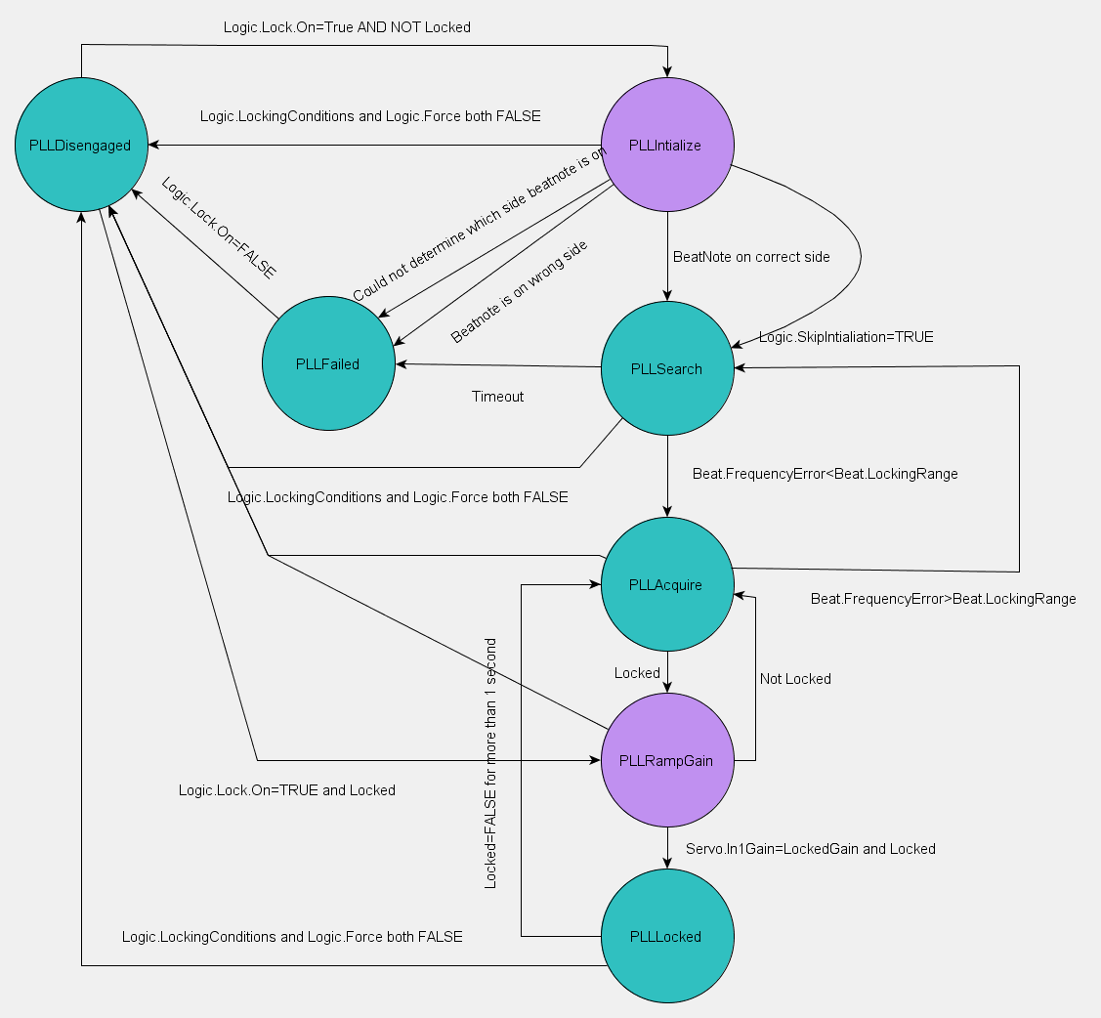
Figure 1: State diagram for PLL autolocking, transitional states in purple
When the autolocker state machine begins running, it either passes to the PLLInitialize state if the pll is unlocked or to the PLLGainRamp state if it is locked.
The user can choose to skip initialization or to initialize the autolocker, in which case it begins by increasing the laser crystal temperature, waiting 30 seconds and determining based on the response of the beat note measured by the frequency comparator if the laser is above or below the PSL in frequency. If the laser is on the wrong side, or the autolocker cannot determine what side it is on, it goes to the failed state, and the user needs to manually tune the crystal temperature. Once the temperature is manually tuned the user can disengage the autolocker and re-engage it to begin the locking process.
When the laser is on the correct side, the autolocker passes to the PLLSearch state, and uses the temperature servo with the beat note measured by the frequency comparator as an error signal, with the common mode board feedback to the PZT disengaged. If the beat note error become less than beat.LockingRange the state machine passes to PLLacquire, or if 20 minutes pass without the beatnote coming into range the autolocker goes to the PLLfailed state.
In the PLLacquire state the common mode board feedsback to the laser PZT with low gain and the temperature servo continues to use the beatnote error as measured by the frequency comparator as an error signal. If the beat notes goes out of the locking range, the state returns to PLLSearch, if the PLL locks it passes to PLLRampGain.
In PLLRampGain the temperature servo error signal is switched to the PZT feedback, and the input gain of the common mode board is ramped at 1dB per second until it reaches the gain used for locking. If the PLL is locked at the locking gain for 1 second, the state transitions to PLLLocked,
It will stay in the locked state unless the PLL becomes unlocked for more than 1 second, in which case it passes to PLLaquire, or if the locking conditions are no longer met it will pass to disengaged.

Example usage:

AlsEndFibrLockFB (
FromCornerPLC1:=RecieveFromCornerPLC1,
FromCornerPLC2:=RecieveFromCornerPLC2,
ALSLaserLocking := Ifo.ALS.End.Fibr.Lock,
ALSLaser:=Ifo.ALS.End.Laser.Head,
Request := Request,
ALSLaserLockingInit := AlsEndFibrLockInit,
FiberTrans:=Ifo.ALS.End.Fibr.Trans.Dc,
FiberRejected:=Ifo.ALS.End.Fibr.Rejected.Dc,
LaserIR:=Ifo.ALS.End.Laser.Ir.Dc,
Demod := Ifo.ALS.End.Fibr_A.Demod,
CommunicationsError:= Ifo.Sys.Communication.Y.Error,
Servo := Ifo.ALS.End.Fibr.Servo);

Error codes:
1: Communications error (lost communication from corner PLC1 or cornerPLC2, or there is an error from the timing system)
2:Reference cavity transmission PD error
4: reference cavity transmission below the limit (limit set in this autolocker)
8: Fiber launch PD (in the fiber distribution box, internal.DC) error
16: Fiber launch power below the limit (limit set in this autolocker)
32: Fiber trans PD error (the limits are enforced in the DC PD library for the local PDs)
64: Fiber trans PD limits not set, they need to be set correctly
128:Fiber rejected polarization PD error
32768: Fiber rejected PD limits not set
256: % of the fiber light that is in the wrong polarization is too large
512: power transmitted by fiber in the correct polarization to interfere with ALS laser is too small
1024: ALS Laser IR power PD error
65536: ALS Laser IR power PD limits not set
2048: Phase Frequency Discriminator Error
4096: Beat note power too low
8192: Beat note out of range of frequency comparator
131072: ALS Laser Error
262144: AutoLocker Failed

Library Dependencies:
Error
SaveRestore
ReadADC
WriteDAC
ALSCommunication
ALSStateMachine
DCPower
Demodulator
CommonModeServo
ALSLaser

