E1300537-v1 Addendum to E0900042 aLIGO OMC Hazard Analysis

Purpose:
This addendum allows the optional use of a lift table in conjunction with people lifting/sliding the OMC up and into position in HAM 6. This is in lieu of using the HAM Installation Arm as described in the E0900042 Hazard Analysis.

Procedure:
- Select a lift table which has sufficient capacity to lift the 100 pound OMC suspension (including the optical bench). The white lift table shown in Figure 1. at LLO is sufficient for this purpose. At LHO and the 3rd LIGO observatory, a similar Genie lift of sufficient capacity can also be used if a lift identical to Figure 1. is not available.
- Wipe all surfaces of the lift table. Cover the table surface with a layer of Ameristat and a layer of UHV aluminum foil.
- With 2 people of similar strength and height, lift the OMCS onto the lift table.
- Roll the lift table into position at HAM 6, raising the table as necessary to avoid the HEPI piers and to bring the table to the height of the HAM ISI table.
- With 2 people of similar strength and height, slide/lift the OMCS onto a Teflon highway (or Teflon pads) and slide to the desired location. With 2 people of similar strength and height, lift the OMCS off of the Teflon.

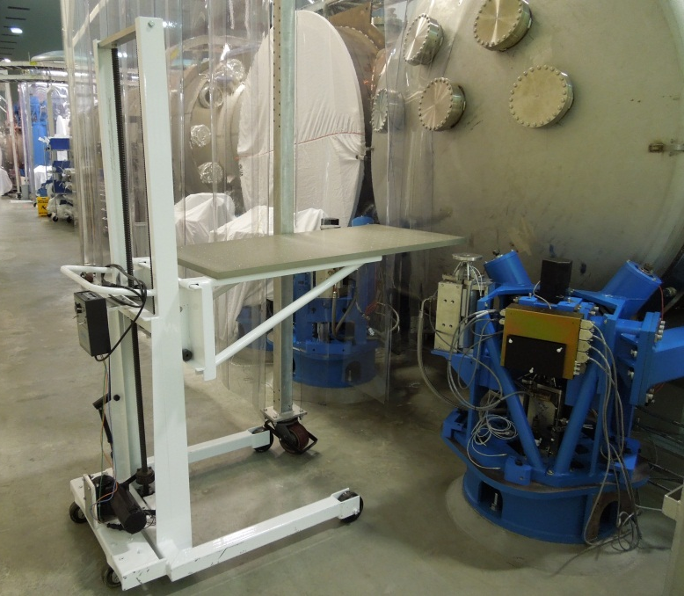
Figure 1. White lift table at LLO positioned in front of HAM6

Hazards:
- Pinch hazard around lift table: Mitigate by being cognizant of the risk and not putting fingers or body parts in between the mechanical parts which may pinch.
- Lifting hazard: Mitigate by using 2 people of similar strength and height and not lifting while in an awkward position which puts undue stress on the back.

