LIGO Laboratory / LIGO Scientific Collaboration

LIGO-E1300564-v5 LIGO 2/28/14

aLIGO Pcal Periscope Pre-Alignment Procedure

R. Savage, C. Conley

Distribution of this document:
LIGO Scientific Collaboration

This is an internal working note
of the LIGO Laboratory.

California Institute of Technology  LIGO Project – MS 18-34  1200 E. California Blvd.  Pasadena, CA 91125  Phone (626) 395-2129  Fax (626) 304-9834  E-mail: info@ligo.caltech.edu | Massachusetts Institute of Technology  LIGO Project – NW22-295  185 Albany St  Cambridge, MA 02139  Phone (617) 253-4824  Fax (617) 253-7014  E-mail: info@ligo.mit.edu
LIGO Hanford Observatory  P.O. Box 159  Richland WA 99352  Phone 509-372-8106  Fax 509-372-8137 | LIGO Livingston Observatory  P.O. Box 940  Livingston, LA 70754  Phone 225-686-3100  Fax 225-686-7189
http://www.ligo.caltech.edu/

Introduction
This document details the procedure for installing and aligning the thirteen beam steering mirrors on the in-vacuum Pcal Periscope Assembly - five for the lower Pcal beam path, four for the upper Pcal beam path, and two for each of the upper and lower camera view paths. See LIGO-D1200174 for exploded assembly, BOM, and general detail information of the complete Pcal Periscope Assembly. All Pcal Periscope assembly and pre-alignments are performed in the H2 PSL Enclosure anteroom.
Before starting this procedure, the Periscope Frame Assembly (LIGO-D1200993), must be built according to LIGO-E1300566, and the Pre-Alignment Setup (see Layout LIGO-D1201412) must be positioned and aligned according to LIGO-T1300585.
The X-Arm versions of Periscope and Pre-Alignment Setup are depicted herein. The X-Arm and Y-Arm Periscope versions are similar by symmetry, and the Pre-Alignment Setup is convertible between X-Arm and Y-Arm configurations.

Prepare Periscope Frame for Cradle Mounting
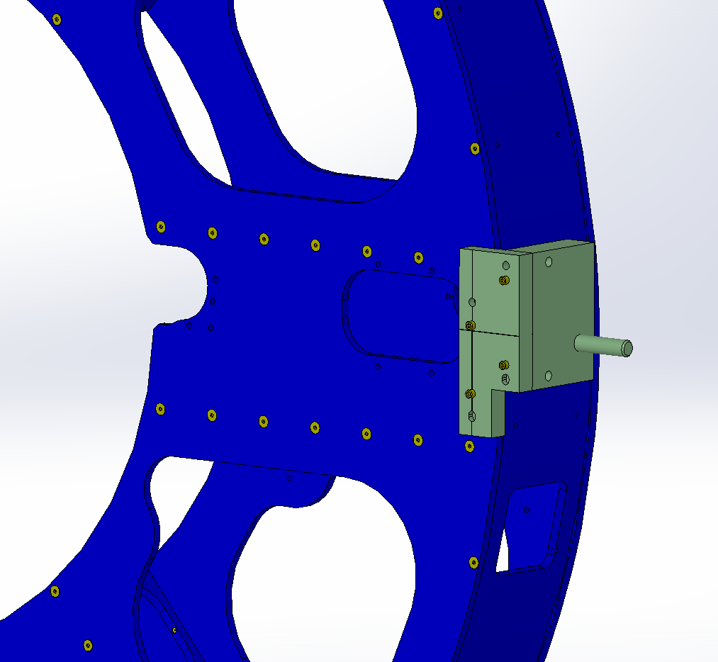
PERISCOPE FRAME
Pivot Axis Assembly 2 PLACES, (OPPOSITES, LEFT HANDED, RIGHT HANDED)
¼-20 x 1-3/8L SHCS 2 PLACES
Figure 1 Right handed Pivot Axis Assembly, LIGO-D1201576, mounted to right side of front plate of D1200993 Periscope Frame. Left handed Pivot Axis Assembly mounts similarly on the left side of the front plate.

- Requires 3 persons.
- Mount left and right handed Tip Axis assemblies to the front plate of the Periscope Frame per Figure 1. The blocks of the Tip Axis assemblies which contact the Periscope Frame front plate are class B. The rest of the Tip Axis assembly is not clean, so cover with clean foil and handle accordingly.
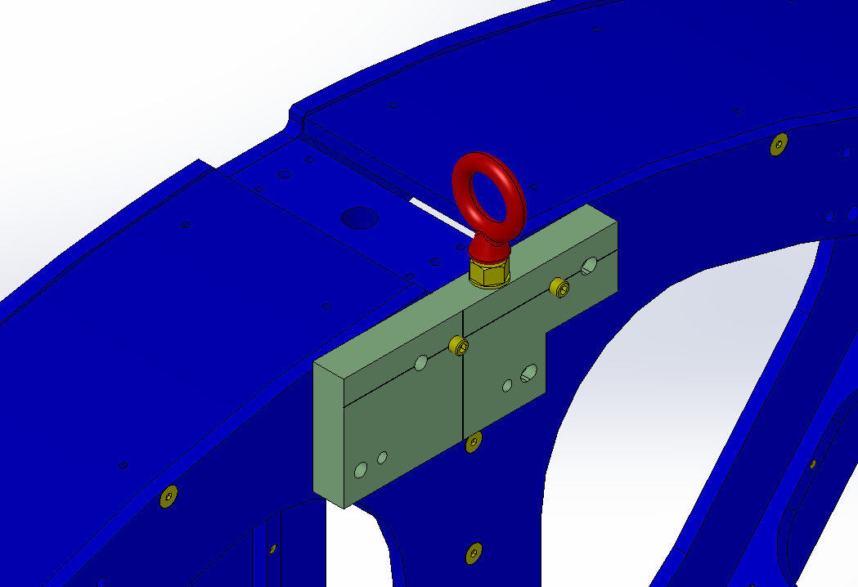
PERISCOPE FRAME
¼-20 x 1-3/8L SHCS 2 PLACES
LIFTING BLOCK ASSEMBLY
Figure 2 Lifting Block Assembly (Lifting Block), LIGO-D1300621, mounted at top of front plate of D1200993 Periscope Frame. Orient eye-bolt perpendicularly to block as shown.

- Mount Lifting Block to the front plate of the Periscope Frame per Figure 2. The eye-bolt must be oriented as shown, and should coincide with the vertical center-plane of the Periscope Frame.

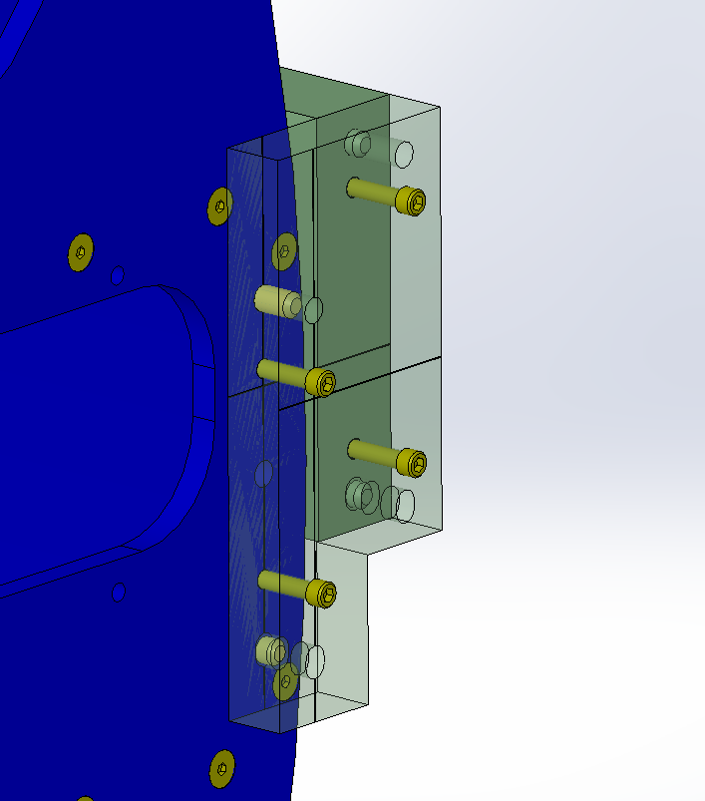
PERISCOPE FRAME
3/8” DIAMETER DOWEL PINS
Figure 3 3/8” diameter dowel pins inserted into Periscope Frame front plate and Pivot Axis Assembly for registration and load bearing.

- Stand the Periscope Frame upright on a clean covered floor dolly with the two Pivot Axis horizontal (Lifting Block at highest point).
- Slightly loosen the two ¼-20 x 1-3/8L mounting screws of each Pivot Axis and insert two 3/8” diameter dowel pins to register each Pivot Axes as per Figure 3.
- Re-tighten the mounting screws.
- Similarly, loosen the two ¼-20 x 1-3/8L mounting screws of the Lifting Block and insert two 3/8” diameter dowel pins to register.
- Re-tighten the mounting screws.
- Keep the Periscope Frame upright to prevent the 3/8” dowel pins from falling out.

Mount Periscope Frame to Cradle
- Using two floor dollies, move the West Cradle into the LVEA through the anteroom double doors.
- Position an engine hoist inside the anteroom to be moved toward the East Cradle.
- Wheel the upright Periscope Frame into position with the hoist, with the front plate facing away from the Cradle (toward the hoist). Using a suitable shackle, hook the Periscope Frame to the hoist via the Lifting Block.
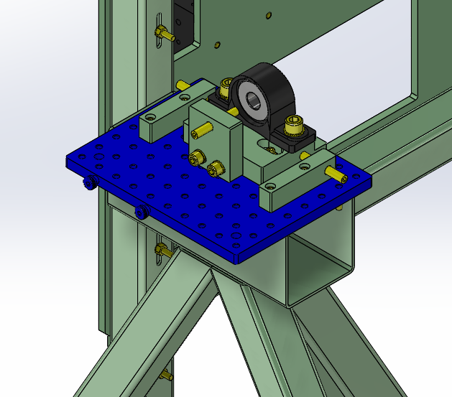
BREADBOARD
SPHERICAL BEARING & SLIDE BLOCK
Figure 4 Spherical bearings are mounted on slide blocks on the breadboards of either side of the Cradles.
- Remove the foil from both Pivot Axes.
- Remove the slide blocks with the spherical bearings from both breadboards, Figure 4, of the East Cradle. Lift them vertically to free their blind slots (not visible in view) from the dowel pins (not visible in view) of the breadboards.
- Lift the Periscope Frame from the floor dolly and slide the spherical bearings with slide blocks over the Pivot Axes.
- While two persons, one at each Pivot Axis, steady the Periscope Frame and keep the bearings on the Pivot Axes, the third person moves the hoist to position the Periscope Frame to the East Cradle. The two persons steadying the Periscope Frame must each maintain one clean hand while the other hand minds the bearing and Pivot Avis.
- As a team, carefully manipulate the Periscope Frame into position on the Cradle using the hoist to set it down with the bearings and slide blocks in position on the breadboard dowel pins. See Figures 5 & 6.
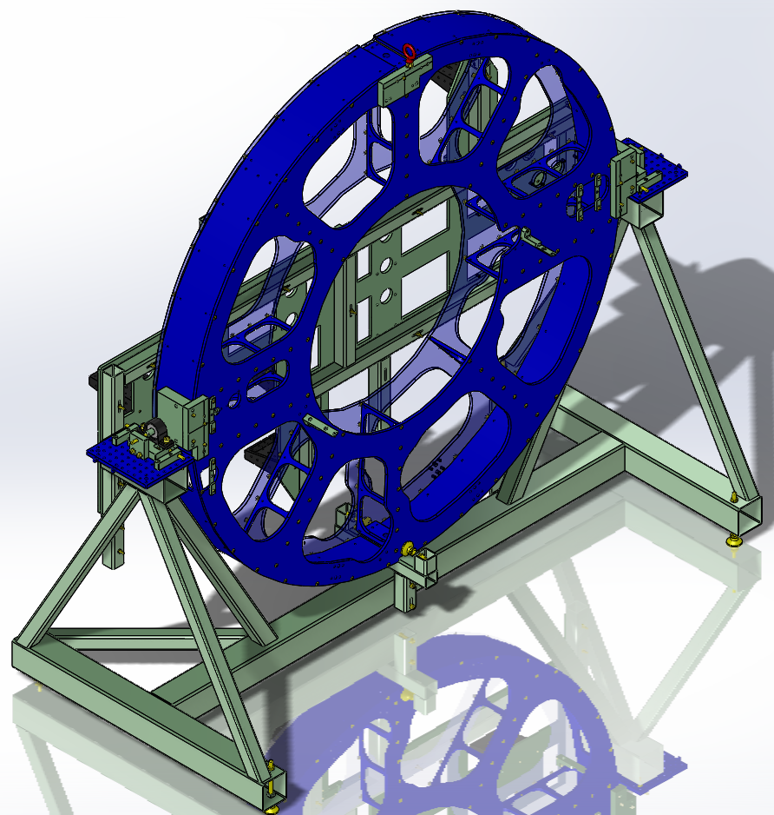
PITCH ADJUSTERS
COVER WITH CLEAN FOIL
PERISCOPE FRAME
Figure 5 Periscope Frame mounted on East Cradle.
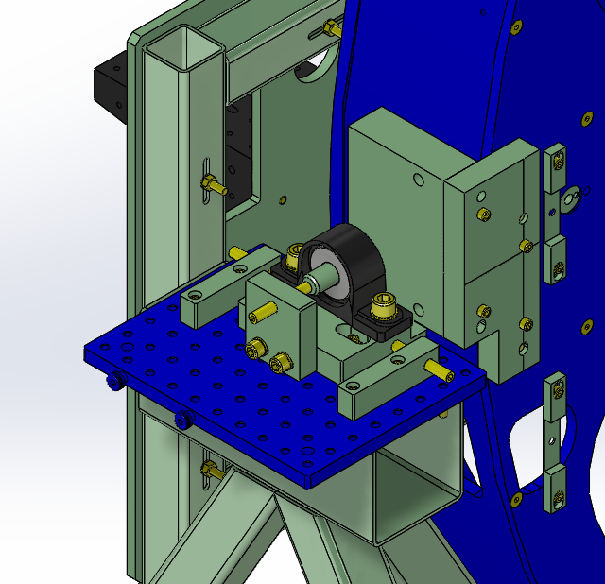
LATERAL ADJUSTERS (2)
YAW ADJUSTERS (4)
Figure 6 Close-up of left Pivot Axis, bearing and slide block, yaw and lateral adjusters.

- Remove the engine hoist from the anteroom.
- Return the West Cradle to its position, aligned on its floor marks using plumb bobs according to LIGO-T1300585, Section 2.7.

Pitch, Yaw, and Lateral Adjustments of Periscope Frame
Setting the pitch and yaw orientation of the periscope frame is achieved using the center target assembly mounted inside the periscope frame and an alignment laser mounted behind the template plates in the opposite pre-alignment cradle and directed through the apertures that represent the axis of the ETM.

- Mount an alignment laser (HeNe or YLF) on the template plates in the cradle opposite the cradle holding the periscope frame and align its output beam through the apertures in the template plates on both frames that are along the ETM axis. Make sure that this alignment is very precise.
NOTE: If necessary, this alignment can be done on the opposite side.
- Install the center target in the periscope frame with the mirror mounted in the ETM aperture and on the side opposite the cradle with the alignment laser (the mirror wants to retro-reflect the beam back toward the alignment laser).
- Visually inspect the contact between the surface of the retro mirror and the center target to verify that they are mated to eachother.
- Adjust the pitch and yaw orientation of the periscope frame using the acutators on the pivot supports and at the bottom of the frame such that the alignment laser beam is retro-reflected to the aperture in the opposite cradle target plate.
- Lock the adjustment screws and re-check the retro-reflection.
- Remove the center target assembly.

Installation and Alignment of Pcal Relay Mirrors
The nine 2” diameter Pcal relay mirrors are installed in this part of the procedure. They are aligned using a 1047 nm iLIGO Pcal laser. The lower (outside) beam path is aligned first because mirror U1 will interfere with the installation and alignment of mirror L1.
The following steps should be completed before proceeding:
- Mirrors have been loaded into all nine mounts, ensuring that they are properly seated and secured and that the HR surfaces are correctly oriented.
- The actuators in all mirror mounts have been adjusted to their center positions (movable plate parallel to back plate), and the locks are not engaged.
- Bases have been installed and roughly positioned in accordance with LIGO-D1200174 with the mounting screws slightly more than hand tight.
- The mirrors that simulate the ETM surface where the Pcal beams are incident have been aligned by positioning the mirrors on the template plates on the cradle opposite to the cradle holding the periscope frame, directing an alignment laser beam through apertures in both sets of template plates, and adjusting the mirror mounts to retro-reflect the beams back toward the laser. This alignment should be done very precisely; it is a critical step in the pre-alignment.
- The two output beam path locations have been marked on the wall of the Ante-room by directing a laser beam through both alignment templates and onto the wall. Note that this requires removal of the U3 mirror mount base. It should be replaced after marking the wall.

Lower Beam Path
- Note that for a Y-arm assembly, all three adjustable Siskiyou mounts are used in the “Right-hand configuration. The mounts should be scribed ahead of time with part and serial numbers, e.g. L2 S/N 04.
- Position the 1047 nm alignment laser such that the beam is directed along the input beam path for the lower ( outer, farthest from center) Pcal beam.
- Carefully align the beam to the center of the apertures in the template plates.
- Install the L1 mirror assembly (D1102439) with the three ¼”-20 screws only finger tight and the mirror directing the input beam downward.
- Install an alignment flag below the mirror and above the L2 mirror location and rotate the L1 assembly to center the reflected beam on the aperture in the flag.
- Tighten the three ¼”-20 screws with approximately 80 in-lbs. torque.
- Move the alignment flag to the location just inside of the L4 location.
- Scribe the L2 mount with the mount designator and serial number (L2 S/N 0?) on the mount back plate leg that will be bolted to the base.
- Install the L2 mount on its base and secure it with its ¼”-20 mounting screw. Note: if necessary, rotate actuator body so that the locking screws are conveniently oriented.
- Adjust the L2 base location and orientation such that the input beam is centered on L2 and the reflected beam is near the alignment target.
- Steer the beam from L2 so that it is centered on the alignment flag
- Tighten the base mounting screw to approximately 80 in-lbs. torque.
- Lock the L2 mirror actuators.
- Recheck alignment, adjust if necessary, and remove the alignment flag.
- Scribe the L3 mount with the mount designator and serial number (L3 S/N 0?) on the mount back plate leg that will be bolted to the base.
- Install the L3 mirror mount on its base and secure it with its ¼”-20 mounting screw. Note: if necessary, rotate actuator body so that the locking screws are conveniently oriented.
- Adjust the L3 base location and orientation such that the input beam is centered on L3 and the reflected beam is near the lower ETM target aperture.
- Adjust the L3 mount such that the beam is centered on the lower ETM beam aperture.
- Install the alignment target strip at the location where the beam reflecting from the ETM target is incident on the periscope structure (near L4).
- Check that the beam is centered on the target strip aperture. If not, check that the base of L3 is properly centered on the mounting hole slot. If not, adjust as necessary to bring the spot reflected from the ETM target to the target strip aperture.
- Lock the L3 mirror actuators
- Tighten the L3 base mounting screw to approximately 80 in-lbs. torque.
- Remove the alignment target strip.
- Scribe the L4 mount with the mount designator and serial number (L4 S/N 0?) on the mount back plate leg that will be bolted to the base.
- Install the L4 mirror mount on its base and secure it with its ¼”-20 mounting screw. Note: if necessary, rotate actuator body so that the locking screws are conveniently oriented.
- Install alignment flag near the L5 location.
- Adjust the L4 base location and orientation such that the input beam is centered on L4 and the reflected beam is near the lower ETM target aperture.
- Tighten the base mounting screw to approximately 80 in-lbs. torque.
- Adjust the L4 mount such that the beam is centered on the alignment aperture. Don’t lock the actuators yet.
- Remove the alignment flag from near the L5 location.
- Install the L5 mirror assembly (D1102439) with the three ¼”-20 screws only finger tight and the mirror directing the input beam from below out toward the target mark on the wall.
- Rotate the L5 mount and tighten the three base screws when it’s reflected beam is as close as possible to the mark on the wall.
- Using the actuators on L4, center the beam reflected from L5 on the mark on the wall.
- Check the centering of the beam on the aperture in the target plate. If it is not centered, iterate the adjustment of the actuators on L4 and the rotation of L5 such that the beam is centered on the target aperture and on the spot on the wall. This is the most difficult part of the alignment and a bit subtle.
- Lock the L4 mirror actuators and recheck alignment.
- Re-torque the mounting screws for all five lower path mirror bases.
- Check that all mirror actuators are locked.
- Verify that L2, L3 and L4 mounts have been engraved with serial numbers on the legs bolted to their bases.
- Verify alignment of output beam after re-torque of base screws and locking actuators.

Upper Beam Path
- Both of the U2 and U3 mirror mounts are used in a Left-hand configuration for a Y-arm assembly. They should be scribed before starting this procedure, e.g. U2 S/N 0?.
- Position the 1047 nm alignment laser such that the beam is directed along the input beam path for the inner (closest to periscope center) Pcal beam.
- Carefully align the beam to the center of the apertures in the template plates.
- Install the U1 mirror assembly (D1102439) with the three ¼”-20 screws only finger tight and the mirror directing the input beam toward the center of the periscope.
- Install an alignment flag along the horizontal path and near the L5 mirror mount. Rotate the U1 assembly to center the reflected beam on the aperture in the flag.
- Tighten the three ¼”-20 screws with approximately 80 in-lbs. torque.
- Remove the alignment flag.
- Scribe the U2 mount with the mount designator and serial number (U2 S/N 0?) on the mount back plate leg that will be bolted to the base.
- Install the U2 mount on its base and secure it with its ¼”-20 mounting screw. Note: if necessary, rotate actuator bodies so that the locking screws are conveniently oriented.
- Adjust the U2 base location and orientation such that the input beam is centered on L2 and the reflected beam is near the upper ETM aperture in the ETM cradle template plate.
- Steer the beam from U2 so that it is centered on the upper ETM aperture.
- Install the alignment target strip at the location where the beam reflecting from the ETM target is incident on the periscope structure (near the 1” diameter hole close to the U3 base).
- Check that the beam is centered on the target strip aperture. If not, check that the base of U2 is properly centered on the mounting hole slot. If not, adjust as necessary to bring the spot reflected from the ETM target to the target strip aperture. Slight adjustments to the U2 actuators may be required. Check the centering on the ETM aperture.
- Tighten the U2 base mounting screw to approximately 80 in-lbs. torque.
- Lock the U2 mirror actuators
- Re-check the alignment on the target strip.
- Remove target strip.
- Install and roughly position the base for U3 (D1200172-1).
- Holes for an alignment flag for the beam from U3 were accidentally omitted from the design. Install an alignment flag in the lower of the two ¼”-20 heli-coils near the CU2 base and orient it normal to the beam from U3 (the dowel pin will be hanging off of the plate.
- Install the U3 mount on its base and secure it with its ¼”-20 mounting screw. Note: if necessary, rotate actuator bodies so that the locking screws are conveniently oriented.
- Adjust U3 to set the height above the plate using the alignment flag and to set the beam approximately 0.256” vertically upward from the center of the flag. The flag is 0.9” wide, so the center of the beam will be about 0.2” below the top edge of the flag.
- Tighten the U3 base mounting screw to approximately 80 in-lbs. torque.
- Lock the U3 mirror actuators.
- Remove the alignment flag.
- Install the U4 mirror assembly (D1102439) with the three ¼”-20 screws only finger tight and the mirror directing the input beam U3 out toward the target mark on the wall.
- Rotate the U4 mount and tighten the three ¼”-20 base screws with approximately 80 in-lbs. torque when it’s reflected beam is as close as possible to the mark on the wall.
- Using the actuators on U3, center the beam reflected from U4 on the mark on the wall.
- Check the centering of the beam on the aperture in the target plate. If it is not centered, iterate the adjustment of the actuators on U3 and the rotation of U4 such that the beam is centered on the target aperture and on the spot on the wall. This is the most difficult part of the alignment and a bit subtle.
- Lock the U3 mirror actuators and recheck alignment.
- Re-torque the mounting screws for all four upper path mirror bases.
- Check that all mirror actuators are locked.
- Verify that the U2 and U3 mounts have been engraved with serial numbers on the legs bolted to their bases.
- Verify alignment of output beam after re-torque of base screws and locking actuators.
- Scribe the base of the U4 mount and the periscope plate to record the azimuthal orientation of the mount. It will be removed for shipping.

Installation and Alignment of Camera View Mirrors
- All four camera view rectangular mirror mounts for each periscope assembly have the same “handedness” – Right-hand for a Y-arm assembly and Left-hand for an X-arm assembly.
- The four camera view bases should be roughly positioned as shown in LIGO-D1200174 sheet 3.
- The four mirror mounts should be scribed with mirror and serial numbers, CU1 S/N0?, etc.

Lower Camera View Beam Path
- Using the HeNe alignment laser set up, mount it to the lower periscope template plate (upside down) and align the beam to apertures in both template plates.
- Install both the CL1 and CL2 mirror mounts.
- Install an alignment flag between the CL1 and CL2 mounts, near CL2.
- Check that the alignment beam is striking CL1 near its center and rotate its base so that the reflected beam is close to the alignment target.
- Tighten the CL1 base mounting screws to approximately 80 in-lbs. torque.
- Adjust CL1 to center the reflected beam on the alignment aperture.
- Lock the actuators on CL1
- Remove the alignment target.
- Check that the alignment beam is striking CL2 near its center and rotate its base so that the reflected beam is close to the ETM center alignment target.
- Tighten the CL2 base mounting screws to approximately 80 in-lbs. torque.
- Adjust CL2 to center the reflected beam on the ETM center aperture in the ETM template plate.
- Lock the actuators on CL2.
- Check that the beam is still aligned on the center ETM aperture in the ETM target plate.
- Re-check that all base mounting screws are torqued to approximately 80 in-lbs. and that all mirror actuators are locked.

Upper Camera View Beam Path
- Using the HeNe alignment laser set up, mount it to the upper periscope template plate and align the beam to apertures in both template plates.
- Install both the CU1 and CU2 mirror mounts.
- Install an alignment flag between the CU1 and CU2 mounts, near CU2.
- Check that the alignment beam is striking CU1 near its center and rotate its base so that the reflected beam is close to the alignment target.
- Tighten the CU1 base mounting screws to approximately 80 in-lbs. torque.
- Adjust CU1 to center the reflected beam on the alignment aperture.
- Lock the actuators on CU1
- Remove the alignment target.
- Check that the alignment beam is striking CU2 near its center and rotate its base so that the reflected beam is close to the ETM center alignment target.
- Tighten the CU2 base mounting screws to approximately 80 in-lbs. torque.
- Adjust CU2 to center the reflected beam on the alignment aperture.
- Lock the actuators on CU2
- Check that the beam is still aligned on the center ETM aperture in the ETM target plate.
- Re-check that all base mounting screws are torqued to approximately 80 in-lbs. and that all mirror actuators are locked.

Preparation for shipping
After pre-alignment, most of the mirror mounts are removed (bases left in place) at the dowel-pinned joint between the mounts and the bases. The mirrors are removed from the mounts and transferred to shipping boxes, noting the orientation of the mirrors so they can be replaced in the same orientation in which they were removed.
The pre-aligned periscope structure is then wrapped in C3 fabric (two HAM door covers), then two layers of ameristat, before being inserted into the shipping crate.
- Remove the CU1, CU2, CL1, and CL2 mirror mounts, returning the mounting screws to the bases and tightening them lightly so they won’t vibrate lose during shipment.
- Verify that all four bases have mounting screws and that they are sufficiently tight.
- Remove the L2, L3, and L4 mirror mounts, returning the mounting screws to the bases and tightening them lightly so they won’t vibrate lose during shipment.
- Verify that all three bases have mounting screws and that they are sufficiently tight.
- Remove the U2 and U3 mirror mounts, returning the mounting screws to the bases and tightening them lightly so they won’t vibrate lose during shipment.
- Verify that both bases have mounting screws and that they are sufficiently tight.
- Remove the U4 mirror mount, returning the three mounting screws to the periscope frame plate and tightening them lightly so they won’t vibrate lose during shipment.
- Verify that all three mounting screws are sufficiently tight.
- Install a strip of aluminum foil around the dowel pins in the lifting bracket so they don’t fall out and rattle around during shipping.

