LIGO Laboratory / LIGO Scientific Collaboration

LIGO- T1300503-v4 LIGO 27th June 2013

Redesign of quad UIM coil driver and magnet size to reduce magnetic coupling

Norna A Robertson, Jeff Kissel, Ken Strain, Peter Fritschel

Distribution of this document:
LIGO Scientific Collaboration

This is an internal working note
of the LIGO Laboratory.

California Institute of Technology  LIGO Project | Massachusetts Institute of Technology  LIGO Project
LIGO Hanford Observatory | LIGO Livingston Observatory
http://www.ligo.caltech.edu/

v2: additions from emails from Jeff K, Ken S and Peter F.

v3 corrected references to current magnet/flag assembly, updating sections 1.1 and 1.2.

v4 added to conclusions section with comments from SUS discussion on 11th June 2013, and added picture of possible redesigns in Appendix C.
Introduction
The purpose of this document is to present options for a redesign of the electromagnetic actuation at the upper intermediate (UIM) level in the test mass quadruple suspension to reduce potential excess noise due to magnetic coupling.
Robert Schofield has taken measurements on ITMY and ETMY at LHO which show excess magnetic coupling at levels 1 and 2 (top and UIM levels) –see alog entry 4640 at LHO https://alog.ligo-wa.caltech.edu/aLOG/index.php?callRep=4640 and also G1300300. Two mitigation steps discussed in the alog entry are removal of eddy current damping magnets on the UIM blades, and introducing slits into the AOSEM mounting plates at the PUM reaction mass. The effects of both of these steps are still to be assessed. In parallel we have been considering the reduction of the size of the magnets used in the actuation between the main chain and reaction chain at the upper intermediate (UIM) level, while increasing the available coil current to maintain the available actuation. We discuss this option below.
We note that all of these potential changes are reported in the Bugzilla system as Bug 21 “high ambient magnetic field coupling to the quad sus optic motion”.

Magnet Size and Flag Design

Availability of sizes
The magnets currently used at the UIM level are 4 off 10mm diam x 10mm thick SmCo magnets, Ni-plated, arranged as shown in D0901346, page 7. Each magnet is paired with a second magnet situated 3 cm behind with opposite polarity, to reduce the overall dipole field, See D1100937.
We have been in contact with the vendors of our current magnets, Electron Energy Corporation. The can supply 10 mm diameter disc magnets of any required thickness. All would be custom made, not off-the-shelf. The lead time for our previous order was 9 weeks, including the Ni-plating and measuring and recording the strength of the magnets.
In conclusion there is no strong reason to pick a particular size (e.g. 10 mm by 2 mm or 10 mm by 1 mm) due to availability.

Flag design
We propose to keep the 3 cm spacing between the main magnet and the shielding magnet, where the opposing magnet's force is a few percent of the primary magnet. Taking the current design D1100937, we have looked at which parts of the UIM BOSEM flag would need to be reworked to accommodate smaller magnets. See draft sketch under other files on this document’s filecard which has been done for putative 10 mm diam. x2 mm thick disc magnets, and 10 mm long times 4.5 mm diam. cylinders (see section 1.3). Which parts need reworked depends on shape of magnet.

More on Flag design and magnet size
Peter F has suggested that we consider a different aspect ratio of magnet, see email 3rd June 2013, copied below.
I wonder if you considered reducing the magnet size by making the narrower diameter, rather
than thinner. Offhand I don't recall which is preferred (if either) for actuation -- i.e., for
minimal off-axis forces/torques in the presence of mis-centering. However, a smaller diameter
magnet of the same length could offer some retro-fit advantages (particularly if we wanted
more like a 10x reduction in magnet volume); I can image two ways of doing the mounting, neither
of which would need new flag parts:

- make some 10mm x 10mm aluminum cylinders, bored for an interference fit of the
new magnets (which might be 3/16" diameter, 3/8" long (4.76 mm diam x 9.525 mm long)) then these Al cylinders
have the same dimensions as the large magnets, and can just be swapped in for them,
without needing any other new parts, OR

- make a new version of the D060393 part, that is both longer and a little smaller in
diameter (round this time); it would be bored for an interference fit of the new
magnets (one at each end), and the outer diameter would be 10mm, such that it
would fit directly into both the flag assembly and the threaded mount (D060392)
Norna noted in reply that there might still be rework required if the sweet spot calculation shows that a significant change in magnet position is required.

Strength Considerations.
Ken Stain has used Mark Barton’s’ Mathematica sweet spot calculation (T1000164-v3 Section 3) to compare the strength between the current 10 mm x 10 mm magnets and 10 mm by 2 mm magnets. He finds that the thinner ones produce about 24% of the force/current, assuming the magnetization is the same. A simple argument from reduction in volume would lead one to expect 20%. See details in Appendix A. Further calculations can be done for other sizes as needed.
Ken has also calculated the case for magnet size 3/16" diameter, 3/8" long (4.76 mm diam x 9.525 mm long). See Appendix B. The strength is around 20% of the case with 10 mm x 10 mm magnet, slightly less than the volume change of ~22%.

Coil Driver Considerations
Assuming we wish to maintain the force available at the UIM, we will need to modify the coil drivers. Jeff Kissel has looked into this. He has considered two cases, one which gives a factor of ~ 6 potential increase in current and one which gives a factor ~ 12.

Modification to give factor of ~ 6 increase
Contents of e-mail from Jeff Kissel 3rd April 2013
Just an FYI
I've thought a little harder / more carefully about modifying the UIM driver (<https://dcc.ligo.org/LIGO-D070481>) to increase its drive strength. One easy fix (very similar to what was done to modify the control HSTS M2 Triple Acquisition (TACQ) drivers, <https://dcc.ligo.org/LIGO-L1200226>), would be to short the output capacitors C12 and C26. This will changes the DC output impedance by a factor of 0.16 (i.e. a reduction by a factor of ~6), and increase the transconductance of the driver from 0.15 [mA/V] to 1.02 [mA/V].
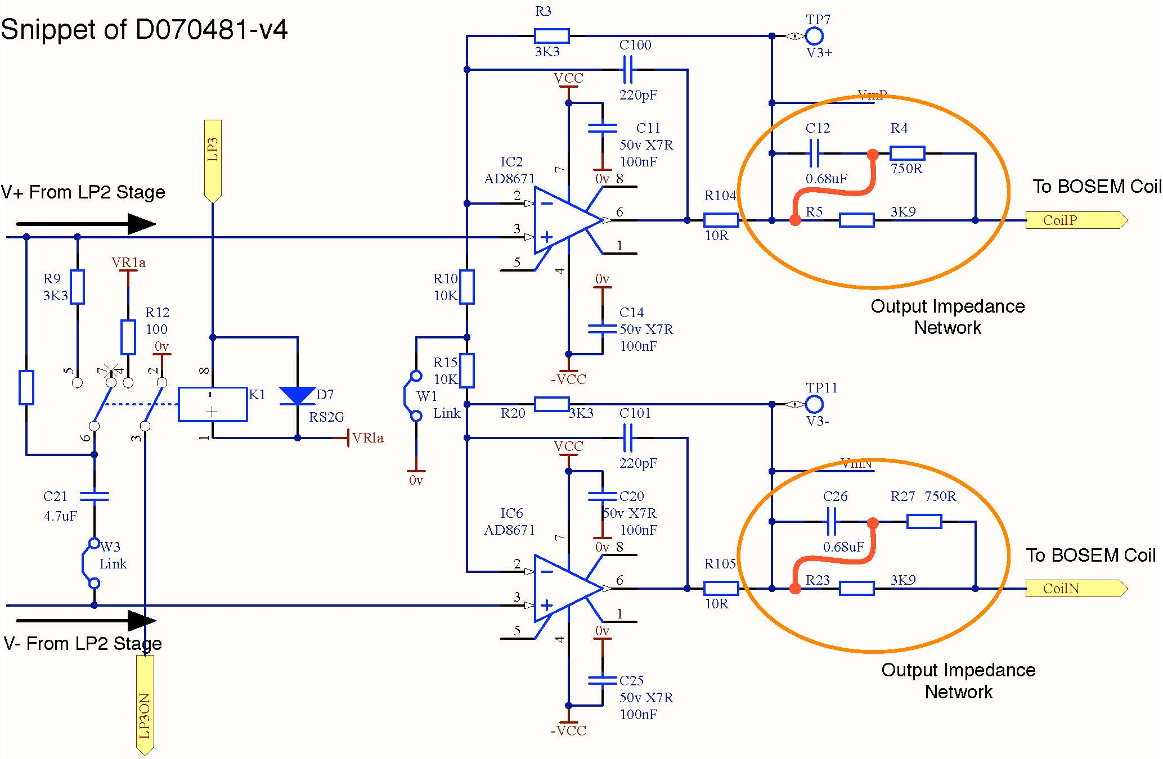
Are there any downsides?
- How does it affect the frequency response?
- It removes the [z:p] = [50:300] [Hz] zero-pole pair from the output, which means the response will be entirely determined by the cascading, switchable [10:1] [Hz] de-whitening filters, and flat when they're turned off.
- The DC response is increased by this removal, so we don't *lose* any range at high-frequency.
- We only intend to use the UIM for drive signals below ~5 Hz, so where we intend to use it (which is well below the original 50Hz zero), we only win.

- How does it affect the actuator noise felt by the suspension?
- In principle, because we're reducing the magnet strength by an equivalent factor, then there is no change in the total force noise on the UIM (even though, of course, the current noise has gone up). I'd like to make some plots to prove this (especially around 10 Hz where the requirements are most stringent), once you've got a magnet strength you'd like in hand, but I think it'll be fine.

- Can the last stage's op-amps handle the increased current?
Looking at the data sheet for the AD8671, <http://www.alldatasheet.com/datasheet-pdf/pdf/48498/AD/AD8671AR.html>, in the configuration we use it (with V_{S} = ± 15 V), the typical output current (I_{OUT}) can be ± 20 [mA]. As mentioned above, the new transconductance would be 1.022 [mA/V], so for our ± 10 V DACs, we can drive ± 10.22 [mA]; well within the op-amps capabilities.

- Is it physically possible / practical given the layout of the PCB?
We have a spare of each of the types of aLIGO drivers here at LASTI (shhh, don't remind anyone!), so I took a look inside and mapped out where the shorting bits of wire would go. Looks as easy as it was for the M2 TACQs. It should be about an hours worth of work for the four channels in each chassis (excluding QA testing, which'll add ~1/2 hour). There's only 4 UIM drivers per IFO (neglecting spares), so this can definitely be done in-house.

In short -- NO! :-)

So, let me know when you've got a magnet geometry you like that reduces the strength by ~6. You'd mentioned on the call that you think reducing the thickness is the easiest way, but the coil-magnet strength at present with the 10Tx10D [mm] magnet and BOSEMS is 1.694 [N/A]. The 5Tx10D [mm] magnets we have already for the HSTSs (a reduction in thickness of a factor of 2), results in a coil-magnet strength of 0.963 [N/A] (with BOSEMs), or a reduction of ~2. From Mark's "Sweet Spot" document, <https://dcc.ligo.org/LIGO-T1000164>, he doesn't have any other BOSEM configuration pre-calculated, and I can't really tell from his Mathematica core-dump if the strength scales linearly with the thickness, or the above is just a coincidence. If not a coincidence, and the strength is linear in thickness, that would mean we'd need ~2Tx10D [mm] magnets. Seems doable.

3.2 Modification to give up to factor of ~12.
From Jeff Kissel email 13th May 2013
The next easiest change would be to start decreasing the resistance on the same, output impedance, parallel network. I would recommend swapping out R4/R27 for something a little smaller, while keeping the max output current below the above mentioned ±20 [mA]. That makes it an "add two shorting wires, and swap two resistors" change, which is still pretty trivial. If we swapped out R4/R27 resistors (now 750 [Ohms]) for 360 [Ohm] resistors, in addition to shorting the capacitor as described below, we would increase the drive strength by a factor of ~11.6. This would increase the output current, during a maximum ± 10 [V] drive to ± 18.95 [mA] @ DC, which is still under the ± 20 [mA] for which the last op amp is rated.

3.3 Further considerations
From Jeff Kissel email 3rd June 2013
As Peter pointed out in a later reply to another email regarding the TOP driver thread, one needs to consider the output impedance matching to the voltage range of the last stage's opamp, as well as the individual component noise. If the last stage's opamp is the dominant noise source, you'll want to add gain to the prior stages of filtering instead of reducing the impedance. Chris Wipf has been modeling the SUS coil drivers recently, so we should have some better information on the UIM driver soon, in order to make a better informed design decision on how to increase the drive strength.

Conclusions
From the previous section we conclude that altering the coil driver to gain a factor of 6 in available current appears to be a simple change, and getting as factor of ~ 12 may still be reasonably “trivial”, though note added section 3.3. We can choose the magnet size to match these factors. At present it is unclear if the magnets at the UIM level contribute to the excess magnetic coupling and therefore we do not have a clear target for how much reduction in coupling to aim for. However as noted by Peter F, while reducing the UIM magnet strength is not expected to reduce the coupling measured in-situ on ITMY and ETMY (LHO), it does address the largest modeled coupling term, arising from DC magnetization of the UIM blade spring caused by the UIM stage magnets (slide 29 of G1300300). He proposes that we settle on the magnet shape (thin disk versus cylinder) then make prototype parts for the chosen design.

4.1 Further conclusions and discussion.
This topic was discussed at the weekly aLIGO SUS telecon on 1lth June 2013. Firstly the question of any issue with alignment of UIM flag/magnet assembly was discussed. Gary notes that when you lock down with locking screws it can drag on the assembly a bit. You spend time aligning. He is not sure what you could do to improve. Maybe rounding the ends? Some debate as to whether that would be better. Maybe a squeeze clamp rather than set screw would be better.
Regarding case A (cylindrical magnet) vs case B (disc), see appendix C, Jeff K noted A would be more stable. Several less surfaces to remain aligned. Counter argument – a certain magnitude of misalignment of the two magnets would give less cancellation in case A. However just make the part well. Worth thinking about alignment in 3 dimensions.
Gary noted whatever we do it would be good to keep the overall weight the same so no rebalancing needed.
Joe noted case A could give stability issues. Need extra cone features, potentially wobbly since small diam. Also haven’t tried a push fit – material is brittle. Would need to check you could do that.
Could have the magnet not quite touching to get round “wobbliness”.
Prototyping is called for.

Appendix A

Email from Ken Strain to Norna Robertson, 8th April 2013
Hi Norna,
I dug out the Mathematica sweet spot calculation and had a go a running the "thick" - 10mm and "thin"- 2mm magnet UIM actuator cases. I found D060106, the BOSEM former drawing, but realise that I'm not sure exactly what the OD of the actual windings on the coil is. Comparing with Mark's T1000164-v3, which shows how well the notebook reflects reality for the 10mm magnets, let me fix that.
If the magnetisation is assumed the same for 2mm and 10mm magnets, I find that the thin ones produce about 24% of the force/current, and a small shift of sweet spot as shown here:
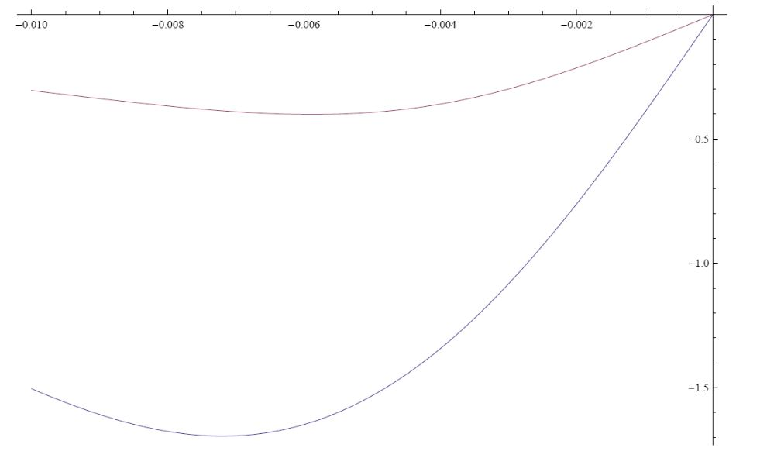
(force constant in N/A vs. coil-magnet coordinate in m.
The parameters I used (and some I did not) are in these lists: (actually the only difference is "l")
bigmagnetvals = Recurse[
LOSvals~Join~{
kB->1.38 10^-23,
T->295,
g->9.8,
mu0->4 N[Pi] 10^-7,
rhoeAl->2.65 10^-8, (* Resistivity of Al *)
rhoepianowire->30 rhoeAl, (* Resistivity of P.W., GUESSTIMATE *)
sigmaeAu->2.67, (* Resistivity of Au paint, measured *)
dipoleM->Bresid/mu0, (* Magnetization *)
massSOS->0.25, (* Final design value *)
massM->rhomM l N[Pi] a^2,
Bresid->1.25, (* Residual field *)
Pi->N[Pi],
rhomM->7400, (* Mass density of magnets *)
ztube->0.0155, (* Separation for magnet to push its own weight, measured *)
zpickup->0.018-l, (* Separation for magnet to pull its own weight, measured *)
masspullapart->0.060, (* Force (in kgf) to separate magnets *)
(* preferred value of small magnet dipole moment *)
mzpref->0.007945632135874319,
(* magnet moment per unit volume for magnet stuff, assumed the same for big and small *)
mz->mzpref/(lold*N[Pi]*aold^2),
lold->0.003175, (* length of small magnets *)
aold->0.0009525, (* radius of small magnets *)
l->0.010, (* length of big magnets *)
a->0.005, (* radius of big magnets *)
(* coil length *)
coillen->0.315*0.0254, (*D060106*)
(* the ends of the coil relative to the origin *)
coilz1->-coillen/2,
coilz2->+coillen/2,
(* the inner and outer radii of the coil *)
coilrad1->0.35*0.0254, (*D060106*)
coilrad2->0.65*0.0254, (*not clear on D060106 - is it?*)
(* the number of turns *)
coilturns->800, (* Aston paper *)
coilsigma -> coilturns/((coilrad2 - coilrad1)*(coilz2 - coilz1))
}
]
thinmagnetvals = Recurse[
LOSvals~Join~{
kB->1.38 10^-23,
T->295,
g->9.8,
mu0->4 N[Pi] 10^-7,
rhoeAl->2.65 10^-8, (* Resistivity of Al *)
rhoepianowire->30 rhoeAl, (* Resistivity of P.W., GUESSTIMATE *)
sigmaeAu->2.67, (* Resistivity of Au paint, measured *)
dipoleM->Bresid/mu0, (* Magnetization *)
massSOS->0.25, (* Final design value *)
massM->rhomM l N[Pi] a^2,
Bresid->1.25, (* Residual field *)
Pi->N[Pi],
rhomM->7400, (* Mass density of magnets *)
ztube->0.0155, (* Separation for magnet to push its own weight, measured *)
zpickup->0.018-l, (* Separation for magnet to pull its own weight, measured *)
masspullapart->0.060, (* Force (in kgf) to separate magnets *)
(* preferred value of small magnet dipole moment *)
mzpref->0.007945632135874319,
(* magnet moment per unit volume for magnet stuff, assumed the same for big and small *)
mz->mzpref/(lold*N[Pi]*aold^2),
lold->0.003175, (* length of small magnets *)
aold->0.0009525, (* radius of small magnets *)
l->0.002, (* length of thin magnets *)
a->0.005, (* radius of thin magnets *)
(* coil length *)
coillen->0.315*0.0254, (*D060106*)
(* the ends of the coil relative to the origin *)
coilz1->-coillen/2,
coilz2->+coillen/2,
(* the inner and outer radii of the coil *)
coilrad1->0.35*0.0254, (*D060106*)
coilrad2->0.65*0.0254, (*not clear on D060106 - is it?*)
(* the number of turns *)
coilturns->800, (* Aston paper *)
coilsigma -> coilturns/((coilrad2 - coilrad1)*(coilz2 - coilz1))
}
]
Everything else is as standard in the notebook (except that I generated two curves in the plots for the two cases).
Ken

Appendix B
Email from Ken Strain, 3rd June 2013.
Hi,
in case it helps, I put Peter's suggestion (3/8ths long, 3/16ths dia.) into Mark's code:
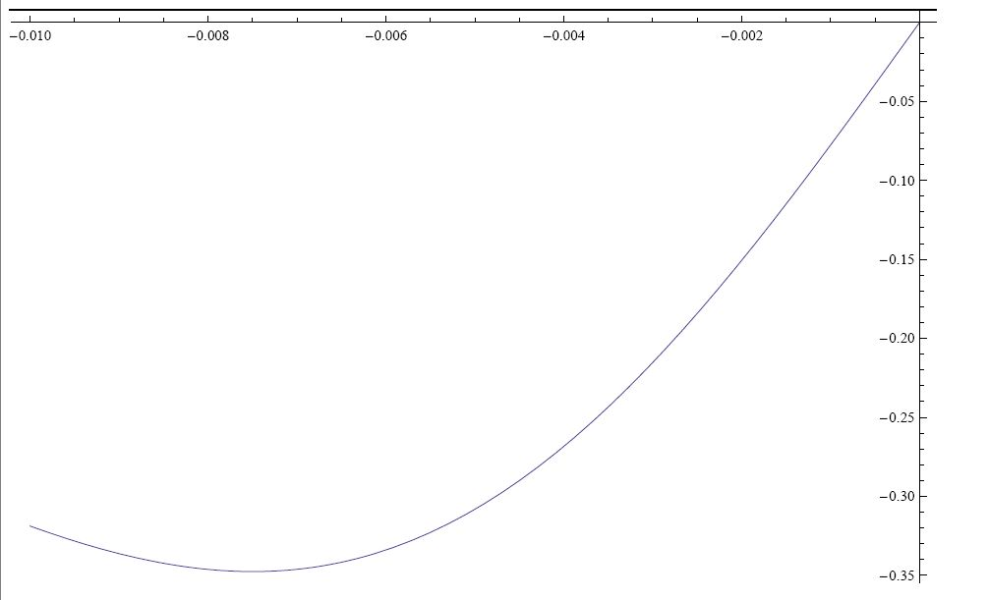
i.e., close to the scaling per volume that might be expected (slightly weaker than the volume would suggest, which would be 22% of the 10x10 strength or 0.37N/A), and the sweet spot has moved out (negative) about 0.3mm to -7.50mm Here the magnet dimensions are l->0.009525, a->0.00238.
If the new magnet were 10mm long, the sweet spot would move out to about -7.60mm (all +/- 0.05mm).

Appendix C
Note that the magnets are labeled as opposite polarity (which is correct) but are shown with same polarity in the top drawing. The drawing D1100937 has been updated on the DCC with red-lined version indicating correct polarities.

