*LIGO Laboratory / LIGO Scientific Collaboration*

LIGO-E1300652-v3 *LIGO* Aug. 15, 2013

Pcal Pre-alignment Cradle Positioning Procedure

P Daveloza, C Serkowski, R Savage

Distribution of this document:

LIGO Scientific Collaboration

This is an internal working note

of the LIGO Laboratory.

|  |  |
| --- | --- |
| **California Institute of Technology**  **LIGO Project** | **Massachusetts Institute of Technology**  **LIGO Project** |
| **LIGO Hanford Observatory** | **LIGO Livingston Observatory** |

http://www.ligo.caltech.edu/

**Introduction**

This document explains the procedure for positioning the structures for the pre-alignment in-vacuum periscopes, for aLIGO Pcal D1200174. The structures consist of two ``cradles", each one capable of supporting a complete periscope structure, allowing the pre-alignment of two of them at the same time. Figure 1 is a schematic aerial and lateral view of the complete assembly.

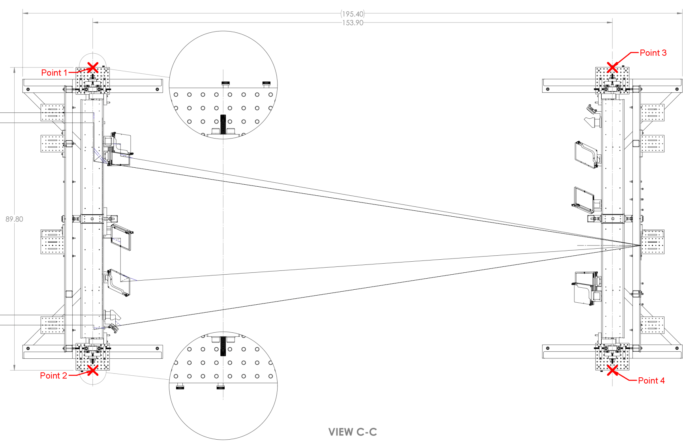**Figure 1:** Aerial view of the assembly

Each cradle has an alignment template, Figure 3, a plate close to the back of each periscope with holes in specific positions where lasers and mirrors can be adjusted. The holes are named, from left to right and from top to bottom: **A, B,** …, with the exception of the upper left, **K**, and lower right, **L**.

The basic idea is to shoot the laser from behind the alignment template of one periscope to direct the beam toward a specific position on the other cradle's template, where a mirror that is emulating an End Test Mass (ETM) bounces the laser back to the original periscope, which finally guides the beam toward the receiver side.

**Cradle Positioning**

1. Place periscope on cradle. Do this by using a 3-man team to lift the periscope and place vertically on a dolly. Make sure there is clean aluminum foil between the periscope and the surface of the dolly. Carefully roll the dolly out of the clean room until it is next to the dolly. Roll in the red “Hoosier” lift from the LVEA into the H2 enclosure, and hook the lift to the lifting eye on the periscope. Lift the periscope with the Hoosier until the structure is at the correct height, then feed the posts on the sides of the periscope into their respective holes on the cradle to lock periscope in place. Unhook the Hoosier from the periscope and carefully roll the Hoosier out of the H2
2. Mark a target on the floor as shown in Figure 1 within ± 1/6 inches. Measure the diagonals and check if they are equal
3. Position cradles using plumb bobs (remember to use middle screw [see Figure 4, Detail A and B]) on the tiny optical table and check if the cord is pressed against the tiny optical table. Draw circles around each cradle leg if necessary
4. Adjust cradle’s height with a scale target so that the 2 small breadboards on each cradle are the same height and check it with the optical level, (Figure 2, top left)
5. Check periscope's height and level it. Once checked, adjust nuts on cradle’s leg
6. Align periscopes to templates, do until both the laser - target alignment and retro-reflection occur simultaneously:
   * Put targets, D1300072 (type-1 to 4), on template and periscope of the same cradle and adjust periscope with the lateral screw on the tiny optical table and move plate if necessary
   * Put targets on the other template and move plate if necessary
   * Check that periscopes and templates are parallel using retro-reflection (Remember that mirror's reflective face has to touch periscope's plate), adjust using perpendicular screws on the tiny optical table.
7. Tighten one of the screws that moves the periscope laterally and one that moves it perpendicular to keep it as a reference
8. Screw mirror's bases if they are not already there, but do not screw the mirror and mount, D1102439, yet
9. Place mirrors in mounts and then screw them onto the periscope
10. Place ETM mimic mirrors and align them using retro-reflection

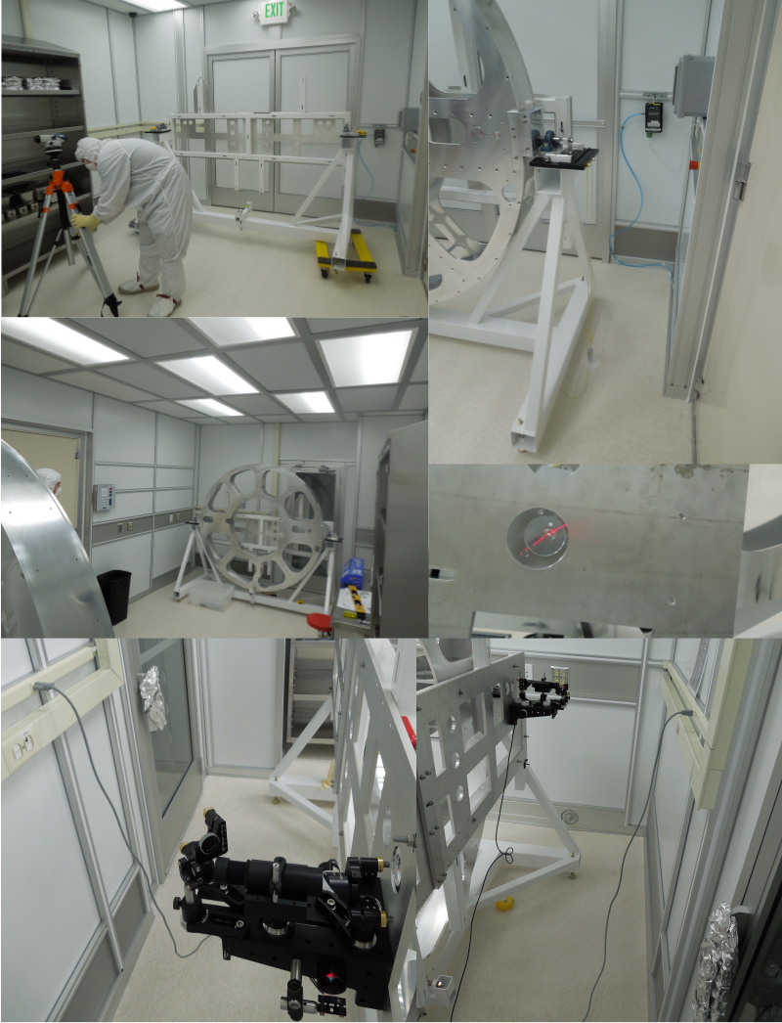

**Figure 2:** H2 LEA assembly

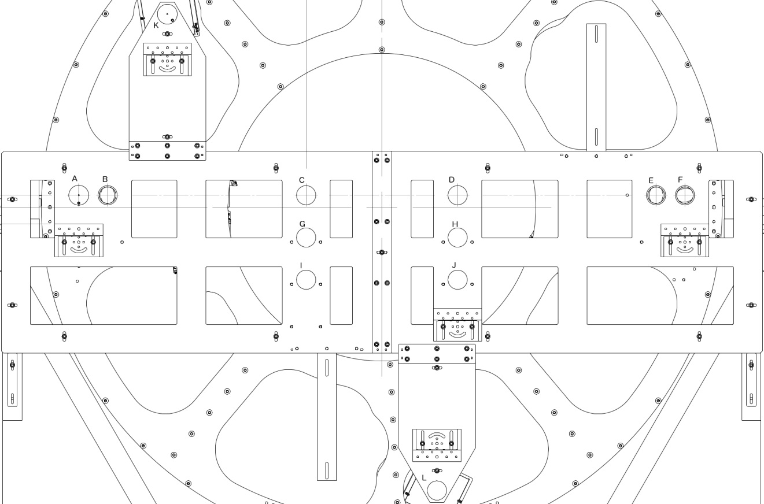

**Figure 3:** Pre Alignment Template



**Figure 4:** Lateral view of the assembly



**Figure 5:** Aerial view of the assembly



**Figure 6:** Front view of the assembly



**Figure 7:** Back view of the assembly

# 