Test Date | Mar 2-4, 2015
Author(S) | Liyuan Zhang, GariLynn Billingsley
Approval(s)
Specification Doc. | LIGO-E0900041 | Specification | < 50 ppm
Procedure Doc. | LIGO-E1000863 | Mean ± Error* | 99 ± 2 ppm
Conclusion
* Error is the calibration error, which is ~2%.
Discussions and Comments:
The scan was done over a 160 mm diameter aperture with the beam and step sizes of 1 mm while keeping the arrow on barrel at Y+ direction. The calibration is done by normalizing the AR reflection signal to the signal from a 1” HR mirror (T=70 ppm) and the variation of laser power during scan is monitored and corrected, the result is summarized in Fig.1.

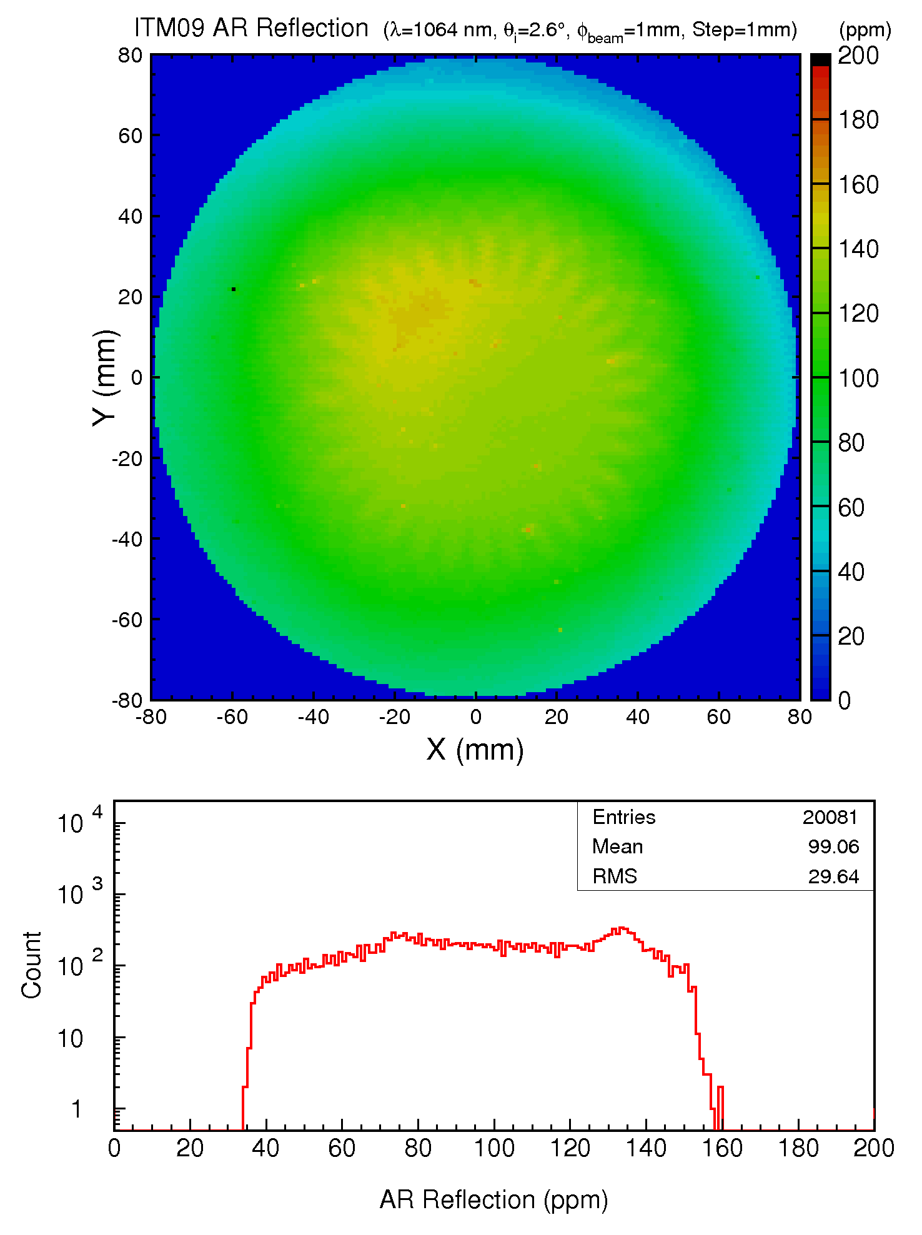
Fig. 1 ITM09 S2 AR reflection over a 160 mm diameter aperture.

