Test Date | HR: Aug. 7-9, 2013. AR: Mar. 10, 2015
Author(s) | Liyuan Zhang, Margot Phelps, GariLynn Billingsley
Approval(s)
Specification Doc. | LIGO-E0900041 | Specification | HR<0.5 ppm, AR<1.0 ppm
Procedure Doc. | LIGO-E1000863
S1 HR (Mean ± RMS) | 0.3 ± 0.1 ppm
S2 AR (Mean ± RMS) | 0.6 ± 0.1 ppm
Conclusion

Discussions and Comments:
For each surface, S1 (HR) and S2 (AR), 4 linear scans of 20 mm are carried out along X+- and Y+- outside central 120 mm in diameter. The arrow on barrel is positioned at Y+ direction. The calibration is done by a contamination cavity HR mirror (1” in dia., No. 8128), of which the HR absorption was measured to be 0.6 ppm in the optical contamination test. The results are summarized in Fig.1and 2 for HR (S1) and AR (S2) respectively.

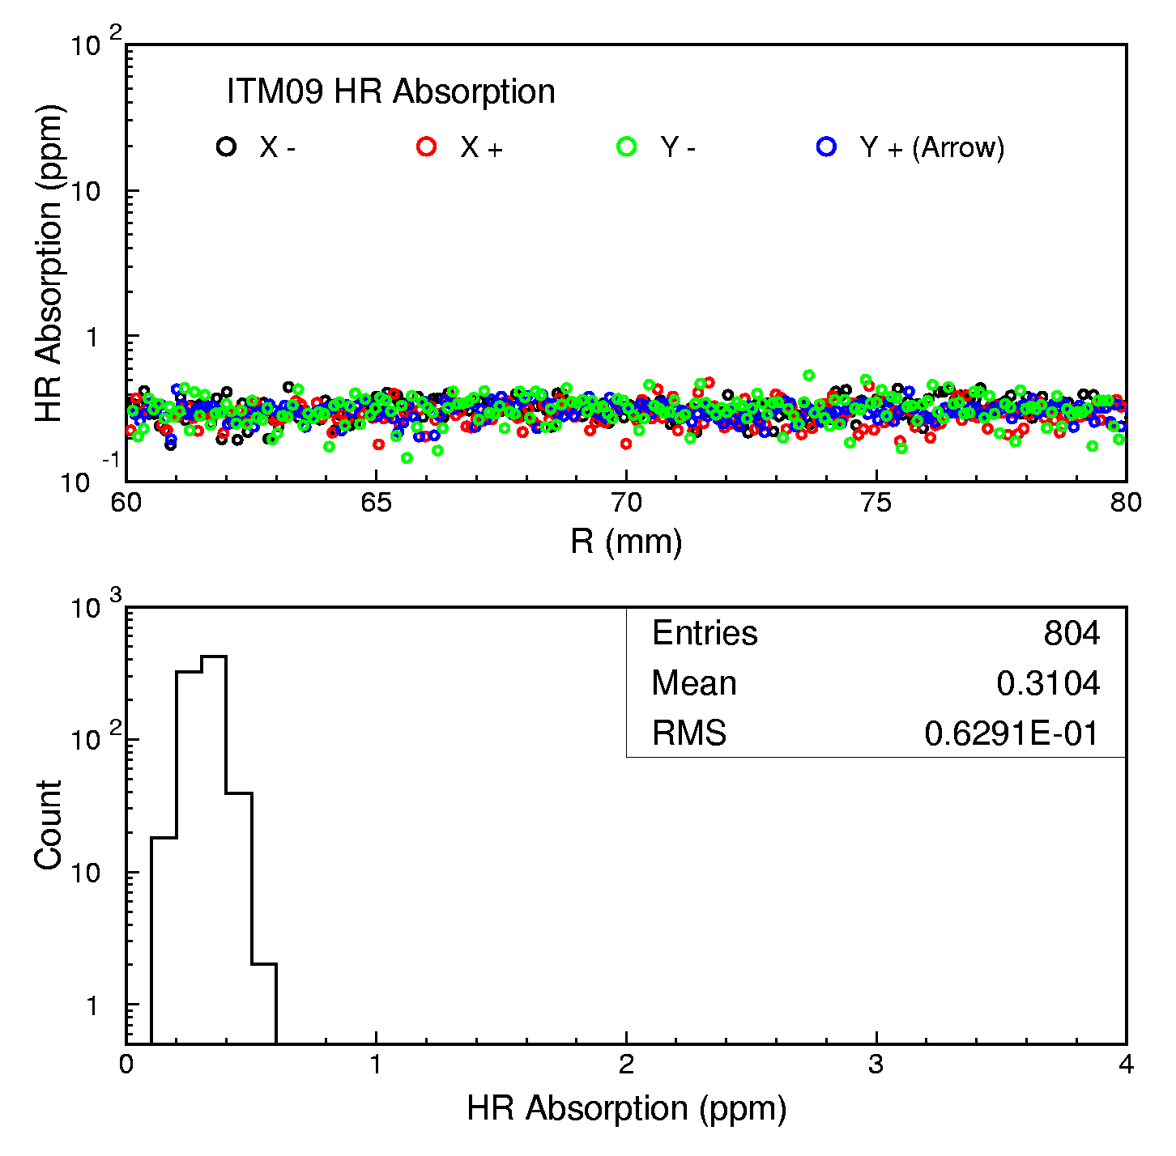
Fig. 1 ITM09 HR absorption measurement along X+- and Y+- outside central 120 mm in diameter.

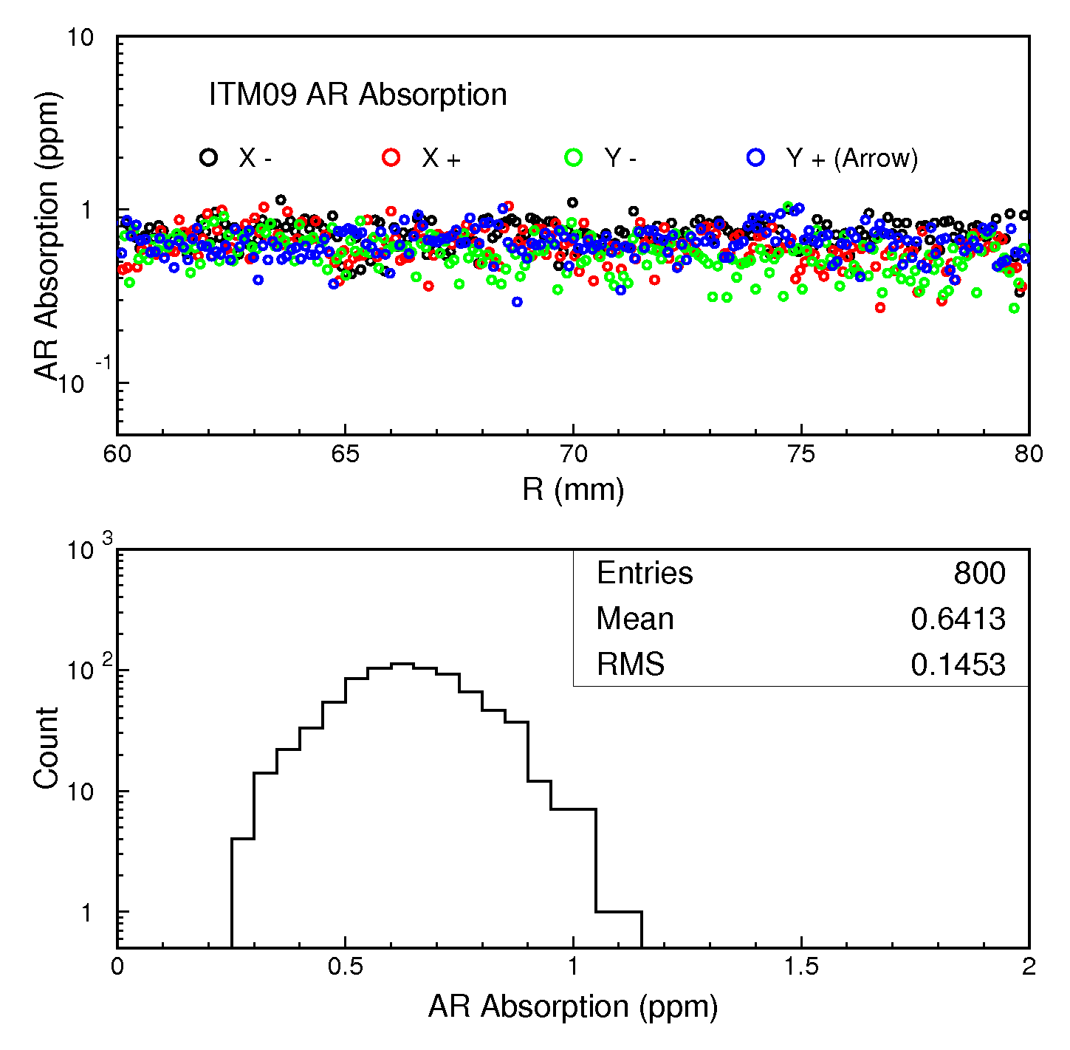
Fig. 2 ITM09 AR absorption measurement along X+- and Y+- outside central 120 mm in diameter.

