*LIGO Laboratory / LIGO Scientific Collaboration*

LIGO- T1300733-v1 *ADVANCED LIGO* 13 September 2013

Relative-intensity noise in optical levers and radiation pressure on the test masses

Eric Black, Mohana Mageswaran, Michael Vargas

Distribution of this document:

LIGO Science Collaboration

This is an internal working note

of the LIGO Project.

|  |  |
| --- | --- |
| **California Institute of Technology**  **LIGO Project – MS 18-34**  **1200 E. California Blvd.**  **Pasadena, CA 91125**  Phone (626) 395-2129  Fax (626) 304-9834  E-mail: info@ligo.caltech.edu | **Massachusetts Institute of Technology**  **LIGO Project – NW17-161**  **175 Albany St**  **Cambridge, MA 02139**  Phone (617) 253-4824  Fax (617) 253-7014  E-mail: info@ligo.mit.edu |
| **LIGO Hanford Observatory**  **P.O. Box 1970**  **Mail Stop S9-02**  **Richland WA 99352**  Phone 509-372-8106  Fax 509-372-8137 | **LIGO Livingston Observatory**  **P.O. Box 940**  **Livingston, LA 70754**  Phone 225-686-3100  Fax 225-686-7189 |
| **Albert-Einstein-Institut**  **Callinstraße 38**  **Hannover, D-30167**  **Federal Republic of Germany**  Phone (05 11) 762 2229  FAX (05 11) 762 2784 | **Laser Zentrum Hannover**  **Hollerithallee 8**  **Hannover, D-30419**  **Federal Republic of Germany**  Phone (05 11) 27 88 0  FAX (05 11) 27 88 100  E-mail: info@lzh.de |

http://www.ligo.caltech.edu/

Purpose and general description

This document describes how and at what level the radiation pressure from the optical levers is expected to affect the advanced-LIGO test masses and the noise floor of the instrument.

# Requirements

From the Design Requirements Document (DRD)**,** [T0900174](https://dcc.ligo.org/DocDB/0001/T0900174/002/T0900174-v2.pdf), we have the requirement that the optical levers shall impose no more than

$$δx\left(f\right)< 4×{10}^{-20}\frac{m}{\sqrt{Hz}}{\left(\frac{10Hz}{f}\right)}^{2}$$

of displacement noise on the target optic.

The displacement noise as a function of frequency on a free mass subject to a fluctuating force is

$$δx=\frac{δF}{m{\left(2πf\right)}^{2}}$$

where the force from a beam with fluctuating power is given by

$$δF=\frac{2δP}{c}$$

leading to a spec on the power fluctuations of

$$δP<{10}^{-6}\frac{W}{\sqrt{Hz}}$$

It is worth noting that the shot noise in a beam of power *P* is

$$δP=\sqrt{\frac{2hcP}{λ}}$$

which, for a laser of wavelength 635 nm, is equivalent to

$$δP=2.4×{10}^{-11}\frac{W}{\sqrt{Hz}}\sqrt{\frac{P}{1mW}}$$

# Procedure

We ran a fiber from the output of one of the oplev lasers to the input of one quadrant of an oplev QPD board, fixing the position of the end of the fiber relative to the QPD as shown in Figures 1 and 2.

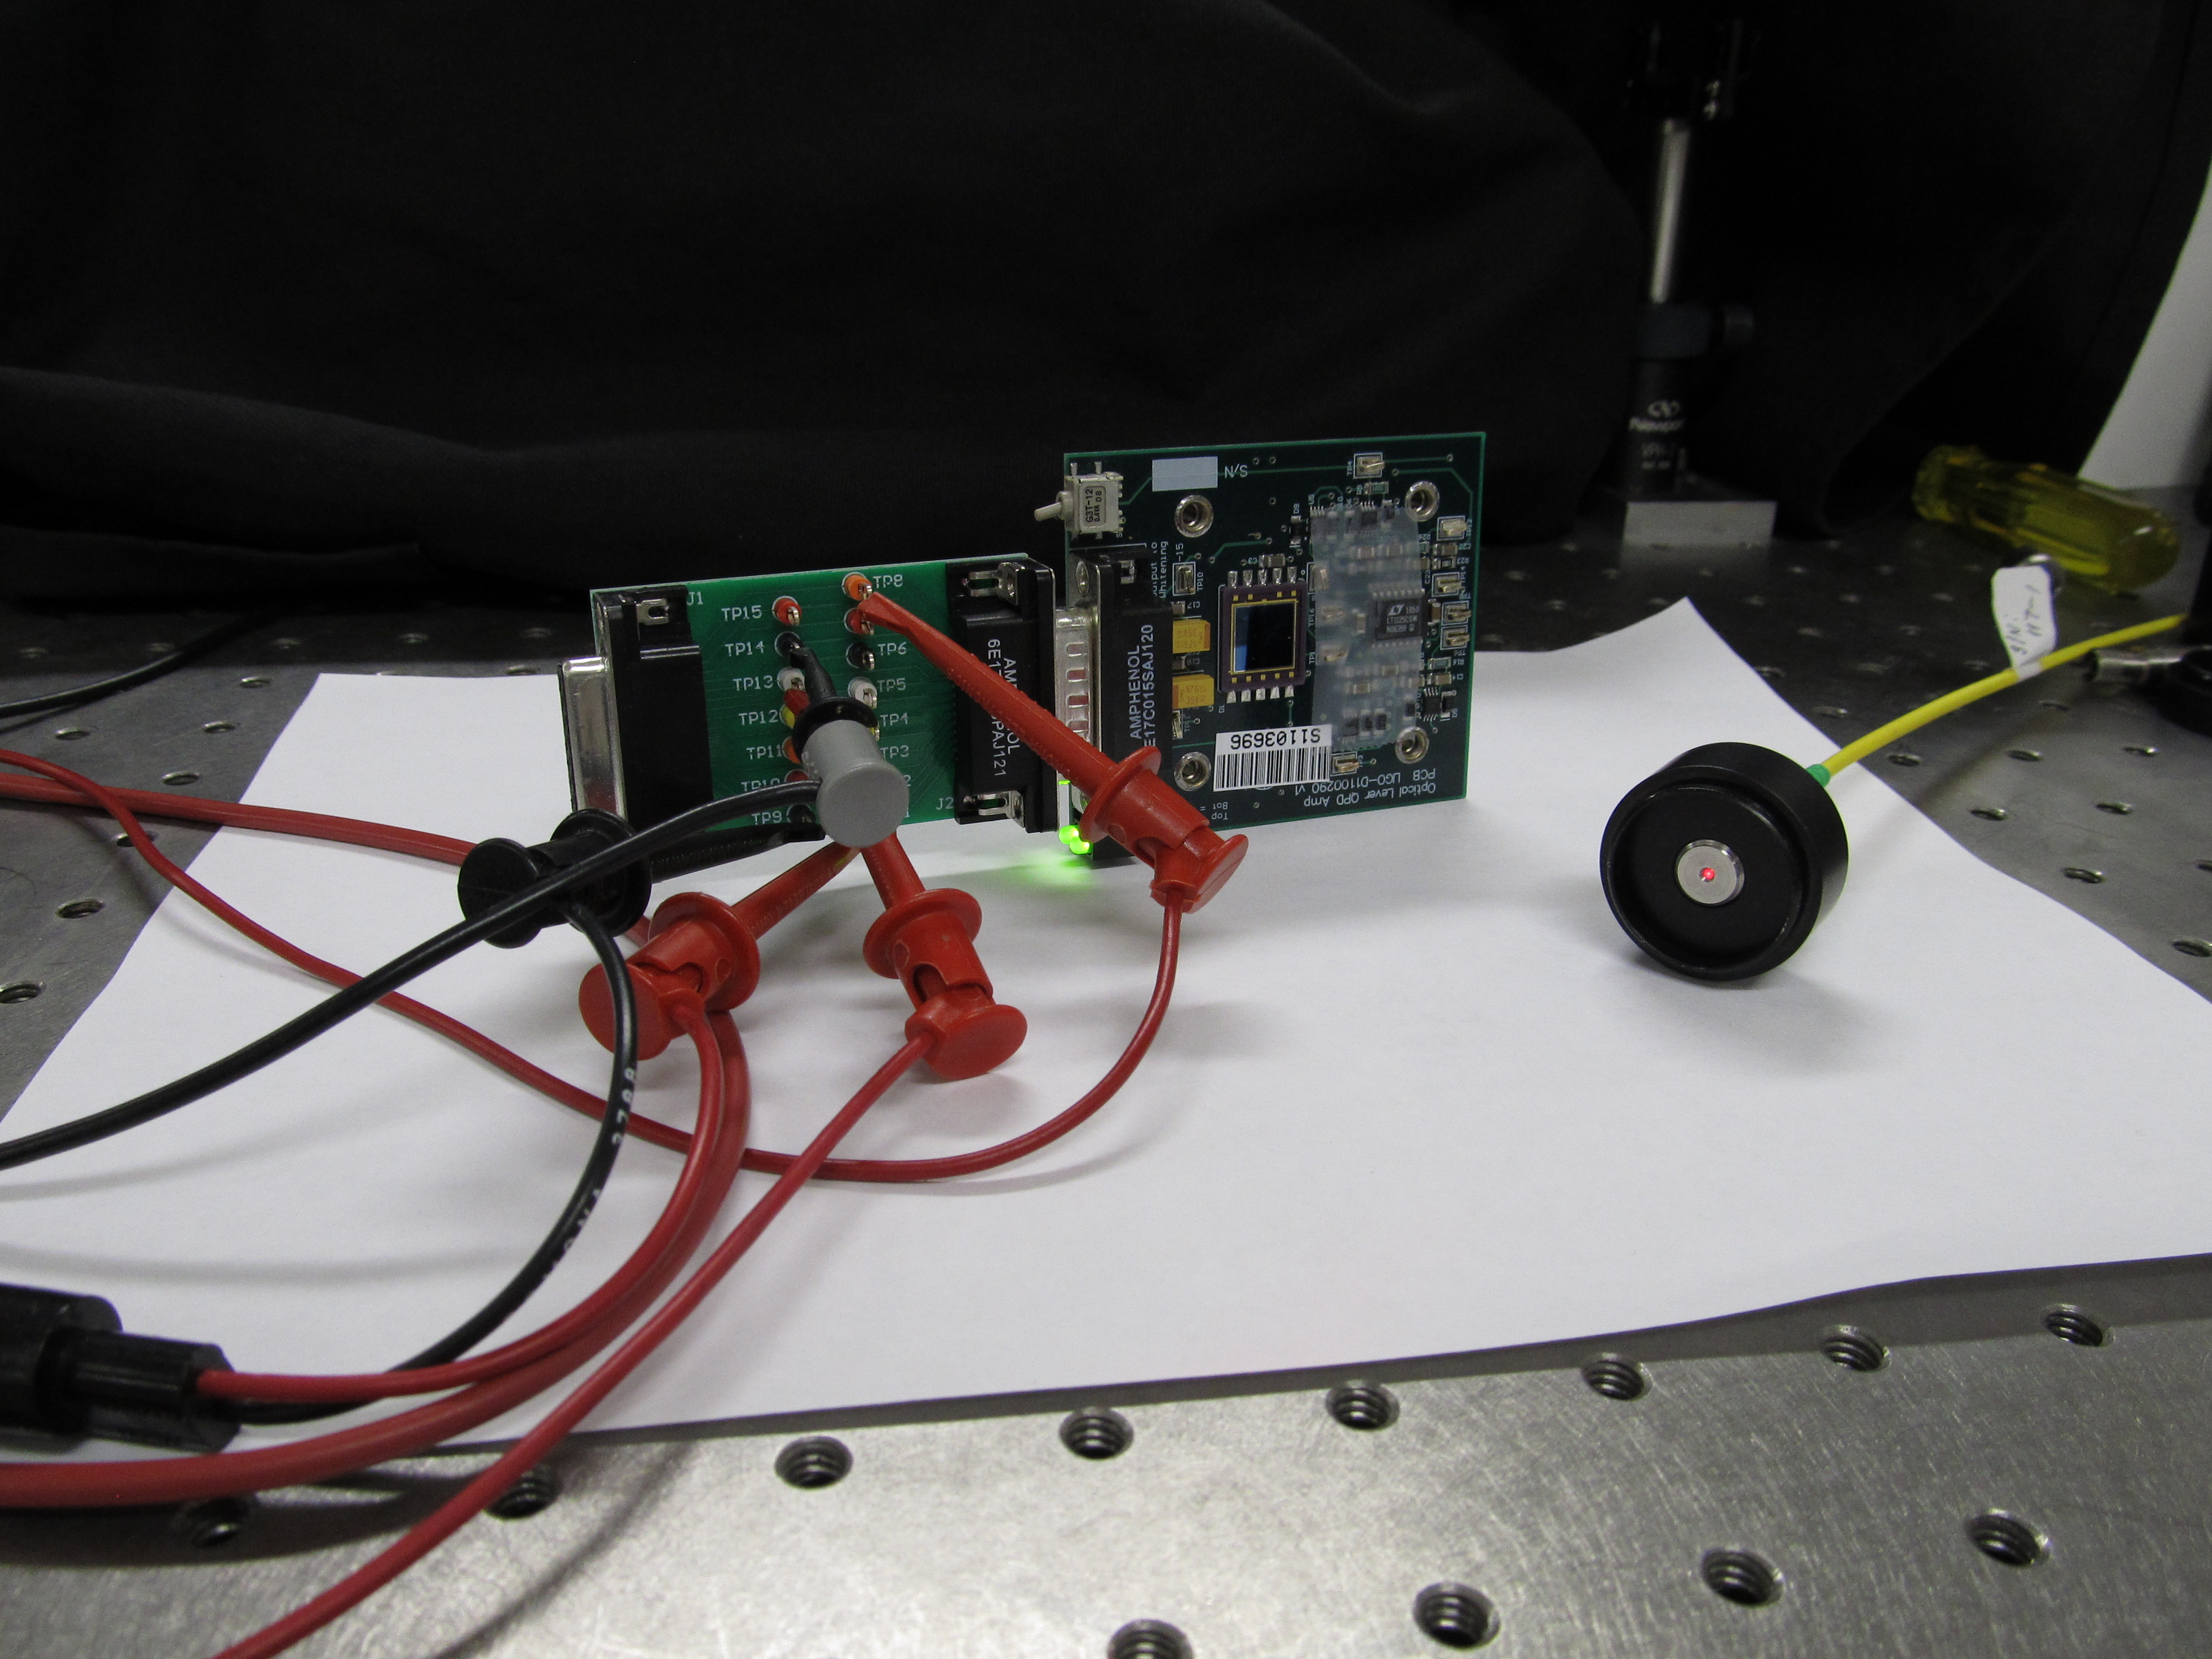

Figure 1: QPD board and fiber coupler (dismounted) for laser-intensity-noise measurement. Clip leads are for QPD bias and readout. Output of fiber is uncollimated and is placed close enough to the QPD so that all the light falls on Quadrant A.

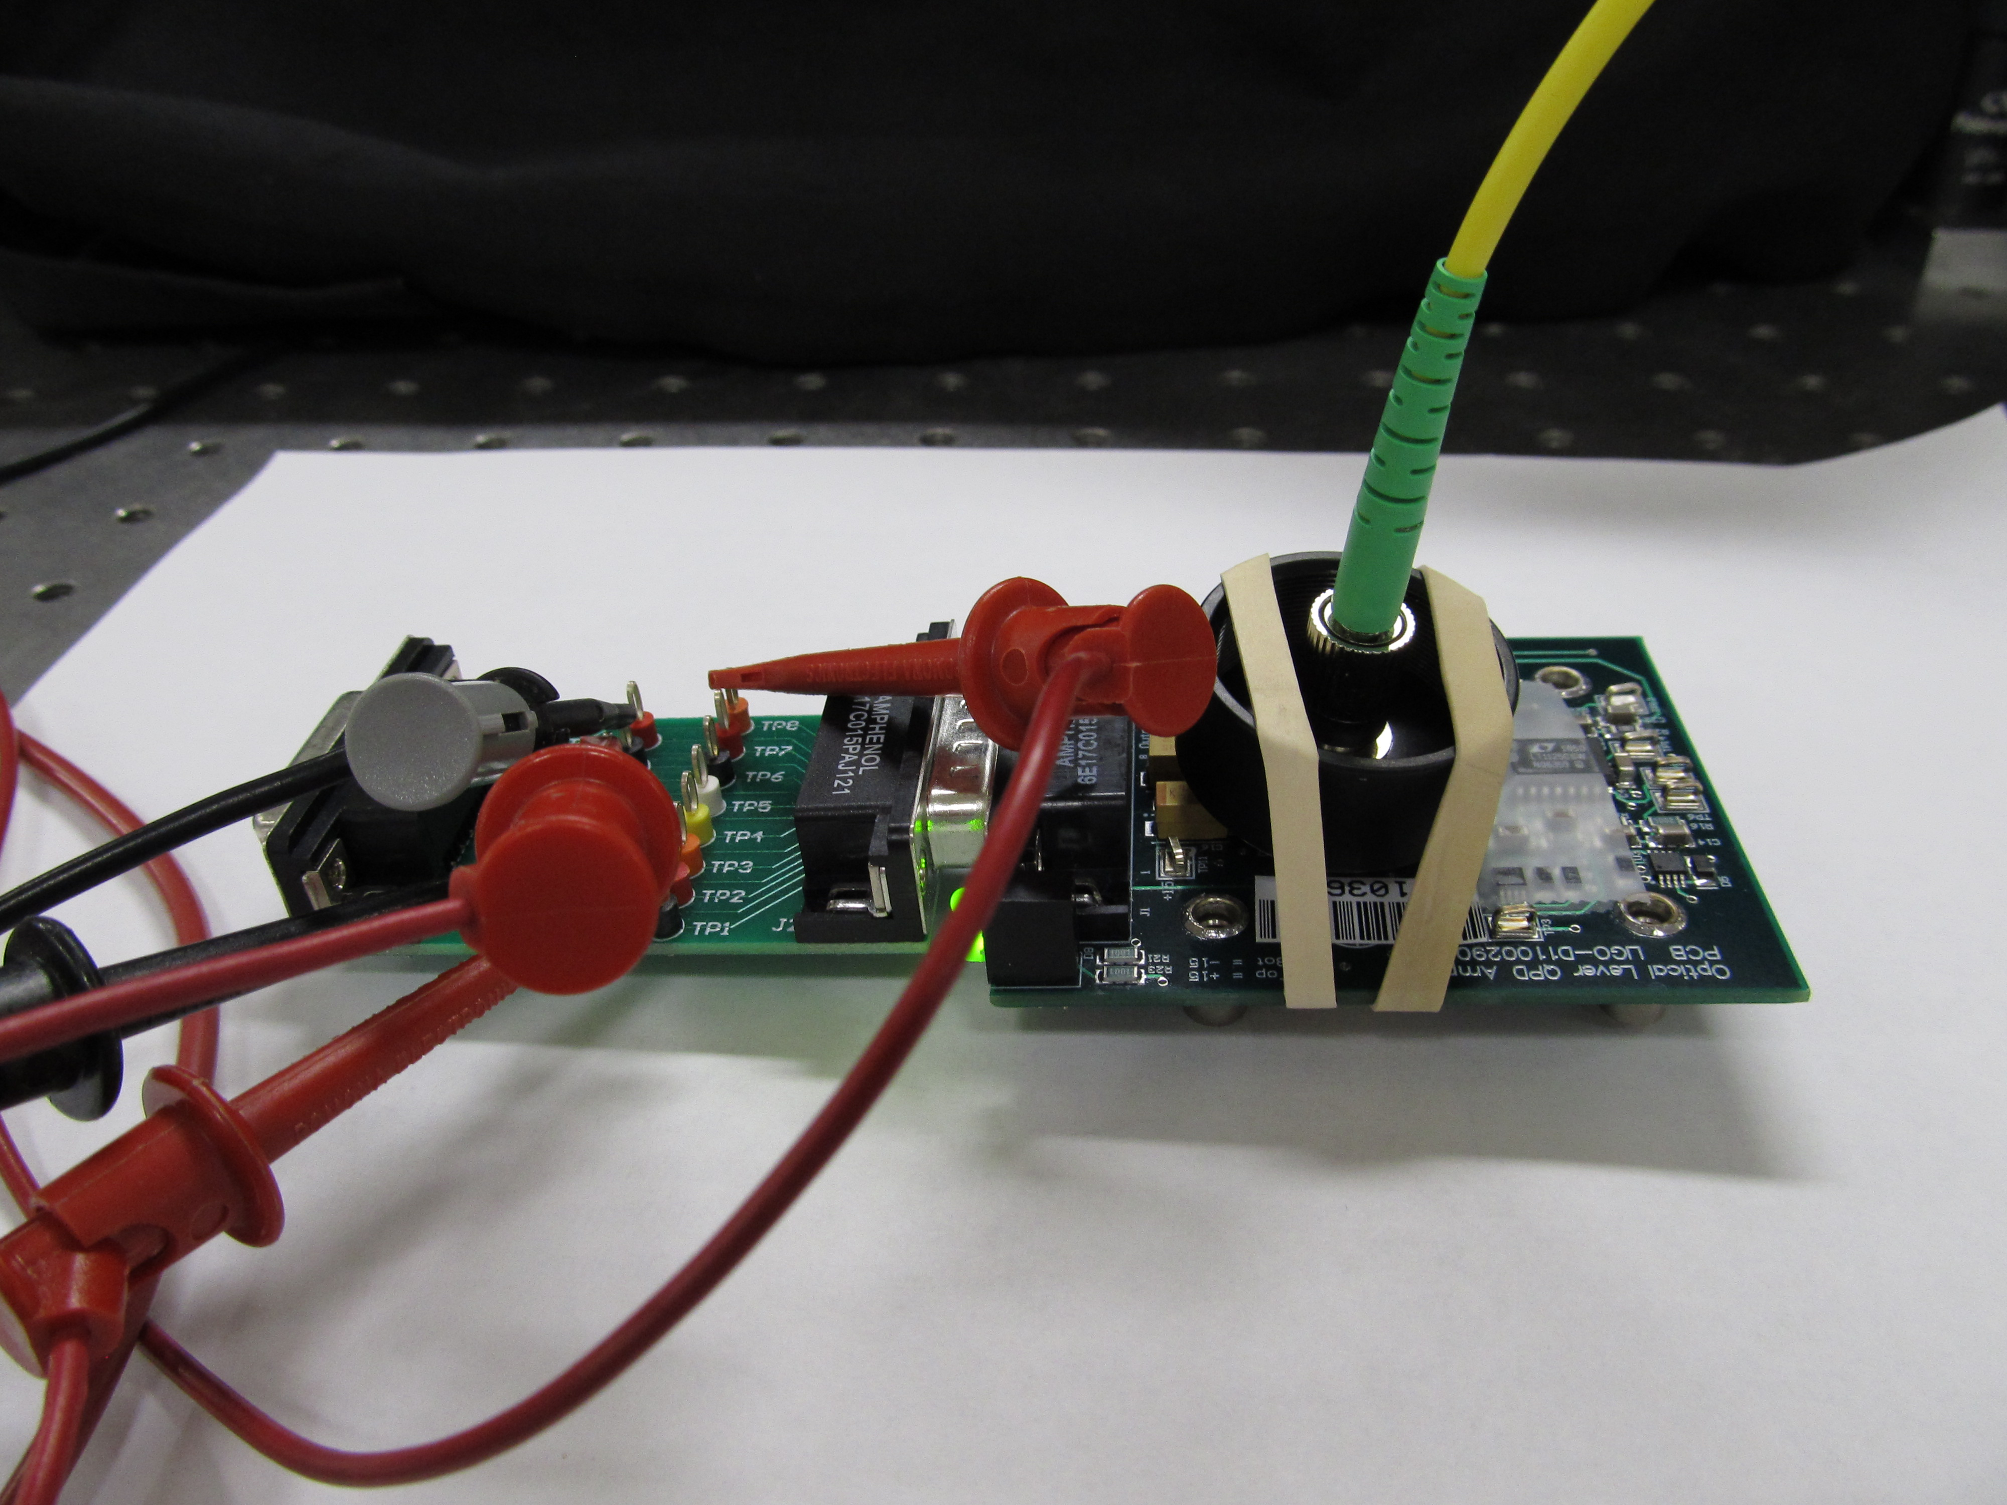

Figure 2: Arrangement to hold the fiber in place relative to the photoreceiver. Black cloth in the background covers the apparatus during measurement to block out room light.

# Settings

Laser: MicroLaser model F12-635S-TE/LIGO

S/N: 137

Max Power: 5 mW

Power Setting: Maximum by front-panel knob

QPD board: Model: LIGO-D1100290-v1

S/N: S1103696

Data Acquisition Units: SR770 Spectrum Analyzer

TDS3012 Digital Oscilloscope

Relevant Settings:

AutoRange: Off

Input Range: 4dBV

Averaging: Exponential

Averages: 44

Overlap: 50.0%

Window: BMH

# Calibration

|  |  |
| --- | --- |
| Laser Power (mW) | QPD Output Voltage (V) |
| 0 | 0.0 |
| 5? | 9.44 |

Calibration is only approximate, since we did not have a power meter handy that could accurately measure the output of the beam at the end of the fiber. At full power, the QPD board read 9.44 V, and the laser theoretically should be putting out 5 mW, according to the label, giving us an approximate transfer function of 5e-4 W/V.

# Results

Figure 3 shows the laser intensity noise as measured. We took data both with the laser off and the laser on to establish the noise floor of the instrument.

Note that if the actual output of the laser is anywhere between 1 and 10 mW our conclusions do not change. We are still between two and three orders of magnitude below the maximum allowed noise level.



Figure 3: Laser intenstity noise as measured using QPD. Upper limit is what we must stay below. Shot noise is a theoretical calculation for a 1mW beam.

# Conclusion

Based on these measurements, we do not expect radiation pressure noise from the optical-lever beams to make a significant contribution to the noise floor of the interferometer.