Prototype Fast Shutter Measurements
Richard Abbott
20 September, 2013

- Overview
This note captures data taken on the in-vacuum fast shutter prototype. At time of writing, there was no fast shutter driver circuit, so 9V batteries were used as the drive source to the motor coil in the fast shutter. The batteries were switched by a MOSFET switch driven by a single shot function generator. The timing data was taken by use of an optical gate constructed with a laser and photodetector. As the fast shutter coil is energized, it rises within an aperture formed by permanent magnets. The shutter coil has a tab on top that will block the laser beam once the coil is raised high enough to occlude the beam.
A series of measurements were taken as a function of the number of 9V batteries providing the drive voltage to the coil. Examination of the recorded transients shows some interesting behavior associated with the coil moving within the fixed magnetic field. An initial transient in current quickly decays back to zero as the coil develops a counter EMF. Sometime later, a damped oscillation is visible in the current waveform as the coil is arrested in the magnetic field of the upper magnet.
- System Constants
Parameter | Value
Measured single 9V battery voltage | 9.22VDC
Measured coil resistance | 23 ohms
Measured coil inductance | 14 mH
Total mass of coil and bobbin | 15 grams
Distance at rest between laser beam and top tab on shutter coil | 2.4mm
MOSFET switch part number | CPC1709J
Current sensing probe part number | Tektronix TCP202
Laser light source | LFI-4502
Sensing photodetector | New Focus model 1811

Figure 1, Single battery, Actuation Time = 5.8 mSec, Acceleration = 143 m/sec². The blue trace is current, and the red trace is the photodetector signal
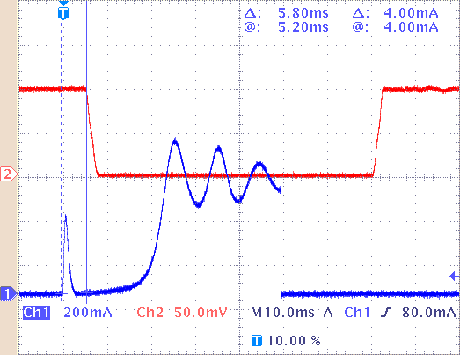

Figure 2, 2 Batteries, Actuation Time = 3.36 mSec, Acceleration = 425 m/sec². The blue trace is current, and the red trace is the photodetector signal
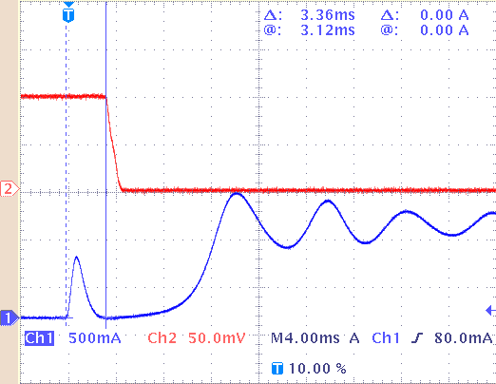

Figure 3, 4 batteries, Actuation Time = 2.48 mSec, Acceleration = 780 m/sec². The blue trace is current, and the red trace is the photodetector signal
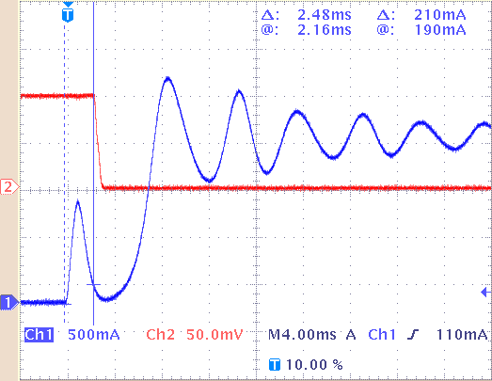

Figure 4 beam blocking tab is visible between the aluminum forks in the foreground
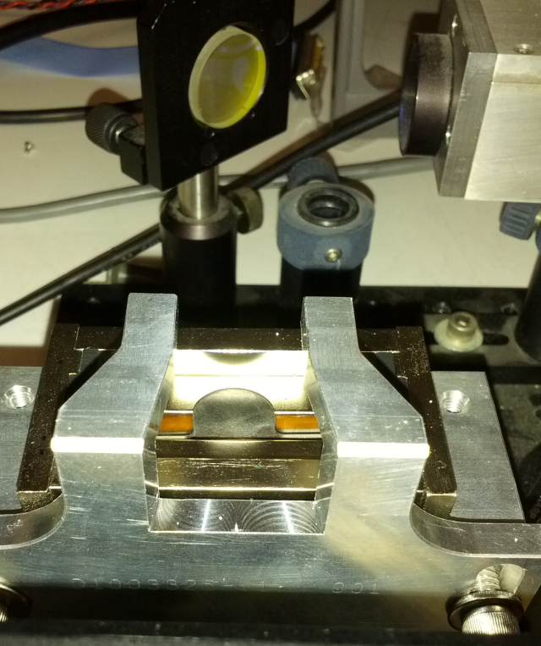

Figure 5 test setup with a single battery hooked up to the coil wires
