ISS PD Array Alignment Procedure
Richard Abbott, Peter King, Calum Torrie
4 October, 2013

- Overview
This note captures a basic framework of the steps used to align the 8-element diode array used in the outer loop intensity stabilization. The overall goal of the procedure is to minimize the conversion of incident beam jitter to detected photocurrent. The angle of the laser beam incident on the array is modulated individually in X and Y while the position of each diode within the array is adjusted horizontally and vertically until minimum conversion sensitivity is observed. The diodes are then locked down preserving minimum sensitivity condition. The alignment of the laser beam incident to the array is set by use of a quadrant photodiode built into the array. An alignment fixture tool is used to set the beam path into the array prior to the start of the alignment procedure.
- General Method
The following assumes the array is totally unaligned as fresh from parts manufacture

  - The original setup used at Caltech has a 300mW Mephisto laser with a wave plate to adjust the split power incident on each diode to something in the vicinity of 5mW. An X-Y piezo steering stage is driven one axis at a time at ~5Vp-p at a frequency of ~1 kHz as the probe of angular jitter.
  - Be sure to see a "double spot" on the far side of the second periscope mirror as an indication of the correct installation of the second periscope mirror HR surface
  - Use V-grooved bore sight tool to establish initial beam alignment.
  - Align QPD, and then lock in place. This position should be refined after completion of the alignment process
  - Install the 8-hole photodiode centering tool plate such that a coarse alignment can proceed.
  - Use the center prism for rough alignment in yaw by loosening the cams and iterating position while looking at the beam centering. The two outer prisms are used for a fine position adjustment serving the four diodes on each prism's respective side. Lock and adjust the prisms by use of the prism adjustment tool. Install prism set screw to lock the prism further in place.
  - Install one PD at a time loosely affixing the screws to get a basic attachment
  - Install X-Y adjustment stage posts taking care to avoid the Kapton film on the back plate. Attach clip leads to PD pins. Install and adjust X-Y stage until the screw hole in the center of the PD aligns permitting the central screw to be installed. Loosen the PD attachment yoke screws to permit the X-Y stage to have free motion (simply loosening the two screws may not be sufficient initially, but it is probably good to snug things up after loosening such that the PD cup is not wobbly. The Kapton film should be slippery enough to permit reasonable adjustment).
  - Center the beam on the PD using a scope. The total voltage on the scope should be ~5VDC assuming 10^3 V/A transimpedance.
  - Begin the process (one axis at a time) of modulating the beam and observing the resultant angular jitter as AM on an SR785. 1 to 2 uA rms per rtHz is the approximate signal level you will see at 1 kHz. Iterate in X and Y until the process converges.
  - Lock the PD in place by tightening the two yoke screws such that the PD is fixed. Check the angle to AM coupling once more.
  - Repeat for all 8 diodes

- Images of the array and associated fixtures

Figure 1, double beam spot visible on flash card after transmission through the input periscope
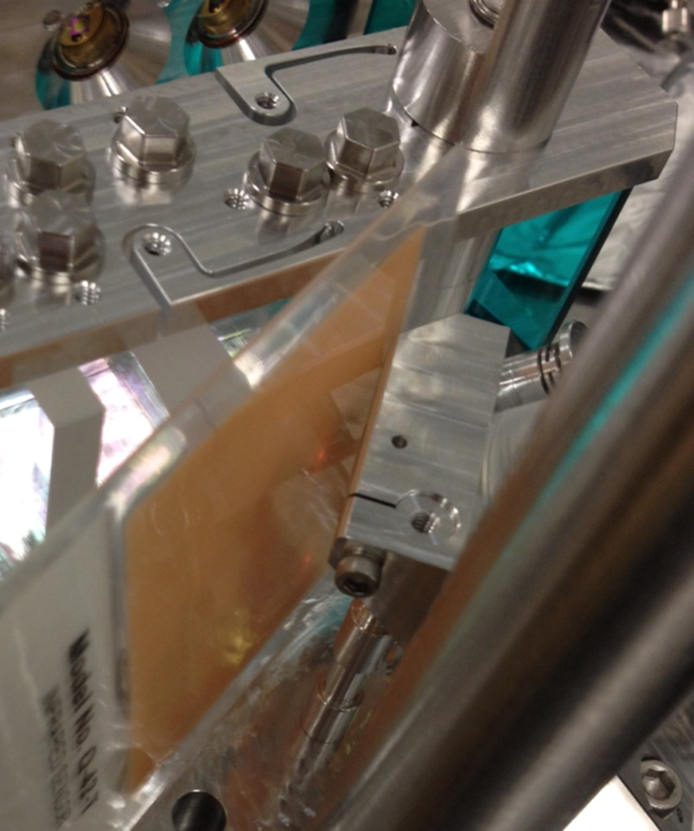

Figure 2, rear view of ISS array showing the black X-Y positioning fixture and exposed leads of photodiodes. Visible in the background are the three clear glass splitting optics and the 6 cam screws used to adjust the splitting optics serving the laser beam position on each individual photodiode.
