**Appendix 1:**

**Monitor Channel Filtering:**

C:\Users\Sheila2\Documents\My Documents\ALIGO\Electronics\ALS Comm PLL\TEST results\SCRN0000.EPS

Figure :IN to INPUT Mon

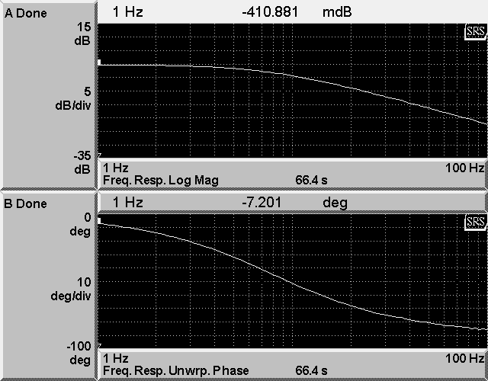

Figure : In to OUtput Mon

**A:\SCRN0001.GIF**

Figure : Output Adjust to VCO

**Appendix 2: Harmonic Distortion**

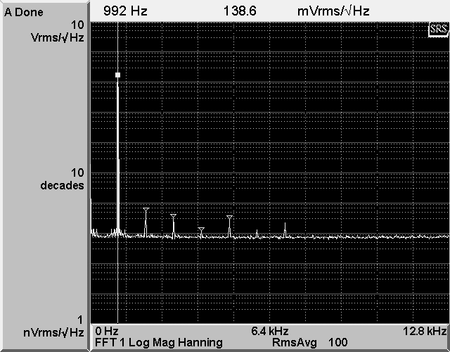

Figure : Harmonic Distortion In to VCO out

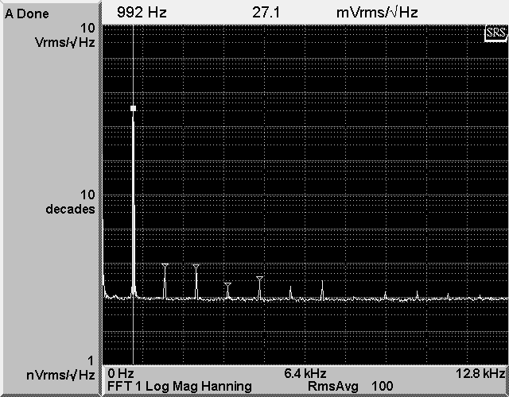

Figure : Harmonic Distortion In to f/phi out

**Appendix 3: Noise Measurements**

**C:\Users\Sheila2\Documents\My Documents\ALIGO\Electronics\ALS Comm PLL\TEST results\SCRN0006.EPS**

Figure : VCO out noise spectra, log space

**C:\Users\Sheila2\Documents\My Documents\ALIGO\Electronics\ALS Comm PLL\TEST results\SCRN0007.EPS**

Figure :f/φ Out noise spectra, log space on frequency axis

**Appendix 3: Transfer Functions**

**C:\Users\Sheila2\Documents\My Documents\ALIGO\Electronics\ALS Comm PLL\TEST results\SCRN0008.EPS**

Figure : IN 1 to VCO out, D3 down transfer function

**C:\Users\Sheila2\Documents\My Documents\ALIGO\Electronics\ALS Comm PLL\TEST results\SCRN0009.EPS**

Figure : Transfer Function: In to f/φ: D2, D12, D13, and D14 down

**C:\Users\Sheila2\Documents\My Documents\ALIGO\Electronics\ALS Comm PLL\TEST results\SCRN0011.EPS**

Figure : In to f/φD2 and D15 down transfer function

**C:\Users\Sheila2\Documents\My Documents\ALIGO\Electronics\ALS Comm PLL\TEST results\SCRN0020.EPS**

Figure : transfer function from IN to INMON DAQ channelC:\Users\Sheila2\Documents\My Documents\ALIGO\Electronics\ALS Comm PLL\TEST results\SCRN0021.EPS

Figure : In to Control mon TF

**High frequency transfer functions**

**A:\AAA1.TIF**

Figure : IN to VCO out

A:\AAA2.TIF

Figure : IN to f/phi high frequency transfer function

Appendix 3: Closed loop transfer functions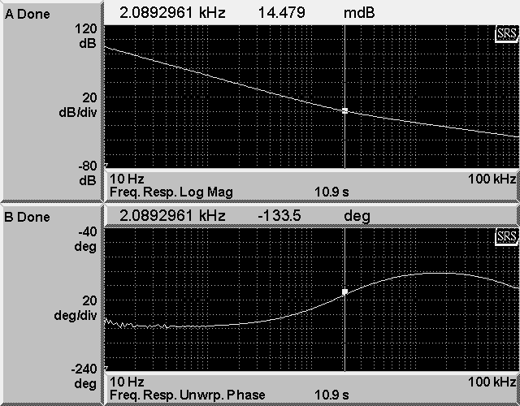

Figure : Two frequency difference dividers, PLL in default configuration (all swtiches up)

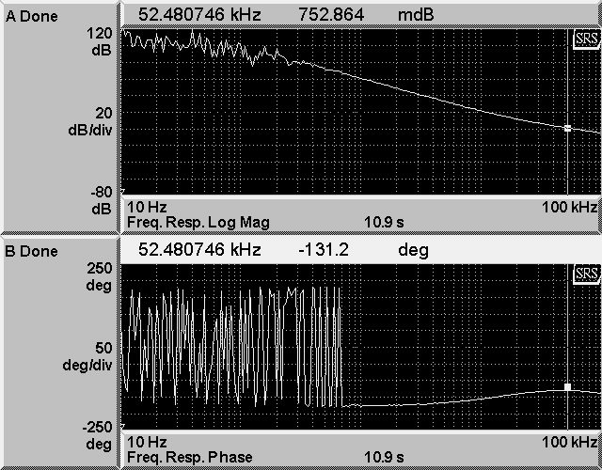

Figure : Two frequency difference dividers, +32dB of gain and both compensation filters engaged (LF+HF)

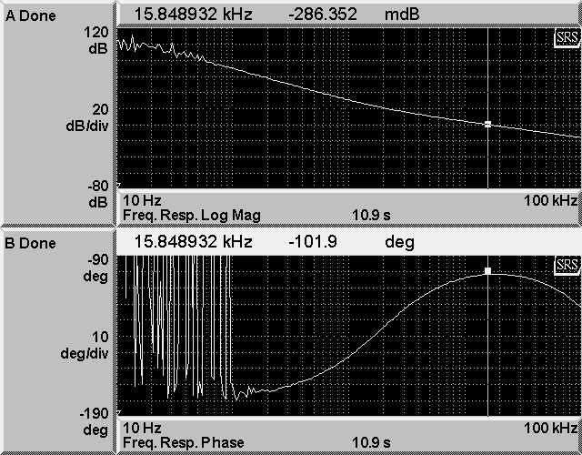

Figure : One frequency difference divider (normal VCO) and default settings on PLL

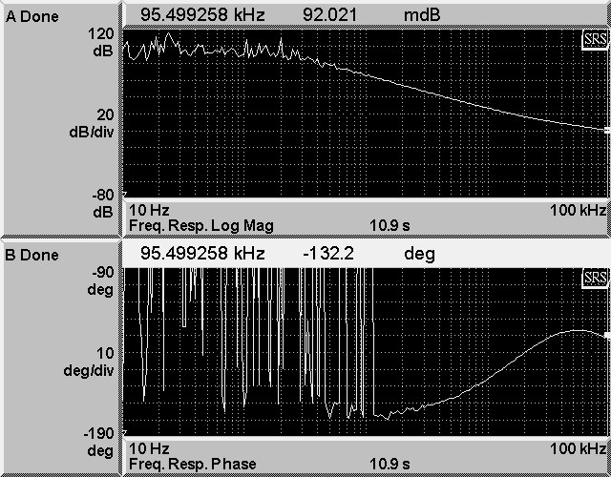

Figure : Normal VCO (1 FDD) +16dB of gain, LF and HF compensation filters on