Ligo_Logo

|  |  |
| --- | --- |
| Date: | November 21, 2013 |
| Refer to: | LIGO-E1300891-v1 |

To: LIGO Lab VRB and external consultants

From: Mike Zucker

Re: **Livingston GV7 leak neutralization: proposed action**

### Objective

We recently determined that most or all remaining leakage into the Livingston Y beamtube enters through the stem and actuator assembly of GV7, a 48" aperture electromechanical gate valve at the tube midpoint.

While the leakage is significant (about 4.6e-5 Tl/s), its delayed response to external gas composition (Appendix B) is *not* consistent with a direct fissure or hole. Data instead suggest, for example, diffusion through some permeable material barrier; a narrow and long (therefore highly convoluted) channel; or a system of two or more discrete leaks in series, separated by dead volume(s) at intermediate pressure.

The LIGO beam tubes were only designed for one-time evacuation and bakeout. Even a brief or partial air dump will reexpose the tube walls to atmospheric water vapor, resulting in unacceptable outgassing. Bakeout to recover adequate surface conditioning would decimate the Laboratory operating budget and science uptime.

Given venting is not feasible, the valve's faulty vacuum boundary cannot be exposed for investigation or repair. The only realistic option is therefore to evacuate the environment around the valve stem. We propose here to:

a) establish a vacuum enclosure surrounding the GV7 stem,

b) maintain this enclosure under vacuum in a safe, economical way throughout the foreseeable future, and

c) avoid unnecessary risk of causing additional leaks or accidents.

With respect to c), the odd behavior of the leak and the potentially dire consequences of any accident suggest particular caution. We worry that the act of drawing external vacuum or otherwise mechanically disturbing the system could exacerbate the leak, perhaps catastrophically[[1]](#footnote-1).

For this reason, we want to thoroughly engineer, review, and (insofar as feasible) test our solution offline before attempting implementation. On the other hand, we also recognize that there is little time remaining before this leak (and efforts to correct it) collide with the aLIGO observing schedule.

### Requirements, Concerns and Constraints

We've adopted the following provisional criteria; some may need to be revisited with new information. It may help to refer to the valve pictures and description given in Appendix A.

#### Pressure and vacuum:

If the current net leak rate could be presumed to remain stable, the beamtube leakage goal of 1e-8 Tl/s per module (Appendix C) could be met by reducing ambient pressure to 0.1 Torr. However, as described above, this oddball leak might *not* be stable. If it "evolves" after initial evacuation, we also may never be able to backfill the enclosure to effect an improvement. As a result, we intend to provide substantial margin from the outset.

We want the enclosure vacuum to be maintained by an ion pump to forego reliability, maintenance and fault interlock issues associated with mechanical pumping. Such an ion pump should be of conventional, standard design and have reasonable size and mass (say, < 1,000 l/s).

This said, the encapsulated volume will contain elastomers, plastics and lubricants never intended for vacuum service. Seals which adapt the existing structure also might not achieve the leak or permeation quality of standard high-vacuum types. Such factors may limit achievable pressure.

We therefore propose the following requirements:

* An ion pump should be able to maintain the target pressure long-term.
* This should be provided with a gate valve to permit bakeout, maintenance and replacement without venting the enclosure volume.
* This valve should have an air-side port to allow offline starting, maintenance or replacement of the ion pump.
* For reasonable longevity, steady-state operating pump inlet pressure should be below 1e-5 Torr, and preferably lower than 1e-6 Torr.
* Limiting pressure should ideally be determined by vapor pressures of internal components that cannot be eliminated, and not by leakage.
* Instrumentation (e.g., cold cathode and Pirani gauge pair) should be provided to monitor the internal pressure independent of the pumping means
* The gauge(s) should be also mounted on a valve to allow maintenance or replacement without venting
* An independent roughing valve should be provided to evacuate the enclosure initially (using a turbopump set), and as a backup.
* Sealing provisions should be stable and insensitive to humidity, temperature, aging, surface cleanliness or other field conditions that may be difficult to control.
* The enclosure and sealing provisions should be deemed very likely to work the first time (by design, analysis, test, or a combination of these), in case there is no second chance.
* If feasible, the same or a closely related design should be adaptable to other LIGO gate valves, including 44" aperture and pneumatic actuator variants.

#### Mechanical/structural:

We are concerned that mechanical and/or thermal shock could disturb whatever is leaking. As a result we should avoid cutting or modifying the welded structure, or disturbing any bolted connection bearing on a vacuum seal.

We do not need to maintain routine valve operability (this valve was opened once and never closed since). However, we do wish to provide the possibility of reversing our modification, and closing the valve (even repairing it) in the future, for example, if the tube is re-baked some day. As a result:

* We can't weld anything to the existing structure
* We can't cut or grind off anything, including the ballscrew, ball nut and shaft, pulleys, clutch, bearings (captivated by welds during assembly), bearing housing, motor housing, or welded brackets
* We can neither torque or loosen the bolts clamping active seals, such as the leadscrew bellows Conflat (the so-called "triple flange")
* However, in the interest of limiting lubricants and elastomers, we can gently remove anything not seal-related that's attached reversibly, e.g., by bolts. This includes, e.g., the motor and gearbox, the shaft encoder, and associated drive belts.
* We must, however, lock the ballscrew and attached gate independently so they can't self-drive under gravity once the drive belt is removed
* Masses and moments of the enclosure and attached pumps/valves/instruments should be supported in a way that does not stress the valve bonnet, stem tube, triple flange, or other attachments
* Atmospheric vacuum loads should likewise be borne in a way that does not stress the existing structure
* The structure should accommodate worst-case thermal and environmental conditions (including prolonged outages of site power and HVAC).

### Proposed Approach

Referring to Figure 1, a large upper housing weldment will be made to enclose the leadscrew, motor brackets, and bearing housing. It will be installed from above using a hoist. For convenient assembly, this upper housing may be in two or three pieces, joined by conventional flanged vacuum seals (either metal or O-ring). It will incorporate the required nozzles for pumping and instrumentation, as well as attachment features for mechanical supports. It will be leak tested in the lab as an assembly[[2]](#footnote-2) and then broken down only as far as required for installation.

The bottom of the upper housing will form a "skirt" which extends below the welded motor mount box base plate, to a plane beneath the "triple Conflat" flange. The lower edge of this skirt is flanged and provided with a bolt pattern; it houses a profiled O-ring groove to seal against the lower housing plate.

The lower housing plate must also seal around the OD of the valve stem nozzle, completing the vacuum boundary. This is not trivial, since the plate is then "captured" between the valve bonnet and the motor housing. Effectively, the lower housing plate must be manufactured and finished in place.

We propose to prepare it in two pieces, assembled together in place around the stem nozzle. The joint is keyed and mechanically reinforced with bolts, but the assembly relies on adhesive (probably epoxy) for vacuum tightness. After it has bonded and cured, squeezed out adhesive will be dressed flush in the way of each O-ring seat. The joint will then be polished flat by hand to achieve contiguous seal planes with appropriate surface finish.

The upper (outer) seating plane mates with the O-ring in the upper housing, to which the plate is bolted. The lower (inner) seating plane extends to the ID of the bore, which is a close slip fit against the valve stem nozzle.

The cylindrical stem nozzle OD is also dressed and polished ahead of assembly to form a suitable sealing face. An O-ring, cut to length and end-welded in place, is captured against both the polished housing plate and the stem nozzle by a clamp ring (also in two parts to permit installation). The ring bears a conical inner recess to distribute both radial (in) and axial (up) compression forces to the O-ring.

A gross leak test can be performed after assembly without pulling vacuum, by injecting helium internally and sniffing outside the joints. The assembly could in principle be reversed and repeated at this point if need be (perhaps breaking apart the adhesive joint and replacing the resulting spoiled parts).

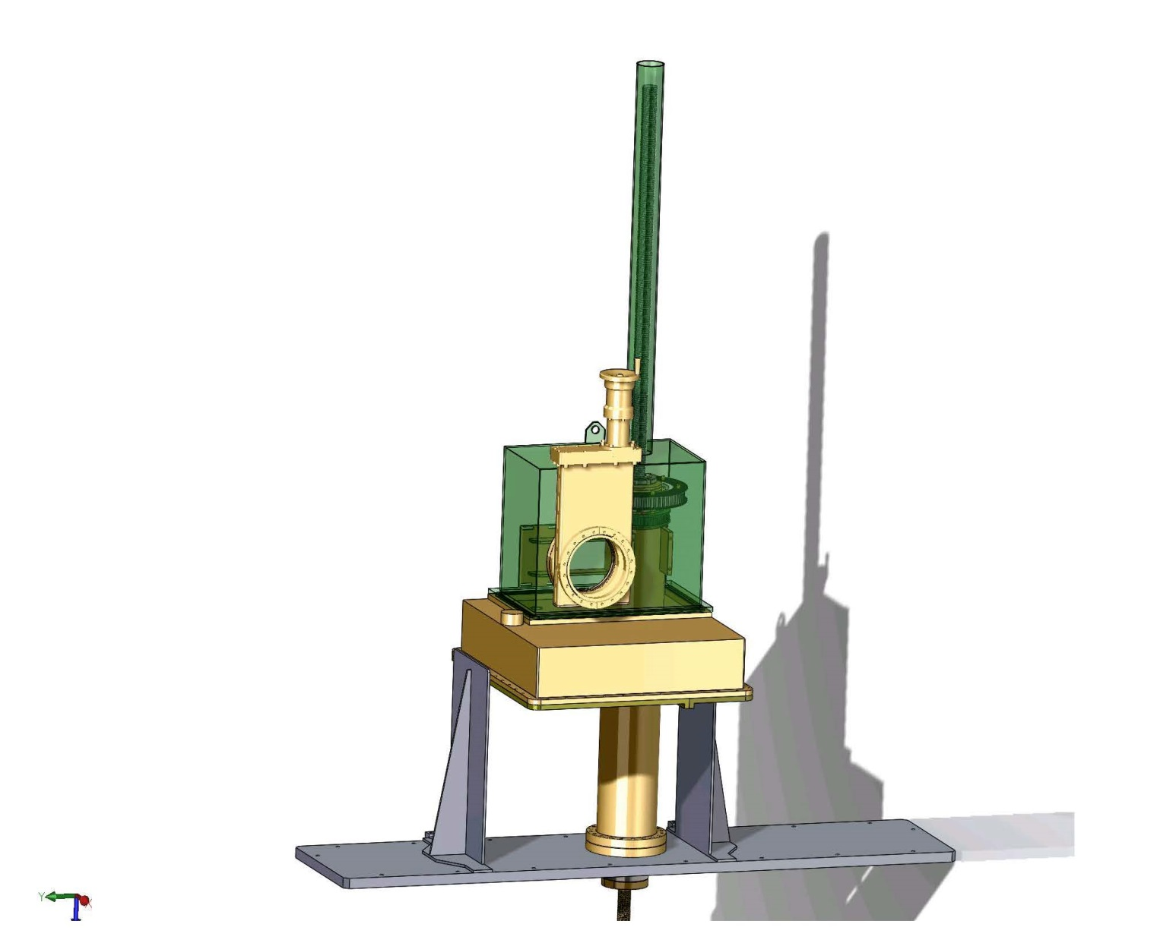

Figure : Proposed enclosure concept for evacuating stem and mechanism

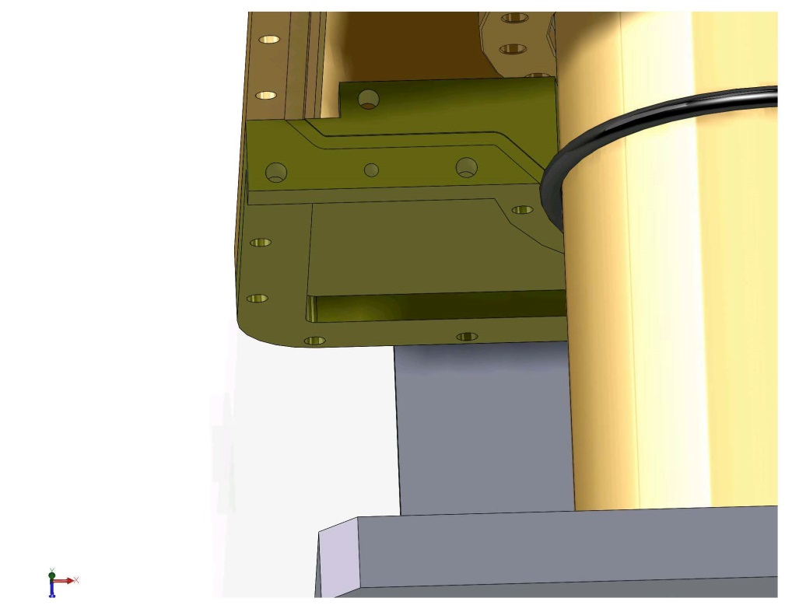

Figure : Split lower plate (disassembled) showing flanged epoxy joint.

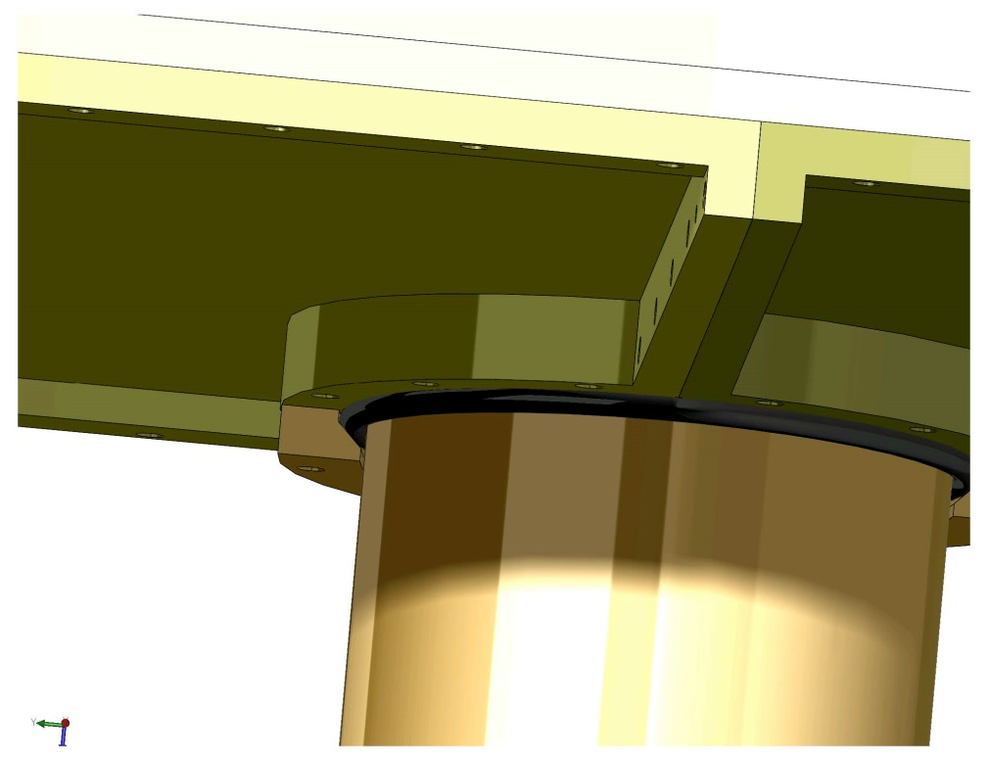

Figure : Assembled lower seal plate with neck sealing O-ring and compression ring.

After assembly and coarse leak testing, the assembly will be evacuated with a turbomolecular pump. After a suitable monitoring period and (presumably) a great deal of outgassing, the volume will be transitioned to the ion pump for maintenance and the turbo port sealed off. Gauge and pump current readings will be recorded continuously and integrated into the site vacuum control and monitoring system (VCMS) data infrastructure.

#### Variations and alternatives

Some alternate approaches have been considered in parallel:

*Fully glued-* We could expand the scope for adhesives, and/or perhaps an elastomeric sealant, to do away with the two O-rings and field-dressed seats that are required in the above approach. Bonding the lower housing plate directly to the stem nozzle and upper housing, in addition to itself, might be simpler. However it might bring difficulties associated with the amount of sealant, length of bond, surface preparation and contamination, and bond stability over time and temperature. It is also not easily reversible if there is an assembly error or if testing reveals a leak.

An intermediate approach would be to prepare an encapsulant or sealant as a contingency, in case the above O-ring system does not seal properly.

*Indium seal (no adhesives)-* In the opposite direction, a joint with no adhesives might be attractive from the standpoints of reversibility, permeability, and hydrocarbon outgassing (at least). A "T-joint" between perpendicular elastomer O-ring planes (say, the lower housing split and outer or inner peripheral seal) is probably not feasible. However, such geometries can be sealed with malleable metals, such as indium. On the other hand such joints generally require very tight tolerances on gap geometry, and high and very uniform compression forces. It is not clear the necessary conditions can be achieved reliably.

### Plan & Resources

The following stages should take about 4 calendar months to complete. This pushes installation sometime in spring of CY2014.

1. Requirements and concept review (3-5 weeks)
   1. Vacuum calculations
   2. Forces, weights, moments
   3. Survey of adhesives
   4. Preliminary (bid package) drawings
   5. Presentation(s) and external review(s)
2. Detailed design (4 weeks)
   1. Detailed fab drawings
   2. Design calculations
   3. Material specs
   4. Process specs
   5. Ordering long-lead components
3. Seal application testing *(concurrent w/ above)*
   1. Adhesive selection
   2. Joint prep, assembly and post-cure dressing
   3. O-ring fab and welding
   4. Polishing and surface preparation
   5. Leakage testing
4. Fab vendor solicitation and qualification *(concurrent with above)*
5. Fabrication & fit check (6 weeks)
6. Assembly and test procedure review *(concurrent w/above)*
7. Installation and characterization (3 weeks)

Through this process we expect the effort will consume about 2 senior personnel FTE, give or take. We require all other activities related to the beamtube recovery and aLIGO installation to proceed in parallel (continued weld leak testing, dehumidification, instrumentation, insulation, X arm evaluation, etc.) so until deploment, we intend to minimize interference with LLO vacuum team staff wherever possible.

It is premature to predict hardware costs, but those having experience with comparable size custom vacuum vessels will probably have a good ballpark idea.

We are proposing to build at least one full "spare" set of deployable hardware (in addition to any process spares needed for testing, assembly accidents, etc.). With one GNB gate valve down, it stands to reason others may follow; given the investment it seems prudent to prepare for future emergency deployment. However, the incremental burden of insuring compatibility with other LIGO valve variants (e.g., pneumatics) has to be evaluated, in addition to the added cost of hardware.

### Appendix A: GV7 Design and Construction

GV7 is a 48" clear aperture electric-drive gate valve, built in 1999 by GNB Corporation under subcontract to Process Systems International (PSI, the LIGO Vacuum Equipment awardee). Mechanical drawings recovered from PSI contract submittals are archived under LIGO-D1300814. A SolidWorks model of the drive mechanism was constructed recently from these diagrams; this is archived under LIGO-D1300876.

The valve's gate and bonnet (rectangular flange sealing the top of the trunk) are each provided with two O-ring seals, with the inner and outer ring separated by a discrete annulus volume. The bonnet annulus is pumped by a 50 l/s ion pump, which intercepts air permeation and leakage through the outer O-ring. When the valve gate is closed, the gate annulus can also be connected to the ion pump and bonnet annulus by a system of valves. With the gate open, however, the gate annulus and its external plumbing is isolated, since it is then contiguous with the beamtube volume. All O-rings are dry Viton or Flourel flouroelastomer, processed and prebaked to remove plasticizers and contaminants.

The gate carriage is lifted and lowered by a geared electric motor and toothed belt, which drive a rotating hollow shaft and ball nut supported by external ball bearings. The rotating nut houses a vertical leadscrew which descends within a long welded bellows (LIGO-D1300861). The lower end of the leadscrew terminates in a cap at the bottom of the bellows, which is anchored to to the gate carriage.

The bellows strokes from a retracted length of approximately 20" (valve open) to extended length of 72" (valve closed). Plastic "anti-squirm" spacers are installed inside to prevent the unsupported portions from contacting the leadscrew. As should be clear from the diagram, the inside of the bellows is nominally at ambient pressure; the exterior of the bellows sees the gate trunk, contiguous with the beamtube volume.

The upper end of the bellows is welded to an 8" nominal OD ConFlat flange, which is sealed to the valve stem nozzle by a copper gasket. This ConFlat flange also supports the drive housing and covers for the drive and for the exposed portion of the leadscrew.

The valve was furnished with prepared tube weld necks to Chicago Bridge and Iron (CBI), the LIGO Beamtube awardee. After precision alignment it was anchored to the midpoint buiilding foundation and butt-welded by CBI between beamtube modules Y1 and Y2. It was last tested (in closed state) after completion of the last beamtube module bakeout; it was then opened and has remained open since.

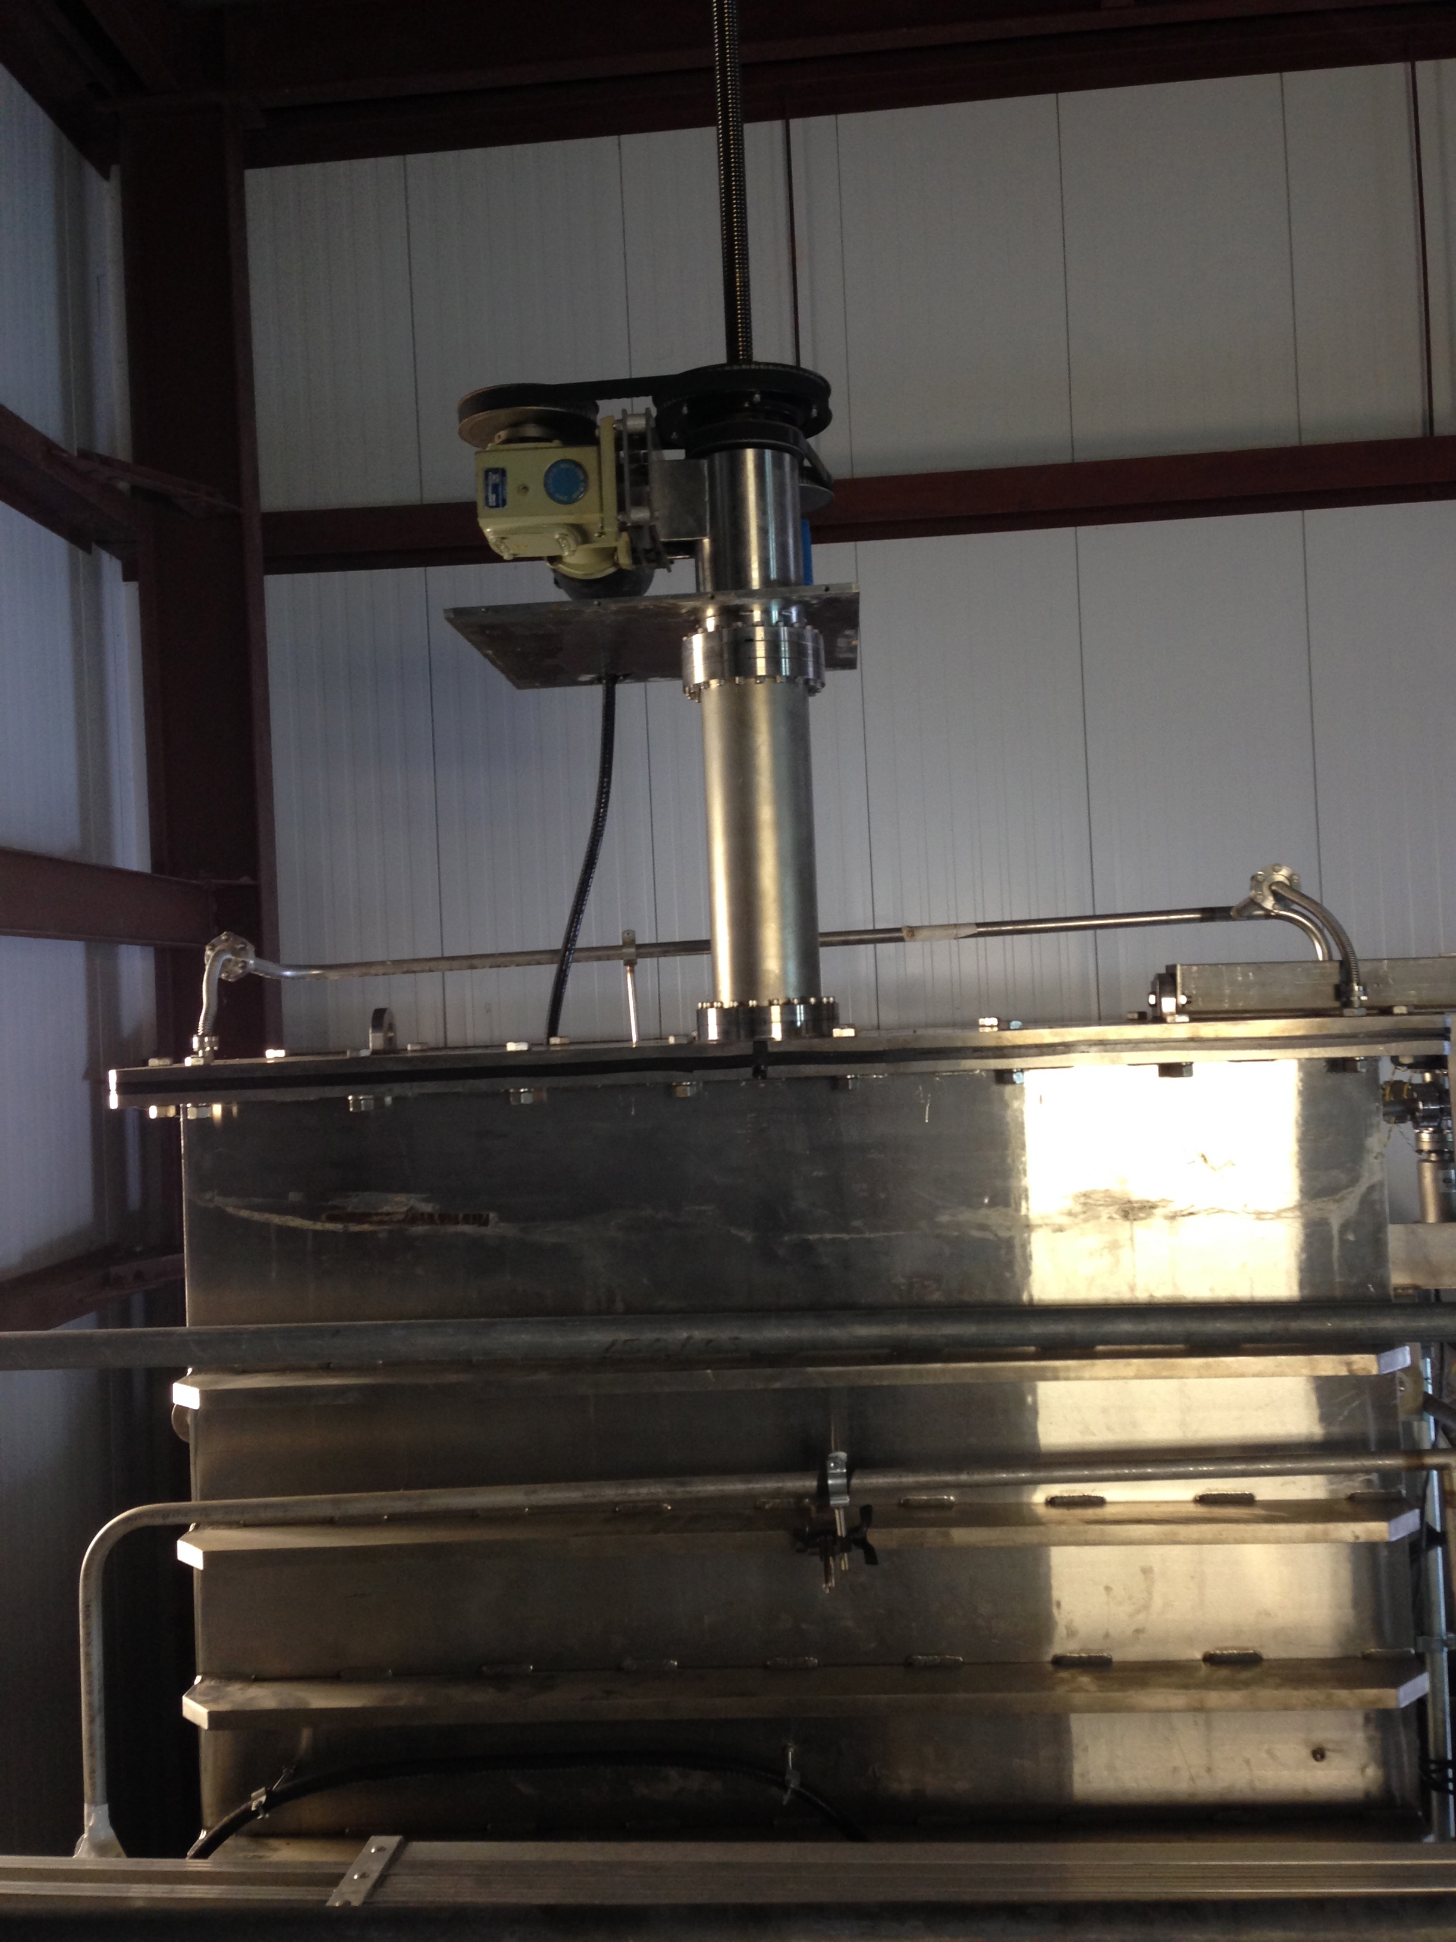

Figure : Upper trunk and stem. The drive housing has been removed to expose the motor, gearbox and leadscrew.

### 

Figure : Cutaway model of drive mechanism, bellows and top of stem.

### Appendix B: Leak History and Evidence Implicating GV7

Early in 2012 the Y (South) beamtube at LIGO Livingston was found to be leaking air. In retrospect, leakage had probably existed since late 2008; it went unnoticed because in that epoch, vacuum instrumentation responded mainly to outgassing detector components in the end and corner stations, and only peripherally to gas originating in the beamtubes.[[3]](#footnote-3)

The largest leak (approximately 2.6e-4 Tl/s) was located on an external stiffener fillet weld at Y=2258m, using a combination of air pressure gradient reconstruction and pump-assisted helium mass spectrometer leak detector (MSLD) methods. The hole was provisionally sealed with VacSeal™ silicone preparation in December 2012. A second smaller leak was also found on a spiral seam weld within 15cm. A third leak was subsequently located in a different zone at Y=1970m. All three confirmed leaks coincided with:

* weld beads
* evidence of chloride surface contamination, due to animal infestations, and
* signs of persistent moisture.

While this confluence of factors suggested a corrosion process, we do *not* find direct evidence of superficial corrosion.

After sealing the above leaks, steady air leakage of 4.6e-5 Tl/s remained (about 15% of the original total). It was estimated by gradient methods to originate within 100m of the arm midpoint (Y=2000m). However, it defied direct detection and localization by exhaustive MSLD surveys. The central 500m of the tube was repeatedly tested to a limiting sensitivity better than 1e-7 Tl/s, but no additional leaks could be found.

These tests included He spray and bag tests of the body, bonnet, and stem of GV7 (Figure 4), the 48" isolation gate valve at the tube midpoint.This valve has been locked open since the tube was originally commissioned in 2001. While all He tests were uniformly negative for direct leakage, with high confidence, some hours after a few of the tests we unexpectedly found elevated He backgrounds within the tube.

One proposed explanation was a "buffered" or "near-virtual" leak, that is, a combination of discrete or diffusive leak channels, possibly in series with some intermediate stored volume. Such an arrangement could possibly delay conduction of helium into the tube with respect to its introduction outside, even while (in principle) supporting a large steady-state flow. At first blush the scenario may seem contrived, but two specialized tests performed in October 2013 appear to support the hypothesis.

#### Test synopsis

The first of these[[4]](#footnote-4) was an extension of our standard He MSLD test method. As usual, a polyethylene film bag was sealed around the GV7 valve trunk and mechanism (Figure 6). The He concentration inside the beamtube was monitored with two He MSLD machines, each backing a 500l/s nominal turbomolecular pump. One of these sampled near GV7, inside the Y midpoint building; the second sampled at the access port Y1-6, 550 meters North.

Normally an external bag is flooded with He for a few minutes, and the MSLD is monitored for prompt deflection. According to computer models and calibration tests[[5]](#footnote-5),[[6]](#footnote-6), a simple external leak produces deflection within seconds locally, and within two minutes at 550m. In this instance, however, the He purge was maintained for 11 minutes and the bag was maintained afterward, as MSLD monitoring continued.

MSLD responses are shown in Figure 7, along with comparable curves for timed calibrations performed with a helium test source. The GV7 response is unequivocal, but the timing and slope of internal tube partial pressure are definitely inconsistent with a simple "direct" leak.

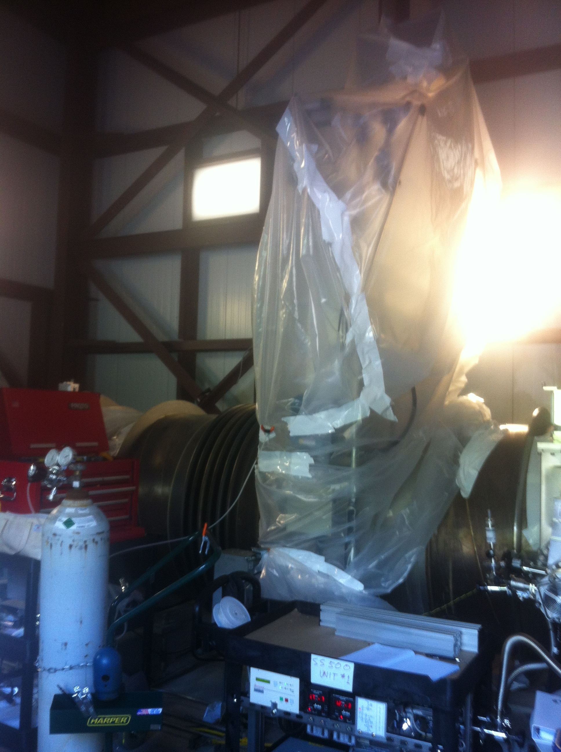

Figure : Bag enclosing trunk and stem of GV7 (10/10/2013).



Figure : He MSLD responses measured adjacent to GV7 (green) and 550m north (blue). For comparison, corresponding responses are also plotted (cyan and red, respectively) for a direct 60-second timed He injection of 1.8e-7 Tl/s near the valve location. In all cases t=0 corresponds to the start of He flow[[7]](#footnote-7). The delayed GV7 response is unequivocal, but also inconsistent with a simple leak.

A second test[[8]](#footnote-8),[[9]](#footnote-9) was performed on 10/24-25. Here a bag enclosing only the GV7 stem was purged with argon gas overnight. By changing the composition of the air surrounding the valve stem, we sought to establish if there was a comparable shift in the composition of gas inside the tube. This was tracked with a residual gas analyzer (RGA) mounted nearby.

The results (Figure 8) appear to indicate that the atmosphere surrounding the GV7 stem is indeed the ultimate source of most or all of the air getting into the beamtube.



Figure : Air displacement test on GV7 stem. RGA ion currents for argon and components of air are plotted vs. time as a fraction of the total ion current, which included contributions from N2 (28), O2 (32), H2O(18), and Ar(40) (but did not include H2 or other species present). The displacement appears to turn over at about 15 hours, which likely corresponded to exhaustion of the argon cylinder.

### Appendix B: Description of the LIGO Beamtubes

*Excerpted from an orientation and requirements document[[10]](#footnote-10) prepared by Rai Weiss and Larry Jones in September, 1994. It is provided here as introductory reference material for students and newcomers.*

#### Beam Tube Functions and Requirements:

The 4 km beam tubes provide the evacuated interaction length for the interferometer beams and the incident gravitational waves. They must satisfy the following requirements:

* The average pressure in the beam tubes is to be less than 10^-6 torr of Hydrogen and 10^-7 torr of water for initial detectors, and will need to be less than 10^-9 torr of Hydrogen and 10^-10 torr of water for advanced detectors.
* The pressure of trace gases such as CO, CO2, CH4 and hydrocarbons is required to be smaller than the water pressure.
* The maximum air leak rate permitted is 10^-8 torr liters/sec per 2 km length.

(The pressure and leak requirements are to reduce the phase noise due to index of refraction fluctuations by the residual gas below the level of other terms in the interferometer noise budget.)

* The clear aperture of the beamtubes is to be 1 meter, to:
* reduce the influence of scattered light in a single interferometer,
* accomodate the use of near infrared wavelengths in future interferometers,
* enable the beamtubes to propagate multiple interferometer beams, and
* allow the use of single interferometer optical systems with spatially distributed beams.
* The beam tube is to attenuate and control the propagation of scattered light. Light scattered by the optical components followed by diffraction or scattering by the beam tube and baffles driven by seismic noise and, finally, recombined with the main beam at an optical component can produce phase noise in the interferometer. A systems requirement on both the optics and the beam tube is that the phase noise due to scattering be smaller than other terms in the noise budget of advanced interferometers.
* The beam tube is required to:
* include baffles to limit the propagation of glancing angle scattered rays. Without baffles the phase noise due to scattering would be dominated by small glancing angle rays that make multiple reflections along the beam tube. With baffles the phase noise is dominated by back scatter from the baffles which is controlled by the baffle design.
* reflect poorly by having a “blackened” and rough interior surface,
* have sufficient aperture to reduce disturbing diffractive effects.
* The beam tubes are to be supported in such a manner as to avoid “stick/slip” on thermal cycling to prevent environmental noise that could interfere with interferometer performance.
* The beam tube must be maintained in a leak free state for a minimum of 20 years.

#### Beam Tube Design Description:

**Mechanical:**

The beam tubes are 3 mm wall 304L stainless steel cylinders with a diameter of 1.24 m. Stiffening rings are externally welded to the tube at 0.76 m spacing to avoid buckling from atmospheric pressure when the tubes are evacuated. The tubes are formed into two elemental types of sections (19.0 m (short) and 19.8 m (long)) by a continuous process of spiral welding from 0.4 m wide sheet.

A long and short section is joined together in the field by a circumferential weld and connected to other sections by a 2.5 mm thick multi convolution expansion joint. The expansion joints serve to take up the thermal expansion of the tubes during 140C bakeout and ambient temperature fluctuations as well as to allow tube alignment.

A 2km assembly of tube and expansion joints, a beam tube module, is the basic unit of the beam tubes. The beam tube modules have a surface area of 7.5 x 10^7 cm^2 and a volume of 2.3 x 10^6 liters. The beam tube modules are separately tested, baked and pumped.

All vacuum welds are TIG using Argon and Helium shield gas with a dry Nitrogen purge gas. Spiral welds are made with an initial interior autogeneous pass followed by an external pass using cleaned filler wire. Circumferential welds made in the field are external with cleaned filler wire.

***Material:***

Sheet stock for the fabrication of the tubes and expansion joints is hot rolled leaving a surface no smoother than 2 microns rms to reduce the optical reflectivity of the steel for specular rays. The sheet is rolled into coils that are annealed in a dry air atmosphere at 450C for 36 hours. The anneal serves to reduce the Hydrogen outgassing to less than 3 x 10^-13 torr liters/sec cm^2 and grows an oxide on the surface to further reduce the optical reflectivity. Coupons of the steel are tested for Hydrogen outgassing as part of the material qualification process before fabrication.

*Vacuum Properties:*

The basis of the beam tube vacuum design is to minimize the outgassing rate of the tubes to economize on the pumping system. The tubes are passive vacuum components -- the interferometer beams do not heat the walls significantly and are not a source for additional gas loads.

The beam tubes, once pumped and baked, are planned to remain evacuated. The beam tubes can be isolated from the vacuum system holding the interferometer components, which will be a more dynamic system, by 48 inch gate valves at each end of a 2 km module. During operation the beam tubes are isolated from condensibles emitted by the interferometer components by cryogenic high pumping speed isolation pumps at each 2km end.

The primary gas load in the beam tubes, after an initial bake at 140C to remove water and other condensible gases, is expected to be hydrogen. The initial interferometer pressure requirements are expected to be met by pumping with getter and ion pumps at 10” aperture ports at each end of a 2 km module.

Additional pump ports are placed at 250 m intervals along the module. These will initially be valved off and used (if necessary) to achieve the pressure requirements of advanced interferometers. The additional ports will be used for enhanced pumping capacity during bake out and leak detection.

The beam tubes are steam cleaned in the field to remove hydrocarbon and dust contamination and remain capped after cleaning until final assembly. During the final assembly the tubes are maintained at an overpressure of class 1000 filtered air.

***Supports and anchors:***

Tube supports are bolted to a concrete slab that is cast and aligned along the 4 km arms before final assembly of the tubes. Supports are adjustable for tube alignment in both directions transverse to the tube axis. Two kinds of supports are used; a fixed support that holds the tube on mounting rings placed at section joins where there are no expansion joints and longitudinally compliant and guided supports placed at the expansion joints which permit longitudinal motion without stick/slip. The connnection between the supports and tube is thermally insulated to reduce heat leak during bakeout. Anchors to resist the longitudinal atmospheric forces on evacuation are installed at the ends of each 2 km module.

***Alignment:***

The absolute alignment of the arms at both the WA and LA site will be determined by a static dual frequency GPS (Global Positioning System) survey referenced to the WGS-84 ellipsoidal grid to several millimeters in all three dimensions. Ten base reference monuments are to be placed at each site: four in proximity to the vertex building, one at each mid point of the beam tubes and 2 at each end station. The reference monuments will be used as fixed receiver points in a differential GPS system with a roving GPS receiver to position the concrete slab and tube supports to an anticipated accuracy of several millimeters relative to the monuments in all three dimensions. Provision is being made to monitor the alignment after installation to measure drift during the LIGO pre-operations and operations phases. The design tolerances in the alignment are to maintain the clear aperture at 100 -0+0.5 cm.

***Leak Test and Bakeout:***

All components of the beam tube (elemental tube sections, expansion joints, pump ports) are required to be leak free, as determined by Helium leak testing, to a level of 10^-9 torr liters/sec with a goal of 10^-10 torr liters/sec. The components are tested before assembly in the field. The circumferential welds made in the field are individually tested to the same requirement and goal.

An entire beam tube module is required to be leak free to a level of 10^-8 torr liters/sec with a goal of 10^-9 torr liters/sec after bakeout in the field. The vacuum acceptance criterion for a 2km beam tube module may be determined by an air signature test. The sensitivity of a such procedure will be determined in the Qualification Test of the sample beam tube later this year (1994) at CBI.

A low temperature bakeout of the beam tubes is required to meet the operational pressure requirements in a reasonable time and to enable air signature tests to qualify the completed beam tube module. The bakeout may open new leaks and is required before beam tube acceptance.

The beam tube module will be baked at 140 C for a month or until the water outgassing rate has dropped to less than 2 x 10^-11 torr liters/sec cm^2 while the tube is at elevated temperature. In order to accomplish the bakeout, the tube and expansion joints are wrapped in 10 cm thick insulation and a DC heating current (~2000 A) is passed through the tube. The bakeout requires 670 kW per module. Power for the bake is to be provided by auxiliary generators and is not planned as part of the facility fixed power distribution system.

***Optical Properties and Baffles:***

The surface of the stainless steel will have an rms roughness larger than 2 microns to reduce the specular reflectivity and the 250 (brown) to 500 (blue) Angstrom oxide coating grown during the steel annealing process will be maintained on the surface to increase the surface optical absorption.

Sheet metal baffles with a projected height of 6 cm are placed every 7 meters from 100 meters to 250 meters nearest a main cavity mirror and then every 19.8 meters along the beam tube at the beam tube supports. The baffles are spiral sections with a normal at 55 degrees to the tube axis facing the nearest cavity mirror. The inner edge of the baffles are serrated with 3.5 mm teeth spaced at a 3.5 mm period along the baffle inner circumference. The serrations serve to destroy the coherence of the baffle diffraction. The baffle angle is chosen to launch specularly reflected rays into absorbing paths in the beam tube.

Currently, the baffles are designed to be fabricated from the same material as the tube walls with the same oxide coating and surface roughness. At 55 degrees angle of incidence the back scattering fraction (BRDF) at 0.5 microns wavelength is measured as 10^-2/steradian. A Breault Research stray light analysis was made of the beam tube and baffles which estimated adequate but not overwhelming margin for scattered light. Based on further modeling and forthcoming measurements of the qualification test beam tubes, the project may decide to place baffles in the first 100 meters of the beam tube nearest to a cavity mirror and to blacken the baffles to improve the BRDF to 10^-3/steradian.

|  |  |  |
| --- | --- | --- |
| ***component*** | ***# WA*** | ***# LA*** |
| tube section, short | 49 | 49 |
| tube section, long | 49 | 49 |
| end section | 2 | 2 |
| expansion joint | 50 | 50 |
| stiffening ring | 2444 | 2460 |
| support ring | 149 | 149 |
| baffle | 122 | 111 |
| baffle stiffeners | 32 | 16 |
| vacuum pump ports | 7 | 7 |
| support, fixed | 49 | 49 |
| support, guided | 50 | 50 |

Table : Beamtube module component count for Washington and Louisiana sites (each site comprises four 2km modules).

1. For example, suppose the limiting conductance was percolation through a "plug" of lubricating grease. Relieving ambient pressure might bubble the grease out, opening an unlimited direct channel. Similarly, pulling an external vacuum might temporarily render the pressure in an intermediate deadspace positive with respect to the outside, inverting the signs of mechanical stresses. [↑](#footnote-ref-1)
2. using a "dummy" lower housing [↑](#footnote-ref-2)
3. The blind spot has since been rectified by adding instruments. [↑](#footnote-ref-3)
4. https://alog.ligo-la.caltech.edu/aLOG/index.php?callRep=9048 [↑](#footnote-ref-4)
5. LIGO-T1300553 [↑](#footnote-ref-5)
6. LIGO-T1200375 [↑](#footnote-ref-6)
7. (Brief upward spikes in the green and cyan traces are believed to be electrical glitches in the MY instrument datalogger, and weren't seen on the instrument display. Displaced initial baselines reflect instrument offsets and residual He backgrounds in the tube at the times of the respective tests; underlying slopes reflect ongoing removal of this background helium, mostly by the sampling apparatus itself.) [↑](#footnote-ref-7)
8. https://alog.ligo-la.caltech.edu/aLOG/index.php?callRep=9325 [↑](#footnote-ref-8)
9. https://alog.ligo-la.caltech.edu/aLOG/index.php?callRep=9352 [↑](#footnote-ref-9)
10. file: beamtube090194.txt , from: R. Weiss Sept 1, 1994

    File history: Partial draft from Larry Jones 081994

    completed first draft R. Weiss 090194 [↑](#footnote-ref-10)