LIGO Laboratory / LIGO Scientific Collaboration

LIGO-T1400035-v1 LIGO Date 1/29/14

ITM11 Inspection Report

Margot Phelps, Calum Torrie, Kate Gushwa, Garilynn Billingsley

Distribution of this document:
LIGO Scientific Collaboration

This is an internal working note
of the LIGO Laboratory.

California Institute of Technology  LIGO Project | Massachusetts Institute of Technology  LIGO Project
LIGO Hanford Observatory | LIGO Livingston Observatory
http://www.ligo.caltech.edu/

Introduction
The document is a report of the coating inspection done at Caltech before shipping ITM11 to LHO on 1/29/14. Inspection was done visually with a flashlight array and a darkfield microscope.

General notes on optical coating inspection

Linear defects are usually caused during the polish process.
Typical linear defects:
1.Chatter marks: Looks like a line of dots …, these are typically chatter marks from polish process.
2. Sleeks: “Plastic deformation” of glass, they look like a scratch but do not have jagged edges.
3. Scratches: Deeper and more jagged than sleeks.

Circular defects are usually caused during the coating process.

Most typical circular coating defects are hazy, circular or donut shaped defects that are different colors than the rest of the coating. The different color indicates different layers of the coating have been broken through or exposed.

ITM11 HR surface

Polish Defects
1. Chatter scratch near 6 o’clock, at coating edge.

2. Chatter mark, 90units long in 5x, horizontal at x=50mm, y=40mm

3. Sleek about 2 cm in from the 6:00 position, in addition to the sleek that is seen on pg. 15 of the ITM11 Final Data Package.

4. Sleek that is seen on pg. 15 of the ITM11 Final Data Package.

Coating Defects
- Numerous coating defects on S1, counted at around 30 over all surface. Greenish, hazy donut shaped defects, ~1mm in diameter. The one closest to the center is ~25mm away from center. These are visible with the flashlight array. Fig. 1 below shows a closeup of the defect taken with an IPhone through the darkfield eyepiece at 10x.

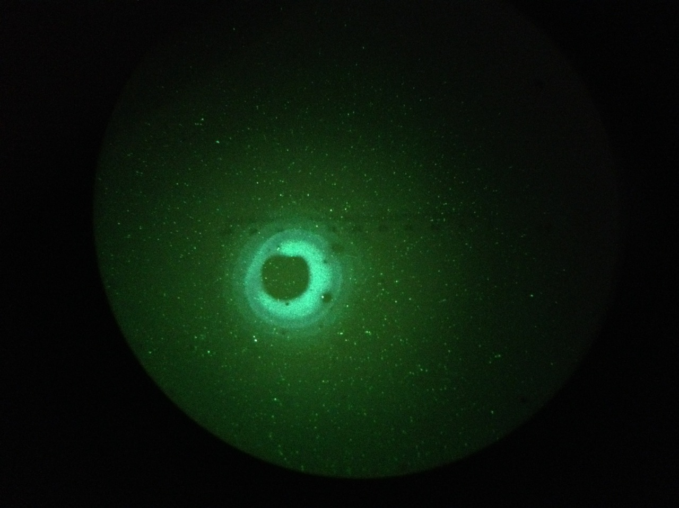
Figure 1: ITM11 HR coating Defect 10x darkfield closeup

2. Addition to what is shown in the picture, there was a “three dot line” of coating defects that look different than the rest of the small hazy spots. Thought to probably be dirt on the substrate under the coating. ~1’’ away from edge, 2-3’' cw from arrow.

ITM11 AR Surface
AR surface looked good overall, there was one area ~3’’ in from the flat that had a faint group of sleeks.

