LIGO HANFORD OBSERVATORY
PO BOX 159
RICHLAND WA 99352

TEL: 509.372.8106
FAX: 509.372.8137

MEMORANDUM

DATE: May 13, 2014

TO: | ISC team
FROM: | Daniel Sigg
SUBJECT: | RF Preamplifier for Broadband Photodetector
Refer to: | LIGO-E1400233-v1

The ALS transmission beams have very weak signals which produces an RF beat note at the level of –20 dBm to –30 dBm. This is getting close to the threshold of the phase-frequency detectors which follow. The presented design adds a Mini-Circuits ZFL-500HLN amplifier to the output of the broadband PD. As an alternative the ZLK-500LN amplifier can be used in situations where even more gain is needed. However, the later amplifier saturates at +3 dBm. Power is patched into the existing supply line. A M8 plug is connected to a M8 socket and wired straight-through. The +15 V and GND lines are brought out and connected to the amplifier. See images below.

BOM (for 3 ifo):
Qty | Item | Distributor | Description
6 | ZFL-500HLN+ | Mini-Circuits | 10 MHz to 500 MHz Low Noise Amplifier, 20 dB gain, 16 dBm max. output
6 | 501-1253-ND | Digi-Key | SMA Plug-Plug Adapter
6 | 277-4135-ND | Digi-Key | M8 3-pos Socket
6 | 277-4124-ND | Digi-Key | M8 3-pos Plug
 |  |  | Hook-up Wire, Cable Tie

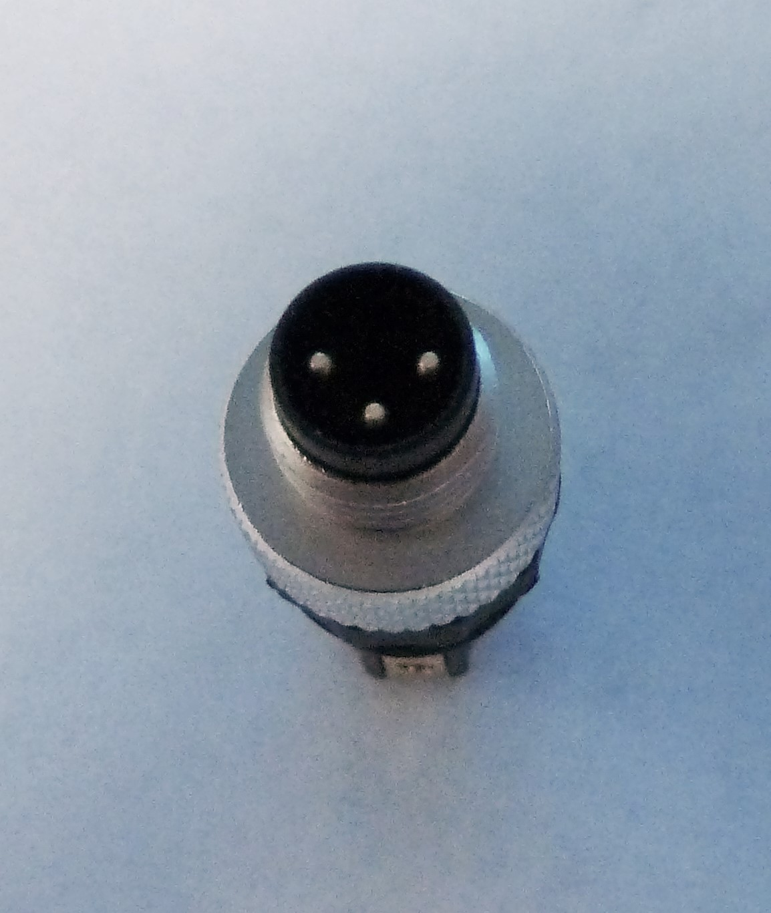 | 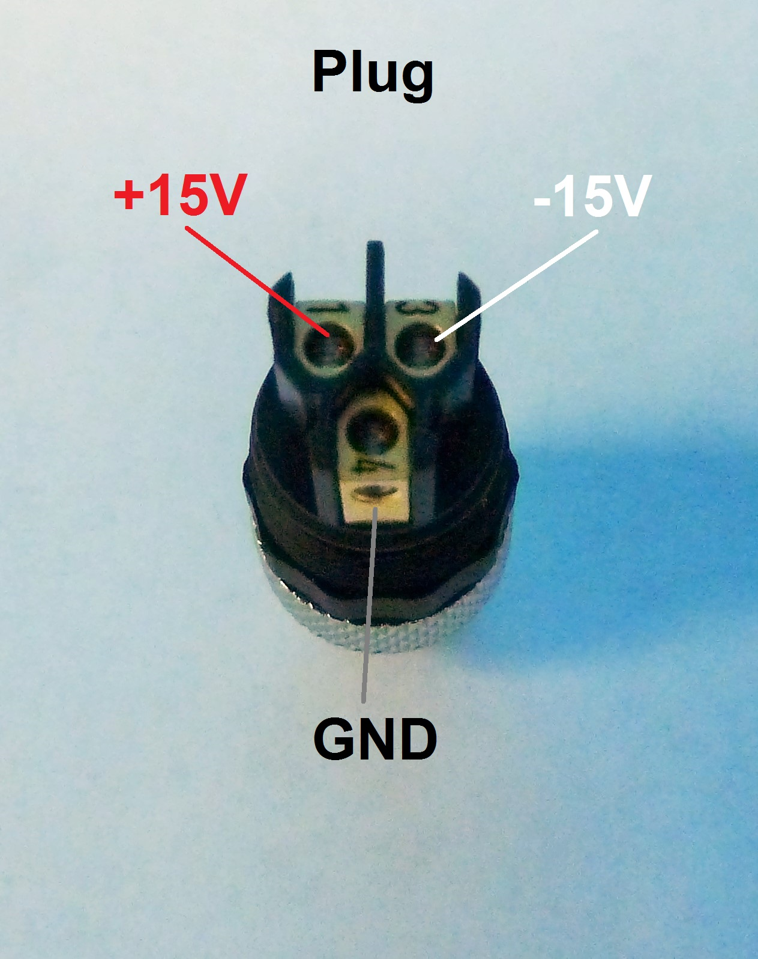
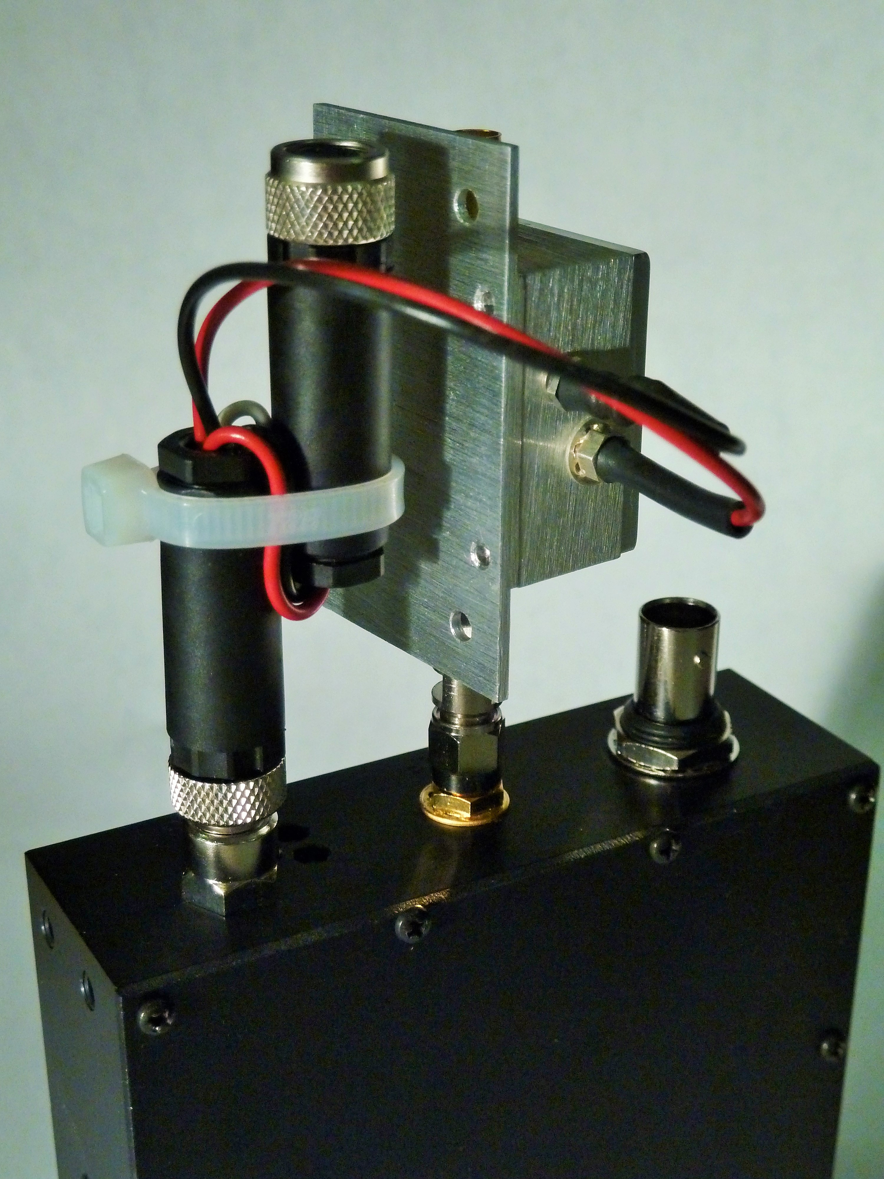 | 