LIGO Laboratory / LIGO Scientific Collaboration

LIGO-T1200191-v4 LIGO 03/30/15

Optical-levers software users manual

Suresh Doravari, Stuart Aston

Distribution of this document:
LIGO Scientific Collaboration

This is an internal working note
of the LIGO Laboratory.

California Institute of Technology  LIGO Project – MS 18-34  1200 E. California Blvd.  Pasadena, CA 91125  Phone (626) 395-2129  Fax (626) 304-9834  E-mail: info@ligo.caltech.edu | Massachusetts Institute of Technology  LIGO Project – NW22-295  185 Albany St  Cambridge, MA 02139  Phone (617) 253-4824  Fax (617) 253-7014  E-mail: info@ligo.mit.edu
LIGO Hanford Observatory  P.O. Box 159  Richland WA 99352  Phone 509-372-8106  Fax 509-372-8137 | LIGO Livingston Observatory  P.O. Box 940  Livingston, LA 70754  Phone 225-686-3100  Fax 225-686-7189
http://www.ligo.caltech.edu/

Scope and introduction
This document describes how to access and analyze optical lever signals using medm screens and data analysis tools such as diaggui and dataviewer. It also documents the pathways in the digital domain along which the various oplev signals are collected and processed. This version (ver-4) covers the current situation as is and will be updated in the near future. In this document the term ‘optical-lever’ is shortened to ‘oplev’.

Accessing the OPLEV medm screens
There are several ways to accesss the oplev screens. The sections below describe each one separately.

OVERVIEW Screens
The Oplev medm screens are most easily accessed through the SUS and ISI buttons on the sitemap. These take you to menu items called SUS_OPLEV_OVERVIEW and HAM-ISI_OPLEV_OVERVIEW screens respectively. These are shown in Figure 1 and Figure 2 for LHO, and Figure 3 and Figure 4 for LLO below. The SUS_OPLEV_OVERVIEW contains all essential information for the SUS oplevs, which address suspended optics (BS, ITMX, ITMY, ETMX, ETMY, PR3 and SR3) and similarly the HAM-ISI_OPLEV_OVERVIEW screen contains information for oplevs which address HAMISIs (HAM 2,3,4,5). Within these screens each oplev is shown as an XY plot surrounded by indicators for its various components as shown in Figure 5. In the top left corner is the label identifying the XY plot such as PR3 or BS. Clicking on this label takes us to the corresponding SUS or ISI screen, which the oplev addresses. The yellow button on top of the XY plot takes us to the full OPLEV screen with all its filter banks and signal pathways as shown in Figure 6. These are further described in the next section. The top-right corner of the XY plot has the SUM channel output and next to it is a bar indicator showing how far the value is between its minimum (10) and maximum (40000) limits. In the lower-left corner of the XYplots is a set of four squares in a 2x2 matrix, which are bar-indicators representing the counts in each of the QPD segments. They fill up from -10k to 0 and ideally should be around -8k so that they add up to -32k. The rationale being that, if there were a misalignment and the spot lands on only one QPD segment, then that segment would not saturate (exceed a count of 32k counts).
The OVERVIEW screens also contain buttons to access the Dataviewer and Diaggui tools, which are directed to load template files for the oplev signals of interest. In the SUS screen, these are divided into two sections. The ones on the lower left open templates containing BS, PR3 and SR3 channels and those on the upper-right open templates with channels of ITM and ETM oplevs. We also plan to add band-limited rms channel indicators to give a quick glance of the spectrum of each pitch and yaw oplev signal.
The layout of the XY indicators in these overview screens broadly mimics the layout of the whole interferometer, making it easy intuitively easy to identify the oplev we are looking at.

Through SUS and HAM-ISI screens
The oplev medm screens may also be accessed from the corresponding suspension screens and from the HAM-ISI (nos 2 to 5) screens. Clicking the yellow “FULL OL CHAIN” button on the bottom-left of the SUS screens opens the corresponding oplev screen. The menu pathway to get to the sus-oplev screens at H1 is shown below in Figure 7.

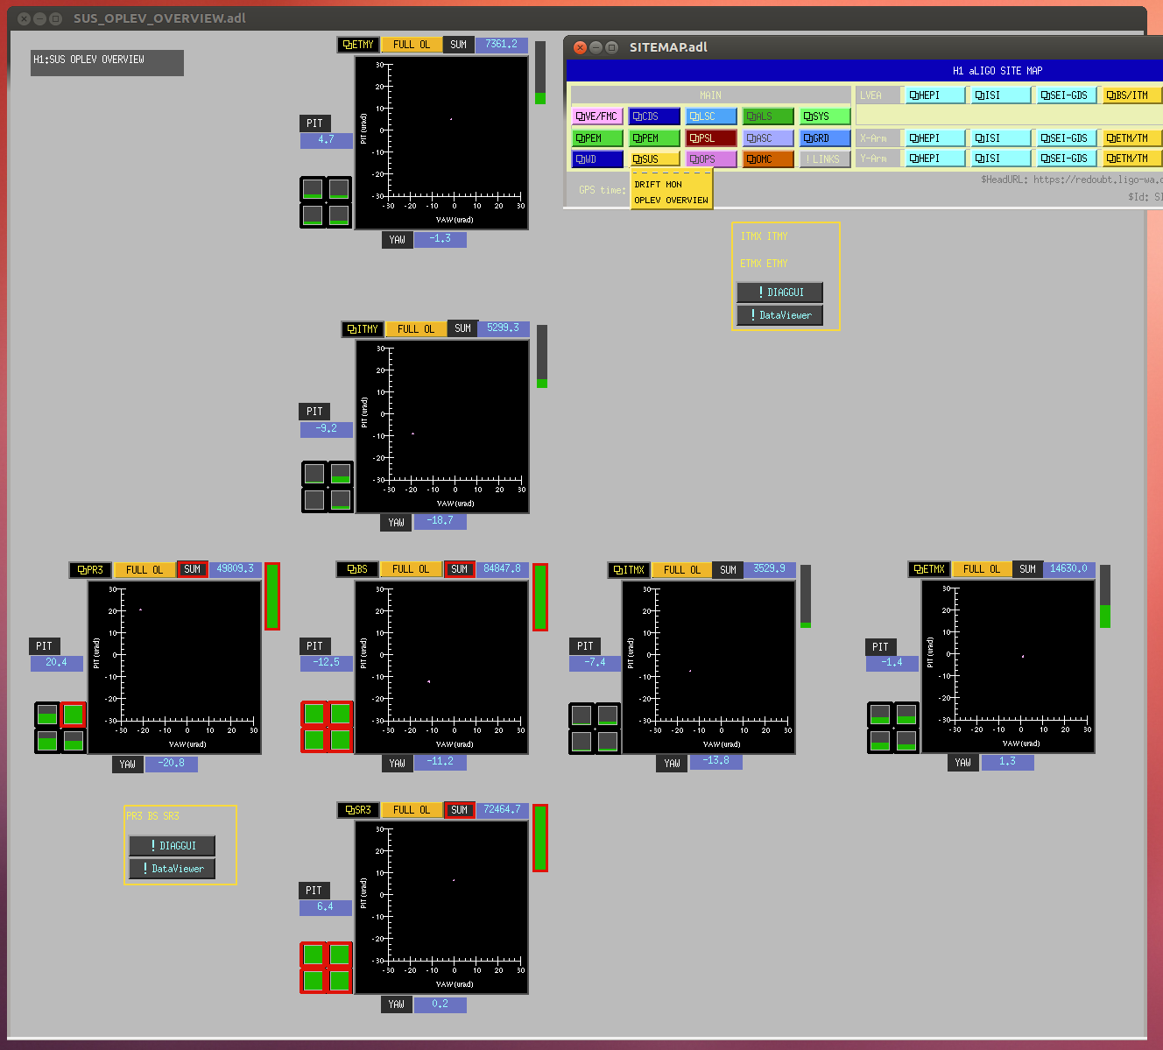
Figure 1. H1 menu pathway to SUS_OPLEV_OVERVIEW screen

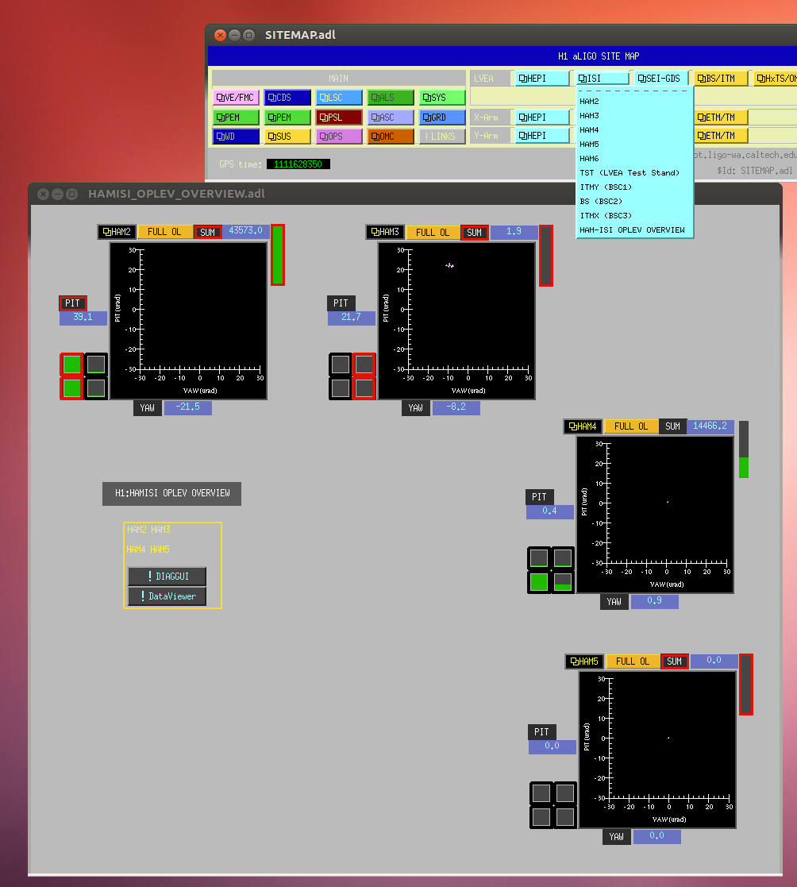
Figure 2. H1 menu pathway to HAMISI_OPLEV_OVERVIEW screen

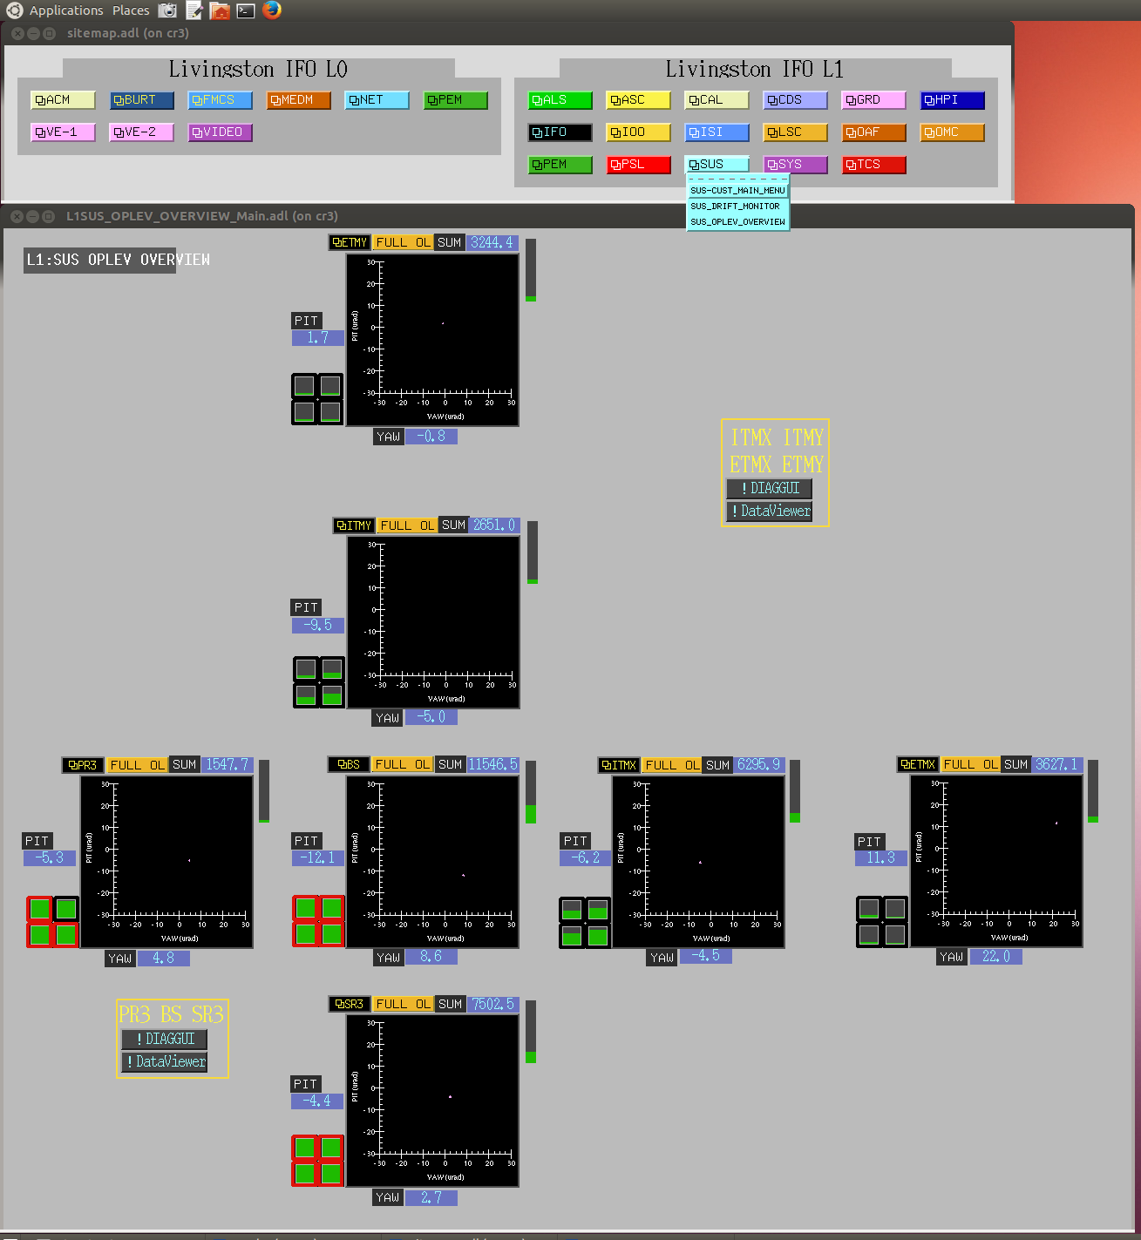
Figure 3. L1 menu pathway to SUS_OPLEV_OVERVIEW screen

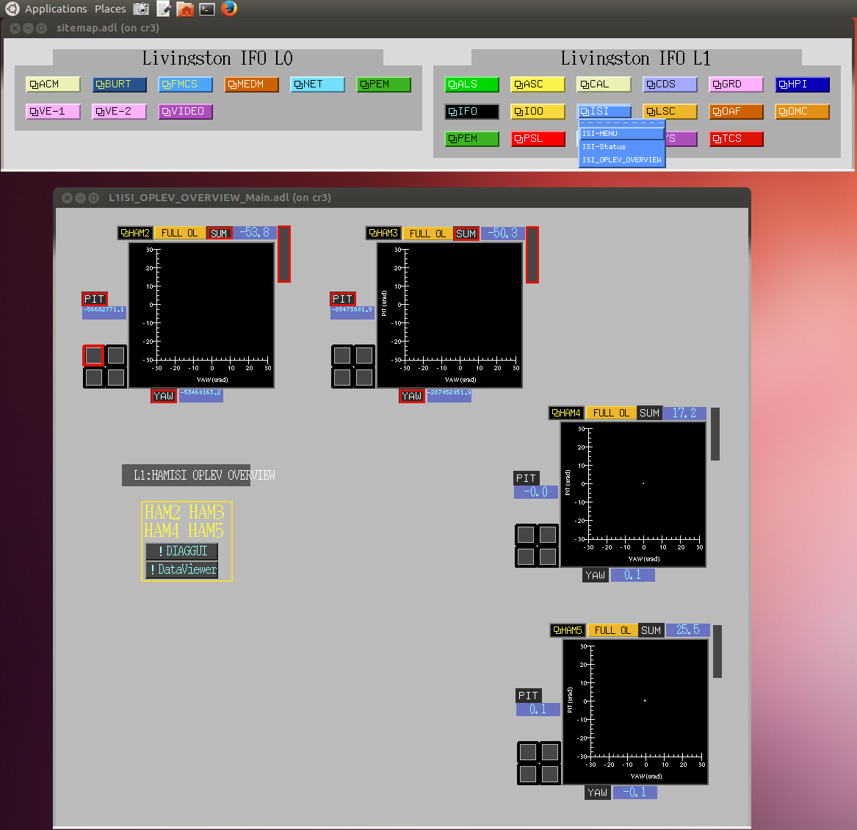
Figure 4. L1 menu pathway to HAMISI_OPLEV_OVERVIEW screen

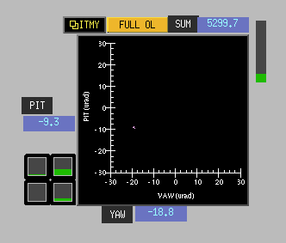
Figure 5. OPLEV XY Plot and indicators corresponding to one OPLEV

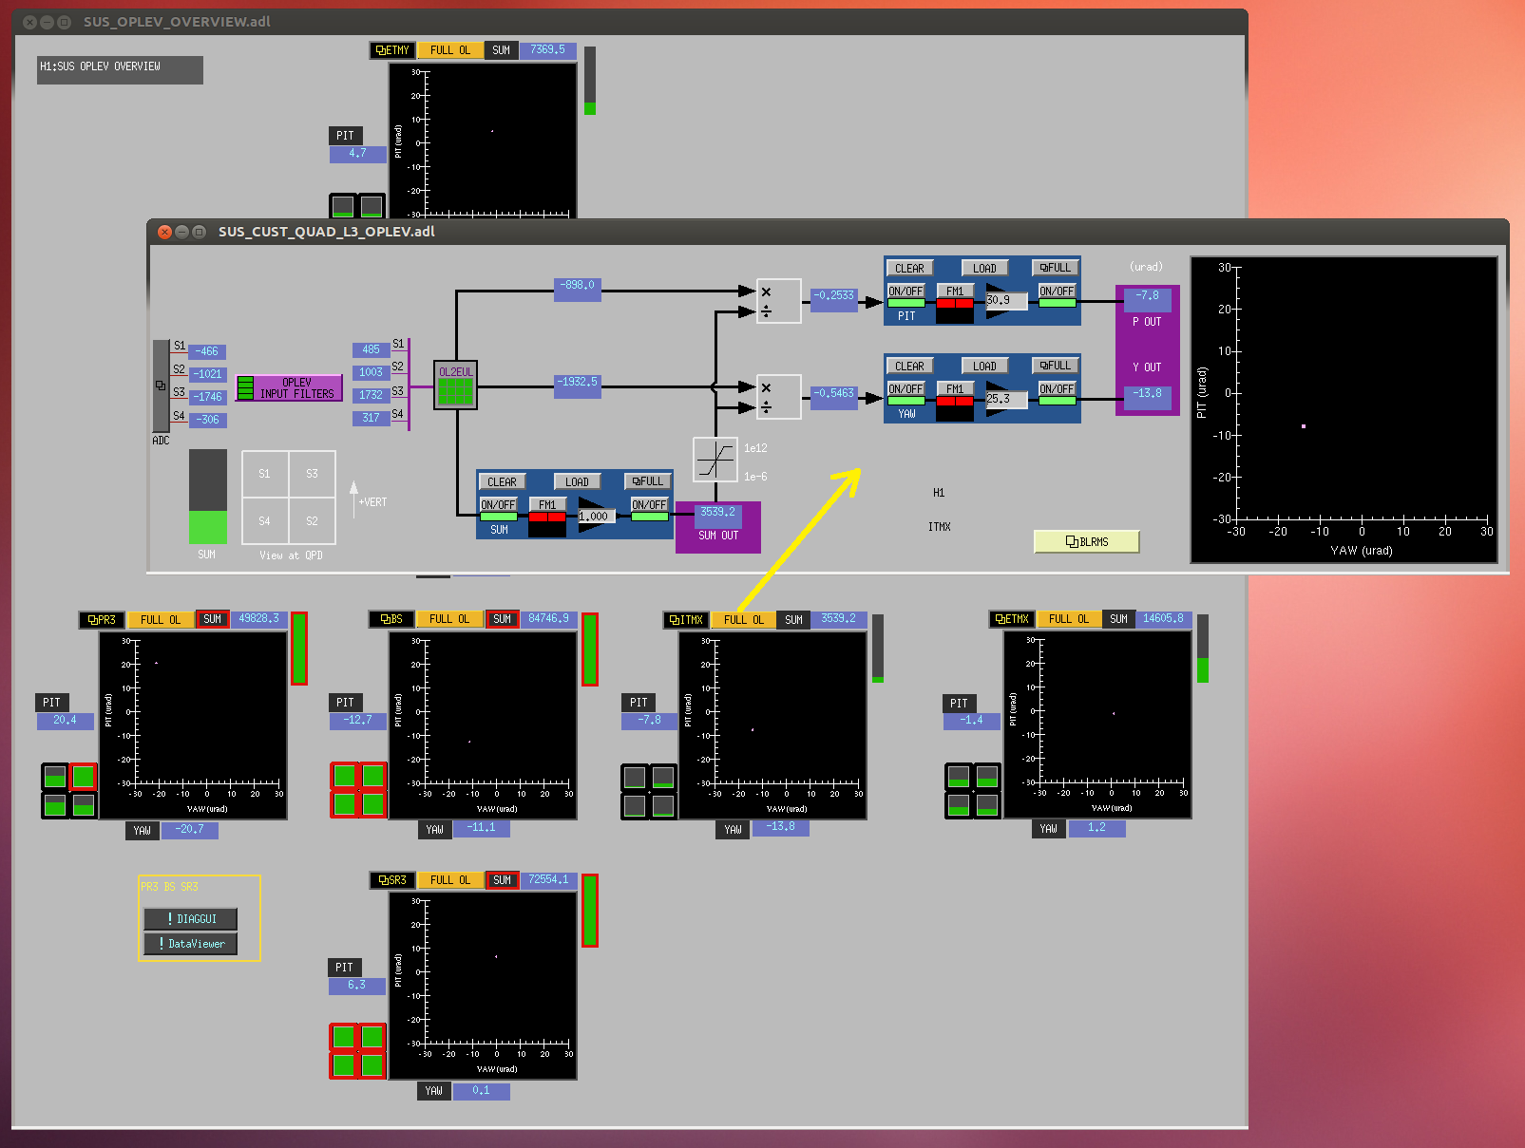
Figure 6. Accessing the FULL-OL screen from the OVERVIEWs

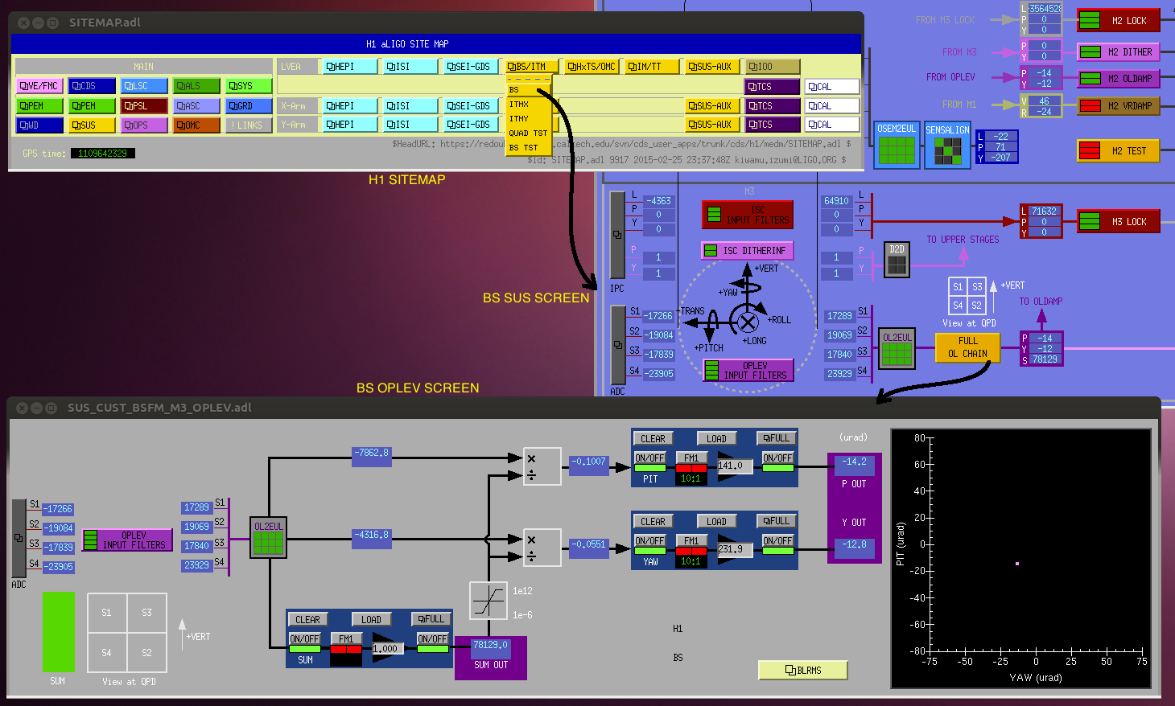
Figure 7. Menu Pathway to SUS-OPLEVs at H1 through SUS screens

Similarly, the HAMISI oplev screens may be accessed through the HAMISI screen as shown in Figure 8. Note that the generic oplev screen itself is different for HAM_ISI’s.
This will be homogenized at as soon as possible so that we just have one kind of oplev screen.
These menu path ways for SUS and HAM-ISI oplevs for L1 are shown in Figure 9 and Figure 10.
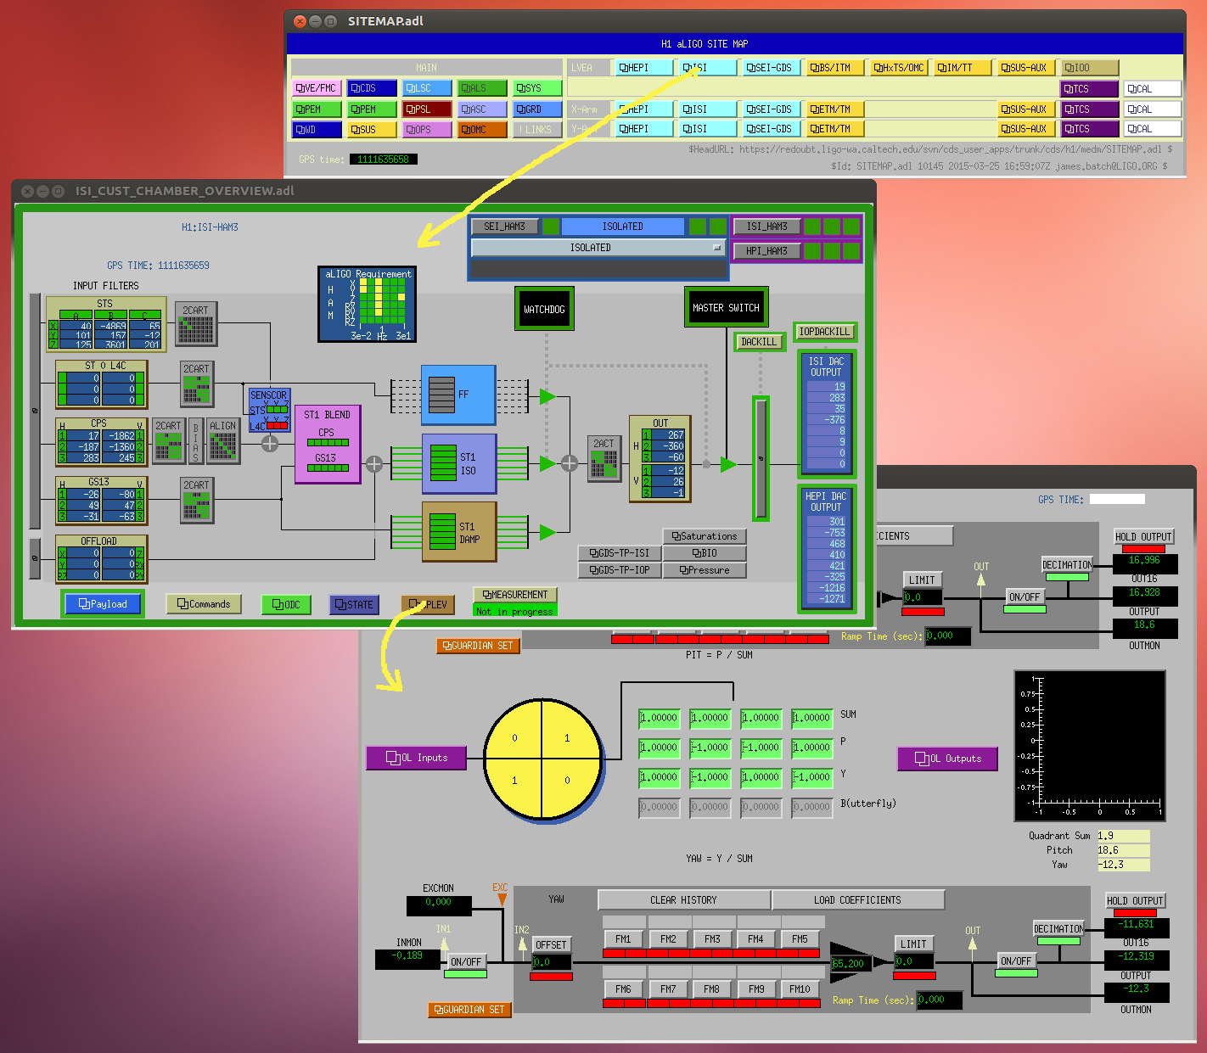
Figure 8. Pathway to HAM-ISI OPLEV through the HAM-ISI screens
The screen for a specific oplev is generated from a generic (master) medm screen that the sus-screens call. This generic screen has macros, which require the variables to customize it to a particular oplev. The yellow “FULL OL CHAIN” buttons in SUS screens pass these variables to the generic screen and thus generate the corresponding screens for each oplev. Therefore editing this generic medm screen affects the screens for all corresponding oplevs. These generic screens are located in the following directories and may be listed by a typical > ls *OPLEV* command at the prompt :

1) For BS: /opt/rtcds/userapps/release/sus/common/medm/bsfm/
2) For HLTS: /opt/rtcds/userapps/release/sus/common/medm/hxts/
3) For Quads: /opt/rtcds/userapps/release/sus/common/medm/quads/
4) For ISI_HAMs: /opt/rtcds/userapps/release/isi/common/medm/hamisi/

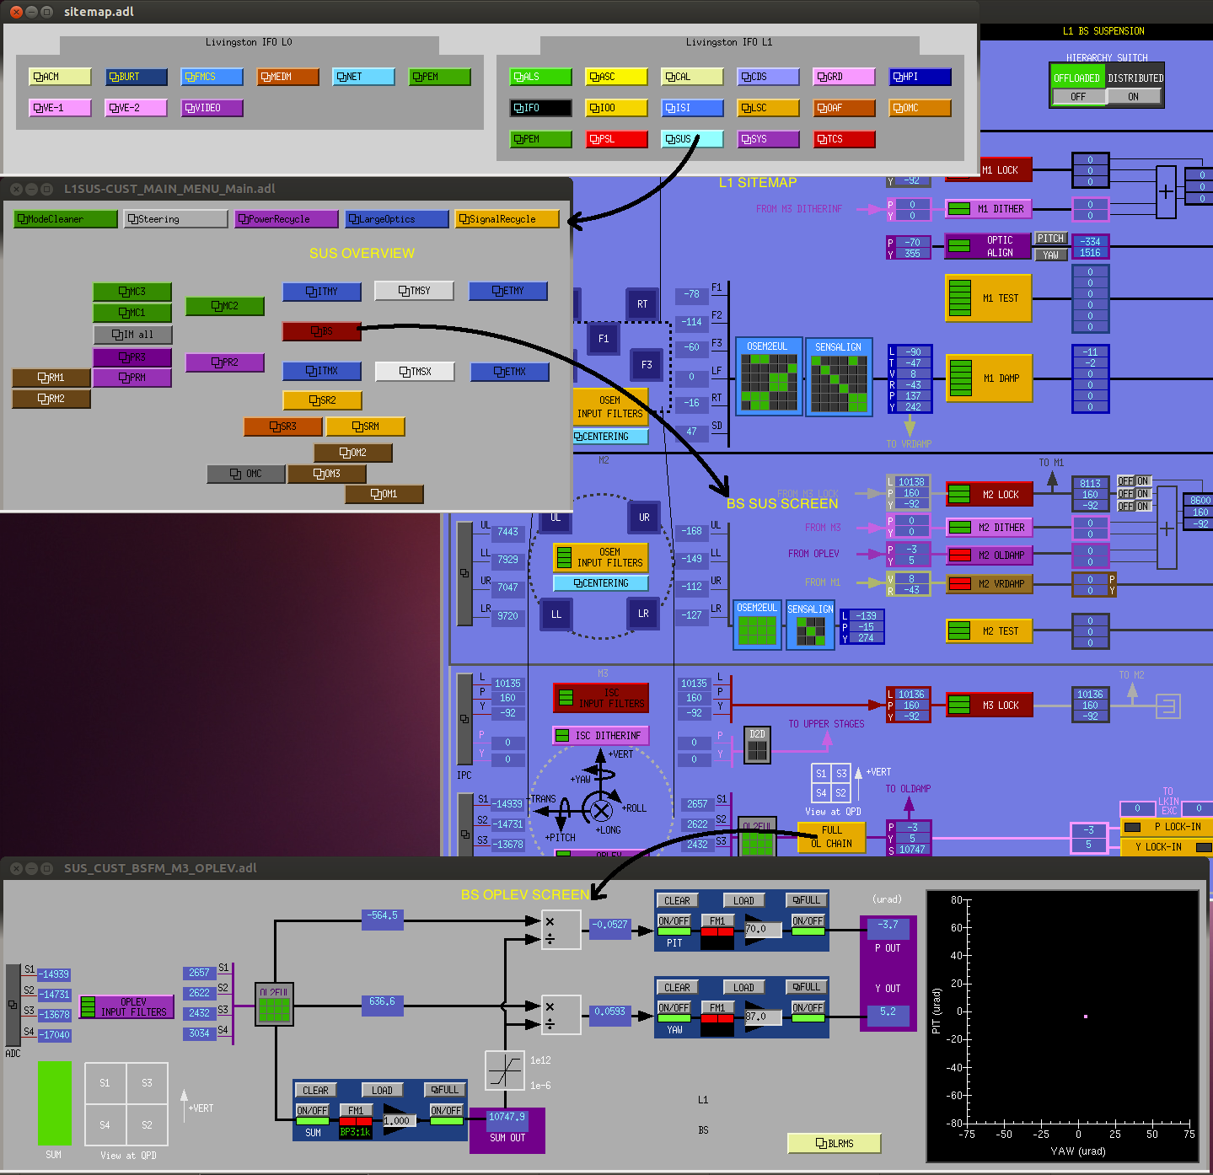
Figure 9. Pathway to SUS-OPLEV screens at L1

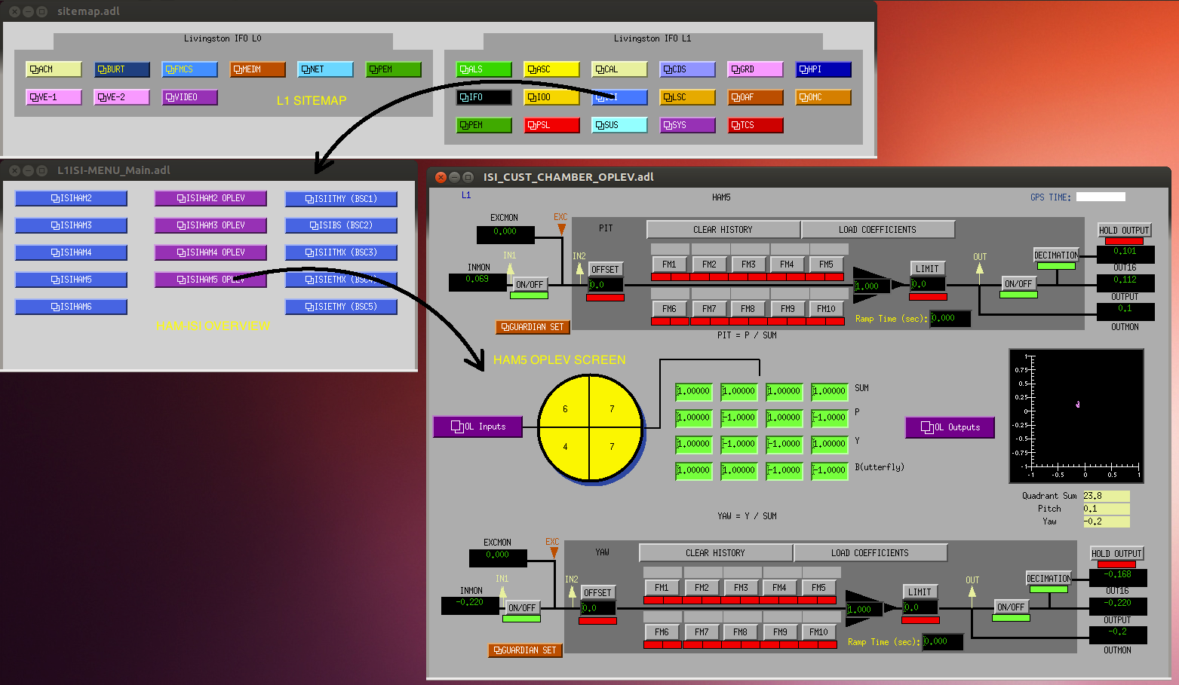
Figure 10. Pathway to HAM-ISI OPLEVS at L1

Accessing OPLEV screens from the command line
In case we wish to call up a particular oplev screen from the command line, then the relevant scripts are located in these directories. These scripts use the generic screens mentioned above and pass the variables to them as required.
They are located in the directory, for H1:
/opt/rtcds/userapps/release/sus/h1/scripts/oplev/
Or alternatively, for L1:
/opt/rtcds/userapps/release/sus/l1/scripts/oplev/
The specific scripts for the various oplevs are:
start_bs_oplev_medm.bsh
start_pr3_oplev_medm.bsh
start_sr3_oplev_medm.bsh
start_etmx_oplev_medm.bsh
start_etmy_oplev_medm.bsh
start_itmx_oplev_medm.bsh
start_itmy_oplev_medm.bsh
start_ham2_oplev_medm.bsh
start_ham3_oplev_medm.bsh
start_ham4_oplev_medm.bsh
start_ham5_oplev_medm.bsh

These can be executed from any terminal since they are soft-linked to a directory on the default path. Namely : /ligo/cds/userscripts/

OPLEV medm screens in detail
The generic oplev screen has various sub-screens, which are useful for diagnostics and for initial alignment of the oplevs. The various parts are shown in Figure 11. below labeled in yellow. The signal flow is from the left of the screen to the right, as in most LIGO screens.

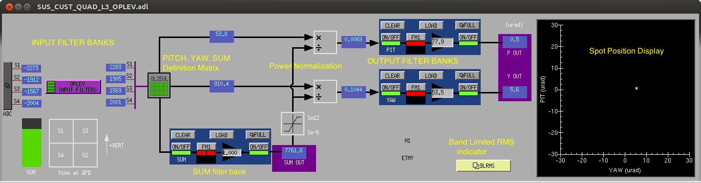
Figure 11. A typical oplev screen for suspensions showing the various parts.
On the left we have Input filter-banks, which show signals received directly from the ADCs. These show the amount of light received on each quadrant of the oplev QPDs. These filter banks also have a filter for compensating the analog whitening of the signal. The analog gain of these whitening filters must be set such that the ADC counts received, with the spot centered on the QPD, are in the range of 8000 to 10,000 counts. The sum of all four is ideally less than 40,000 counts. We must also ensure that when the spot is completely located on one quadrant, the ADC does not saturate (counts must be less than 32,000). Note that there is usually some spillage of light when the spot is located on a single quadrant.
After this initial signal conditioning the signals are routed to a matrix, which defines the Sum, Pitch, Yaw and Butterfly (crinkle) of the oplev (in some cases this last combination is computed but not used later). Next component is the normalization (division) of the PIT and YAW signals by the SUM. This step takes care of power fluctuations in the laser and the normalized PIT and YAW positions may be interpreted as spot position on the QPD, in units of the spot diameter. The spot diameter on the QPDs is approximately 2.0mm in all cases. This is further calibrated to give us motion of the optic directly in μrad units.
These PIT and YAW signals are low pass filtered in the filter banks just before plotting them. This is because we are not interested in the high frequency part of the signal to obtain the mean position of the spots. Also at higher frequencies (>10 Hz) the signals are largely unassociated with optic motion (since the optic are very quiet above 1 Hz) and therefore dominated by external noise sources such as pier motion, acoustic pickup in the fiber and laser intensity noise etc. The XY display on the right side of the oplev screen plots this filtered spot position in μrad.

Accessing Oplev signals from dataviewer/diaggui
The dataviewer template files are located in the directory for H1:
/opt/rtcds/userapps/release/sus/h1/scripts/oplev/dv_templates
Or alternatively, for L1:
/opt/rtcds/userapps/release/sus/l1/scripts/oplev/dv_templates
The specific files are:
BS_PR3_SR3_oplevs.xml
HAM_ISI_oplevs.xml
ITM_ETM_oplevs.xml
These templates give us access to both live signals and stored frames since the channels selected are “DQ” channels. A typical output is shown below in Figure 12.
These templates are useful in looking for glitches in the raw data stream.
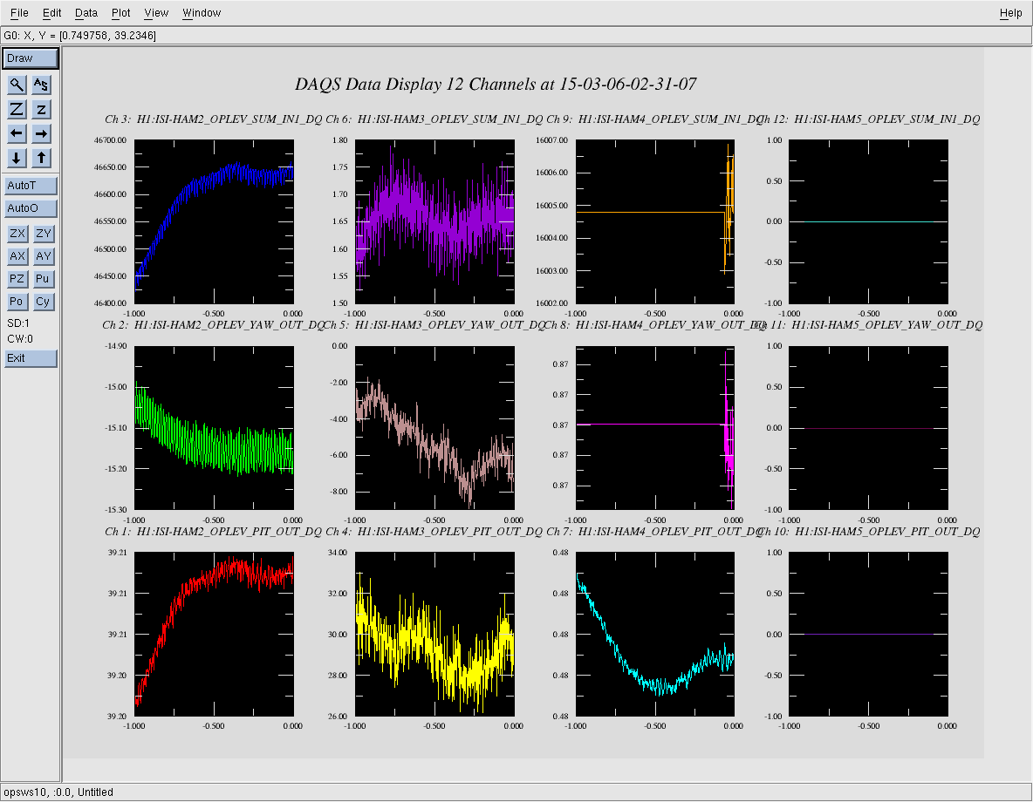
Figure 12. Typical output from dataviewer template files

The diaggui template files are located in the directory:
/opt/rtcds/userapps/release/sus/h1/scripts/oplev/dtt_templates
The specific files are:
BS_PR3_SR3_diaggui_templates.xml
ETMs_ITMs_diaggiui_templates.xml
ISI_oplev_diaggui_templates.xml
A typical output from these files is shown in Figure 13.

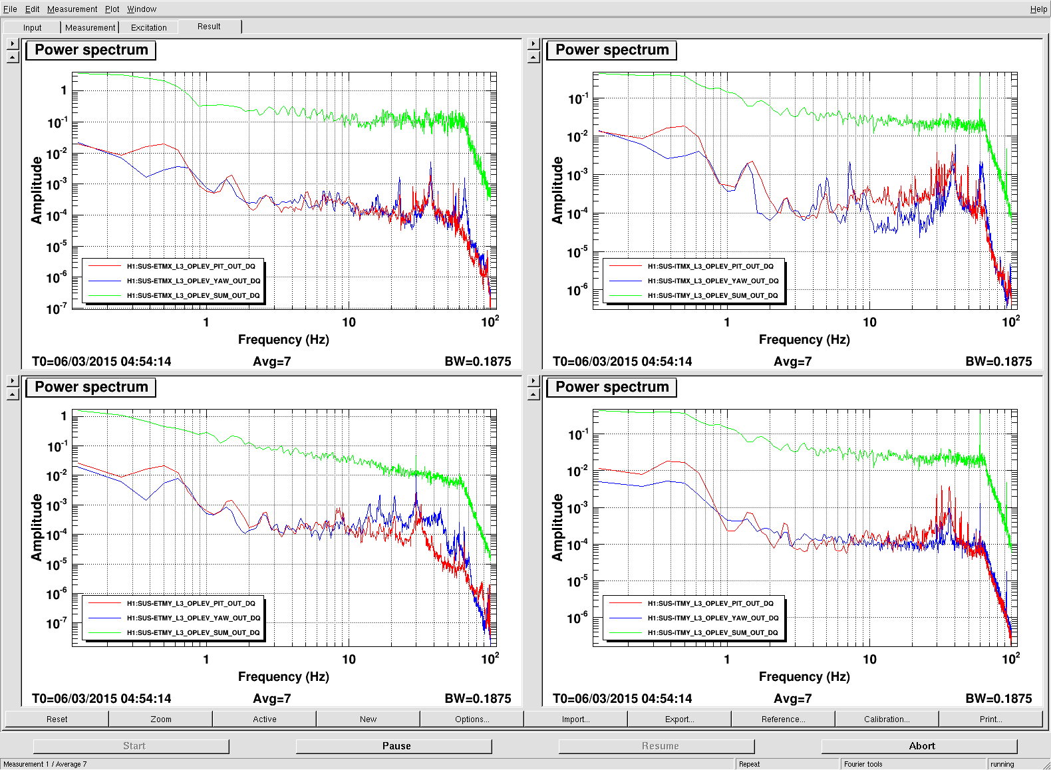
Figure 13. Typical output from a dtt template.
ASD of PIT YAW and SUM signals are shown for each oplev
Opening and running these files in diaggui will result in a measurement such as the one shown. These plots may be used to look at the noise levels of the oplev signals across the band of frequencies from 0.1 Hz to 100 Hz.
Similar files are available for L1 in the corresponding directories.

Models
The oplev simulink models are a subset of the SUS models (for those suspensions which have oplevs). The HAM-ISI oplevs signals are collected in a convenient suspension model, where there are ADC channels available and then they are sent over the reflected memory or inter-core communication pathways to the respective ISI models. A series of diagrams below show the signal pathways for various oplevs.
The oplev portion of a quad suspension model is shown below in Figure 14. Figure 15 shows the oplev portion of the BS suspension model. Figure 16 shows a portion of the IM suspension model, which picks up oplev signals for PR3 and ISI-HAM2. Figure 17 shows the signal for HAM3 and HAM4 being picked up by MC2 suspension model and then sent to over to ISI-HAM3 and ISI-HAM4 models. Figure 18 shows SRM model where the signals for ISI-HAM5 are picked up.
There is an existing ECR which aims to remove the difference between the way oplev signals are processed for SUS-oplevs vis a vis HAM-ISI oplevs: Refer to ECR No. E1400452, Integration Issue 971.

(Contd.)

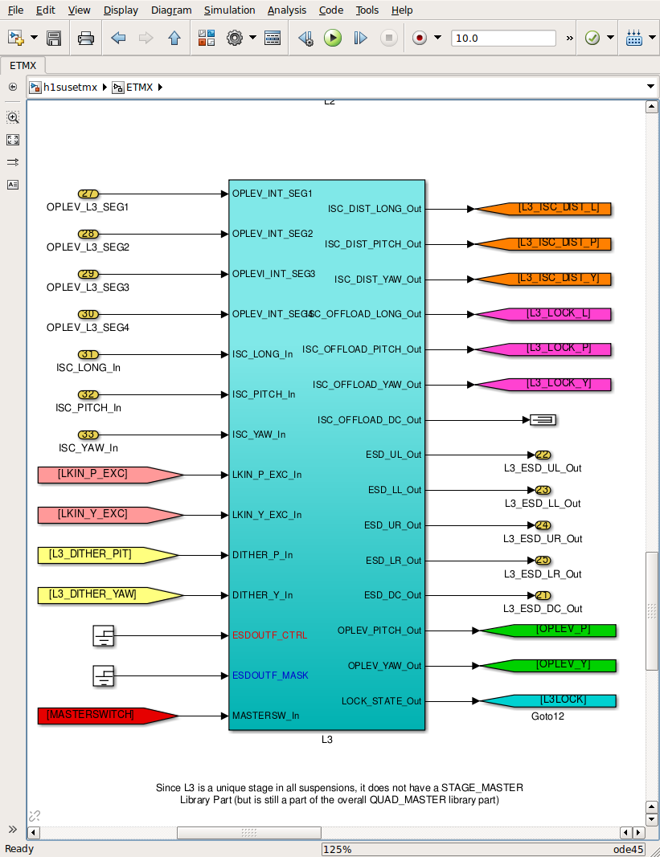
Figure 14. This shows the oplev signals inside a typical quad suspension model. ETMs and ITMs have this structure.

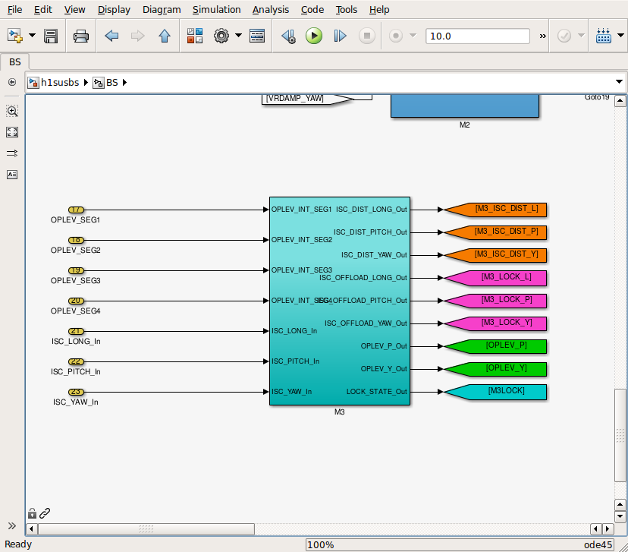
Figure 15. This shows the handling of BS oplev signals inside the BS suspension model

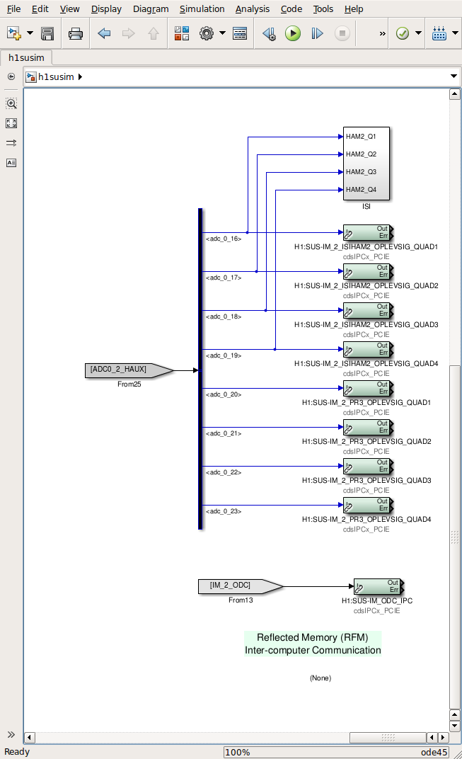
Figure 16. PR3 and HAM2 Oplev signals being collected in SUSIM model and being passed on.
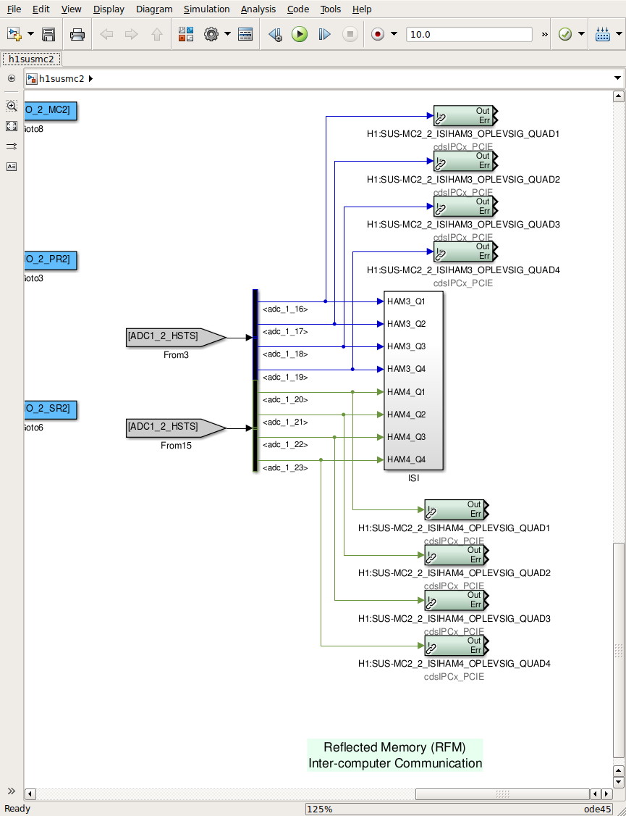
Figure 17. HAM3 and HAM4 oplev signal are picked up in this portion of MC2 suspension model

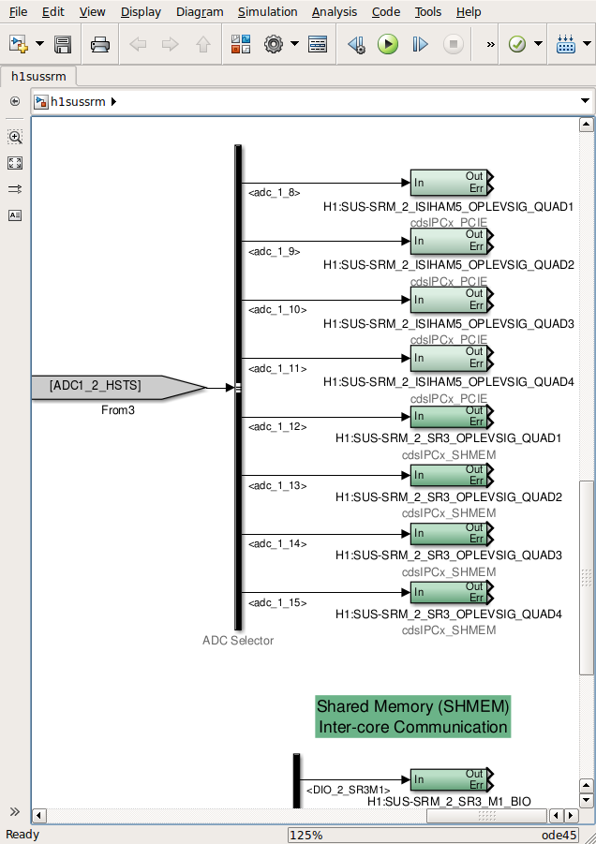
Figure 18. HAM5 oplev signals are picked up in SRM sus model.
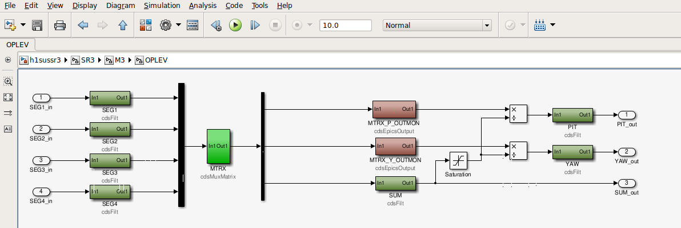
Figure 19. All these signals are typically processed in the models with a structure such as the one shown here from SR3.

Note correspondance with the medm screens. The dark green boxes on the left are input filter banks, the pale green box is the pitch, yaw, sum definition matrix, these are followed by the sum filter bank and then the normalization of PIT and YAW by the sum. To avoid division by zero there is limiter block which prevents the sum from going below zero. Then there are the output filter banks. The output of these filter banks are used for local damping in some suspensions and as position and drift monitors in others.

Troubleshooting

Sl. No. |  | Problem Behaviour | Probable causes | Action to be taken
1. |  | There are blank white fields in the indicators and menu buttons do not respond on the medm screens | - Front end model is not running  - Frame-builder is not running | - Check with CDS team and Restart the model  - Check with CDS team and Restart frame builder
2. |  | The spot is not centered on the QPD | The optic reflecting the oplev beam has moved. | - if the motion was initiated by the commissioning team and they certify that this new position is going to be the nominal position then reposition the QPD so as to center the spot. Refer to E1200037 for alignment procedure.  - If not, move the optic back to its nominal position and check to see if the spot is centered on the QPD.
3. |  | Pitch and Yaw signals show very large noise | Laser spot has completely moved off the optic and the SUM counts have fallen close to zero. | Refer to item 2 above for centering the spot on the QPD
4. |  | Pitch and Yaw signals are frozen and show no response | ADC has saturated due to too much whitening gain | Check the ADC counts on the INMON of the input filter banks. If they are above 32k, lower whitening gain such that each quadrant is less than 10k (with the spot centered on the QPD)
5. |  | Pitch or Yaw signals show strong coherence with Sum signal at all frequencies | The spot is on the edge of QPD and motion of the optic is causing clipping of the beam on the edge of the QPD | Refer to item 2 above and move the spot to the center of the QPD
6. |  | The PSD of the sum signal does not have a 1/f frequency spectrum with the RIN above 10^-5 at low frequencies | The oplev laser is glitching | Refer to T1400593 to fix the laser. Typically this just requires the laser power to be adjusted slightly in order to stop the glitching.
7. |  | PSD of Pitch and Yaw signals show large peaks above 10 Hz. | The suspended optics and HAM-ISI table-tops are quiet at frequencies above 10Hz. So any peaks we see at high frequencies are due to pier motion or fiber motion | Check the pier grouting or any other device in contact with the pier which might be shaking it. Check the fiber path to make sure it is not in contact with any device which might be causing it to vibrate.
8. |  | The SUM signal is not close to 40k counts | - spot has moved off the QPD or  - Laser has been switched off or has died  - Laser power has been reduced by turning the power knob | - refer to item 2 above and restore the spot to the center of the QPD  - Switch on the laser and then refer to T1400593 to choose a glitch free laser power level. Then adjust the whitening gain to set the INMON counts in the Input filter banks to 10k on each quadrant.  - Turn the power knob on the laser to obtain a glitch free performance. Refer to T1400593 for the procedure. Then follow step b. above
 | 9. | PIT or YAW outputs show angular motion which is not equal to that indicated by optic witness channels (osem signals) | - The calibration factors are not correct. | - The calibration factors are found in the GAIN field of the output filter banks of PIT and YAW signals. Refer to LHO alogs 1400321 and 1400312 for relevant calibration procedures

Related documents
T1000625 CDS Software Documentation

T1400593 Optical Lever Fermion II Internal Optimization Procedure
E1200037 Optical levers alignment procedure
E1300964 Optical lever telescope assembly procedure

