Ligo_Logo

|  |  |
| --- | --- |
| Date: | November 18, 2014 |
| Refer to: | **LIGO-T1400723-v1** |

From: M. Zucker

To: VRB

cc: H. Overmier, K. Ryan, J. Giaime, R. Oram, A. Lazzarini, D. Reitze

Re: **LLO Y beamtube leak & outgassing rates**

**Abstract:** The LLO Y beamtube was sealed from 12 to 17 November, 2014 by closing GV9 and GV4. An RGA at the tube midpoint recorded the time evolution of principal gas species. The residual air leak rate is now found to be *QN2* = 8.3x10-9 Tl/s, about 1/5,000 the rate before GV7 was encapsulated on 13 October. This rate is comparable to those observed on the LLO X arm[[1]](#footnote-1) and at LHO[[2]](#footnote-2). It is not expected to impact aLIGO observations.

The apparent water vapor desorption rate also appears smaller than previously estimated, suggesting the previous epoch of air leakage may have caused less lasting damage than initially feared.

**Method:** The beamtube was sealed at both ends (GV4 and GV9 closed). 95 hours of data were analyzed, starting 1 hour after the gate valves were sealed. We monitored the tube midpoint with the Pfeiffer QMA220 mass spectrometer in multiple-ion detection mode at 2, 14, 18, 28 and 40 AMU, sequencing with a cycle period of approximately 14 seconds. All channels were recorded by Faraday cup with a fixed amplifier range of 0.1 nA full-scale. The empty channel at 5 AMU was also monitored and used to correct each datum for preamplifier offset. Ion source emission was 1.65 mA (nominal optimum). The small ion pump which normally maintains the RGA tree was turned off for this test.

Total pressure was recorded by 8 inverted magnetron cold cathode gauges, distributed along the tube's length. Four of these misbehaved or suffered data dropouts. The remaining four (PT990, PT753, PT984 and PT624) were averaged to estimate the mean pressure. Taken with the sum of RGA ion currents, this indicated RGA calibration factor *<Pcc/Isum> =* 900 Torr/ampere (air-equivalent).

Tube wall temperatures were recorded by six thermocouples, two of which also suffered data dropouts. The remaining four (at Y1-7, Y2-1, Y2-4 and Y2-7) tracked closely. Their mean varied from 7.5C to 20.2C, and averaged 14.2C over the test duration. Despite the variation, temperature effects did not appreciably affect fit parameters and were therefore disregarded.

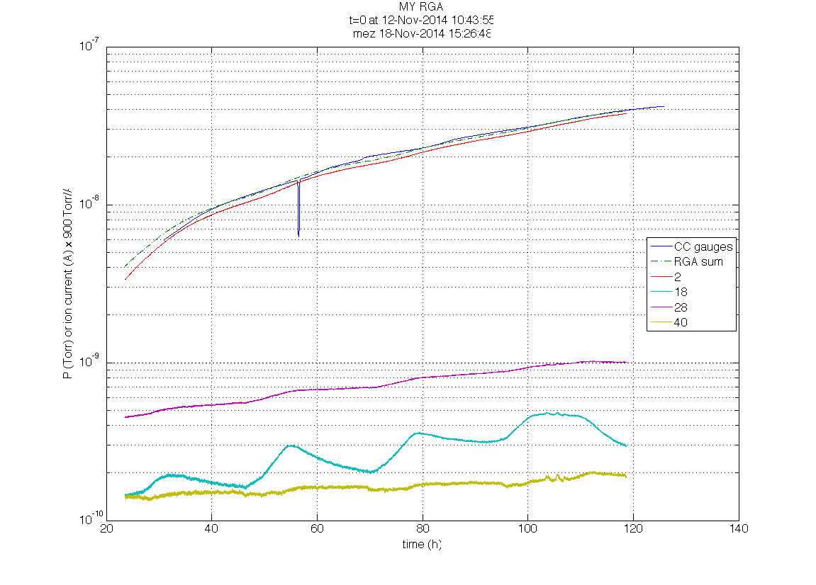

Figure : Ion currents for main species plotted with mean of cold cathode gauges, using approximate RGA calibration *<Pcc/Isum> ~* 900 Torr/ampere. (Glitch at 57 hours was a framebuilder reboot).

**Results:** Rates of change for each species are shown in Figure 2 and Table 1.

*Residual air:* The measured nitrogen flux corresponds to 8.3x10-9 Tl/s, about 1/5000 the measured rate before the GV7 repair. This is (barely) consistent with the original beamtube leak specification (although it exceeds the "goal"). In any case this level will not bother aLIGO.

The residual leak rate is about a decade too small for detection and localization, given our current state of the art; however it would be instructive to locally retest the two weld leaks already identified and repaired, using the boosted He MSLD apparatus.

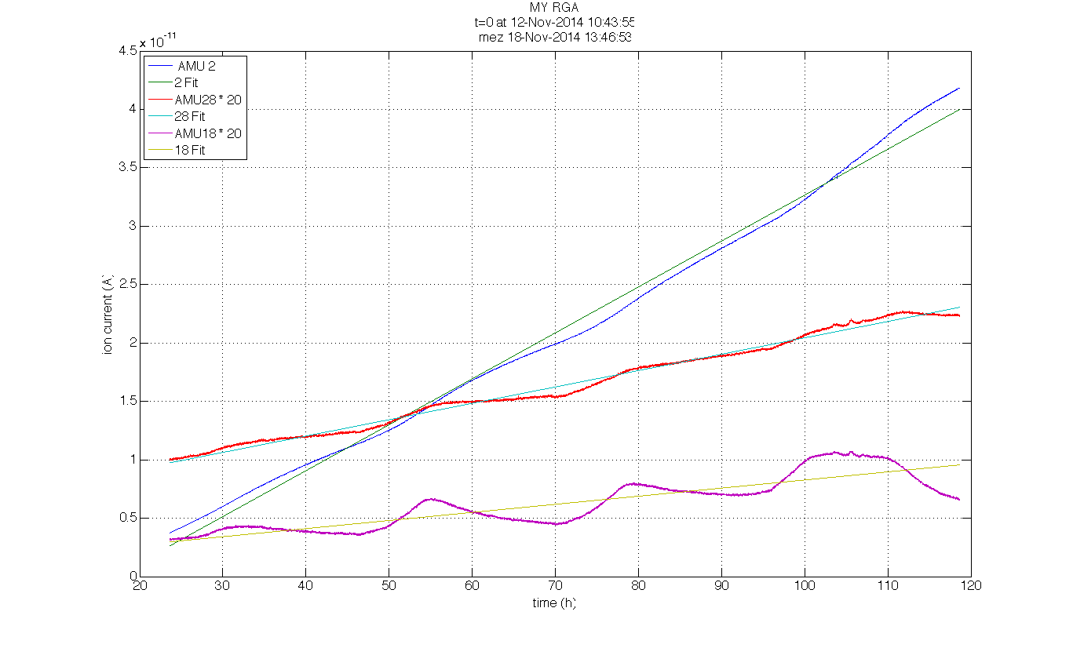

Figure : Hydrogen, nitrogen and water vapor ion currents with linear fits. Water and nitrogen have been scaled up by a factor of 20 for visibility.

|  |  |  |  |
| --- | --- | --- | --- |
| *Species* | *Mean*  *(10-8 Torr)* | *Slope*  *(10-7 Tl/s)* | *Fit r2* |
| N2 | .074 | + .084 | 0.99 |
| H2 | 1.92 | + 4.69 \* | 0.99 |
| H2O | .028 | + .041 \* | 0.78 |
| Σ (2,18,28,40) | 2.03 | + 4.82 \* | 0.99 |
| cold cathodes | 2.32 | + 5.03 | 0.99 |

Table : Fitted residual gas flux during passive accumulation, using calibration of 900 Torr/ampere. The mean tube wall temperature was 14.2 C over the test duration. (\* = air-equivalent ionization).

*Hydrogen:* After correcting for hydrogen's reduced ionization cross-section with respect to air (typically quoted as a factor of 2.4), the implied tube wall desorption flux is

<*JH2*> = 7.3 x 10-15 Tl/s/cm2 @ 14.2 C

According to Weiss[[3]](#footnote-3), the original H2 desorption measured after bakeout (averaged between Y1 and Y2, and corrected to 14.2 C) was about 1.0 x 10-14 Tl/s/cm2.

*Water vapor:* Similarly, we can take the rate of rise at 18 AMU as a rough indicator of the water desorption rate. The water acquired from atmpospheric leaks could remain spatially concentrated near the entry points (which are close to our sampling point, the tube midstation). However, if we instead presume it is uniformly distributed we find

<*JH2O*> = 2.4 x 10-17 Tl/s/cm2 @ 14.2 C

This appears within the range initially deemed acceptable for the tubes, suggesting that we did *not* lose too much ground to re-deposition of water during the period of heavy leakage from 2008 through 2012. Indeed, the steady-state water partial pressure at the midpoint prior to the test (while end-pumped) only exceeded our ultimate water vapor goal of 10-10 Torr by a factor of 1.5.

1. [T1301007](https://dcc.ligo.org/LIGO-T1301007) [↑](#footnote-ref-1)
2. [T1400243](https://dcc.ligo.org/LIGO-T1400243), [T1400285](https://dcc.ligo.org/LIGO-T1400285), [T1400439](https://dcc.ligo.org/LIGO-T1400439), [↑](#footnote-ref-2)
3. [LIGO-G1300116](https://dcc.ligo.org/LIGO-G1300116), p.43. Note that the H2 figure cited for Livingston Y2 is missing a decimal point. The correct value is 2.6 x 10-14 Tl/s/cm2. [↑](#footnote-ref-3)