*LIGO Laboratory / LIGO Scientific Collaboration*

LIGO-T1400733-v1 *Advanced LIGO* November 30, 2014



Tidal Controls in Advanced LIGO



Daniel Sigg

Distribution of this document:

LIGO Scientific Collaboration

This is an internal working note of the LIGO Laboratory.

|  |  |
| --- | --- |
| **California Institute of Technology**  **LIGO Project – MS 18-34**  **1200 E. California Blvd.**  **Pasadena, CA 91125**  Phone (626) 395-2129  Fax (626) 304-9834  E-mail: info@ligo.caltech.edu | **Massachusetts Institute of Technology**  **LIGO Project – NW22-295**  **185 Albany St**  **Cambridge, MA 02139**  Phone (617) 253-4824  Fax (617) 253-7014  E-mail: info@ligo.mit.edu |
| **LIGO Hanford Observatory**  **P.O. Box 159**  **Richland WA 99352**  Phone 509-372-8106  Fax 509-372-8137 | **LIGO Livingston Observatory**  **P.O. Box 940**  **Livingston, LA 70754**  Phone 225-686-3100  Fax 225-686-7189 |

http://www.ligo.caltech.edu/

# Rational

Tidal controls are somewhat separated from the main interferometer length controls due their very low bandwidth. In Advanced LIGO the tidal actuator is provided by the seismic isolation system of the two end test masses. The HEPI system has a range of roughly a millimeter and a maximum bandwidth around 10 mHz (due to the lower cut-off of the ISI blend filter). The ISI system also has a range of roughly a millimeter and a useful bandwidth of maybe 100–200 mHz.(to stay below the suspension resonances). The two top stages of the quadruple suspension system, M0 and L1, both have ranges in the 10s of µm and a bandwidth of about 1 Hz. We propose to use a combination of SUS L1 and HEPI to provide a tidal actuator which has a low settling time—with the actual controls located in the ISC end station system.

# Requirements

## Tidal Actuator

The requirements for the tidal actuator are as follows:

|  |  |  |
| --- | --- | --- |
| Tidal actuator range | ±700 | µm |
| Settling time | <2 | s |
| Location | ETMX/ETMY |  |
| Bandwidth of HEPI feedback path | ~0.01 | Hz |
| Bandwidth of SUS feedback path | ~0.2 | Hz |

The tidal actuator is configured hierarchically with the SUS controls signal serving as the error signal for the HEPI path. The SUS controls signal is typically added to the L1 and L3 drive stages of the ETM suspensions. The L3 drive (ESD) is used for the differential arm cavity signal and has a high bandwidth. The L3 drive is off-loaded to the L1 drive at low frequencies to extend the range. A separate low bandwidth L1 drive input, which is independent of the L1/L3 off-loading hierarchy, is also added to the L1 drive stage. This slow path is used for both the local slow feedback and the common mode tidal signal which is derived from the laser frequency offset (MC-F).

The total L1 drive signal then serves as the input to the tidal off-loading to the HEPI path. Alternatively, the off-loading of the L1 drive could either be done to the M0 stage or the SEI system, if the HEPI system is locked.

## Error Signals

The following signals are used for tidal feedback:

|  |  |  |
| --- | --- | --- |
| Mode cleaner fast controls (MC-F/CARM) | common | Full interferometer |
| Differential length controls signal (DARM) | differential | Full interferometer/ALS |
| Green PDH (ALS REFL-SLOW) | individual | ALS |

ISC End Real-time

HEPI

L

SUS

ISC L

ESD

L1

DARM

HEPI

SUS

Integrator

MC-F

Slow

ISC End EtherCAT

States

Controls Topology

Arm

SUS

Comm

Arm

Integrator

Green PDH

SFM

SFM

SFM

# Controls Topology

## Green Arm Locking

The arm stabilization system locks a 532 nm laser to each arm cavity. The transmitted green light is then used to derive independent differential and common arm cavity length signals. To robustly and rapidly hand-off to the main 1064 nm laser it is convenient to run the end station laser at a fixed offset relative to the main laser. However, initial length lock offsets and tidal motion requires adjustment of the arm length. This is done in two steps: First, the slow controls output of the common mode board used for green cavity locking is send to the tidal actuator. Secondly, the offset of the VCO which is used to offset the 532 nm laser from the main laser can be adjusted to exact frequency using a servo of lower bandwidth with the frequency counter as an error signal.

## ALS Transition Phase

During the transition of the arm cavities from the ALS signals to the main laser the slow controls feedback path from each individual arm cavity is set to hold its output at its last value and the VCO servo is turned off. Once the DARM signal is feedback to the ETM suspensions it will automatically appear as an L1 controls signal which is then bled off to HEPI. The common mode signal is treated slightly differently by using the main laser to follow the common length of the arm cavities.

## Full Interferometer Locking

Once the interferometer is fully locked to main laser and the arm cavity power has built-up to its maximum value, the common mode signal of the interferometer is split into a fast path which feeds back to the additive offset of the mode cleaner board and a slow path which feeds through the digital LSC system to the mode cleaner length (MC-L). For this to work the slow path of the mode cleaner has to be turned off. The fast path of the mode cleaner is fed back to the laser frequency using the VCO which controls the AOM into the reference cavity. For the common tidal feedback path the fast controls signal of the mode cleaner (MC-F) is used as an error signal into the common path of the tidal servo. The common path is added to the Green PDH slow path, before it is sent to the ETM suspension.

# State Machine

The state machine for the tidal controls resides in the end station EtherCAT and real-time systems of the ISC. The Arm Locking guardian is responsible to select the required tidal feedback path. Its states are extended to include arm locked, arm locked with slow feedback, transition and red locked. The guardian then requests a corresponding state from the ALS state machine residing in the corner EtherCAT system. In turn, this request is forwarded to each arm cavity auto-locker which resides in the end station EtherCAT system. The end station auto-locker will send a tidal request to the end station real-time system, depending on the state of the arm locking.

The end station real-time system sends the state of the slow feedback path back to the auto-locker. Only when the slow path is engaged and running and only when the frequency servo bit is set, will the auto-locker turn on the VCO servo which keeps the VCO near its nominal frequency.

## Arm Cavity States

The ALS auto-locker for each arm cavity has the following states:

|  |  |
| --- | --- |
| Invalid | Part of the ALS auto locker |
| Disable | Part of the ALS auto locker |
| Unlocked | Part of the ALS auto locker |
| PLL Locked | Part of the ALS auto locker |
| End Locked | Highest state of the ALS auto locker Tidal is disengaged |
| Slow Engaged | Tidal is engaged  ALS slow controls signal is used for tidal feedback VCO servo is on when frequency servo bit is enabled |
| Transition | Tidal is engaged  Holds the ALS slow controls output at the last value |
| Red Lock | Tidal is engaged |

The Invalid, Disable, Unlocked and PLL Locked states are summarized as Unlocked for the real-time system. The ALS auto locker controls the transitions up to End Locked. Once the system has reached the End Locked state, any of the other states can be selected directly through the ALS state machine and the guardian. If the system falls out of lock, the ALS system will relock automatically and return to the requested state.

## Tidal States

The tidal servo in the real-time system has the following states:

|  |  |  |
| --- | --- | --- |
| Unlocked | 0 | Tidal feedback is off HEPI integrator is bled off slowly ALS slow controls integrator is bled off slowly COMM path integrator is bled off slowly |
| End Locked | 1 | Tidal feedback is off HEPI integrator is holding ALS slow controls integrator is holding COMM path integrator is holding |
| Slow Engaged | 2 | Tidal feedback is on HEPI integrator is running and reliefs the SUS L1 controls signal ALS slow controls signal is fed to the suspension L1 drive COMM path integrator is holding |
| Transition | 3 | HEPI integrator is running and reliefs the SUS L1 controls signal ALS slow controls integrator is holding at its last value COMM path integrator is running and fed to the suspension L1 drive DARM can be sent to the suspensions L3 (EDS) drive |
| Red Lock | 4 | HEPI integrator is running and reliefs the SUS L1 controls signal ALS slow controls integrator is holding at its last value COMM path integrator is running and fed to the suspension L1 drive DARM is sent to the suspensions L3 (EDS) drive State does not reset when ALS unlocks as long as the red transmission is above threshold |

When the system is on Red Lock, the green cavity can lose lock without any consequences on the tidal feedback. If needed, the green beam can be shuttered off. However, if the interferometer loses lock and red transmitted light falls below threshold, the tidal system falls back to the Transition state. If the green isn’t locked neither when this happens, the tidal system will immediately fall back to the Unlocked state. Since the interferometer needs to be relocked, the guardian will probably request Slow Engaged next.

## Filters and Switching

### TIDAL_ERR Filter (HEPI path)

This is a standard filter module which is always on. Its input is the total L1 signal from the ETM suspension. It is used to calibrate the L1 signal in µm.

### TIDAL_CTRL Integrator (HEPI path)

The integrator driving the HEPI length signal has two controls inputs: an enable switch and a bleed switch. When the filter is enabled, the filter is on and integrating the input. When it is disabled, the filter output is on hold and the input is ignored. The bleed switch can be turned on when the filter is disabled. If it is on, it will reduce the integrator output at a fixed rate which can be configured.

### TIDAL Calibration Factor (HEPI path)

The tidal integrator is followed by a fixed gain of 1000 to account for the fact that HEPI expect nm rather than µm.

### ARM_ERR Filter (arm cavity path)

This is a standard filter module which is always on. Its input is the ALS-X/Y_REFL_SLOW signal. It is used to calibrate the REFL_SLOW signal in µm. The REFL_SLOW signal is typically already calibrated in kHz of the green laser frequency.

### ARM_CTRL Integrator (arm cavity path)

The slow controls integrator follows the slow controls filter. The switch logic is the same as for the tidal integrator.

### COMM_ERR Filter (common length path)

This is a standard filter module which is always on. Its input is the IMC-MC_F signal. It is used to calibrate the signal in µm. The IMC-MC_F signal is typically already calibrated in kHz of the red laser frequency.

### COMM_CTRL Integrator (common length path)

The common length integrator follows the common length filter. The switch logic is the same as for the tidal integrator.

### ARM_DRIVE Filter (arm cavity and common length path)

This is a standard filter module which is always on. Its input is the sum of the outputs of the arm cavity integrator and the common length integrator. Its output is sent to the L1 stage of the ETM where it is summed to the off-loaded component from the L1 stage. It is used to “un-calibrate” the signal from µm into L1 units. It can also be used to invert the L1 transfer function.

# Human Interface

The medm screen for the tidal servos is shown below:

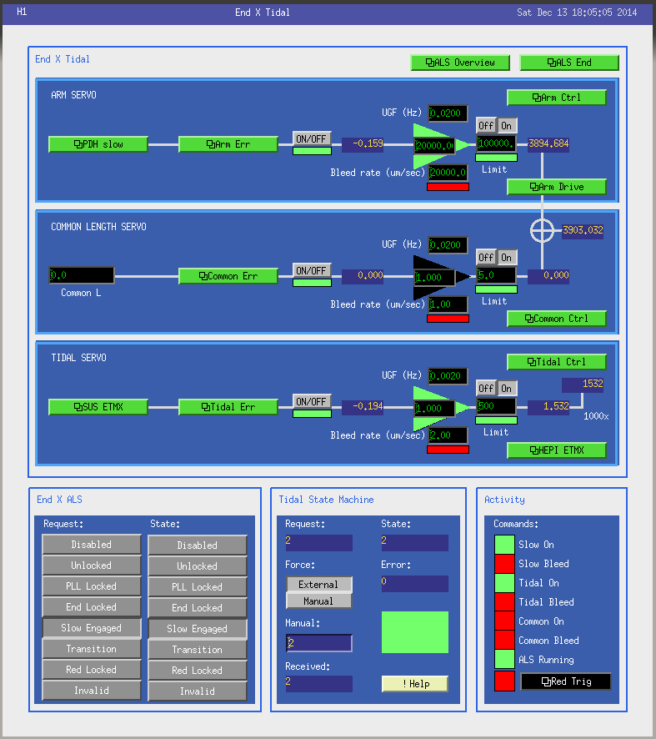

The states of the tidal system can be determined through the EtherCAT system (“External” setting) or locally (“Manual” setting). The error messages are explained by clicking on the “green” square. At the bottom right the currently active tidal commands are listed. It also contains a link to the trigger screen for the red transmission power.

# Integrator Filter Module

The Integrator Filter Module (IFM) implements a single integrator only, but has a couple of additional features compared to a standard filter module:

* The digital filter uses direct form type I representation with the old output as the filter history value.
* The output limiter is enforced both on the output itself as well as on the history value. This prevents the run-away integrator.
* The integrator has a bleed-off feature. When the bleed is engaged, the filter output ramps towards zero at a specified rate.
* An optional bias value can be added to the filter output. This makes it easy to support a PZT offset, for example.
* Most other features of the standard filter module, such as hold, test outputs, etc. are available as well.
* Turning the integration off will reset its history to the input value. No ramp feature at the moment.

The medm screen for the IFM is as follows:

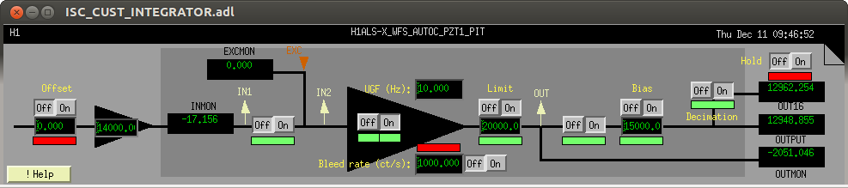

The available parameters are

* Input offset with separate enable switch.
* Input gain.
* On/off switch.
* Filter on/off switch.
* Unity gain frequency (must be non-negative).
* Bleed rate (must be non-negative) with separate enable switch.
* Limiter value (must be non-negative) with separate enable switch.
* Output on/off switch.
* Output bias with separate enable switch.
* Output hold switch.
* Decimation switch for OUT16 channel.

The testpoint and EPICS channel names are the same as in the standard filter module:

* IN1/INMON: before the input on/off switch.
* EXC: added after the input on/off switch.
* IN2: after the excitation is added.
* OUT/OUTMON: after the limiter, but before the output on/off switch and bias.
* OUTPUT: at the output of the module.
* OUT16: same as OUTPUT but with an optional 8Hz decimation filter.