*LIGO Laboratory / LIGO Scientific Collaboration*

LIGO-T1500016-v2 *LIGO* January 22, 2015

*Design overview for the new test mass electro-static driver*

P. Fritschel, R. Abbott

Distribution of this document:

LIGO Scientific Collaboration

This is an internal working note

of the LIGO Laboratory.

|  |  |
| --- | --- |
| **California Institute of Technology**  **LIGO Project** | **Massachusetts Institute of Technology**  **LIGO Project** |
| **LIGO Hanford Observatory** | **LIGO Livingston Observatory** |

http://www.ligo.caltech.edu/

# Introduction

This document contains the requirements and other input that went into the design of the low-noise, low-voltage electro-static (ES) driver for the end test masses. The input test masses will be covered separately. The only potential use for the ITM ES actuators (known at this time, at least) is for active damping of parametric instabilities. For that function, we expect to require a high-voltage driver for the ITMs, given their much smaller actuation coefficient.

# Requirements for ETM ES driver

* The existing high-voltage (HV) ES drivers will continue to be needed and used on both ETMs for lock acquisition. The new LV driver will need to accommodate this function; i.e., switching between the HV and LV drivers needs to be incorporated.
* *Switching requirements*. Switching between HV and LV driver paths should be independently selectable for each electrode quadrant. Low-pass filtering in the signal paths should be switchable, independently for each channel. Given that the DARM feedback can be applied to a single ETM, switching between HV and LV driver paths can be done on a given ETM when it is not being used for feedback. Thus switching transients do not need to be considered.
* *Bias.* The bias channel will always be supplied by the existing HV driver. The bias is controllable from -400 V to +400 V, and is low-pass filtered.
* *Noise.* The output voltage noise must satisfy the requirements given in [LIGO-T1500001](https://dcc.ligo.org/LIGO-T1500001). This includes the noise from the DAC (General Standards, 18-bit), which should be modeled using the results given in [LIGO-G1401399](https://dcc.ligo.org/LIGO-G1401399).
* *Acoustic mode damping.* To enable active damping of parametric instabilities, each quadrant must have an input for damping signals in the frequency band 10-100 kHz. The maximum force required for PI damping is estimated to be ~100 nN-pk for a single quadrant (for the ETM-ERM gap); see [LIGO-T1500019](https://dcc.ligo.org/LIGO-T1500019) for details. For 400 V bias, this corresponds to 5 V-pk. The PI damping path range should thus be at least this large.
* *Range, signal path.* The output range for the signal path (DARM feedback) should be at least 40 V pk-pk below 1 Hz, for each quadrant. See section 3 for details.

# Range

For the required drive range for DARM feedback, we look at L1 data. Log entry [14428](https://alog.ligo-la.caltech.edu/aLOG/index.php?callRep=14428) describes work on reducing the ES drive amplitude. Initially the ES drive was dominated by microseism signal; with special filtering, the range was reduced by a factor of 10.

1000 counts = 3 V

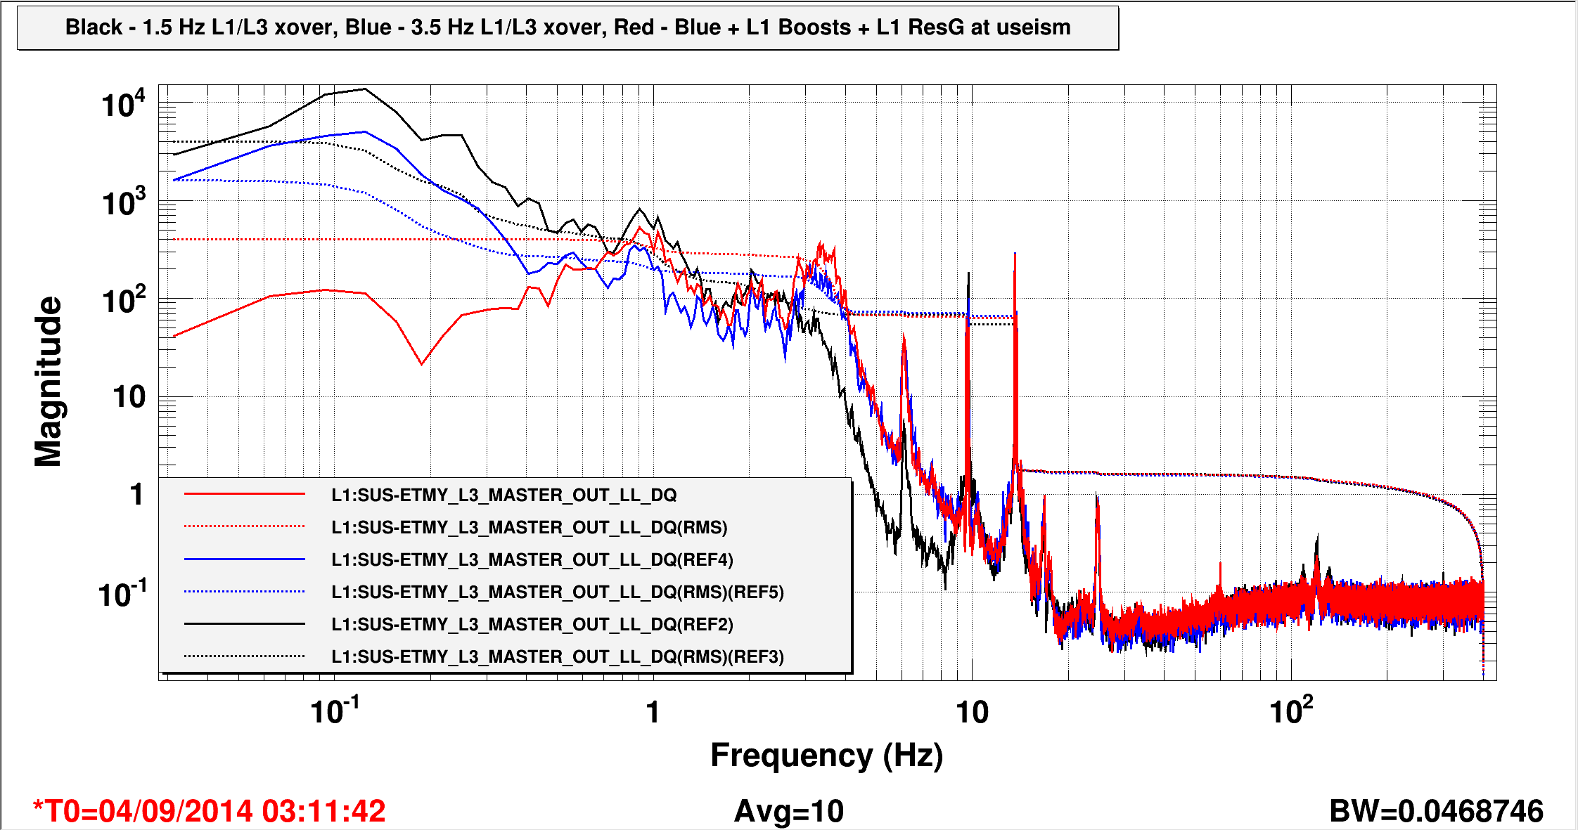

Figure 1. Data from LLO log entry 14428, showing the reduction in the rms ES drive (DAC output) by (1st) increasing the L1-L3 crossover frequency, and (2nd) by adding low frequency gain to the L1 stage. More typically, the microseism resonant gain filter is not engaged to give more margin around the crossover, and the rms DAC output is about 1000 counts. The bias voltage for these measurements was 550 V (400 V on the bias electrode, -150 V DC on each signal electrode), and DARM feedback was going to ETMY only.

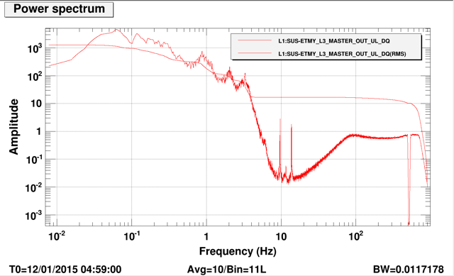

**Figure 2.** ES drive signals from L1, January 12, 2015: signal sent to the 18-bit DAC. DARM feedback is sent only to ETMY, and the effective bias is 550 V. There is a 1 Hz low-pass filter in all the output channels of the ES driver. Top: Spectrum showing an rms of about 1200 counts, or a DAC voltage of 3.5 V-rms. Bottom: Time series showing a maximum excursion of 12,000 counts, or 35 V p-p.

With the new ES driver, we will be feeding back to both ETMs, reducing the required force per ETM by a factor of 2. On the other hand the bias will be at most 400 V, which reduces the force by a factor of (550/400) = 1.37. So the above 35 Vpp of drive would turn into 24 Vpp.

There should be some room to reduce the drive range with additional filtering, as shown in the black curve of Figure 1. On the other hand we would also like the option of reducing the bias voltage. We therefore set the range requirement at 40 V pk-pk, for frequencies below 1 Hz.