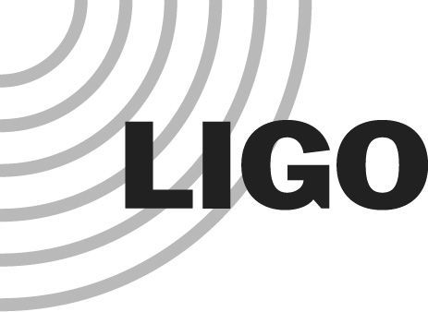
LIGO LABORATORY

Subject | Final Design Review (FDR) charge:  End Reaction Mass (ERM) with a central hole
To | Final Design Review (FDR) committee:
Eric Gustafson
Mike Landry (chair)
Brian O’Reilly
Hiro Yamamoto
cc | omt@sympa.ligo.org  Mike Zucker, GariLynn Billingsley, Norna Robertson, Calum Torrie
From | Dennis Coyne
Refer to | L1500094-v1
Date | 9 June 2015

Background
During the aLIGO design effort, the separation between the End Test Mass (ETM) and the End Reaction Mass (ERM) was set (at 5 mm) without taking proper account of the damping due to residual gas partially confined in the narrow gap (“squeezed-film damping”). More recent analysis of this effect shows that the damping will increase the suspension thermal noise to an unacceptable level; the noise is estimated to be just less than quantum radiation pressure noise at full power, depending on the final gas pressure in the chambers. In light of recent LIGO observatory vacuum challenges, the need to replace the ERM with a design which mitigates the squeezing-film damping is more pressing. Our intent is to replace the current ERM (a right circular cylinder) with a new ERM with a central hole (a torus with rectangular cross-section) to relieve the gas and yet still maintain a narrow gap for high Electro-Static Drive (ESD) actuation authority. The baseline design philosophy and requirements is that the revised ERM has the same interfaces as the current ERM.

FDR Charge
The design review may well be a protracted effort requiring several meetings over the coming months. This is likely to be a 3-step review process covering requirements and design:
- In the near term we need a review to approve the request for quote (RFQ) on the fabrication of the ERM and its coating. We plan to proceed with the RFQ in parallel with any unresolved (but not critical) technical issues (such as concern for ambient magnetic field coupling to the ERM substrate, scattered light from the central hole and its bevel, etc.)
- Once quotes have been received, we'll need a rapid technical review to consider the quotes, as well as those technical issues which have been addressed in the interim. This review will be the basis for recommending to proceed as the basis for submitting a Change Request (CR) for the CCB to allocate upgrade funds.
- Possibly a third step to review and resolve any remaining issues, i.e. a truly "final" review.

The ERM effort is on a fast-track due to the commissioning team's desire to be able to replace the current ERMs shortly after the end of O1. GariLynn Billingsley will be the principal presenter of the revised ERM design.

The FDR committee is requested to answer the following questions in a written report with their recommendations (at each of the three steps in the review, as noted above):
- Are the requirements for the ERM well established, complete and reasonable?
- Should the ERM be required to have a conductive coating to dissipate electrostatic charge?
- Is the redesigned ERM consistent with the existing interface requirements to the quadruple pendulum? If not are there any compelling reasons to consider a different interface to the quadruple pendulum suspension?
- Is the proposed ERM design a good approach to achieving the requirements?
- Are there any optical scattering concerns related to the proposed ERM design, especially related to the bevel and surface of the central hole?
- Is the proposed leaded glass material compatible with the LIGO ultra-high vacuum (UHV) system requirements?
- Does the coupling of the proposed leaded glass material to ambient magnetic field fluctuations cause motion beyond required levels?
- Does the change in moments of inertia of the ERM have a negative impact on the quadruple pendulum suspension?
- Are there any other technical issues associated with the requirements or the design?

Please convene as soon as documentation is made available by GariLynn Billingsley.

