LIGO HANFORD OBSERVATORY
PO BOX 159
RICHLAND WA 99352

TEL: 509.372.8106
FAX: 509.372.8137

MEMORANDUM

DATE: August 26, 2015

TO: | ISC team
FROM: | Daniel Sigg, Koji Arai
SUBJECT: | EOM/AOM Diver Modifications
Refer to: | LIGO-E1500353-v1

This modifications apply to D0900761-B, D0900847-B, D0900848-C and D1000216-B to bring them to revisions C, C, D and C, respectively.

The affected serial numbers are S1500117 to S1500128.

Power Board D0900848-C
Change 1:
Capacitors need to be added to prevent the AD829 driving the pass transistor from oscillating.

C20, C35, C36, C37, C50, C51, C52, and C63 → 1nF
C91 → add a 100pF between U6 op27 (PIN6) and VREFP (PIN7)
should fit between the pads of C22 and R32
W1 → remove solder jumper

Change 2:
Remove the protection diodes which are no longer needed with the use of the power sequencing relays

D1, D2, D3, D4 → remove

Change 3:
Fix the gain in the differential output stages.

R66, R68 → 5.49K, shift and use only the pad above R70 and R74
J1, J2 → add a jumper wire from the free end to ground (see pic)

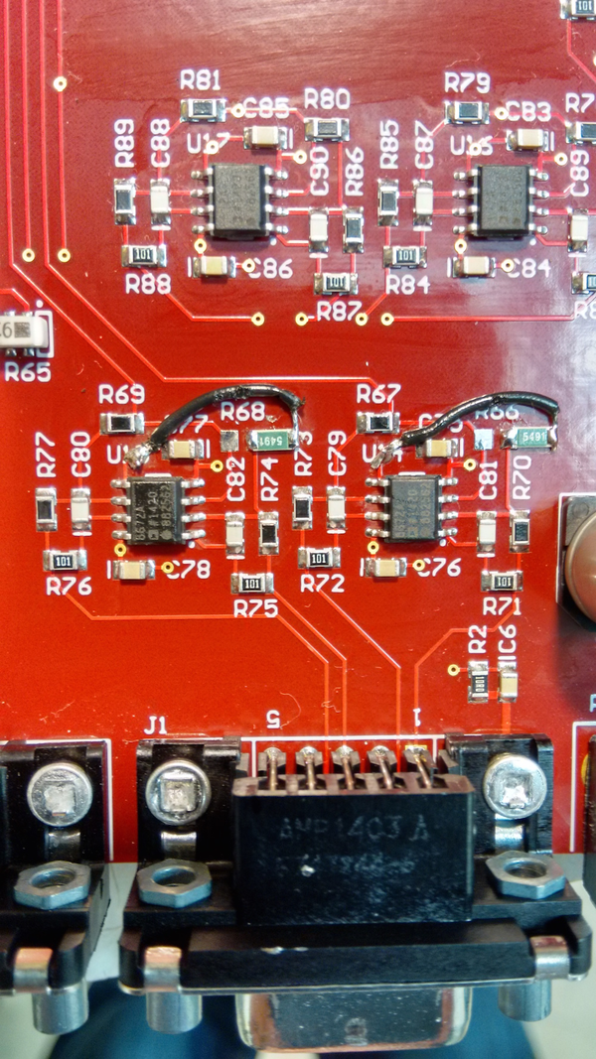
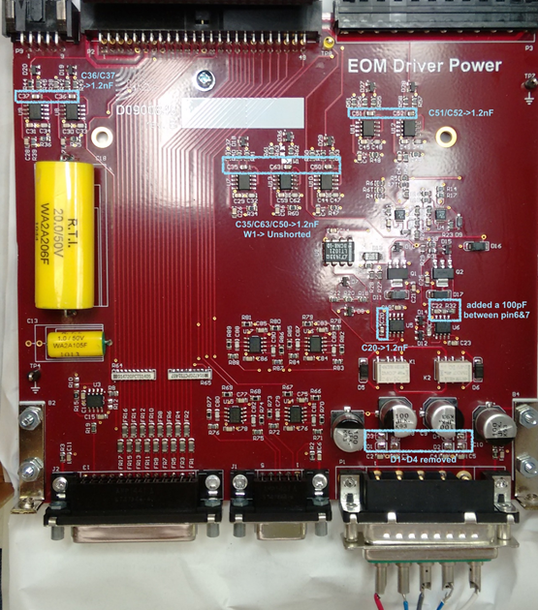
Servo Board D0900847-B

Change 1:
Reduce the high frequency gain of the servo to allow for better phase margin.

R69 → 200
C49 → 1nF
R71 → 3.3K
R67 → 3.3K

Change 2:
Add capacitor at the output drive to ground to reduce the backfeed of RF from the attenuator board.

C58 → 1nF, add between signal and ground pin of SMA connector J5

Attenuator Board D1000216-B

Change 1:
Add capacitor at the control input to ground to reduce the backfeed of RF to the servo board.

C2 → 1nF, add between signal and ground pin of SMA connector J3

Controller Board D0900761-B
No change.

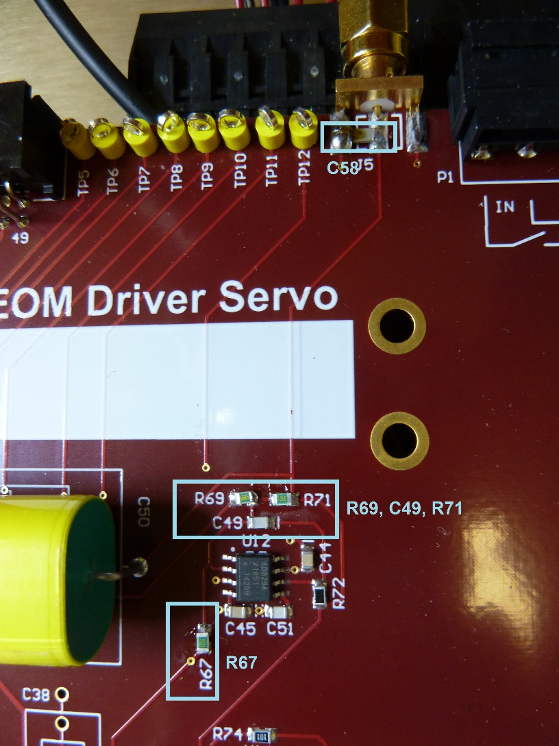
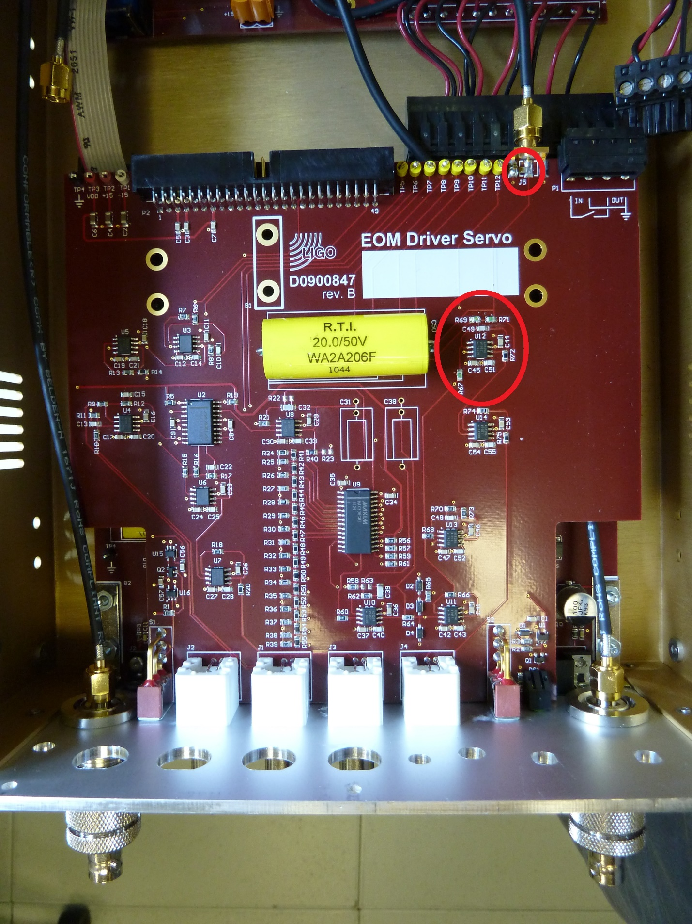
BOM (for 12 units):
Qty | Item | Distributor | Description
108 | 311-1122-1-ND | Digi-Key | 1nF, 0805, NPO  Power board: C20, C35, C36, C37, C50, C51, C52, and C63  Servo board: C49
12 | 311-1111-1-ND | Digi-Key | 100pF, 0805, NPO  Power board: C91
24 | P5.49KDACT-ND | Digi-Key | 5.49K, 0805, 0.1%  Power board: R66, R68
12 | P200DACT-ND | Digi-Key | 200, 0805, 0.1%  Servo board: R69
24 | P3.3KDACT-ND | Digi-Key | 3.3K, 0805, 0.1%  Servo board: R67, R71
24 | 478-1492-1-ND | Digi-Key | 1nF, 1206, NPO  Servo board:C58  Attenuator board: C2
1 | 6710 BK005-ND | Digi-Key | Hook-up wire

