LIGO HANFORD OBSERVATORY
PO BOX 159
RICHLAND WA 99352

TEL: 509.372.8106
FAX: 509.372.8137

MEMORANDUM

DATE: September 21, 2015

TO: | ISC team
FROM: | Daniel Sigg, Koji Arai
SUBJECT: | EOM/AOM Diver Modifications
Refer to: | LIGO-E1500353-v3

This modifications apply to D0900761-B, D0900847-B, D0900848-C and D1000216-B to bring them to revisions C, C, D and C, respectively.

The affected serial numbers are S1500117 to S1500128.

Power Board D0900848-C
Change 1:
Capacitors need to be added to prevent the AD829 driving the pass transistor from oscillating.

C20, C35, C36, C37, C50, C51, C52, and C63 → 1nF
C91 → add a 100pF between U6 op27 (PIN6) and VREFP (PIN7)
should fit between the pads of C22 and R32
W1 → remove solder jumper

Change 2:
Remove the protection diodes which are no longer needed with the use of the power sequencing relays

D1, D2, D3, D4 → remove

Change 3:
Fix the gain in the differential output stages.

R66, R68 → 5.49K, shift and use only the pad above R70 and R74
J1, J2 → add a jumper wire from the free end to ground (see pic)

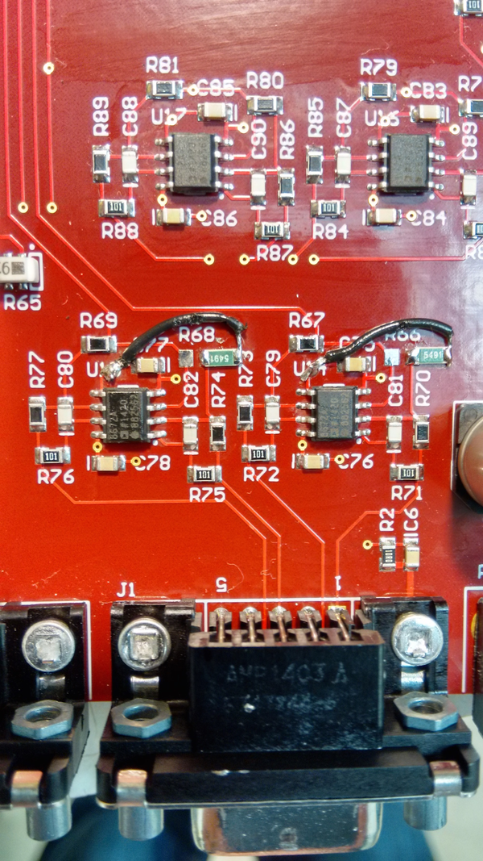
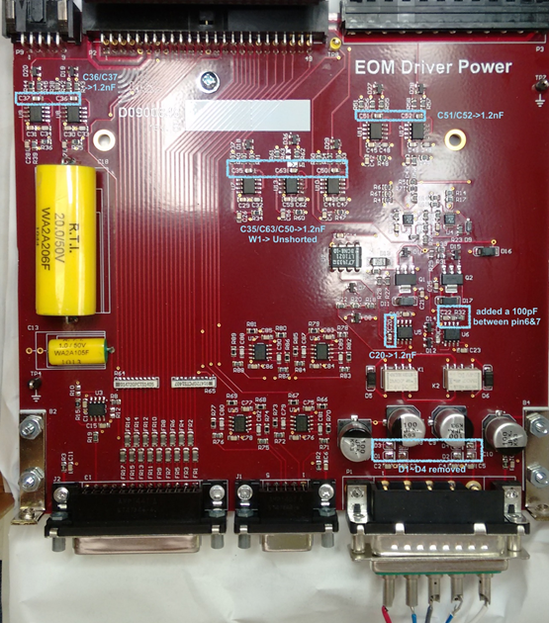
Servo Board D0900847-B

Change 1:
Reduce the high frequency gain of the servo to allow for better phase margin.

R69 → 66.5
C49 → 1nF
R71 → 3.3K
R67 → 3.3K

Change 2:
Add capacitor at the output drive to ground to reduce the backfeed of RF from the attenuator board.

C58 → 1nF, add between signal and ground pin of SMA connector J5

Attenuator Board D1000216-B

Change 1:
Add capacitor at the control input to ground to reduce the backfeed of RF to the servo board.

C2 → 1nF, add between signal and ground pin of SMA connector J3

Controller Board D0900761-B
Change 1:
Double the gain of the monitor points.

R27A, R27B → 6.65K

Final Checks:
After re–assembling the chassis the following checks should be performed:

Check 1: Test the tabs of Q3 to Q9 on the power board for shorts with the rear panel.
(Powering up the chassis with a short will damage the transistor.)

Check 2: Make sure the backplane board is inserted center into the rear connectors.
(It is possible to offset the backplane by one row and damage Q1 or Q2 on the
power board.)

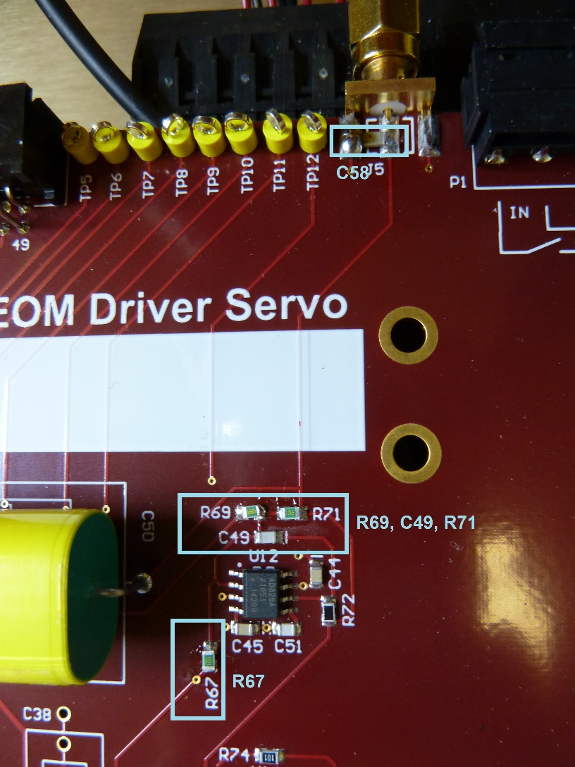
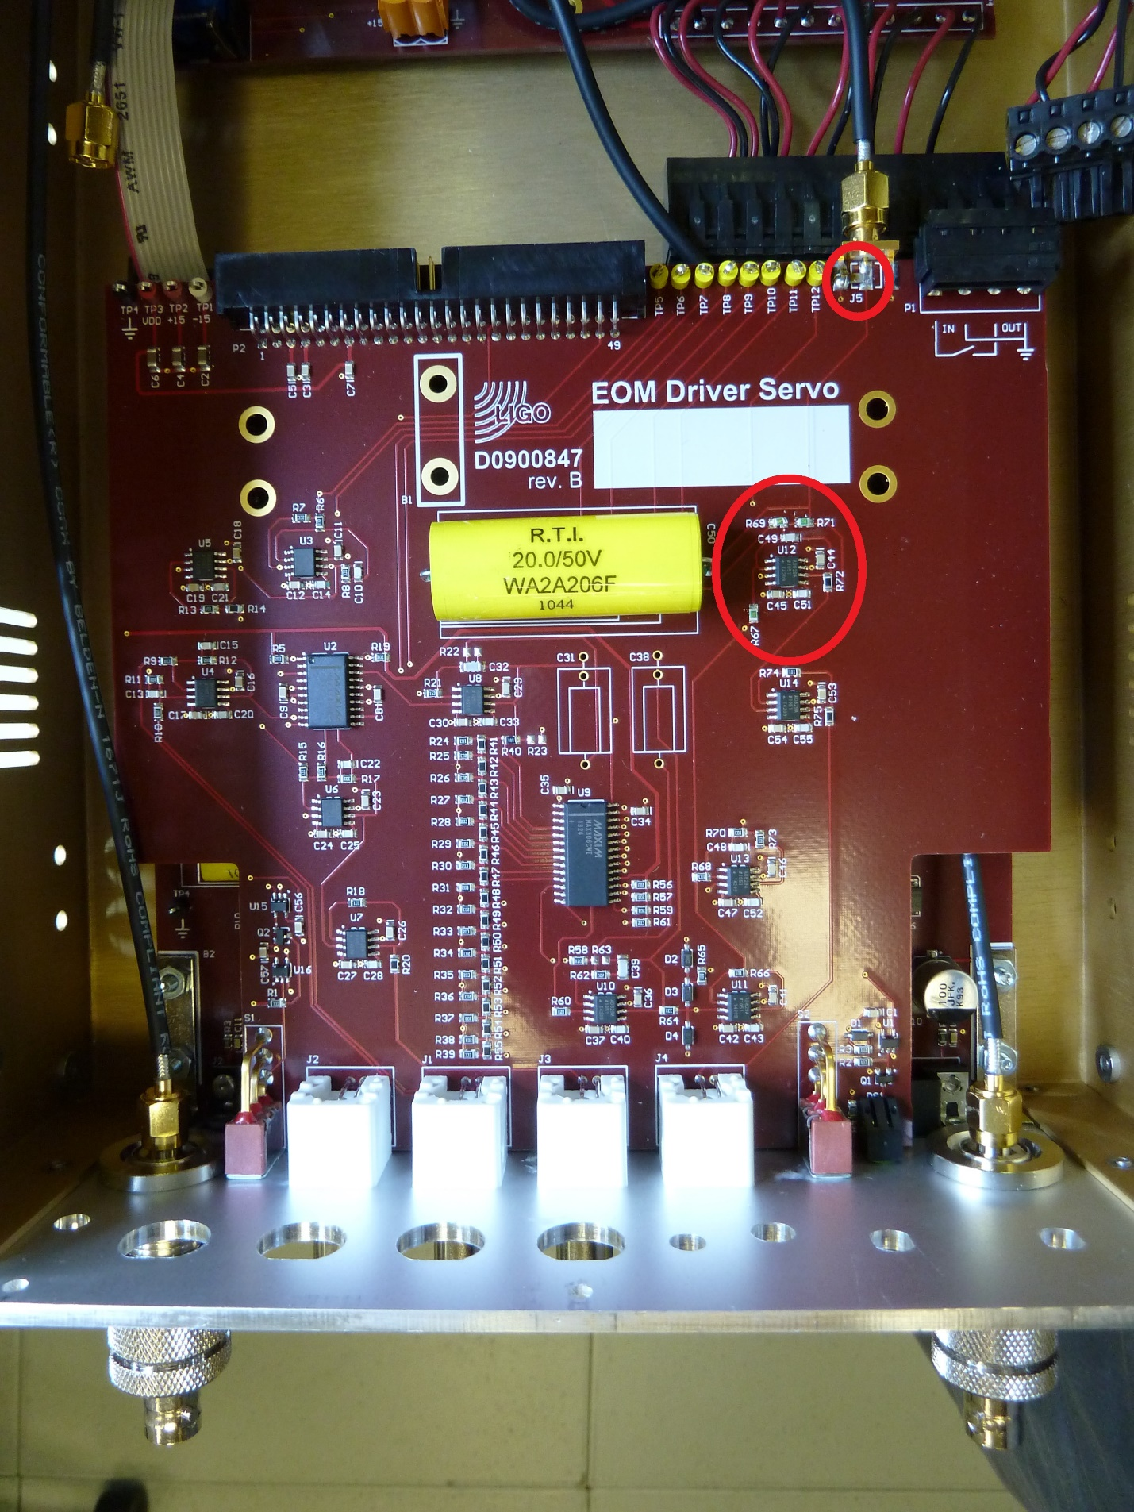
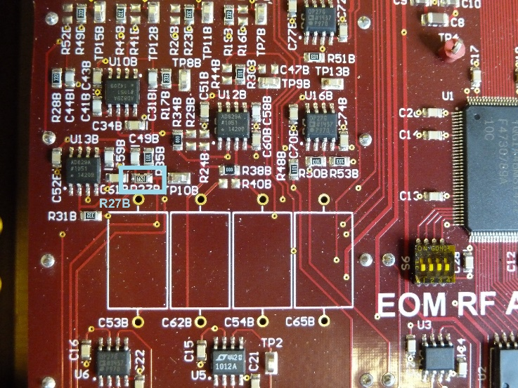
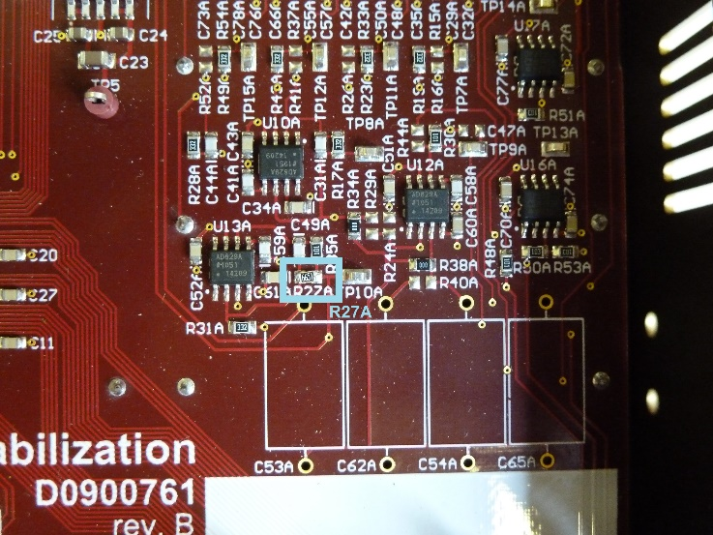
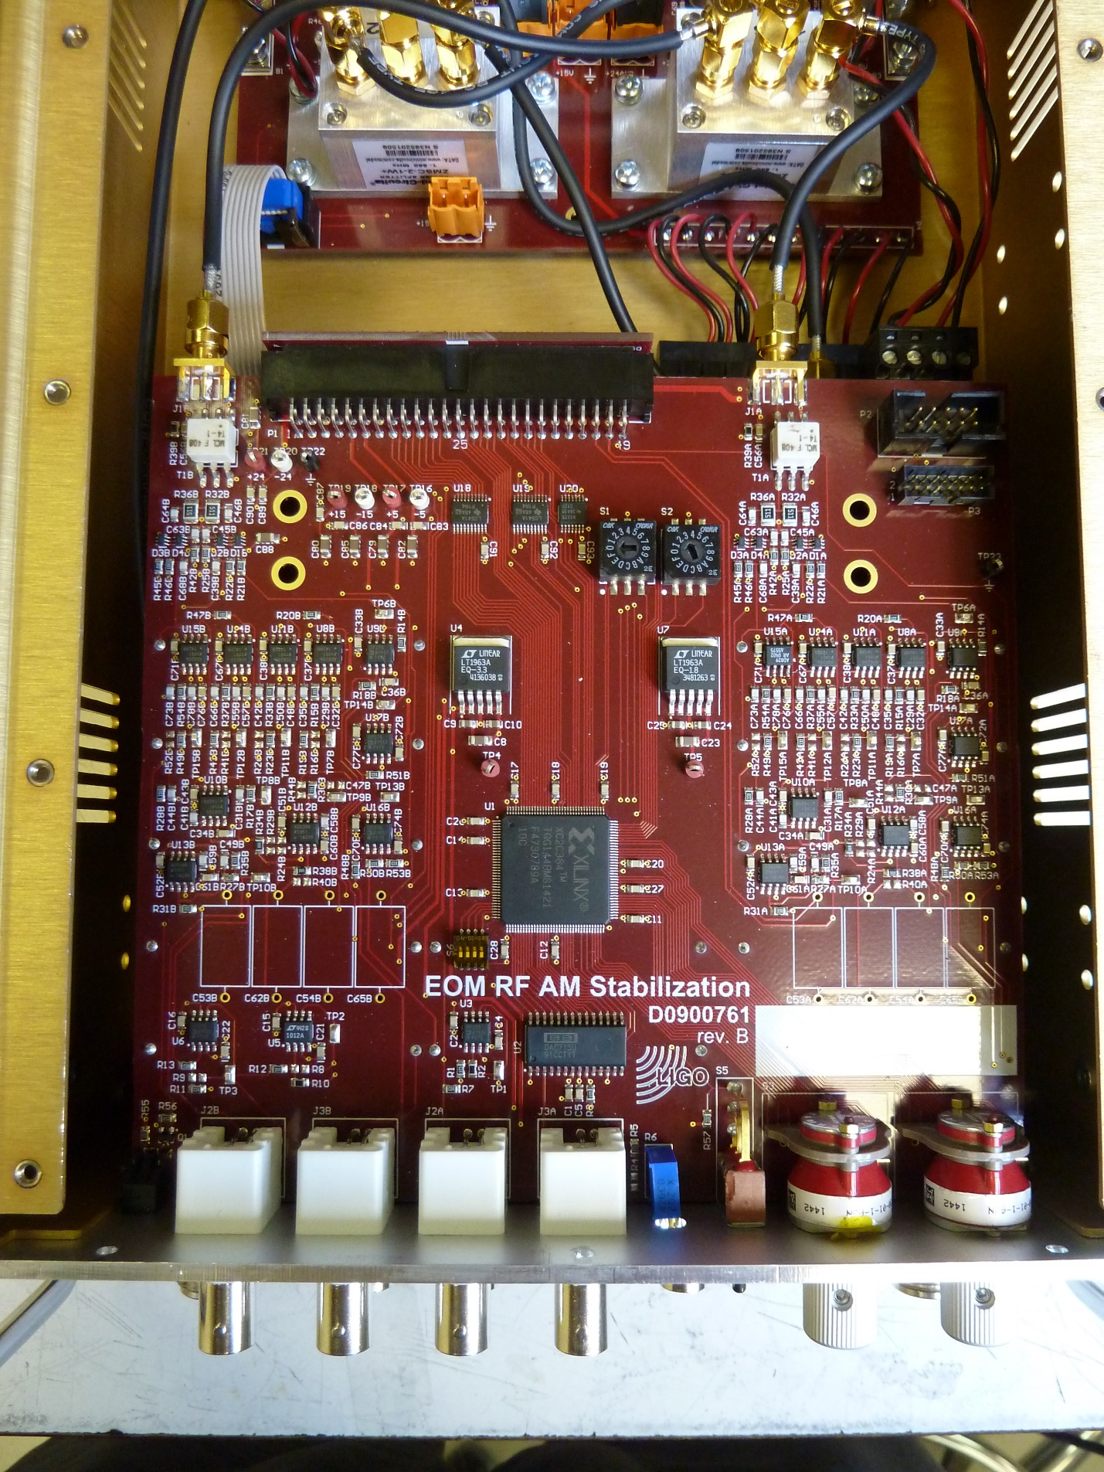
BOM (for 12 units):
Qty | Item | Distributor | Description
108 | 311-1122-1-ND | Digi-Key | 1nF, 0805, NPO  Power board: C20, C35, C36, C37, C50, C51, C52, and C63  Servo board: C49
12 | 311-1111-1-ND | Digi-Key | 100pF, 0805, NPO  Power board: C91
24 | P5.49KDACT-ND | Digi-Key | 5.49K, 0805, 0.1%  Power board: R66, R68
12 | P66.5DACT-ND | Digi-Key | 66.5, 0805, 0.1%  Servo board: R69
24 | P3.3KDACT-ND | Digi-Key | 3.3K, 0805, 0.1%  Servo board: R67, R71
24 | 478-1492-1-ND | Digi-Key | 1nF, 1206, NPO  Servo board:C58  Attenuator board: C2
24 | P6.65KDACT-ND | Digi-Key | 6.65K, 0805, 0.1%  Controller board: R27A, R27B
1 | 6710 BK005-ND | Digi-Key | Hook-up wire

