September 18, 2015
Maximum ETM displacement for Hardware Injections, pre-O1
LIGO-T1500484-v2
Peter Fritschel

The purpose of this memo is to define the maximum ETM displacement that can be achieved for the purposes of hardware injections, when an interferometer (H1 or L1) is operated in its nominal low-noise mode.
There are two main assumptions in the calculation. One is that a single ETM Electro-Static Driver (ES-Driver), operating in low noise mode, provides all the available arm length excitation. In principle, larger excitation could be achieved below about 20 Hz with the PUM driver, but I have not included this (could be revisited if necessary). The other assumption is that approximately 20% of the ES-Driver range is available for injections. This is based on H1, where approximately 30% of the ES-Driver range is used, and must be reserved, for DARM control.
The other inputs to the calculation are:
- ESD force coefficient (from H1 ETMY): 1.55e-10 N/V²
- ESD Bias: 380 V
- ES-Driver poles (all real): Two at 2.2 Hz; one at either 160 Hz (for H1), or at 3300 Hz (for L1)
- ES-Driver zeros (all real): Two at 50 Hz; one at 3100 Hz (for H1 only)
- Max HW injection range, expressed in DAC counts: +/- 30,000
The result of the calculation is shown in the plot below. Two other comments are worth making:
- The HW injections may be made before several digital notch filters that are not fully compensated in the inverse actuation function. So there may be several frequencies (narrow bands) where no drive amplitude is possible. The details would need to be gathered from the actual digital filter files in use, and may be different between H1 and L1.
- The L1 ETMY ES-Driver upper pole was moved up from 160 Hz to about 3 kHz, so it has more drive capability above 150 Hz as shown in the plot. This modification could be made to the H1 ETMY driver as well (at the expense of time and person-power).
The plot also shows the option of using one of the ETM Photon Calibrators to apply the signal injections. This curve assumes 1 W of modulated PCal laser power (+/- 0.5 W about a mean value). The PCal also has the advantage that the inverse actuation function is quite simple (involves no notches).
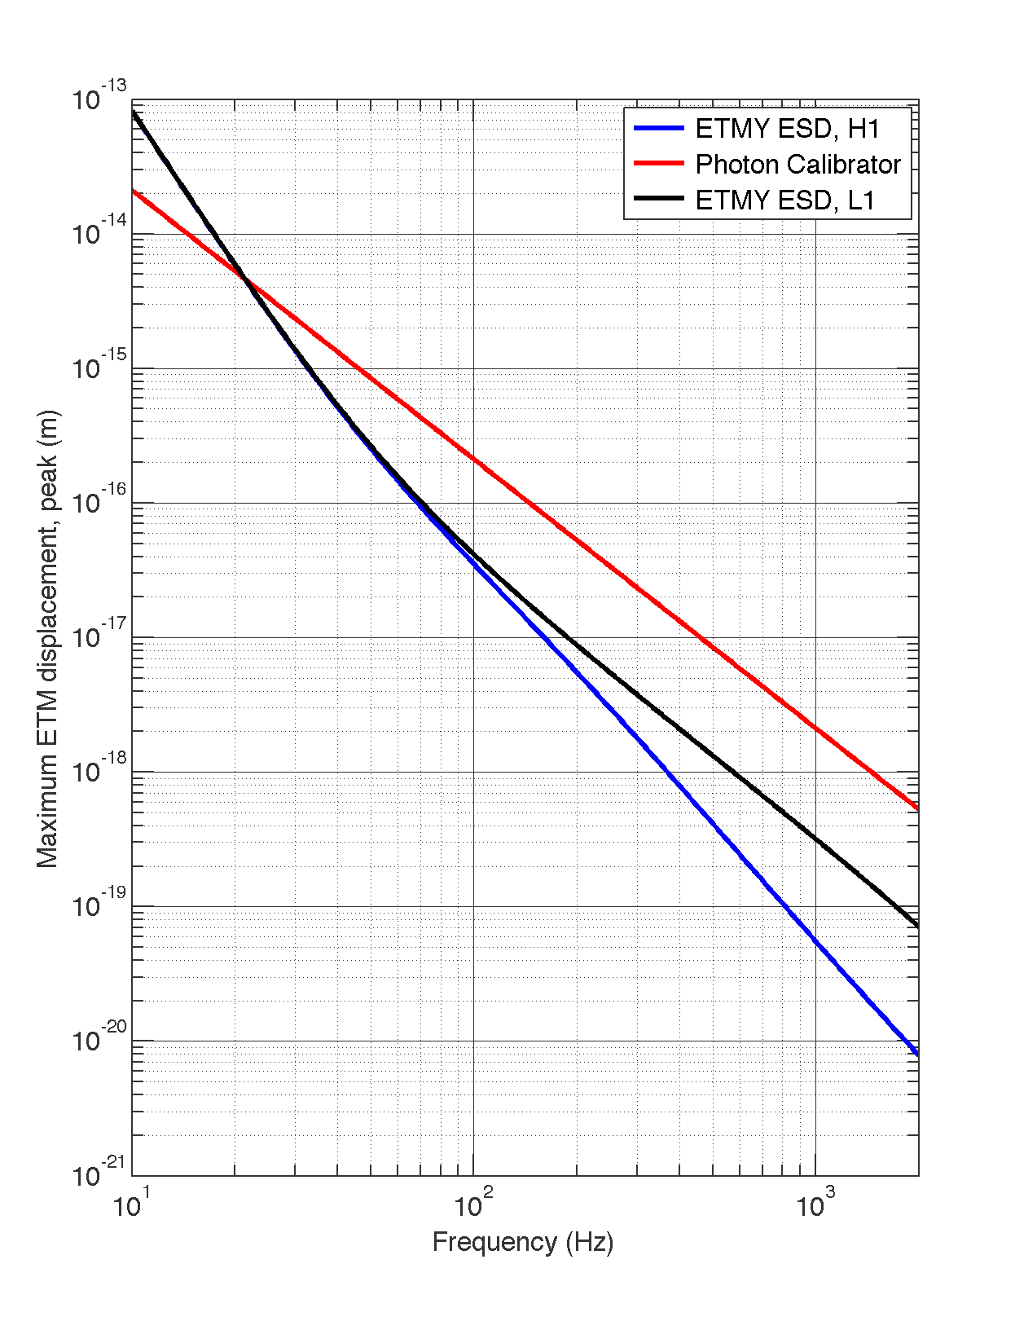
Figure 1. Maximum ETM displacement, and thus arm length change, available for hardware injections. The blue curve is for the H1 ETMY ES-Driver, operating in low noise mode. The black curve is for the L1 ETMY ES-Driver, also in low noise mode. The red curve is for a single photon calibrator, with 1 W pk-pk of modulated laser power (PCal lasers are nominally 2 W output power).

