LIGO Laboratory / LIGO Scientific Collaboration

LIGO-T1500514-v3 LIGO October 16, 2015

LIGO Instrument Report in connection with GW150914

Commissioning team (ed. by P. Fritschel)

This is an internal working note
of the LIGO Laboratory.

California Institute of Technology  LIGO Project | Massachusetts Institute of Technology  LIGO Project
LIGO Hanford Observatory | LIGO Livingston Observatory
http://www.ligo.caltech.edu/

Introduction
This document summarizes the instrumental investigations that have been performed as part of the vetting of event candidate GW150914. These investigations fall into the following categories:
- Assessment of the basic status and performance of the interferometers around the time of the event candidate.
- Surveys for any inadvertent excitation that could have caused the event candidate.
- Analysis of signal propagation through the DARM chain
- Investigations of any environmental disturbances or instrumental malfunctioning that could have caused the event candidate.
- Evaluations of potential malicious signal injection or creation.
Many of these investigations have been reported in the EVNT log, and are collated and summarized here.

Interferometer status and performance
Lock State. Both interferometers were locked with DC readout for significant time spans both before and after the event; furthermore, both interferometers were in the OBSERVATION MODE state during the event, and for at least 45 minutes both before and after. Furthermore, all guardian nodes that are required to be OK for the instruments to be OBSERVATION READY were OK during and surround the event (see EVNT log entry 11327). Here are the numbers:

State | IFO | Start | End | Time before | Time after
DC_READOUT | L1 | 1126214378 | 1126264691 | 12.5 hrs | 1.45 hrs
 | H1 | 1126247600 | 1126274322 | 3.3 hrs | 4.16 hrs
OBSERVATION MODE | L1 | 1126256591 | 1126264691 | 48 min | 1.45 hrs
 | H1 | 1126252143 | 1126274322 | 2.0 hrs | 4.13 hrs

Sensitivity and noise performance. Both interferometers were operating at a sensitivity – as indicated by NS-NS inspiral range – that was within their normal range for science mode data. The inspiral range was maybe 10% below the maximum for each interferometer, and was quite stable from minute-to-minute in the time spans around the event. This is shown in these DetChar summary plots; the event occurred at time 09:50:45 in these plots:

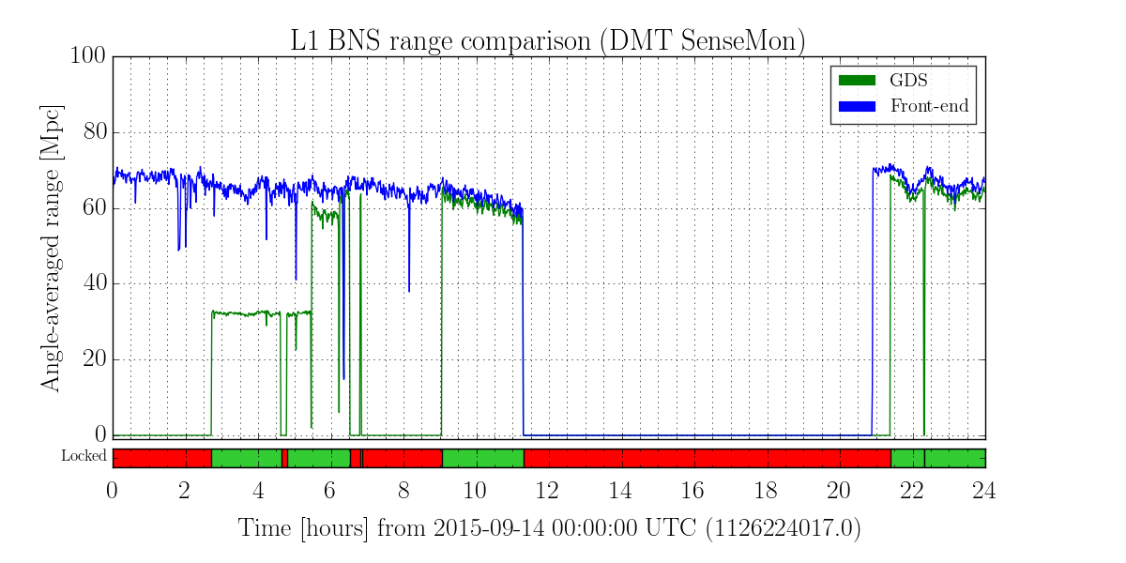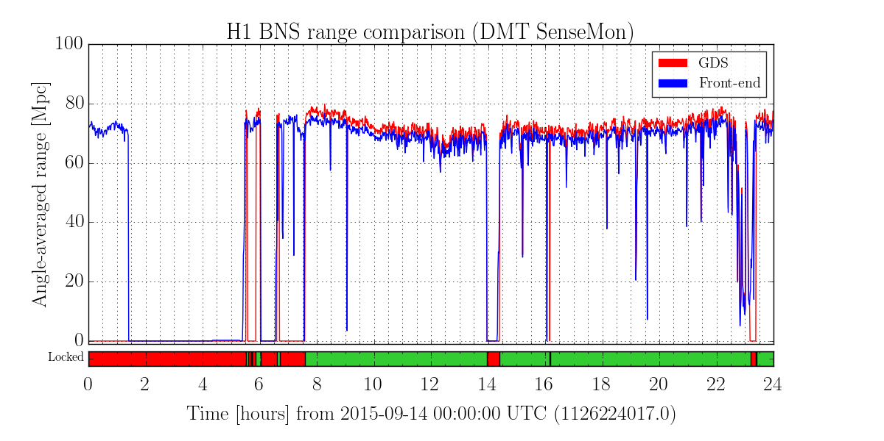

The following 2 plots are pulled from EVNT log entry 11249, and they show the distribution of the strain noise spectra, over a time span of approximately 2 hours surrounding the event.
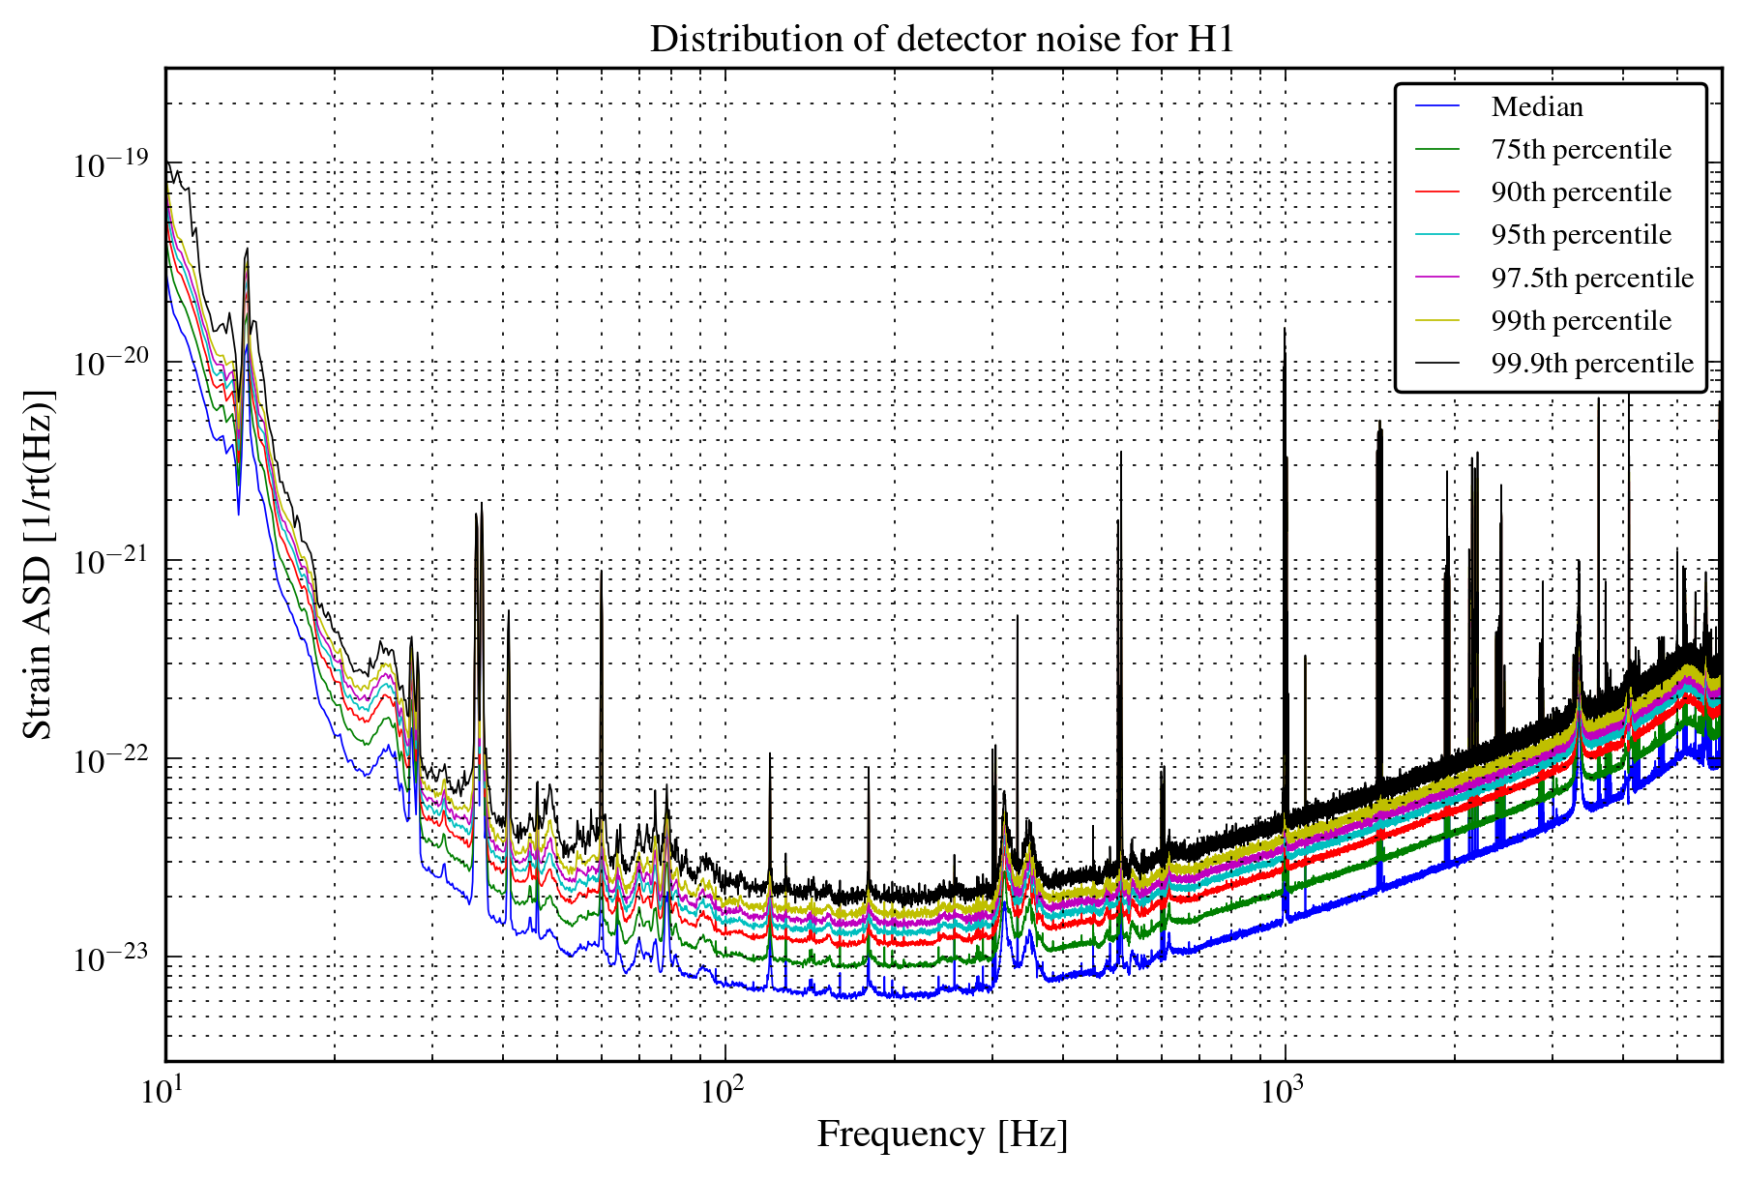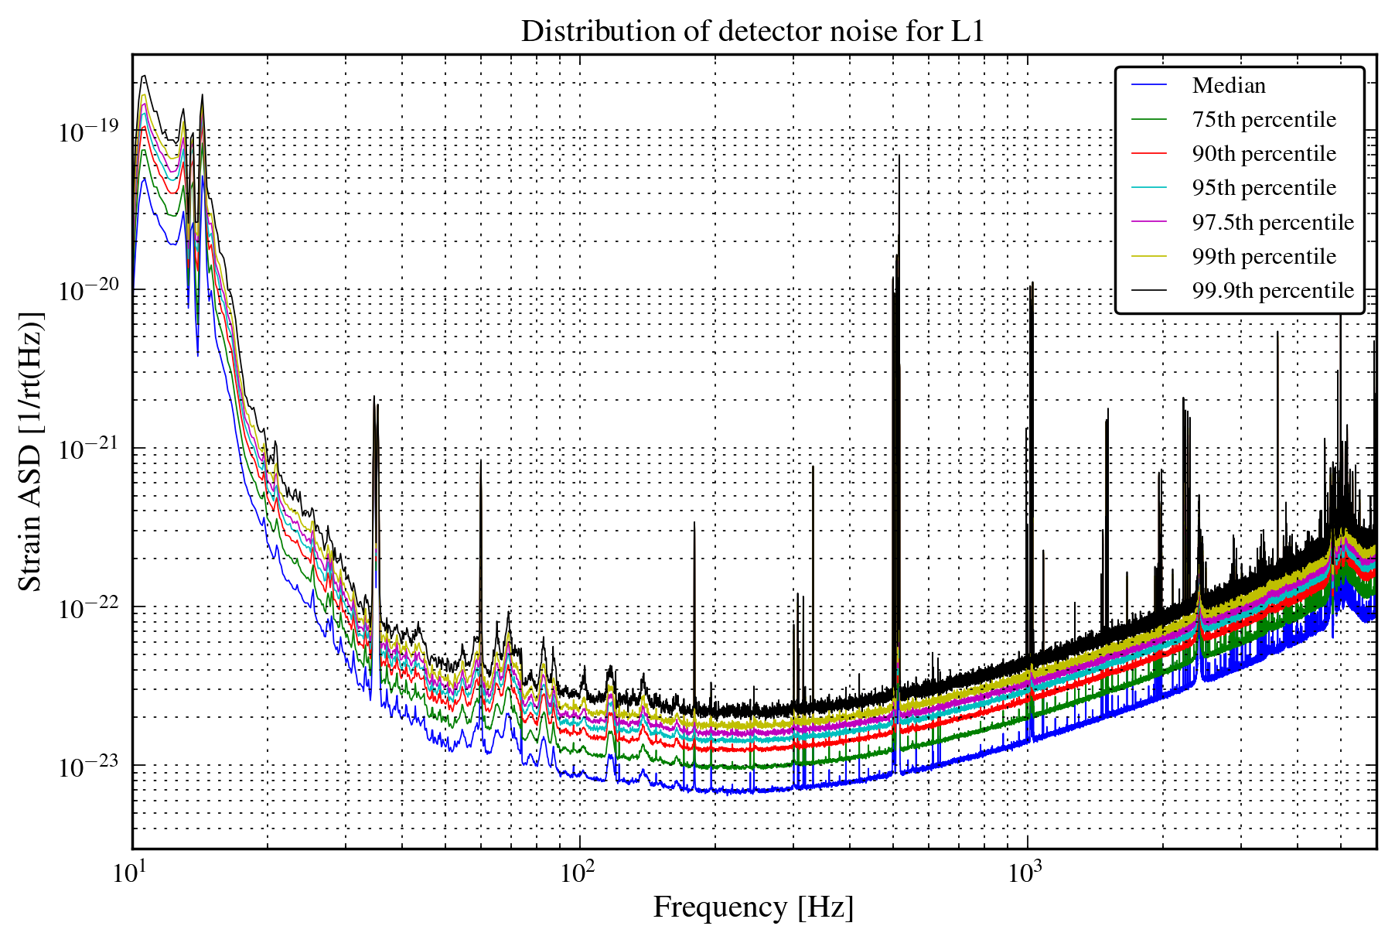
More details of this analysis can be found in that log entry (11249), including a comparison of the statistics of each frequency bin compared to Gaussian statistics. In short, there is no dramatic deviation from Gaussianity for the frequency band of interest, though there is some deviation in the 40—100 Hz band in each interferometer, associated with the spectral peaks seen in each strain spectrum.
The CAL-DELTAL_EXTERNAL spectra for H1 and L1 (i.e., the front-end CAL-CS calibration) for the two-minute window surrounding the event are posted in EVNT log 11216. Also, EVNT log entry 11338 shows that the calibration parameters were steady at and surrounding the time of the event.
Noise budgets. Recent noise budgets were made for each interferometer; they should represent well our understanding of the noise of each interferometer at the time of the event. They are found at:
- H1, noise budget for 2015-09-12: LHO log entry 21162
- L1, noise budget for 2015-09-18: LLO log entry 20647
The situation is essentially the same for each interferometer. The noise is dominated by shot (quantum) noise, at the expected level, for frequencies above 150-200 Hz. Between 30—100 Hz, the observed noise is higher than the sum of known noise sources, by approximately a factor of 2 (higher at some spectral peaks). The source of this excess noise is, for the most part, not known. However, it was discovered recently (Oct 6) that one of the H1 end station (X) Transmission Monitor beam diverters had not been closed, and that the resulting scattered light was causing the ~78 Hz bump in H1.
Calibration. All calibration related measurements on the interferometers had been completed well before the event, and the front end calibration that is constructed using these measurements was running on both H1 and L1. For H1, LHO alog entry 21513 states that the front end calibration was stable from approximately 3 days prior to the event, to about 6 hours after the event (at that point, a small change to the calibration model violin mode filters was made to make them more accurate). For L1, the front end calibration was updated roughly 12 hours before the event, and a photon calibrator sweep made approximately 2 hours before the event indicated no significant errors in the calibration (LLO log entry 20525). Small improvements were made to the front end calibration on both interferometers in the week or so following the event.
Timing. The relevant ADC time stamps (photon calibrators and OMC) and DAC timing delays (photon calibrator) were checked at both LHO and LLO over a 5 minute window around the event. These checks are reported in EVNT log entries 11217 (LHO) and 11230 (LLO). All timing was good to within 1 microsecond (except for the L1 DAC DuoTones, which were not running at the time).
In addition, each observatory records an absolute time marker that is independent of this DAQ timing system used for the real-time system. These markers are IRIG-B signals produced by independent GPS-based clocks at the end stations, recorded by PEM I/O chassis at 16384 Hz. At the time of the event, such markers were recorded at both end stations at LHO, and at End-X at LLO. These channels have been examined, as reported in EVNT log entry 11263. The examination confirmed that the ADC time stamps for both H1 and L1 were valid.
There is now also a full report on the timing for the event candidate in LIGO-T1500516. This report confirms that the DuoTone and IRIG-B timing diagnostics verified the proper timing of the DAQ system.
Front end code. Checks have been made at both LHO and LLO to verify the source code running on the front ends. No significant anomalies were found; see EVNT log entry 11260 for LLO, and 11330 for LHO.

Inadvertent excitations
Shortly after the event was found it was established that the signal was not an intended gravitational wave hardware injection (‘blind’ or otherwise). Subsequently, checks were performed as to whether it could be an inadvertent hardware injection. Any such accidental injection would need to go through one of the digital excitation points in one of the real-time control models, as these are the only ‘built-in’ excitation paths in the system.
Thus for both H1 and L1, all digital excitation channels were examined for a time span 10 seconds before and 10 seconds after the event GPS time (1126259462). This is reported in EVNT log entry 11253. No transient signals were found in any of the digital excitation channels (only the intended periodic signals for the photon calibrator and L1 continuous wave injections).

Signal propagation through the DARM loop
A powerful test is to track the event signal waveform at different points along the DARM signal chain (servo loop). A signal that comes in as amplitude modulation of the light detected by the output photodetectors (as a gravitational wave signal would) will have a particular, calculable waveform at different points in the signal chain. A signal that comes in somewhere else in the chain, but produces the same event waveform in the calibrated strain channel, will differ from the event waveform at other points in the chain. This signal tracking was performed for both H1 and L1, and is reported respectively in EVNT log entries 11273 and 11308. The result showed that the event signal had to come in at the input of the DARM servo; or more specifically, the event signal could not have been injected after the output photodetector (OMC DCPDs) ADC channels.
Note that this conclusion also rules out the event signal coming in through other signal paths that add in to the DARM chain, in particular the MICH and SRCL correction paths. The analysis also verified that the event signal appeared consistently in both output photodetectors, and that it did not appear in the photodetector NULL channel (difference of the two).

Environmental disturbances & instrument artifacts
No glitches have been found in close proximity to the event in any of the PEM channels; this analysis is reported in EVNT log entry 11267. But were the PEM sensors sensitive enough to register a disturbance that could have caused the event? PEM injection tests performed during ER8 allow us to give some quantitative answers to this question.
We’ll start with a magnetic field transient, which is an environmental disturbance that could well occur in coincidence between the two observatories. The event signal corresponds to a single test mass motion of about $4×{10}^{-18}$ m-pk at 100 Hz. Pre-O1 PEM injection results are reported in LLO log 20599. They show a maximum magnetic field coupling at 100 Hz of several$×{10}^{-11}$ meters of test mass motion per Tesla; we’ll use a value of $4×{10}^{-11}$ m/T. It would therefore require a 100 Hz magnetic field transient of amplitude 10⁻⁷ Tesla-pk to produce the event signal. This would show up in the recorded magnetometer channel as a +/- 16,000 count signal! Clearly, any magnetic field transient that could have caused the event signal would have been easily picked up.
Next on the list is vibrations, mainly acoustically driven. The pre-O1 PEM injections indicate that vibrational coupling noise is the environmental noise source that is closest to both H1 and L1’s strain noise floor. Ambient vibrational noise, coupling into the strain channel, is estimated to come as close as a factor of 3-5x below the strain noise floor in the event signal frequency band. But the PEM vibrational sensors (microphones, accelerometers, and also the ISI GS13 geophones) do measure the ambient vibrational noise in this band (i.e., they are not sensor noise limited). Since the event signal has a signal-to-noise ratio of roughly 10 in the strain channel, this means that a vibrational transient that could cause the event signal would show up in the vibrational sensors with an SNR of 30-50 – it would have been picked up by the glitch analysis of these channels.
In the domain of instrumental artifacts, misbehavior in an auxiliary length degree-of-freedom (DoF) should be considered. As noted in EVNT log entry 11258, a MICH motion large enough to create the event signal would not be detectable by the MICH length sensor. However, we note that the MICH loop has a very low bandwidth (10 Hz) and rolls off quickly above that; at 100 Hz the open loop gain is -40 dB and falling steeply. Thus any misbehavior in the MICH loop, like a servo oscillation, seems incapable of producing sufficient signal at one to a few hundred Hz. The situation with PRCL and SRCL is different. For both these DoF, the coupling to DARM is smaller than that for MICH, so that a signal in either of these DoF that would be big enough to cause the event signal in DARM, would be detectable in the PRCL or SRCL length sensor (SRCL coupling to DARM is $2-3×{10}^{-5}$ at 100 Hz, and falling with frequency, so a really large SRCL signal would be required). The consideration for angular degrees-of-freedom is similar to that for MICH: these control loops are even lower bandwidth and more strongly low-pass filtered to get any action from that at 100-200 Hz.
Searches were made for evidence of known instrument artifacts at the time of the event. This included:
- Acoustic modes responsible for parametric instabilities. Monitoring of these modes for L1 indicated stable amplitudes for these modes, and no abnormalities (EVNT log 11340).
- RF ‘whistles’. This L1 RF interference phenomenon was shown not to be occurring in DARM at or around the time of the event in EVNT log entry 11271.
- RF45 AM glitches. This H1 glitch phenomenon associated with the 45 MHz EOM modulation drive was shown not to be occurring at or around the time of the event in EVNT log entry 11227.

Malicious injections
Could the event signal have been created via malicious injection, in some way that would not have been picked up by the tests described so far in this document? First, we note that analyses of auxiliary channels did not indicate any correlated transient noise in either interferometer at the time of the event (see EVNT log entry 11267 for omega-scans; entry 11258 specific to the beamsplitter Noisemon channels, and entry 11268 for all corner-station Noisemon channels). It seems that a malicious injection would thus have to be done in one of three ways:
- Via software, after the data is collected
- A force applied to a test mass using a method that would not be picked up by the interferometer/PEM channels that are acquired
- A signal coupled in somehow on the DARM sensing side, ahead of the OMC DCPD ADC channels
Regarding the first possibility, note that the signal would have to be added to more than 20 channels, all with the appropriately transformed waveform, in order to pass the DARM signal chain check described in section 4. The process would have had to account for DARM path digital filter changes that were made on both interferometers not too long before the event (mid- to late-August 2015). Add to this the challenge of undetectably altering the frame files, or altering the channel data before it is written to frames.
For a malicious force applied to a test mass, note that the tests noted already rule out: using a photon calibrator, as this would have been picked up by the Pcal intensity monitor channels; applied magnetic fields, as this would have been picked up by the magnetometers. To produce the event signal, a force on a test mass of 3 nN-pk at 100 Hz is required. To produce this via radiation pressure, say with a laser pointing in through a viewport, would require 1 W of modulated power around 1 micron wavelength. Thus, it is not feasible with a laser pointer, or the ALS laser green beams.
Looking into other potential hardware injection spots has revealed a hole in our monitoring of the ETM drive signals. It turns out that the analog monitors of the low-voltage electro-static driver do not have enough sensitivity to have seen a drive signal that could create the event signal, for reasons described in LHO alog entry 22199. The ES driver has front panel test inputs that are summed with the regular drive inputs; these inputs are always active (i.e., there are no enable switches). Thus the potential exists for an analog waveform to be injected into the ETMY ES driver test inputs, undetectable by the driver monitor channels. The best evidence we have against this possibility are the inspections that were made of the end stations on September 22, 2015 (LLO) and September 29, 2015 (LHO); photos of the ETMY driver show nothing connected to the front panel test inputs (EVNT log entry 11317). Note also that an injection at this point would need to invert the transfer function (low-pass filtering) of the driver, which itself is different between H1 and L1 in a subtle but significant way.
Regarding the third possibility, it is hard to fathom any injection occurring in the in-vacuum part of the DARM chain, especially since the OMC shroud blocks the readout photodiodes from external view. Outside the vacuum, the photodetector signals go to an ISC Whitening/VGA chassis (D10002559), then to an Anti-Alias chassis (D0902783), then to the ADC card in the LSC I/O chassis. There are no chassis panel test inputs on either of these modules, so any excitation would need to have been made by some electro-magnetic coupling, or by connecting up to some appropriate internal point in the circuits. Again, inspections of the LVEA did not come up with any rogue setups that could have accomplished this. To aid in evaluating any other ideas, the figure below shows the signal chain from the OMC to the ADCs that readout out the DCPDs. The values given in purple text along the chain indicate the signal level at that point that corresponds to a test mass displacement of $4×{10}^{-18}$ m-pk at 100 Hz.

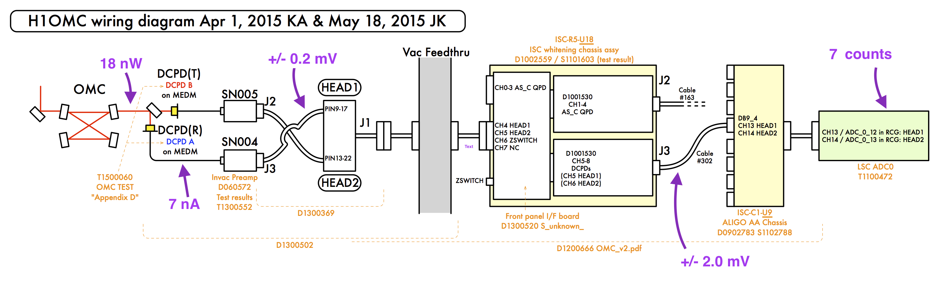

That is, not including analog excitation inputs that could be connected to a signal source that is not part of the real-time digital system; this category is addressed in the ‘malicious injection’ section.
We noted in section 2 that the code running at the time of the event was checked and verified; that leaves actually reviewing/reading it to look for any malicious code – that has not been done as of yet.
A possibility only for the ETMY driver on both H1 and L1; on ETMX the bias voltage is turned off during science mode for both interferometers so no force could be applied.
At LHO, we also know that any door access in either end-station would have been flagged in the swipe card access log.

