LIGO Laboratory / LIGO Scientific Collaboration

LIGO-E1600080-v1 LIGO March 8, 2016

AOS/ISC SQZ: Output Faraday Isolator Test Report (LLO)

K. Arai, G. Moreno, F. Matichard

Distribution of this document:
LIGO Scientific Collaboration

This is an internal working note
of the LIGO Laboratory.

California Institute of Technology  LIGO Project | Massachusetts Institute of Technology  LIGO Project
LIGO Hanford Observatory | LIGO Livingston Observatory
http://www.ligo.caltech.edu/

Overview
The replacement OFI for LLO was built in order to accommodate the modification for the squeezed vacuum injection. We have performed mechanical and optical tests to confirm the performance of the OFI. We certify that the assembled OFI fulfills the all optical and mechanical requirements by comparing the test results with the requirements.

Overall evaluation result
All mechanical and optical testing results meet the requirements except for the backscattering. As described in Section 3.2.3 it is considered as not an immediate threat of the sensitivity. In the following sections, the individual requirements are visited.

Comparison between the test results and the requirements

Mechanical requirements

Table balance - balance weights (output side)
Procedure: E1201074 Section 3.6.1.4 P. 86
Weight Offset Location: The bottom edge of the weights is 31.5 mm (1.24 inch) away from the bottom side of the table (= 1.54 inch from the top side of the table, 1.51 inch nominal as shown in the figure)
Placed Weights: D1300016-1, D1300016-2, D1300016-3
Evaluation: OK. The counter weights were placed so that the table is leveled.

Table balance - balance weights (input side)
Procedure: E1201074 Section 3.6.1.4 P. 87
Weight Offset Location: The left edge of the counter weights is 16 mm from the inner side of the left leg plate of the prism holder. (= 3.04 inch from the left side of the table, 2.80 inch nominal)
Placed Weights: D1300023-1, D1300023-2
Evaluation: OK. The counter weights were placed so that the table is leveled.

Table balance – wire lengths
Procedure: E1201074 Section 3.6.3
Table height: Adjusted to be nominal within 0.1mm
Wire violin frequency: Input Left - 187Hz, Output Left - 187Hz, Output Right - 191Hz, Input Right - 186Hz. “Left” or “right” are defined by the side seen from the input beam.
Evaluation: OK. The table height well adjusted, wire lengths/tensions well agree within 3%.

Table position – EQ stop centering
Procedure: E1201074 Section 3.7
Table position: The EQ stops were aligned to the center of the hole with 1mm precision.
Evaluation: OK.

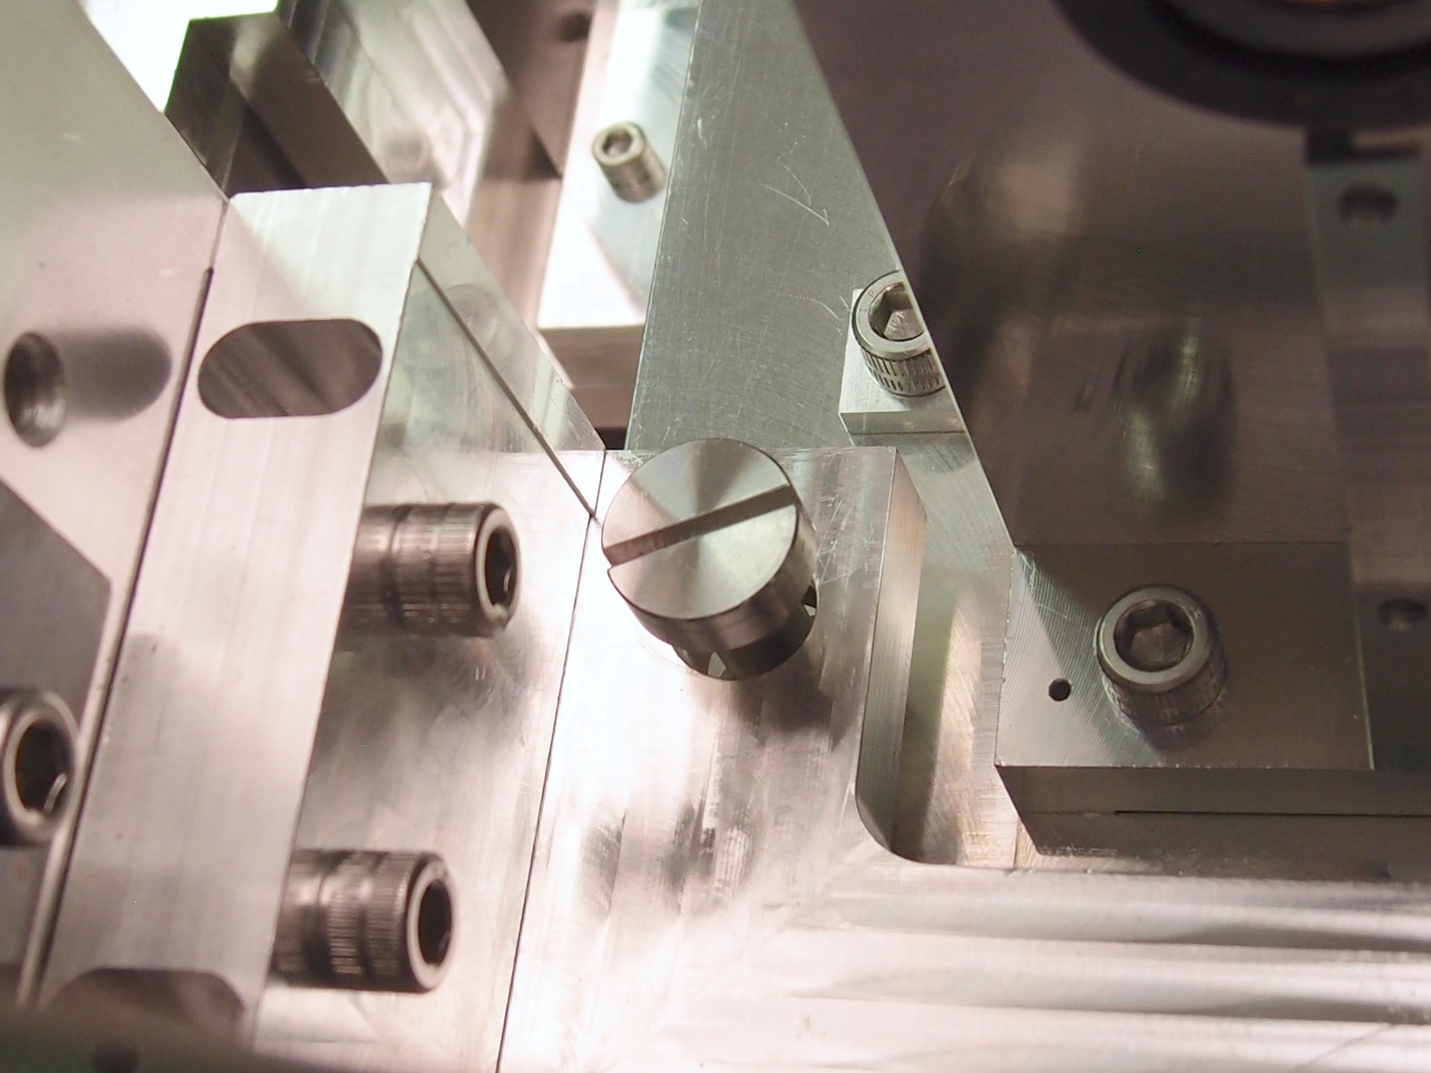  Input Left | 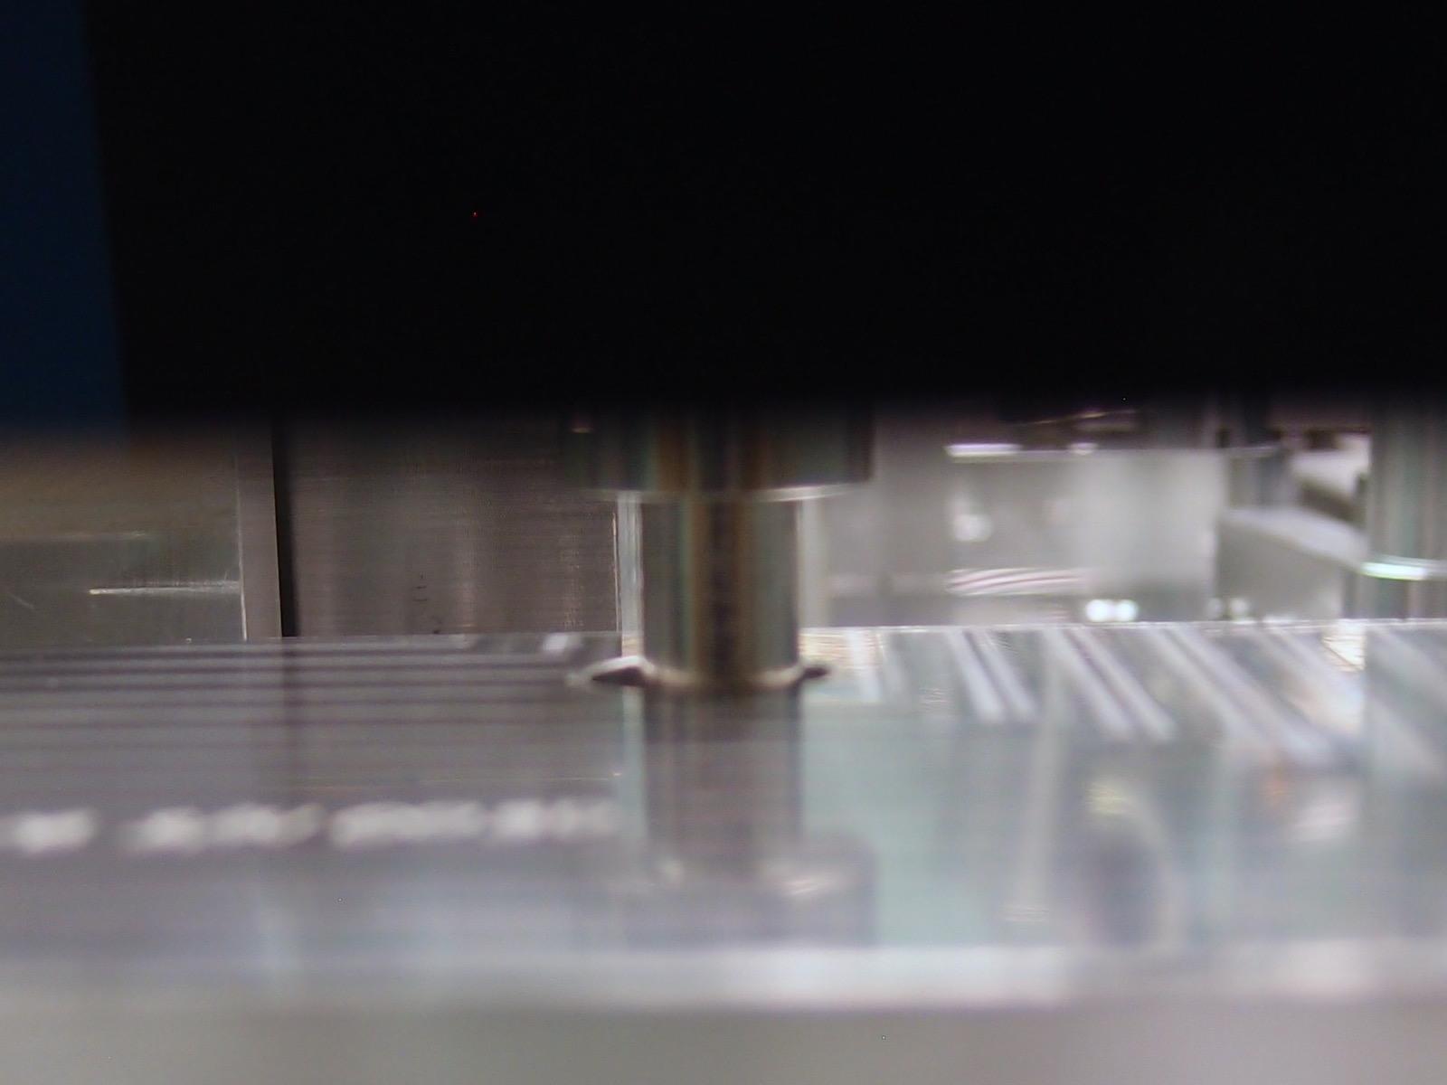  Output Left
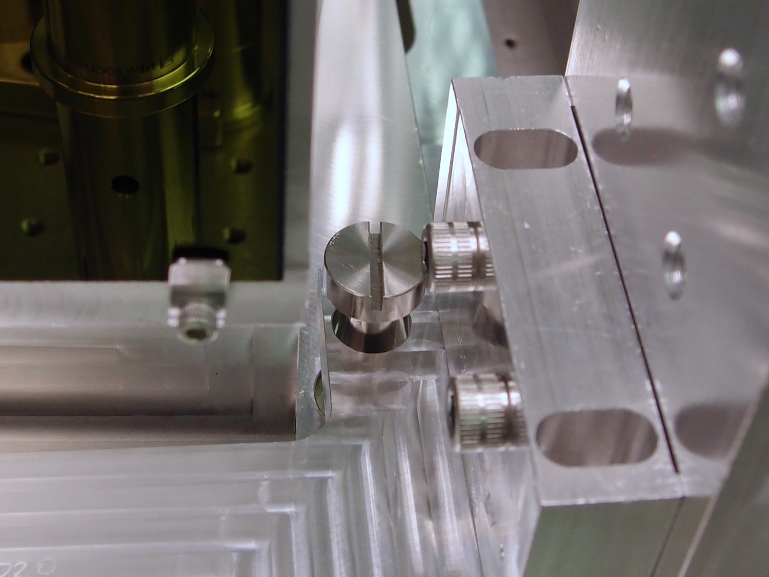  Input Right | 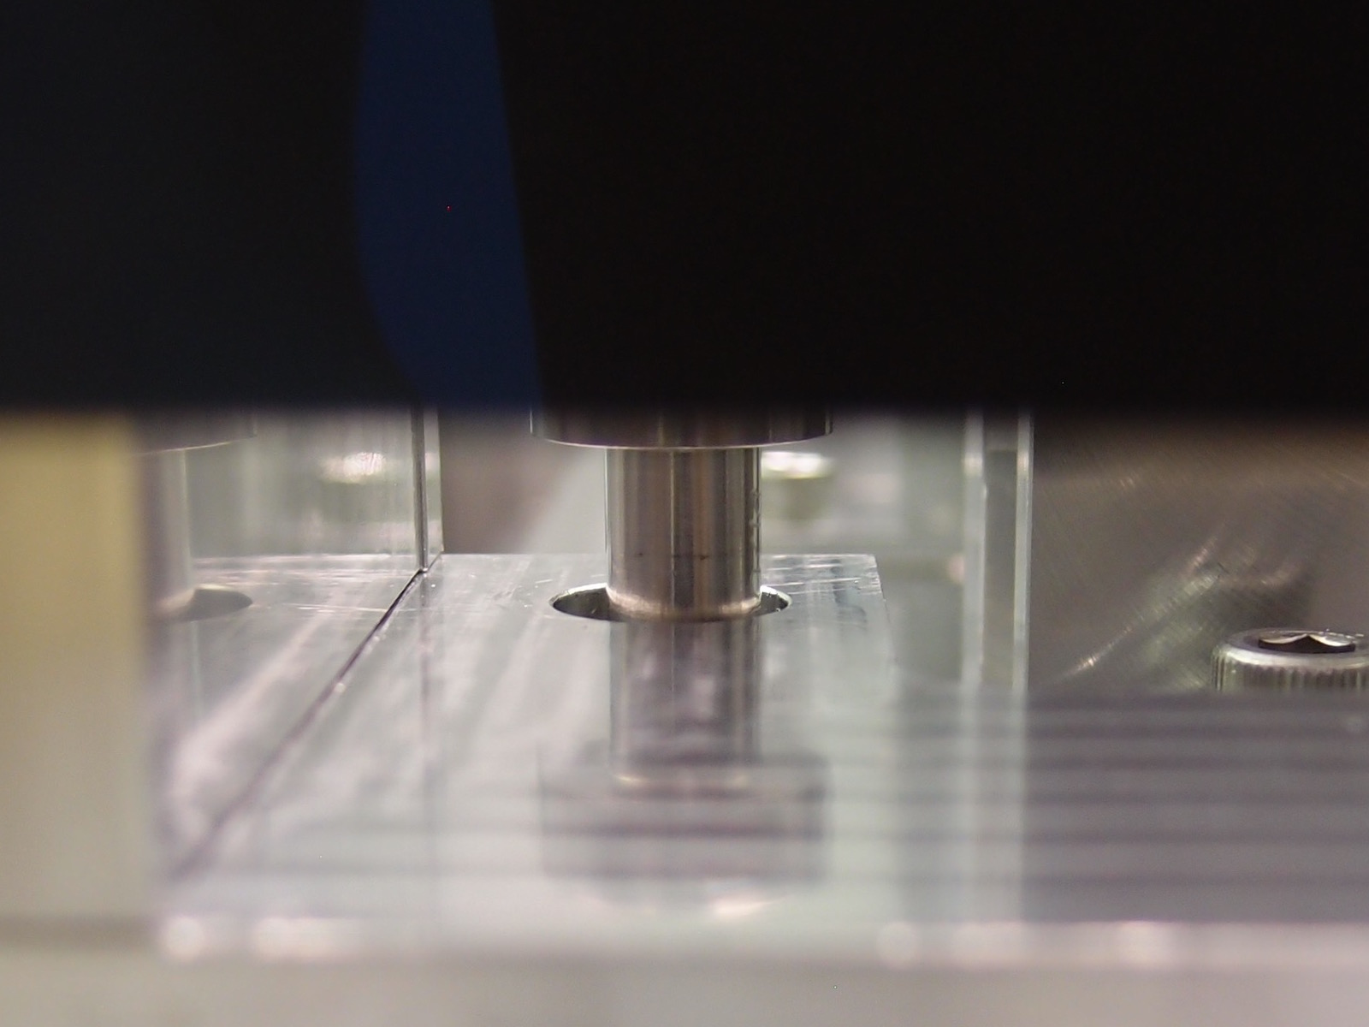  Output Right

Suspension damping
Requirement: T1000308 Sec 1.1.6 Resonance quality factors are to be about 30.
Procedure: N/A. Laser shadow sensor setup, with mode excitation by hand.
Results:
- Longitudinal mode: resonant frequency 0.62Hz, quality factor 18
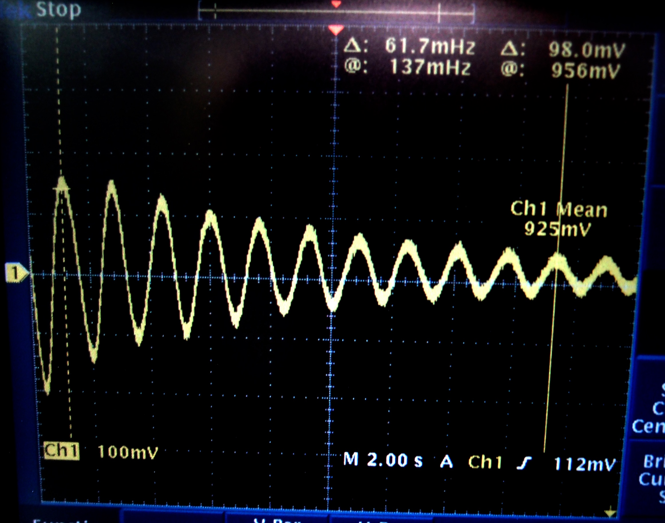
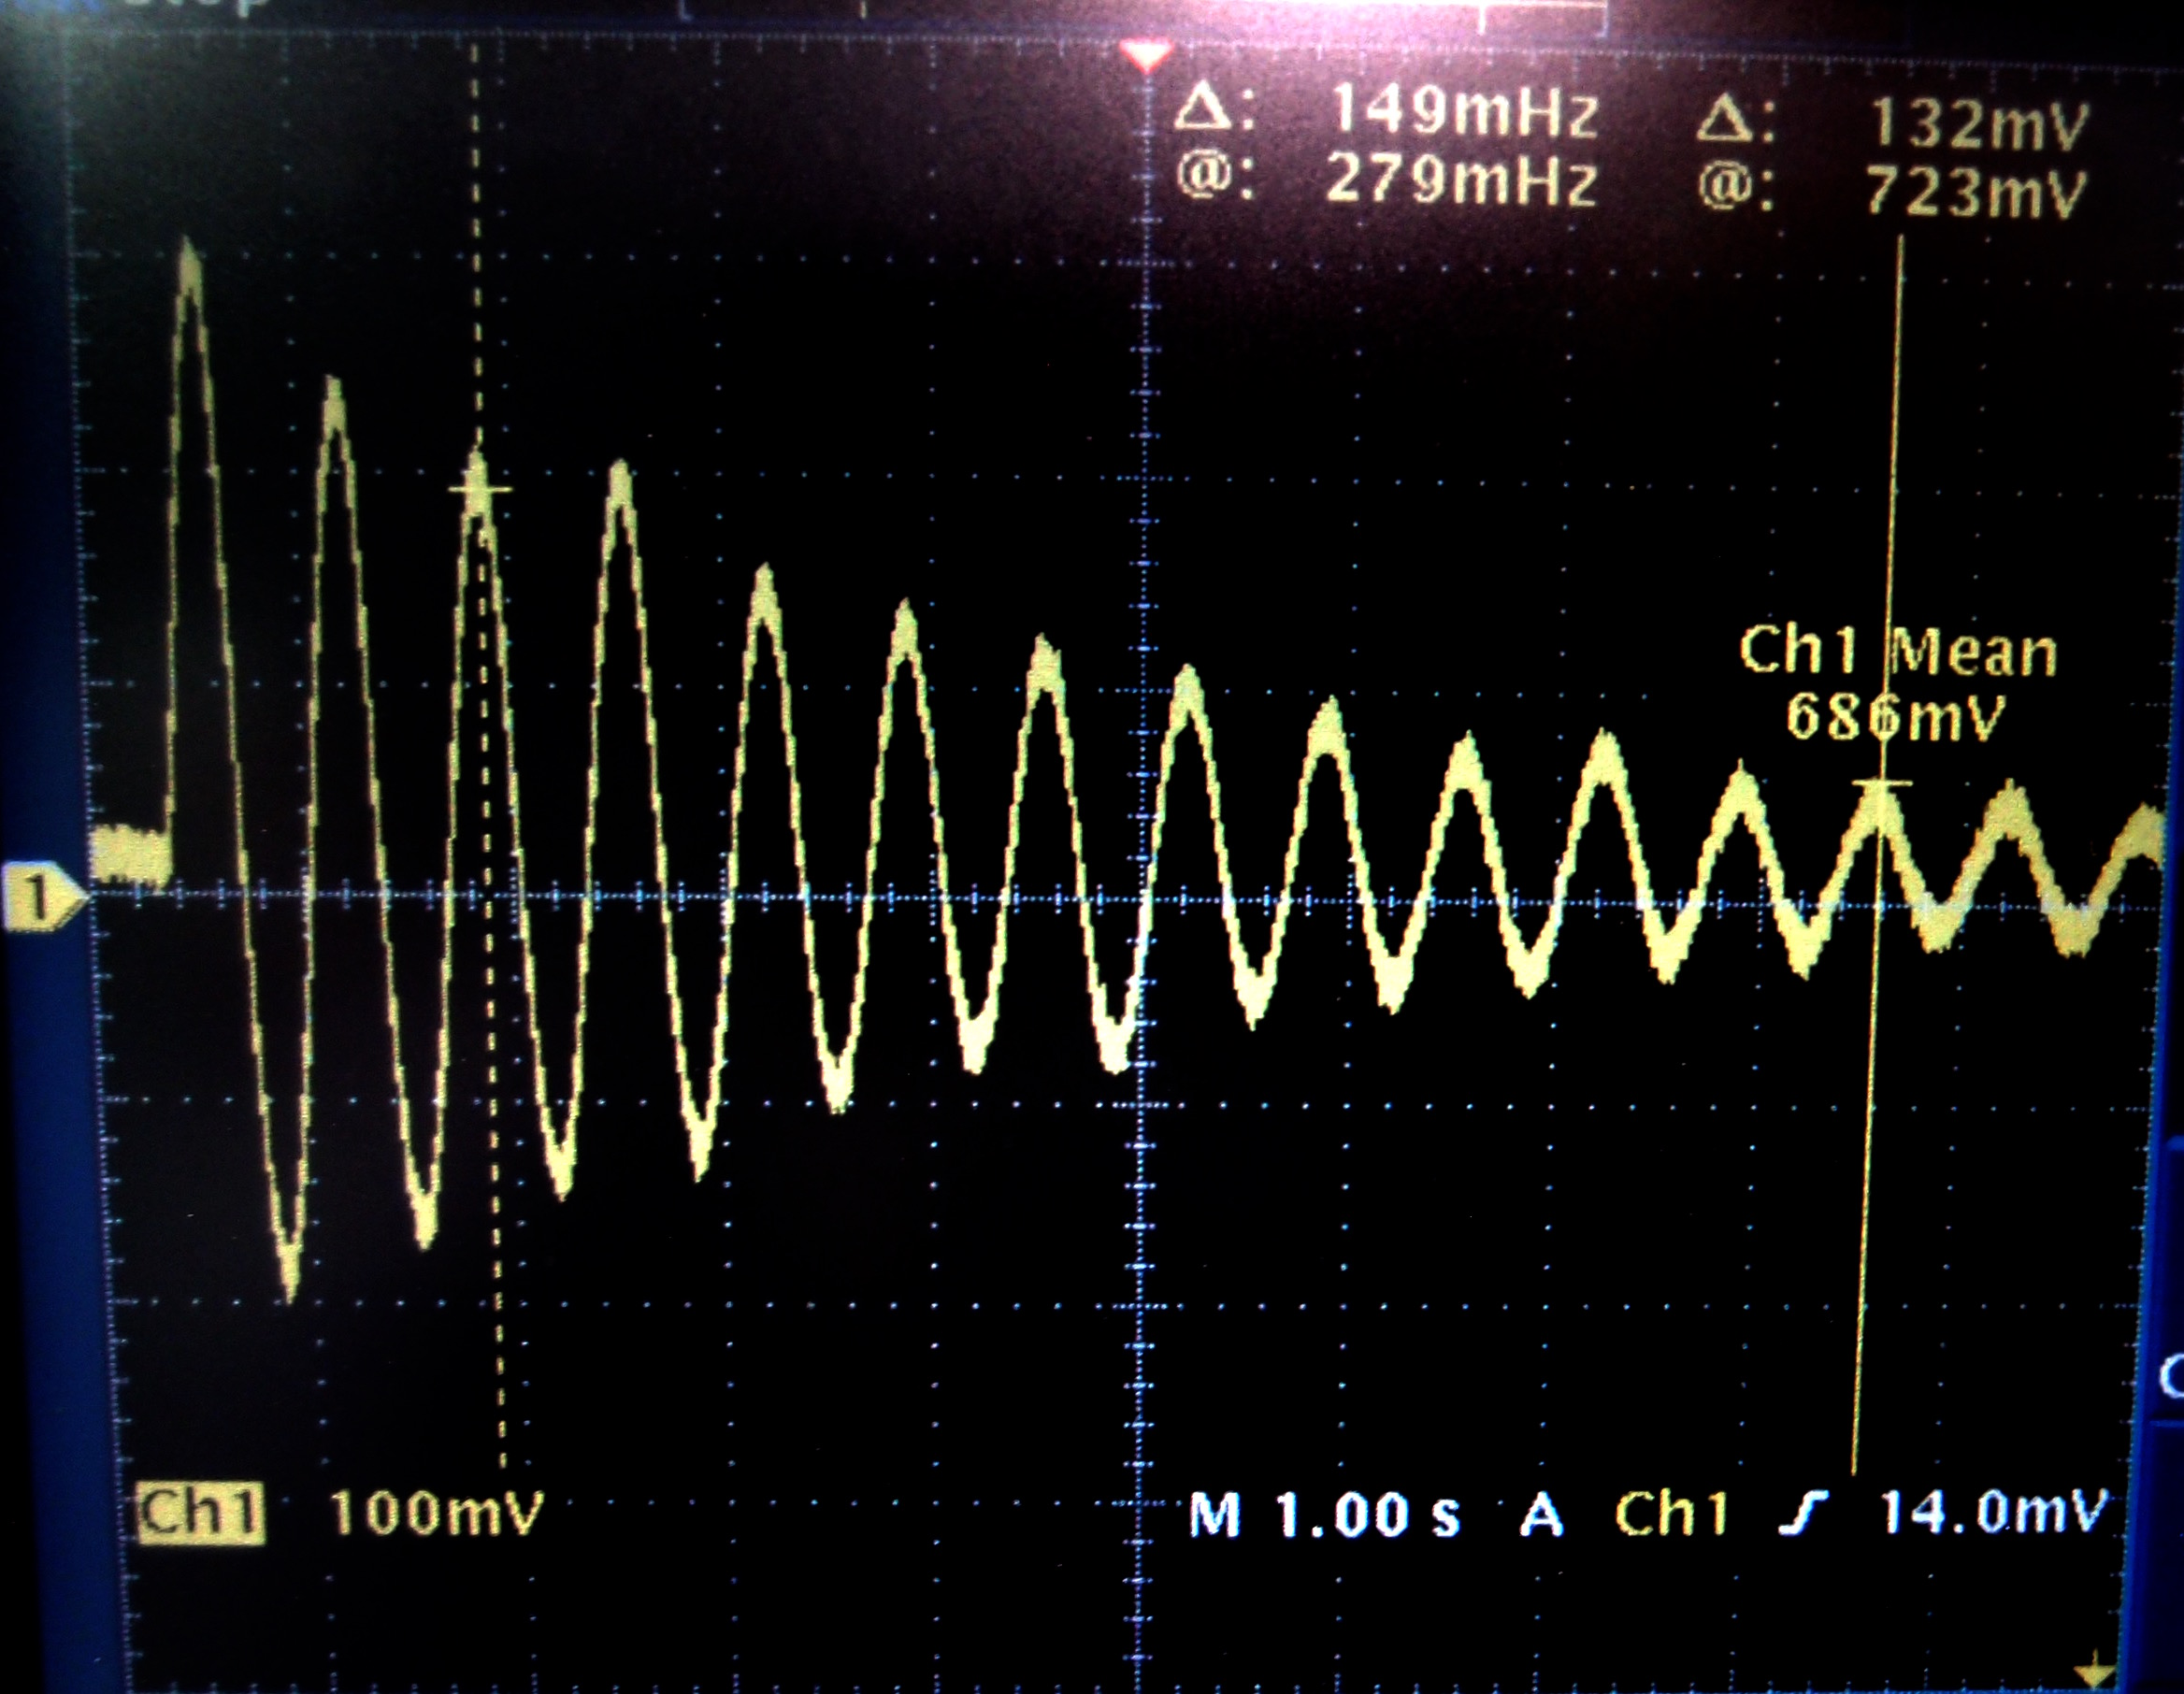  - Vertical mode: resonant frequency 1.49Hz,  quality factor 23 | - Pitch mode: resonant frequency 1.06Hz, quality factor 15
- Side mode: resonant frequency 0.63Hz,  quality factor 13 | - Yaw mode: resonant frequency 1.05Hz, quality factor 17
- Roll mode: Unable to excite as it
Evaluation: OK. All the Q factors were suppressed below 30 in order to avoid excitation of the transient large motion as well as the scattered light associated with it. The requirement assumes the attenuation of 40dB as a safety factor and at this level low Q factor down to 10 does not change the assumed attenuation.

Optical requirements

Optical transmission
Requirement: More than 95%. T070061 sec 4.3 Faraday Isolator Requirements
Procedure: E1201074 Section 4.1, LLO ALOG 24578, LLO ALOG 24660
Measurement result: 96.7% LLO ALOG 24984
Evaluation: OK

Optical isolation
Requirement: More than 30dB. T070061 sec 4.3 Faraday Isolator Requirements
Procedure: E1201074 Section 4.1, LLO ALOG 24600, LLO ALOG 24984
Measurement result: 39.2dB, LLO ALOG 24984
Evaluation: OK

Backscattering
Assumption: 5 x 5e-4 1/sr, T1000308 Sec 1.1.3
Procedure: E1201074 Section 4.1, LLO ALOG 24600
Measurement result: 0.56ppm (upper limit). LLO ALOG 24984. This reflectivity was at 1m away from the OFI with an aperture diameter of 10mm. Using these parameters, we derive the corresponding BRDF of 7e-3 1/sr.
Evaluation: The number is about 3 times larger than the value assumed in the design. Therefore, a careful follow up of the scattered light noise measurement would be necessary, although it can be considered as not an immediate threat because of the following reasons:
1) The measured number was the upper limit due to the measurement scheme.
2) According to T1000308 Sec 1.1.7, this three times larger BRDF does not exceed the AOS requirement except at 24Hz for the X direction.
3) The backscatter has not been tested for the current LLO OFI. It has been reported in the attachment of LHO ALOG 10996 for the LHO OFI that the backscatter reflectivity was 86ppm, which is more than 150 times larger value than the new measurement.

Backscatter isolation
Requirement: Best effort. This is a squeezer requirement which is not explicitly given in aLIGO requirement.
Procedure: E1201074 Section 4.1, LLO ALOG 24578
Measurement result: 800ppm = 31dB, LLO ALOG 24984
Evaluation: OK.

Squeezer transmission
Requirement: Best effort. This is a squeezer requirement which is not explicitly given in aLIGO requirement.
Procedure: E1201074 Section 4.1, G1600019, LLO ALOG 24600
Measurement result: 97.9%, LLO ALOG 24984
Evaluation: OK.

Shack-Hartmann Wavefront Test
Requirement: 1) Double pass Zernike #4 term < 0.012, 2) Double pass Zernike #6 term < 0.012, 3) Double pass Zernike #7-#15 term < 0.012
Procedure: E1201074 Section 4.2
Measurement result:
Z4 term = 0.005um, Z6 term = -0.011um,
Z7~Z15 terms = 0.007, 0.002, 0.002, 0.004, 0.002, 0.002, 0.002, 0.000, -0.001
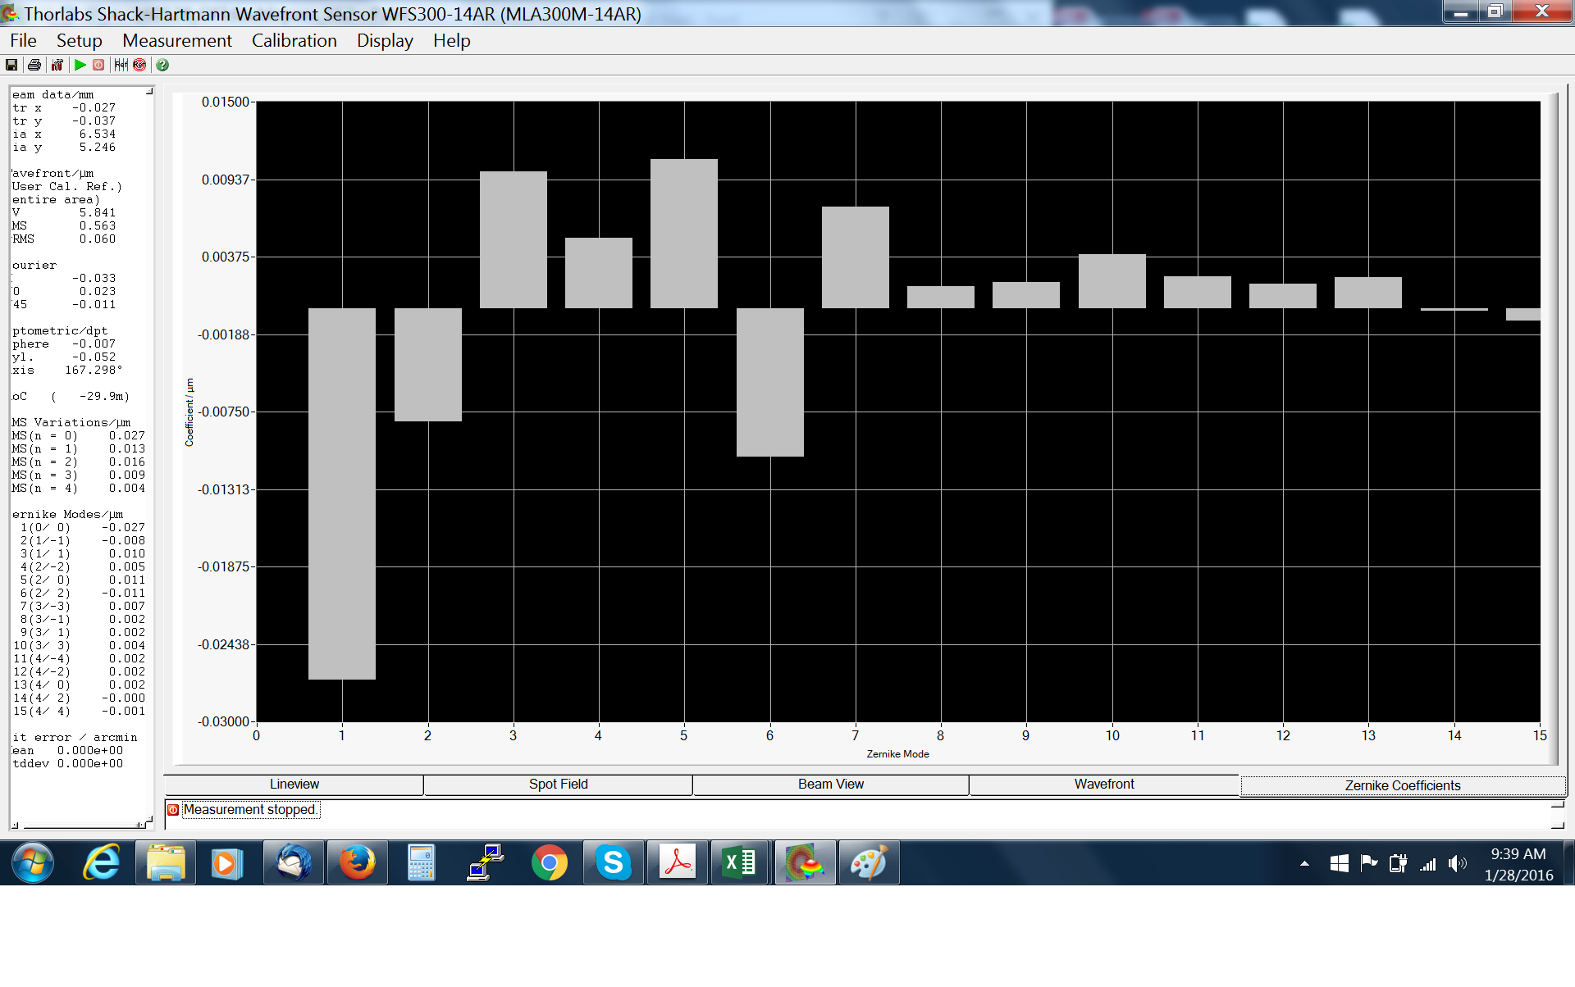
Evaluation: OK.

Additional references
E1300389 Align/Install Output Faraday Isolator LLO Test
E1300390 Align/Install Output Faraday Isolator LHO Test

