LASER INTERFEROMETER GRAVITATIONAL WAVE OBSERVATORY

-LIGO-

CALIFORNIA INSTITUTE OF TECHNOLOGY

MASSACHUSETTS INSTITUTE OF TECHNOLOGY

Document Type  Test Procedure | DCC Number  T1600056-v1 | March. 1, 2016
TCS AOM Driver Monitor Installation instructions
B. Abbott

Distribution of this draft:
This is an internal working note of the LIGO Laboratory

California Institute of Technology Massachusetts Institute of Technology
LIGO Project – MS 18-33 LIGO Project – MS 20B-145
Pasadena, CA 91125 Cambridge, MA 01239
Phone (626) 395-2129 Phone (617) 253-4824
Fax (626) 304-9834 Fax (617) 253-7014
E-mail: info@ligo.caltech.edu E-mail: info@ligo.mit.edu

http://www.ligo.caltech.edu/

Performed by:____________
Date:_____________
Board Serial Number: _____________

- Overview
The Thermal Compensation System (TCS) AOM Driver has two LEDs that encode the status of the driver using either red or green light. The purpose of this document is to explain how we can extract these signals, and monitor them in the control room. The key to their meaning is below:

A red LED status is read as +4.25V signal on the LED Monitor Output, which is read by the Beckhoff Binary Output module as a logic “1”. A green LED presents 0V on the Monitor Output, and is read as a logic “0” by the Beckhoff system.

- Dissasembly
In order to modify the panel, and install the hardware, it is necessary to first remove the cover. This is shown in the next few steps:

-Remove the 16 screws that hold the sheet metal onto the inner assembly:

4 top screws

5 screws on each side

And 2 countersunk screws on the bottom.

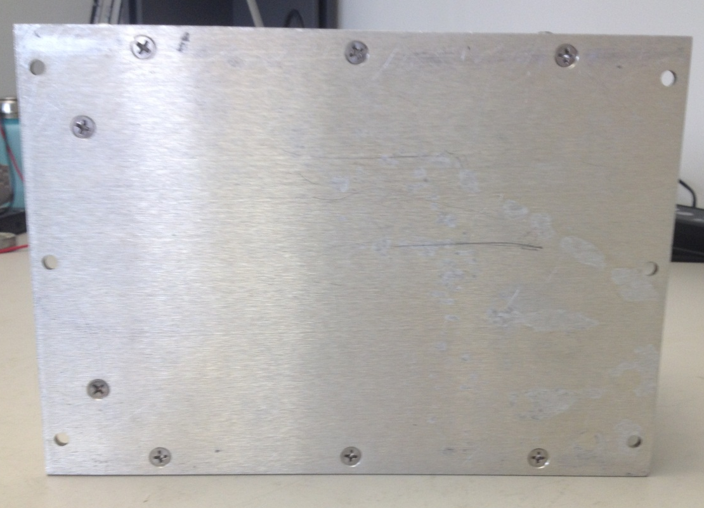

Next, slide the inner assembly out, toward the back panel:
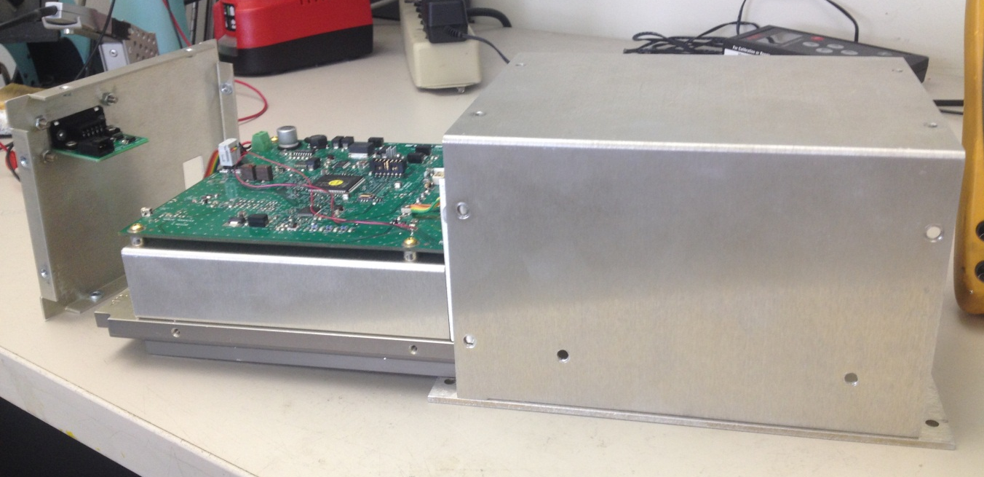

The status LED signals can be hijacked off of the PC board, and sent to the control room for monitoring. The places on the PC board where the signals come from are shown below:

Status 1 GND Status 2
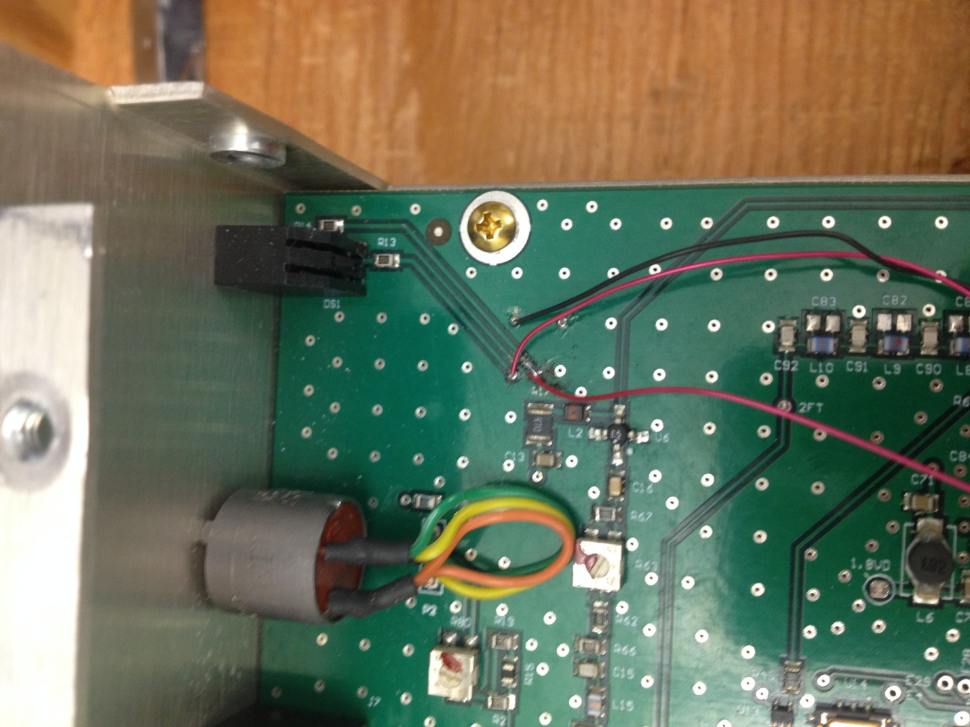

Here’s a close-up of the picture above, for clarity: All of these vias are GND:
R14 is on the
Trace for Signal 2

R13 is on the
Trace for Signal 1

These three places have vias into which a wire-wrap wire can be inserted and soldered. The Status 2 via in the picture above was slightly lifted, so I soldered it to the trace, instead. These wires are then inserted into the connector thusly:

Status 1 (Pin1) Status 2 (Pin2) GND (Pin3)
This connector is plugged into the AOM Monitor Board (D1500404). In order for that board to be used, 5 holes must be cut in the back panel of the AMO Driver enclosure. The central hole is a rectangle, 1.35” wide x 0.6” tall (+/- 0.1”), and the other four holes are 5/32” in diameter, and are spaced in a centered rectangle around the above hole. They are 0.65” apart, vertically and 1.65” apart horizontally. They should look like the drawing, below:

The board and connector should be able to pass through this panel, and be screwed on, like this (as viewed from the inside):

And the whole assembly should be positioned roughly like this:

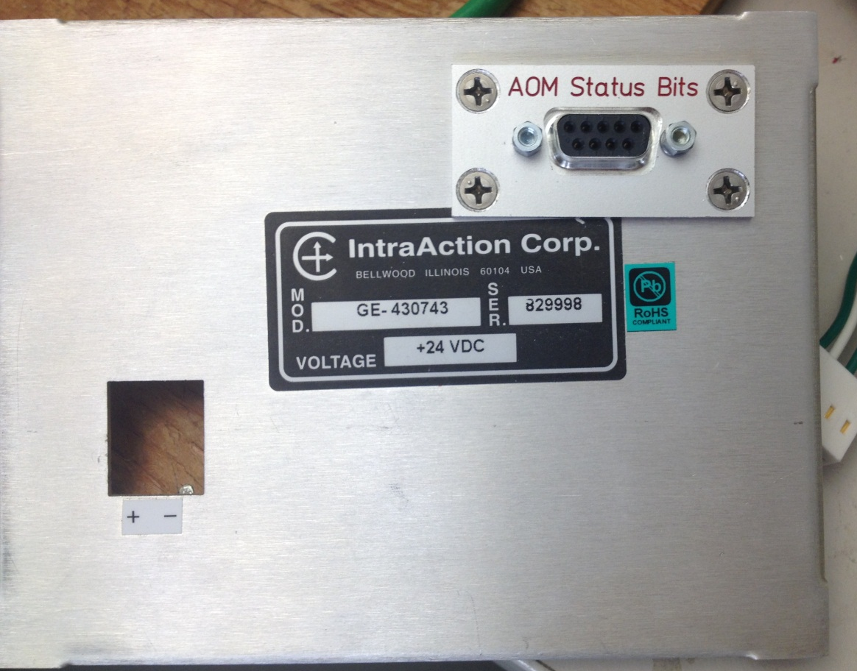

That way, it won’t interfere with any of the internal AOM Driver parts.

Before attaching the connector to the AOM Monitor board, slide the whole assembly in, and put in all the screws except the 8 that attach the back panel.

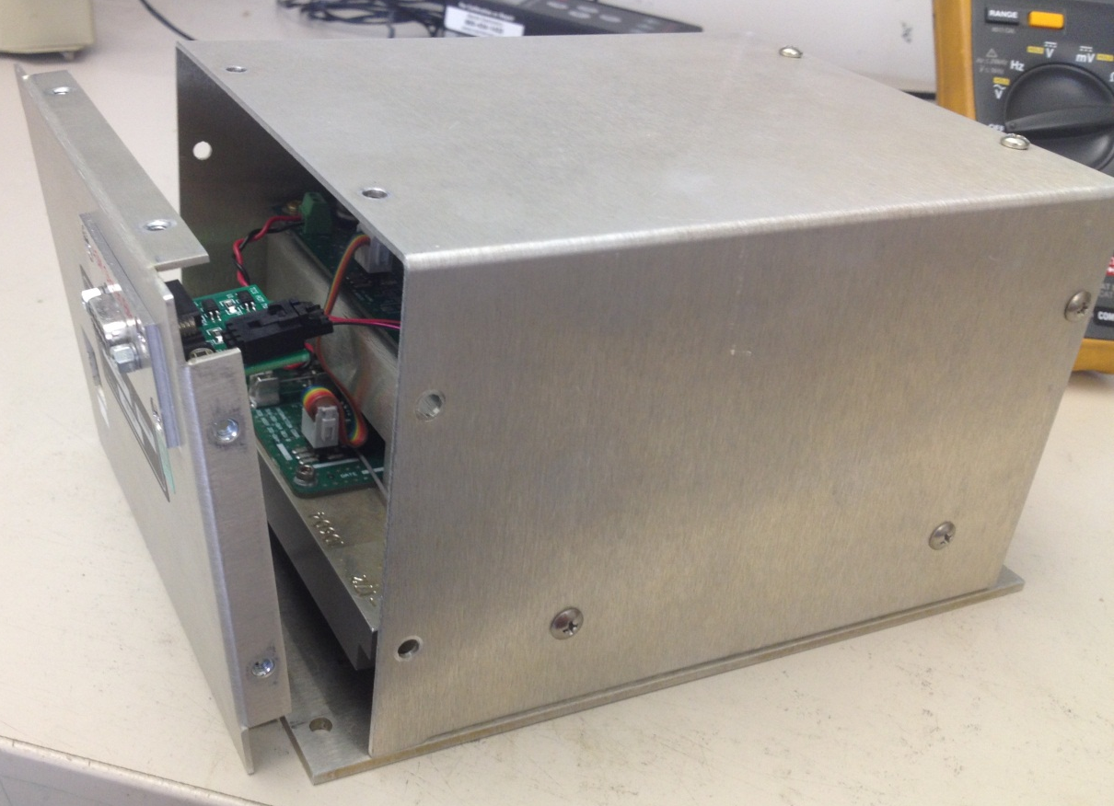

Now, plug in the connector, and attach the back panel with the six roundhead screws and 2 countersunk screws. At this point the modulator should be powered up with +24V and GND, and a separate 5V-to-GND should be supplied to pins 1(+) and 7(GND) of a 9-pin breakout attached to the AOM Mon connector. With no AOM plugged in, both LEDs should be red, and pins 6 and 2 should read +4.3V to pin7 (GND).

