Nicolas Rothbacher
Mentor: Eric Fries
Draft 4: 5/11/16
Extending a Plotting Application for the LIGO Open Science Center
INTRODUCTION/BACKGROUND
Albert Einstein first theorized gravitational waves in 1916 as a consequence of his theory of general relativity. The predicted amplitudes of these waves were incredibly small, making observation of these waves difficult [1]. In the 1960s, Joseph Weber led the first serious efforts to detect gravitational waves [2]. Weber’s original design used a large mass of aluminum and piezoelectric detector to sense changes in length of the aluminum bars. In the late 1960s and 1970s, prototype interferometer detectors were constructed, and in 1980 the NSF funded the construction of a 40 meter prototype at Caltech and a 1.5 meter prototype at MIT. These prototypes demonstrated the feasibility of a large interferometer and led to the creation of the Laser Interferometer Gravitational-Wave Observatory (LIGO) [3]. On September 14th, 2015 Advanced LIGO (aLIGO) directly detected a gravitational wave [4].
aLIGO is pair of detectors constructed using a modified Michelson interferometer design: one in Hanford, Washington and the other in Livingston, Louisiana. The detectors are separated by 10 ms of light travel time, and are oriented slightly off-axis from one another. The interferometers use 1064 nm lasers and $L=4 km$ arms, along with a number of signal enhancements. A passing gravitational wave induces a change in the length of the arms $ΔL\left(t\right)= δL_{x} - δL_{y}=h\left(t\right)L,$ where h is the strain amplitude projected onto the detector and$δL_{x}$ and $δL_{y}$ are the changes in arm length. h is the primary output channel, and the sensitivity of this output is determined by two main factors: the antenna pattern and the frequency of the wave detected. The antenna pattern is dependent on the sky position of the binary merger that produced the gravitational wave, the inclination of the binary orbit, and the orientation of the arms of the detector [5].
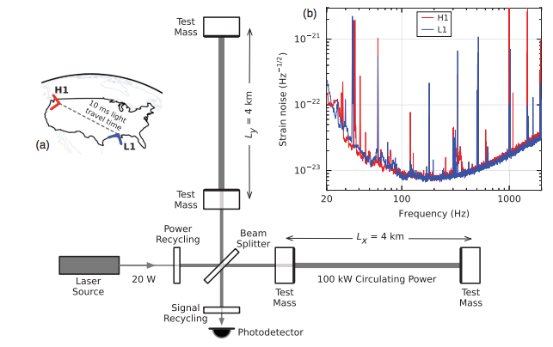
Figure 1: a) Arrangement of detectors and configuration of interferometer. b) Strain noise vs. frequency, showing the highest strain sensitivity in the middle part of the frequency spectrum.
This variation in strain sensitivity is due to different sources of noise. At low frequency, the limiting noise source is seismic vibration. At intermediate frequencies it is thermal noise. At high frequencies, the quantum shot noise produced by the Heisenberg uncertainty principle become the major noise source.
The gravitational wave event detected on September 14, 2015, GW150914, swept through frequencies from 35 to 250 Hz in 0.2 s with a maximum strain amplitude of $1.0 x{ 10}^{-21}$ occurring at the highest frequency. GW150914 is the first direct detection of gravitational waves. This event has great historical value, and it is vital that the data and analysis be presented to the public in an effective and understandable format. This project will expand the existing plotting software used by LIGO to represent the data in an interactive and publicly useful manner. The current plotting software used by LIGO, splot, generates static plots of a time series of the strain, as well as a spectrogram an amplitude spectral density of the strain. splot can also apply various types of filters to the data, adjust the sampling rate, and perform similar data manipulations. The goal of this project is to expand this functionality to include interactivity and other features useful to representing data to the public.

OBJECTIVES
This project has three goals: to introduce interactive features to splot, to integrate additional existing data analysis algorithms to splot, and to create a simplified version of splot that does not use JavaScript. The primary objective is to expand splot to allow the user to interactively zoom in on different parts of the plots, and apply a filter or modify an existing filter. Both of these features would allow real time manipulation and would not require the user to reload the page. The secondary objective is to allow the user to produce an Omega-scan, a correlogram, and an audio file of the strain. An Omega-scan, shown in Figure 2, is a version of a spectrogram that tunes input parameters to maximize the power recovered by the spectrogram. A correlogram displays the correlation between the strains in the two detectors, after correcting for differences in phase and shifting in time. This will allow the user to see the importance of having two detectors and to visualize how the two detectors confirm the observation. An audio file is of interest as the signals are usually in the frequency band that is audible to the human ear. The tertiary objective is to implement a version of splot that works without the use of JavaScript. This version of splot would have to be greatly simplified.
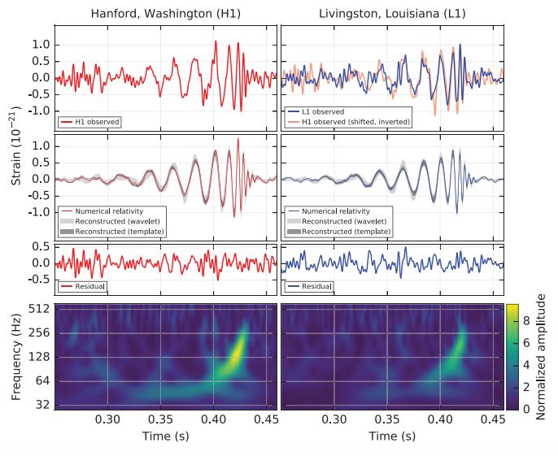
Figure 2: Various possible data outputs from splot. Top row shows strain vs. time, second row filters for most sensitive band, third row shows extracted noise and bottom row shows an Omega-scan of the data.

APPROACH
The primary objective of implementing interactive elements will be accomplished by using a preexisting Python package in conjunction with JavaScript to ensure that the user can access these features without needing to reload the page. Some candidates for Python packages that would allow interactivity include Bokeh and mpld3. The current implementation of splot is already written in Python, so incorporating a Python package should be a fairly simple task. The biggest obstacle will be merging code between splot and a Python package, and deciding which package will work best with splot.
The secondary objective of producing additional outputs could be somewhat more difficult for two technical reasons. First, the servers may not be able to return an Omega-scan or a correlogram in a timely manner. In this case, the possibility the user submitting a request for the plot and alerting the user when the plot is ready should be investigated. Second, the integration may be difficult because it is plausible the existing analysis code cannot be easily merged with splot. Either of these technical issues may make the secondary objective intractable.
The tertiary objective is a much lower priority than the other two. It would involve writing a configuration case with a much reduced set of features that could be used on a browser without JavaScript enabled. This could require rewriting a considerable amount of code and would only serve a very small portion of the public, so this would be attempted only after exhaustive work on the other two objectives.
WORK PLAN
The summer research fellowship is 10 weeks long. The first two weeks will be spent investigating the Python packages mentioned in the approach, Bokeh and mpld3, and implementing splot into these new packages. This should only take two weeks since the current implementation of splot is already written in Python and transferring this over into these packages will simply be a matter of comparing the functionality of splot to that available in the Python packages, selecting one and making sure that splot transfers over well. The next four weeks will be spent programming the extensions to splot that will allow users to interact with the plots generated. This will take longer as fully implementing these interactive features will involve making sure that splot is able to work correctly in a webpage environment utilizing JavaScript. The next three weeks will be devoted to completing the secondary objective of the project, creating the other data output tools. At this point, implementing features into the web-based splot tool should be a more established method and much of the code should already be written for these output tools allowing this objective to take less time to implement more features. The last week will be reserved for the tertiary objective if the other two have been completed. Since this objective is simply transferring what exists currently to a webpage, this objective can be completed in a single week.
REFERENCES
[1] A. Einstein, Sitzungsber. K. Preuss. Akad. Wiss. 1, 688 (1916).
[2] LIGO, https://www.ligo.caltech.edu/system/media_files/binaries/313/original/LIGOHistory.pdf
[3] J. Weber, Phys. Rev. 117, 306 (1960).
[4] B. P. Abbott et al., PRL 116 061102 (2016).
[5] D. G. Keppel, Doctoral Thesis, 33 (2009).

