LASER INTERFEROMETER GRAVITATIONAL WAVE
OBSERVATORY

-LIGO-

CALIFORNIA INSTITUTE OF TECHNOLOGY

MASSACHUSETTS INSTITUTE OF TECHNOLOGY

Document Type  T - Technical notes | DCC Number  T1600185-v2 | May 27, 2016
aLIGO L4C Interface Chassis Test Plan
D. McManus, B. Abbott, S. Abbott

Distribution of this draft:
This is an internal working note of the LIGO Laboratory

California Institute of Technology Massachusetts Institute of Technology
LIGO Project – MS 18-33 LIGO Project – MS 20B-145
Pasadena, CA 91125 Cambridge, MA 01239
Phone (626) 395-2129 Phone (617) 253-4824
Fax (626) 304-9834 Fax (617) 253-7014
E-mail: info@ligo.caltech.edu E-mail: info@ligo.mit.edu

http://www.ligo.caltech.edu/

Introduction
The tests described below are required to verify the correct operation of the aLIGO L4C Interface Chassis electronics. These tests should verify the correct operation of all four boards internal to this chassis. There are three L4C interface boards, and a Back Board in each chassis.

Test Equipment
Network Analyzer
Oscilloscope
Digital Multimeter (DMM)
Triple Power Supply (+/- 18V, 5V Fixed)
One 25-pin Dsub Breakout
One 9-pin Dsub Breakout

Serial Numbers
Input the internal board serial numbers below:

L4C Interface Board (1) | L4C Interface Board (2) | L4C Interface Board (3) | Back Board

Tests

Input Power
Hook up power to the back panel of the chassis with +18V going to pin 1, -18V to pin 3, and GND going to pin 2. Turn on all of the power switches, and record the current being drawn. The nominal current is ~320mA +/- 10mA.

+18V_______mA -18V_______mA

At this point, all of the front and back panel power LEDs should be lit.
LEDs Lit?____________

Voltage Output
The following tests make sure that the chassis is supplying the correct voltages to the L4Cs. On the appropriate connector, verify that the correct voltages are present in the table below. Use the appropriate switch on the back panel to turn on and off the power to the specific device to verify switch operation. Watch the front panel LEDs to verify the correct switch operation.

Connector | Pin | Voltage expected | Present and switchable?
L4Cs 1&2 | Pin 3(+) to Pin 16(GND) | +15V
L4Cs 1&2 | Pin 4(-) to Pin 17(GND) | -15V
L4Cs 1&2 | Pin11(+) to Pin 24(GND) | +15V
L4Cs 1&2 | Pin 12(-) to Pin 25(GND) | -15V
L4Cs 3&4 | Pin 3(+) to Pin 16(GND) | +15V
L4Cs 3&4 | Pin 4(-) to Pin 17(GND) | -15V
L4Cs 3&4 | Pin11(+) to Pin 24(GND) | +15V
L4Cs 3&4 | Pin 12(-) to Pin 25(GND) | -15V
L4Cs 5&6 | Pin 3(+) to Pin 16(GND) | +15V
L4Cs 5&6 | Pin 4(-) to Pin 17(GND) | -15V
L4Cs 5&6 | Pin11(+) to Pin 24(GND) | +15V
L4Cs 5&6 | Pin 12(-) to Pin 25(GND) | -15V

Channel Tests

L4C Channel Tests

To test the gain of the L4C channels, float channel 1 and 2 and input a 50mV p-p signal from 1Hz to 10kHz in the pins specified below, and read the appropriate outputs.

4.3.2.1 No Binary In pins Grounded

Input Connector | Signal Out | Expected transfer function | Function correct?
L4Cs 1&2 pins 1(+) and 14(-) | AA Out 1  pins 1(+) and 6(-) | DC Gain of  23.5 dB
L4Cs 1&2 pins 9(+) and 22(-) | AA Out 1  pins 2(+) and 7(-) | DC Gain of  23.5 dB
L4Cs 3&4 pins 1(+) and 14(-) | AA Out 2  pins 1(+) and 6(-) | DC Gain of  23.5 dB
L4Cs 3&4 pins 9(+) and 22(-) | AA Out 2  pins 2(+) and 7(-) | DC Gain of  23.5 dB
L4Cs 5&6 pins 1(+) and 14(-) | AA Out 3  pins 1(+) and 6(-) | DC Gain of  23.5 dB
L4Cs 5&6 pins 9(+) and 22(-) | AA Out 3  pins 2(+) and 7(-) | DC Gain of  23.5 dB

4.3.2.2 Ground “From Binary Out” connector pins listed in the “Ground” column to “From Binary Out” pin 5.

Input Connector | Ground | Signal Out | Expected transfer  function | Function  correct?
L4Cs 1&2 pins 1(+) and 14(-) | Pin 1 | AA Out 1  pins 1(+) and 6(-) | DC Gain of  12.5 dB
L4Cs 1&2 pins 9(+) and 22(-) | Pin 6 | AA Out 1  pins 2(+) and 7(-) | DC Gain of  12.5 dB
L4Cs 3&4 pins 1(+) and 14(-) | Pin 2 | AA Out 2  pins 1(+) and 6(-) | DC Gain of  12.5 dB
L4Cs 3&4 pins 9(+) and 22(-) | Pin 7 | AA Out 2  pins 2(+) and 7(-) | DC Gain of  12.5 dB
L4Cs 3&4 pins 1(+) and 14(-) | Pin 3 | AA Out 3  pins 1(+) and 6(-) | DC Gain of  12.5 dB
L4Cs 3&4 pins 9(+) and 22(-) | Pin 8 | AA Out 3  pins 2(+) and 7(-) | DC Gain of  12.5 dB

Unground “From Binary Out” connector pins from pin 5.

L4C Channel Noise Tests
To test the noise of the L4C channels, ground the appropriate pins on the input connector, and do a noise measurement from 0.1 Hz to 10KHz on the output connector pins specified below. Read the noise at 1Hz and 10Hz. Ground the appropriate pins on the From Binary Out connector. The observed numbers should be below the specification to pass this test.

L4C Channel | Ground  the following | Expected  Noise  @1Hz | Actual Noise  @1Hz | Expected  Noise  @10Hz | Actual Noise  @10Hz
L4C 1  GND pins 1 and 14  Measure AA Out 1 pins 1 and 6 | Nothing | 270nV |  | 157nV
 | Pin 1 (Gain) | 190nV |  | 88nV
L4C 2  GND pins 9 and 22  Measure AA Out 1 pins 2 and 7 | Nothing | 270nV |  | 157nV
 | Pin 6 (Gain) | 190nV |  | 88nV
L4C 3  GND pins 1 and 14  Measure AA Out 2 pins 1 and 6 | Nothing | 270nV |  | 157nV
 | Pin 2 (Gain) | 190nV |  | 88nV
L4C 4  GND pins 9 and 22  Measure AA Out 2 pins 2 and 7 | Nothing | 270nV |  | 157nV
 | Pin 7 (Gain) | 190nV |  | 88nV
L4C 5  GND pins 1 and 14  Measure AA Out 3 pins 1 and 6 | Nothing | 270nV |  | 157nV
 | Pin 3 (Gain) | 190nV |  | 88nV
L4C 6  GND pins 9 and 22  Measure AA Out 3 pins 2 and 7 | Nothing | 270nV |  | 157nV
 | Pin 8 (Gain) | 190nV |  | 88nV

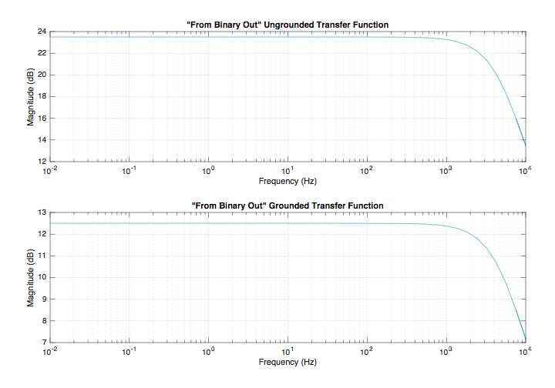
Reference L4C Channel Transfer Functions

