LIDT Logboock
Jan 2016 –

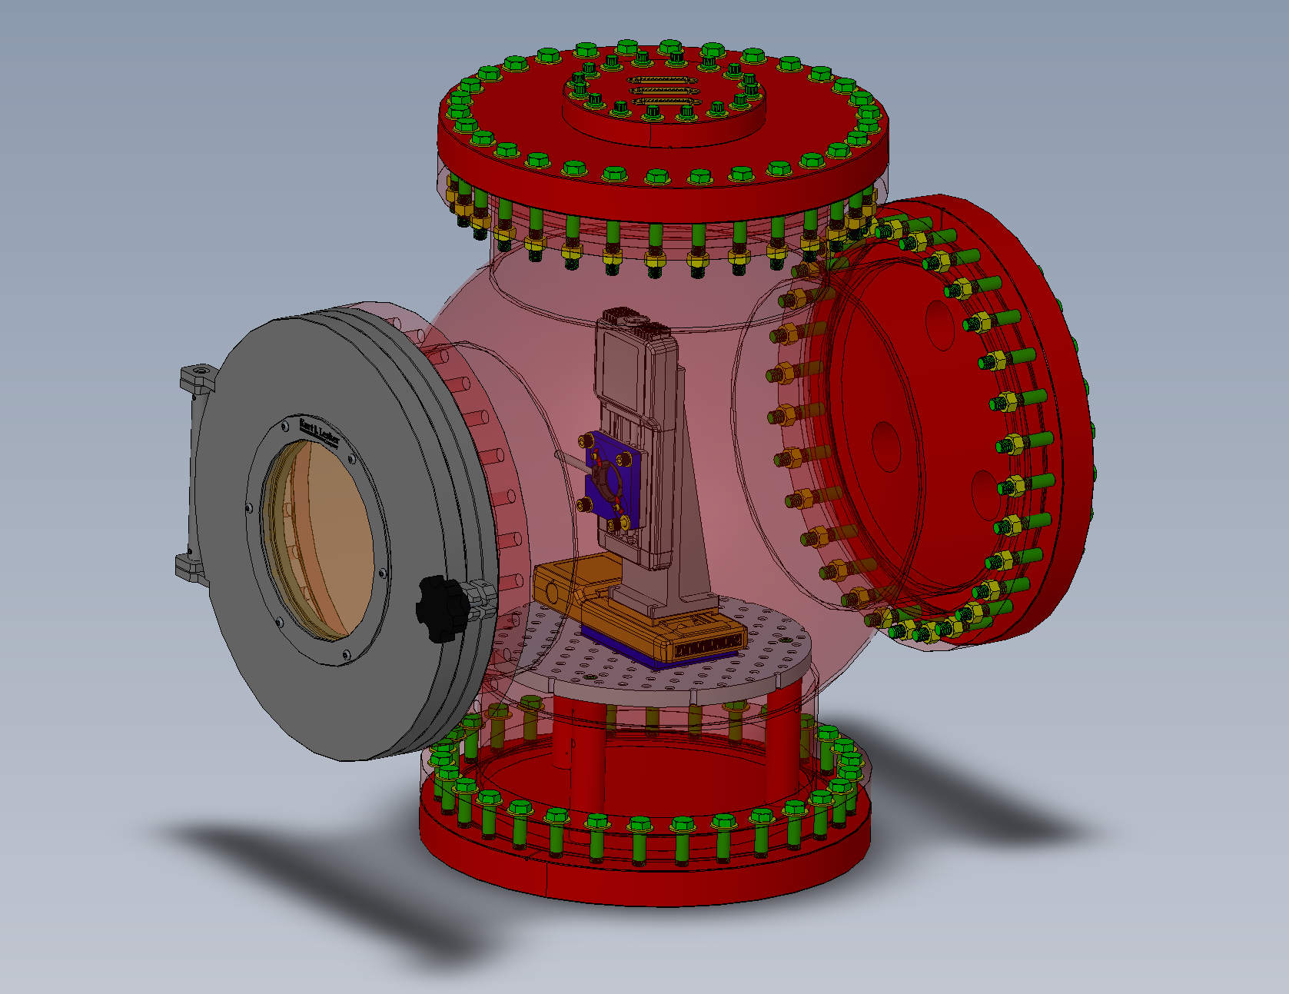

Vacuum test 5 Jan 2016
Excel tables: F:\Alena\LIDT\Vacuum test\Jan 5\vac test tables anf graphs

To do:
- Racks for the controllers
- Mount the gauge
- Final vacuum test with N and a venting valve

Pump line from 5 Jan:

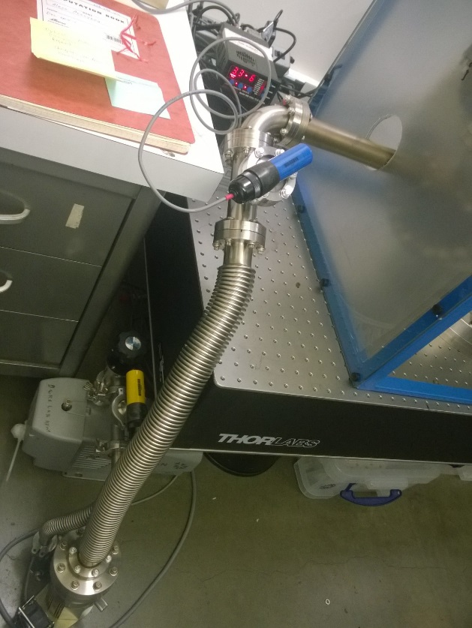

- Roughing pump on
- Turbo on at e-1 torr
- CCG turn on within 20 sec
- E-5 reaches within an hour

Vacuum test with new gauge controller
Start: Friday about 5 PM Jan 8
Pressure on Saturday 1:53 PM is 1.1*10^-6 torr
Pressure on Monday morning 7:30 AM is 5.8*10^-7 torr
Pressure on Jan 19

Optical layout Jan 19:
Incident angle on the target: 4 degrees
Beamdump from Steve
Periscope from Liyuan
Rails: one from Bob, one from Liyuan
Additional board from Calum
Need to buy 10 inch rods and clamps, the rest is from Bob

Status Jan 20:
Set at is taken a part, ultrasonic cleaned. Baking started at 3PM until Friday noon.

Status Jun 28:
Laser training. Tutorial how to turn the laser on and of below:
Turn the key, wait, press the green button, wait, press “emission”, press the red button on the screen, at first choose 10% intensity. Check the laser beam, make sure it is dumped at the end, and increase the intensity if needed.
To switch off the laser first put the intensity down to 0%, press the “emission” button, turn the key.

Status March 03:
Pump line upgraded:
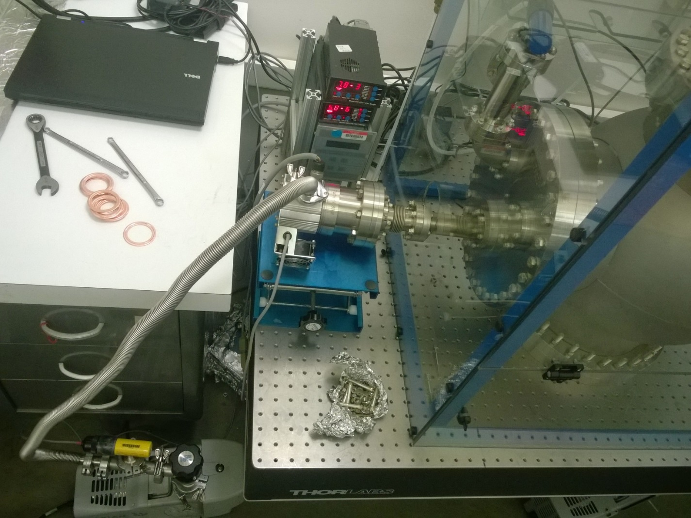
Exchanged the roughing pump, shorten the pump line after turbo. Vacuum test started at lunch time Wednesday, pressure in an hour 1*10-^5 tor, next morning 8 10^6, Friday 5.8 10^-6 torr. Ok for measurements.

Status March 23:
Exchanges the viton ring on the door. Big improvement on vacuum. Pressure over the night:
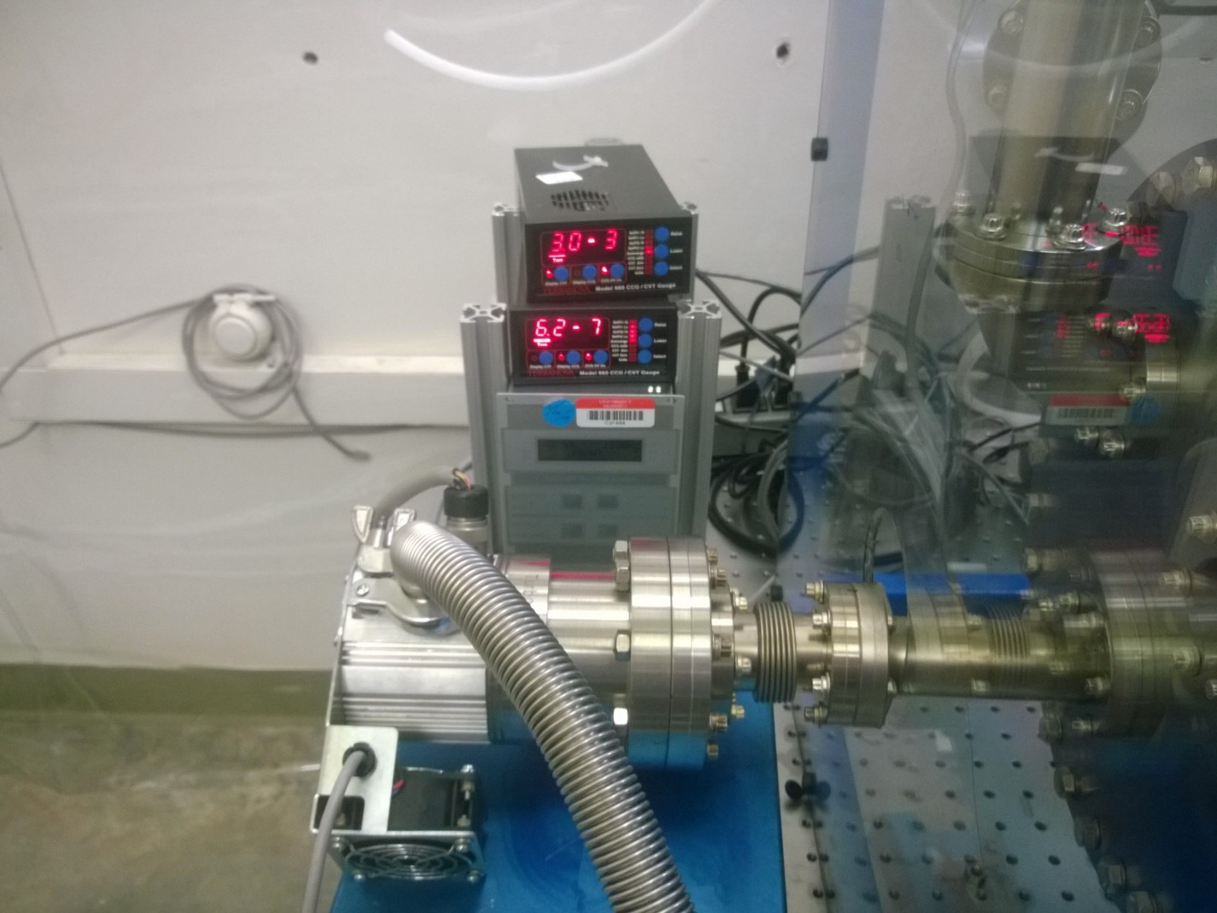
How to save ASCII from DATAQ (compatible with Mathematica):
File->Save as->
File name: as ***.dat
Save as type: All files
Chose ASCII -> mark both things on the right upper corner

Status March 28:
Final vacuum test with a new venting valve:
Current value
TeamViewer monitoring. Voltage curve in ch1. Sample rate 0.2 for two channels (0.1 per channel) -> every 10 sec

Vacuum log:
from Jan 8, Feb 25, and March 28
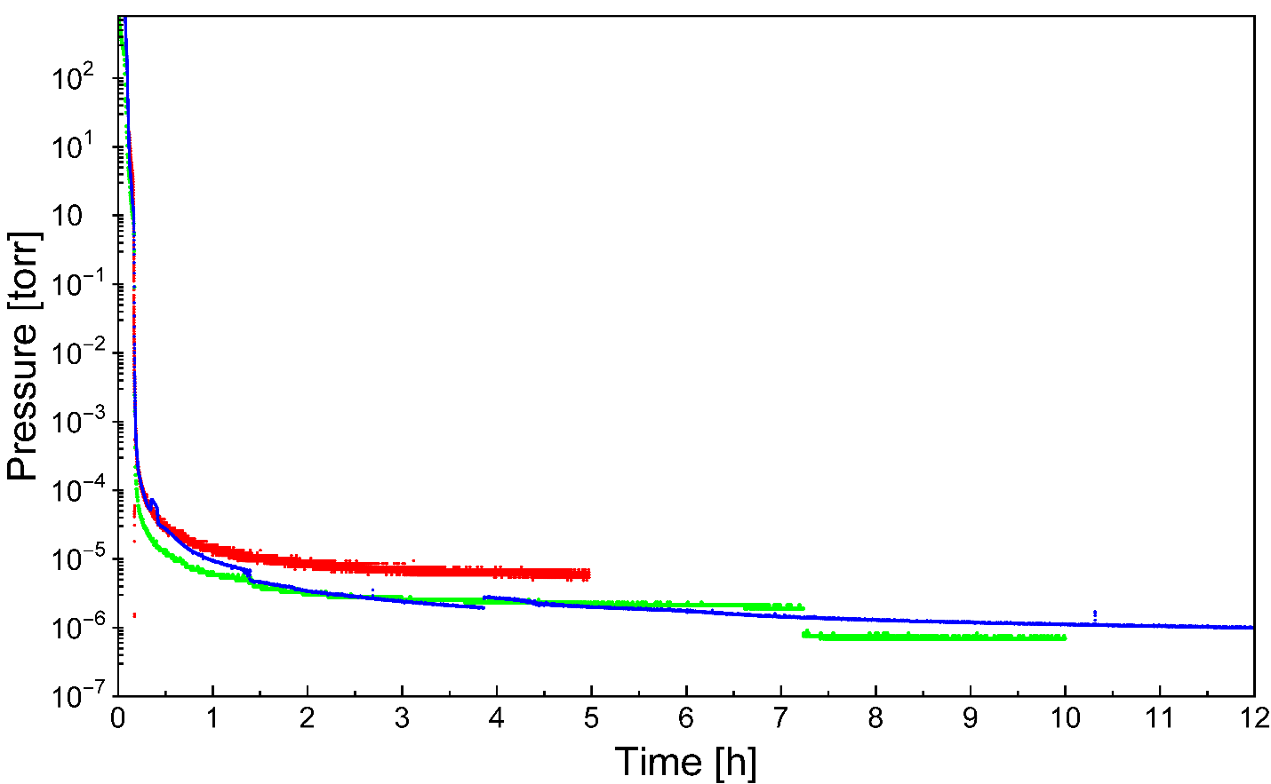
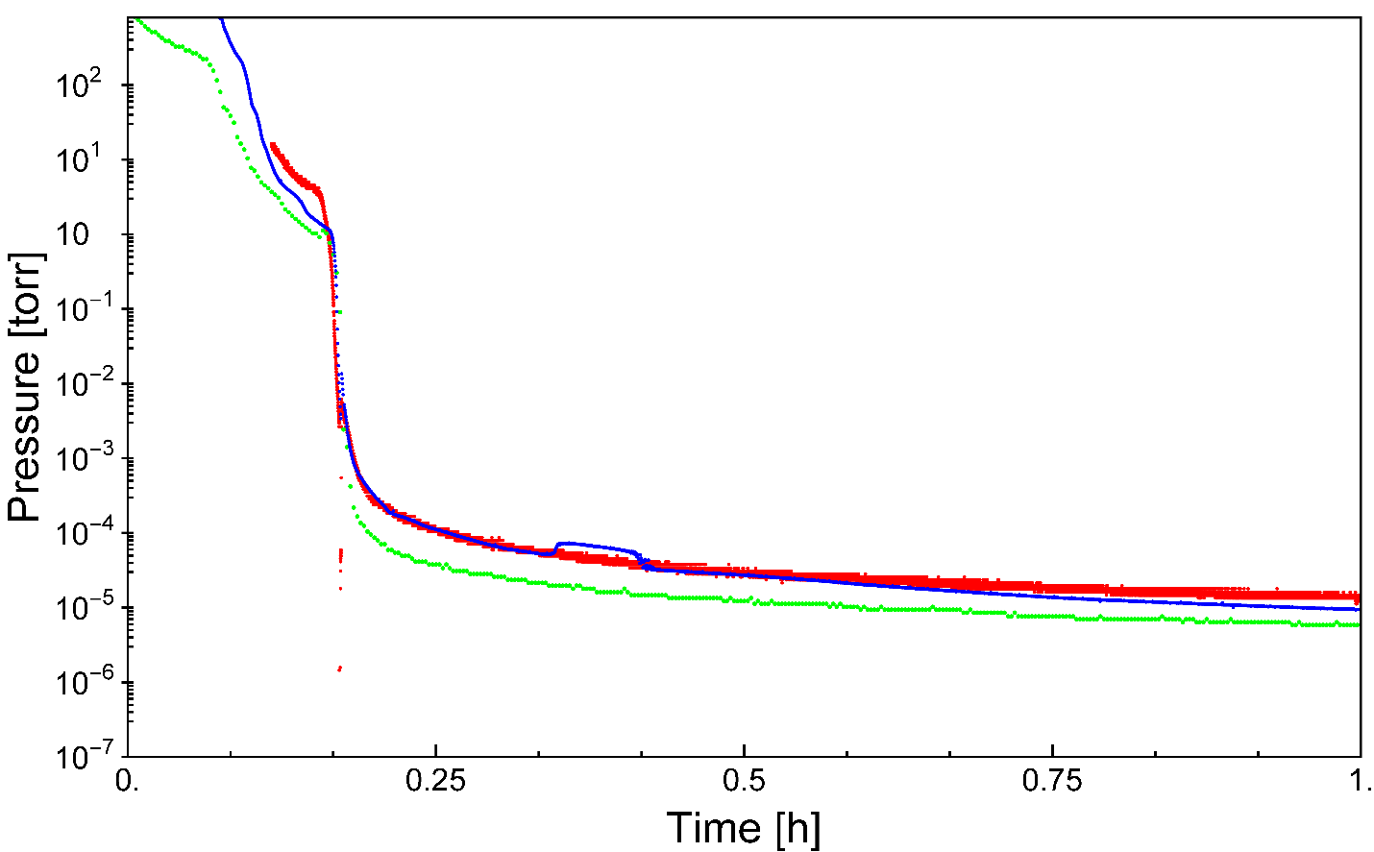

Status April 22: Started bake out at up to 100 C for a week:
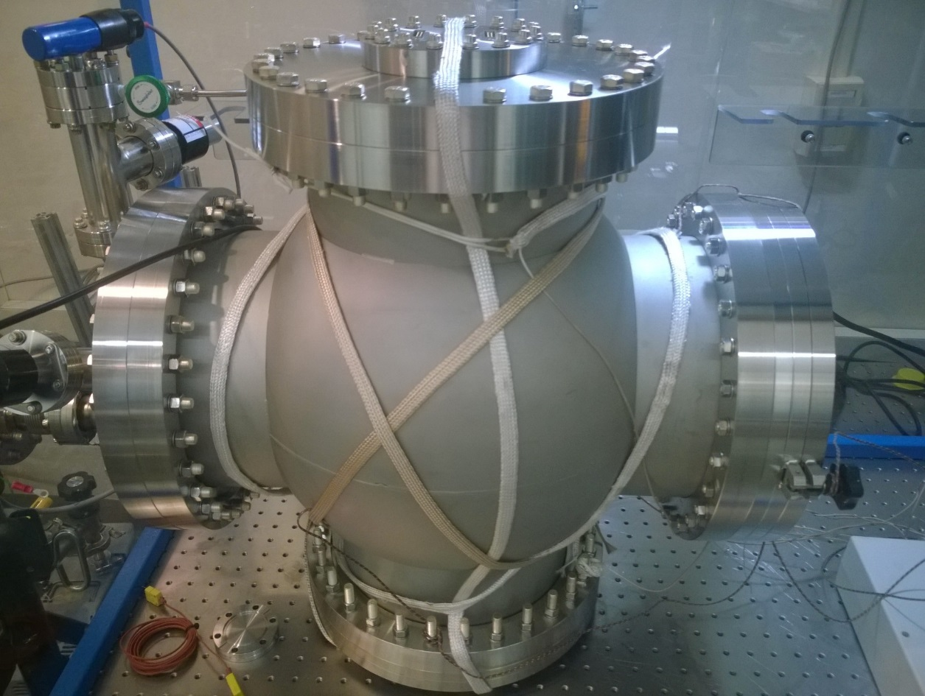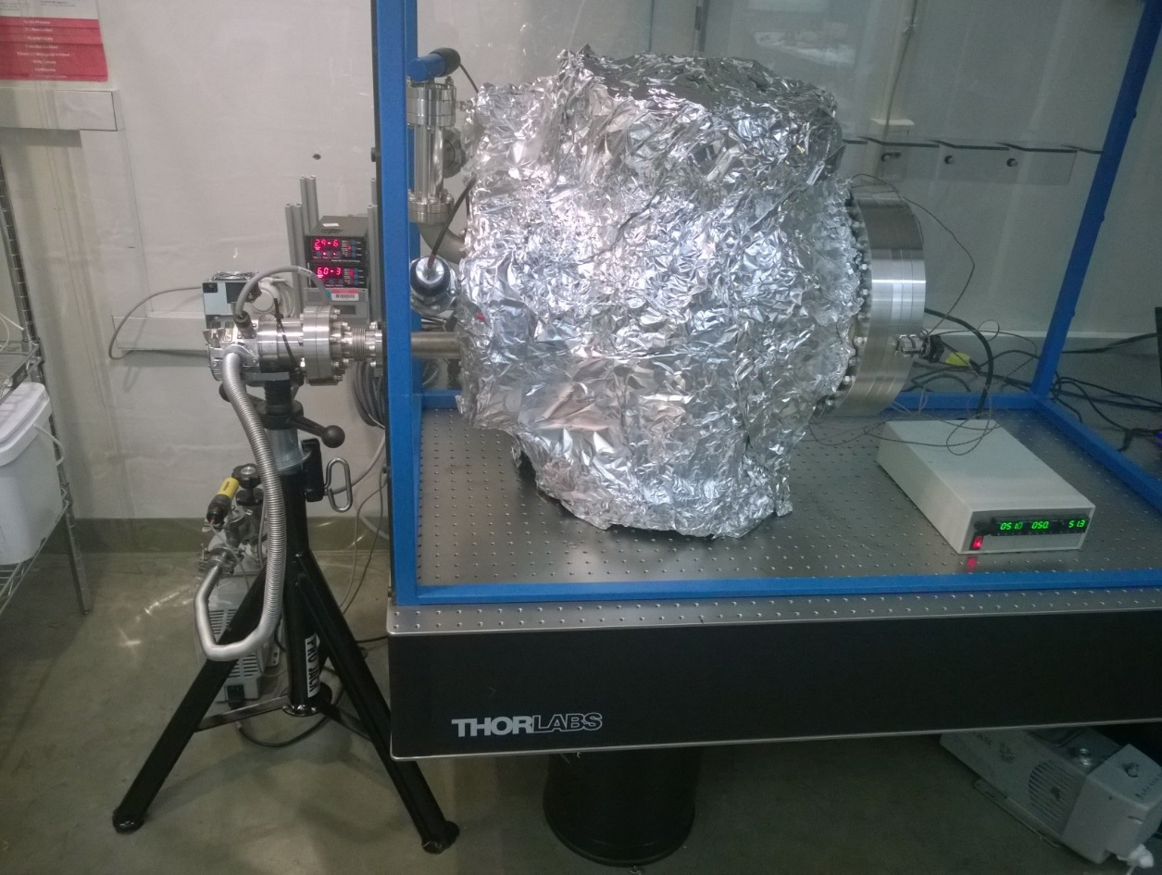
Pressure curve during the bake out:
Hitter tap controller max soak time is 48 hours. After that it was turned on manually every time.

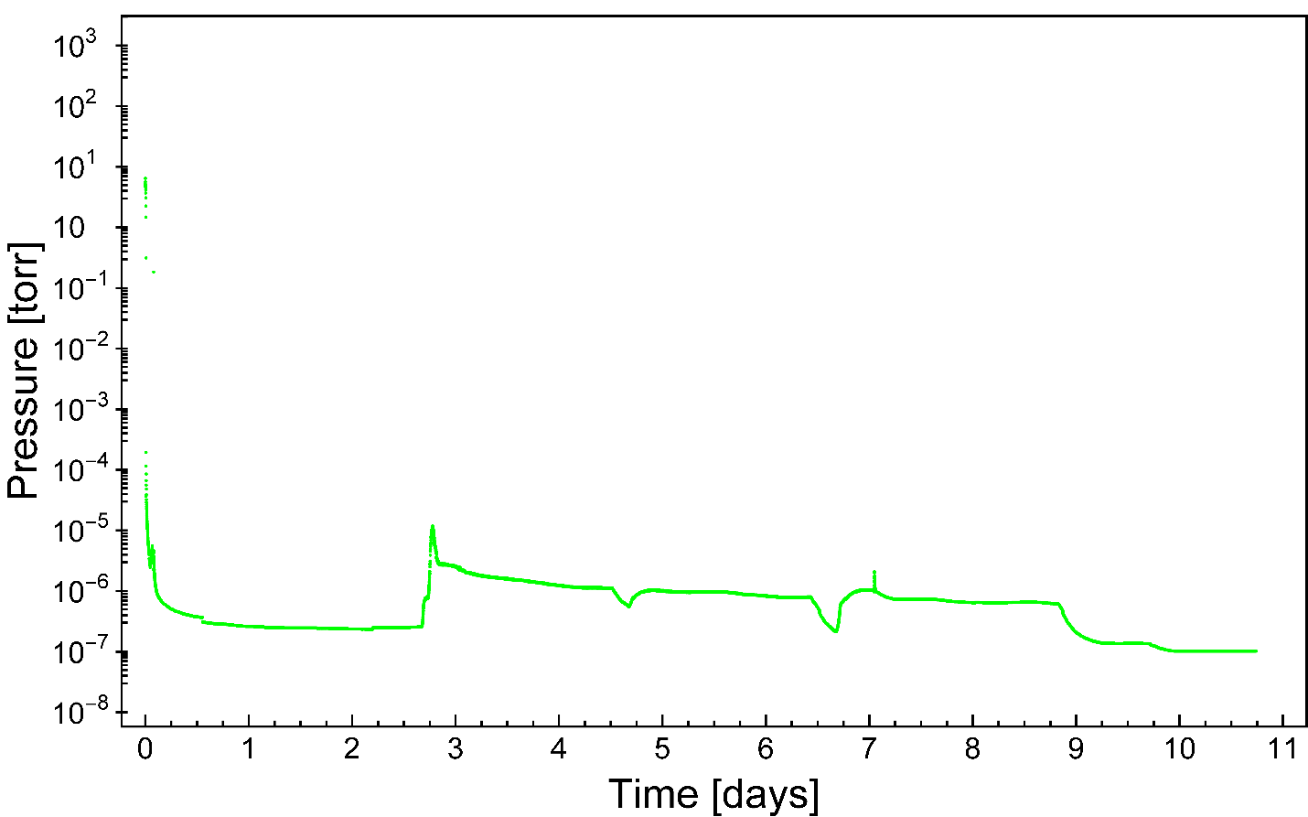
Hitting turn back on 115 C
Hitting turn back on 75 C
Cooling down
Hitting turn on 75 C
Pump down

Status May 5: Pump down after the first vent with N: very fast

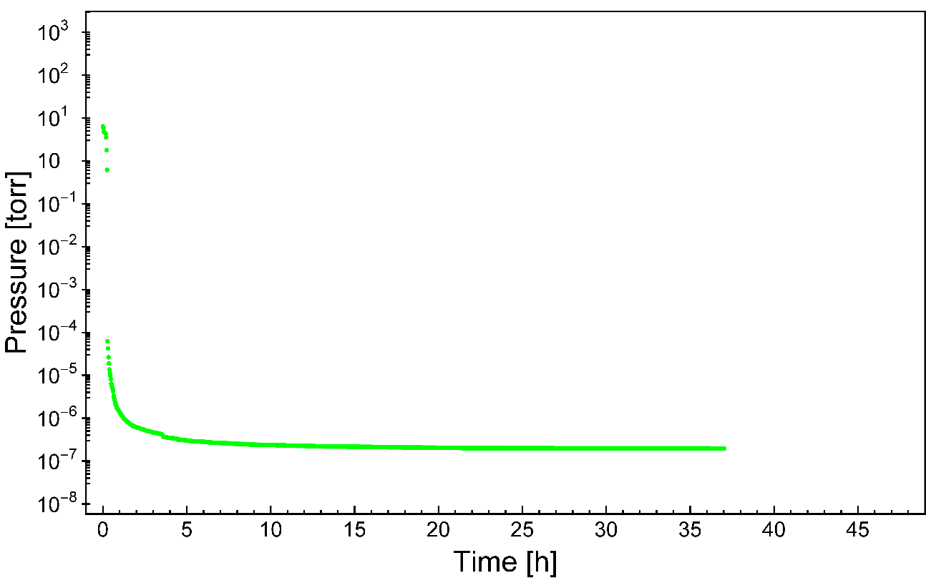

Status May 23: Pump down with XY stage inside for the first time
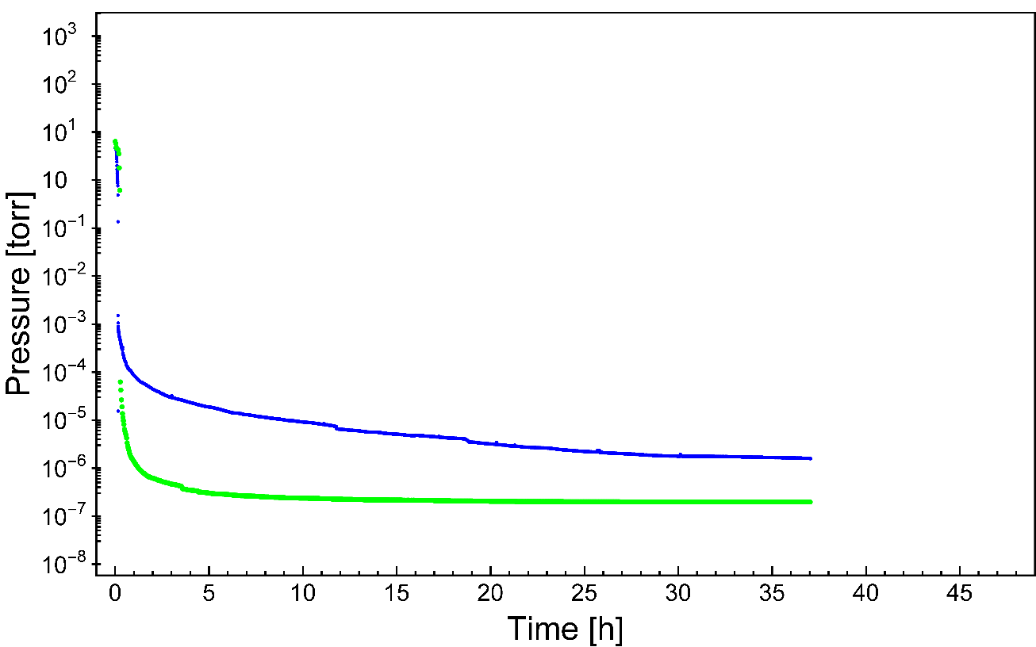

Status June 6: Improvement for later xy-stage pump downs:
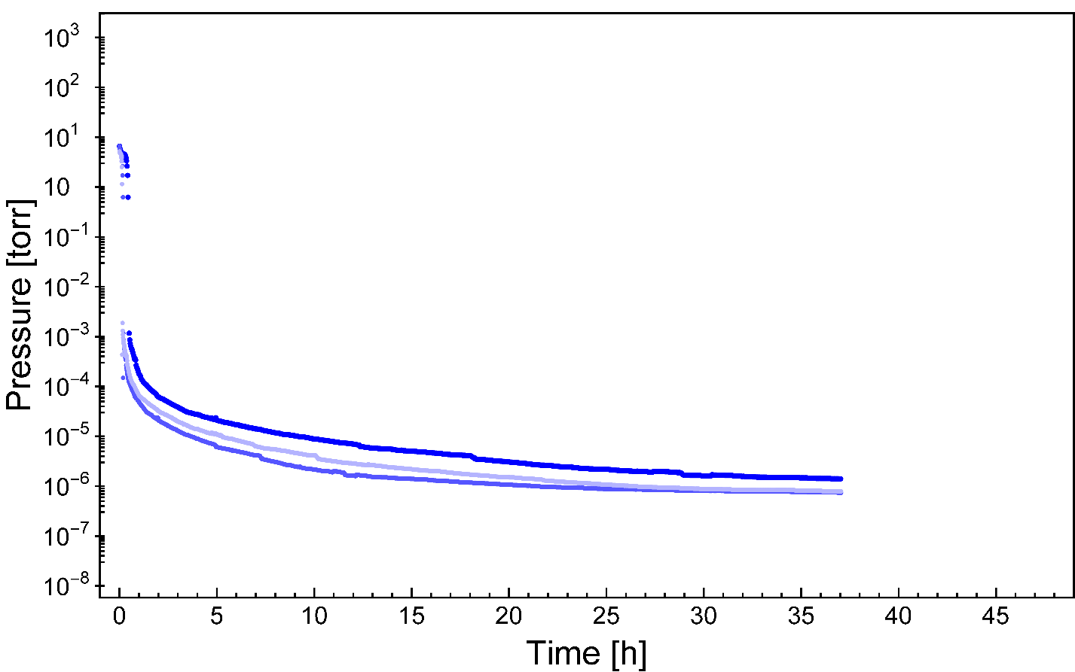

Laser layout alignment
Placed a beam profiler at the target position but outside the chamber: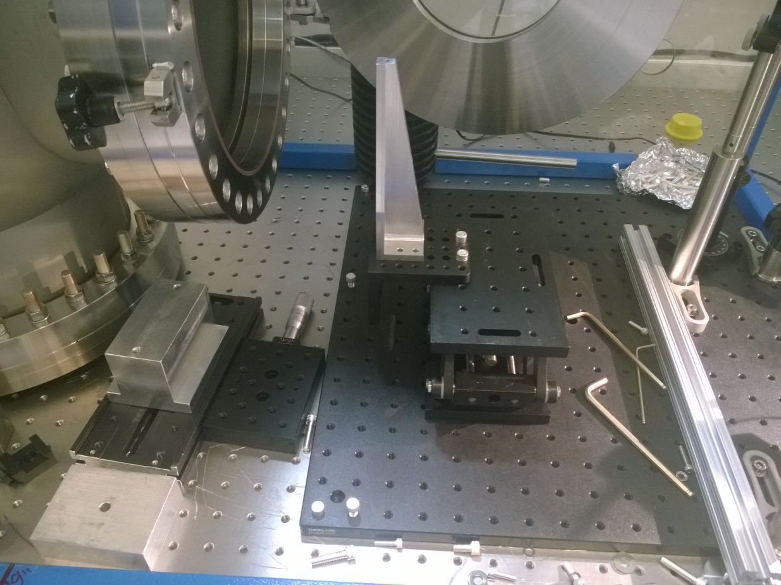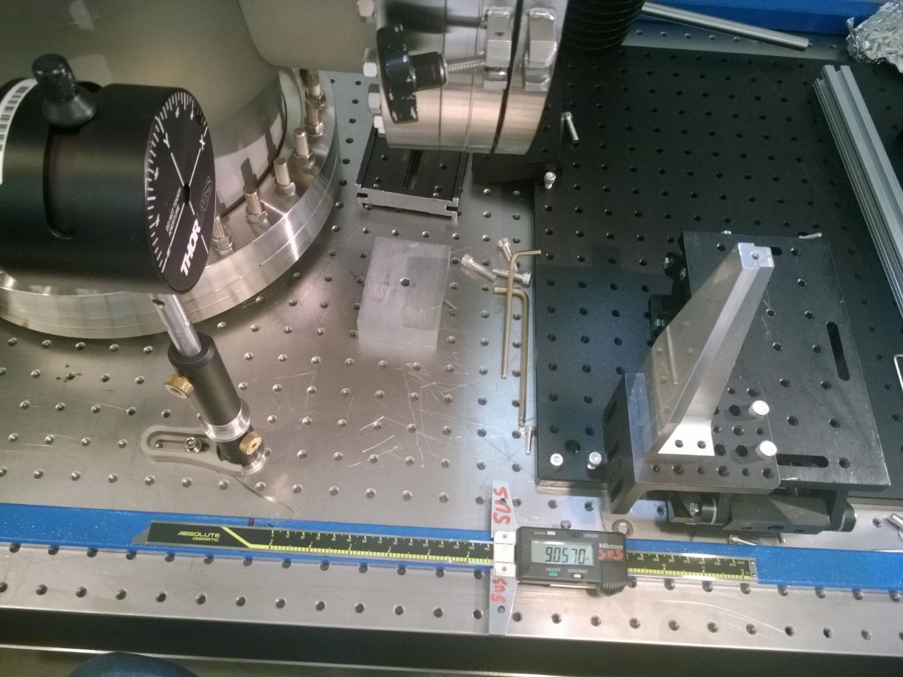
Laser: anodized pipe -> mirror -> periscope ->mirror -> mirror-> focal lance-> beam profiler
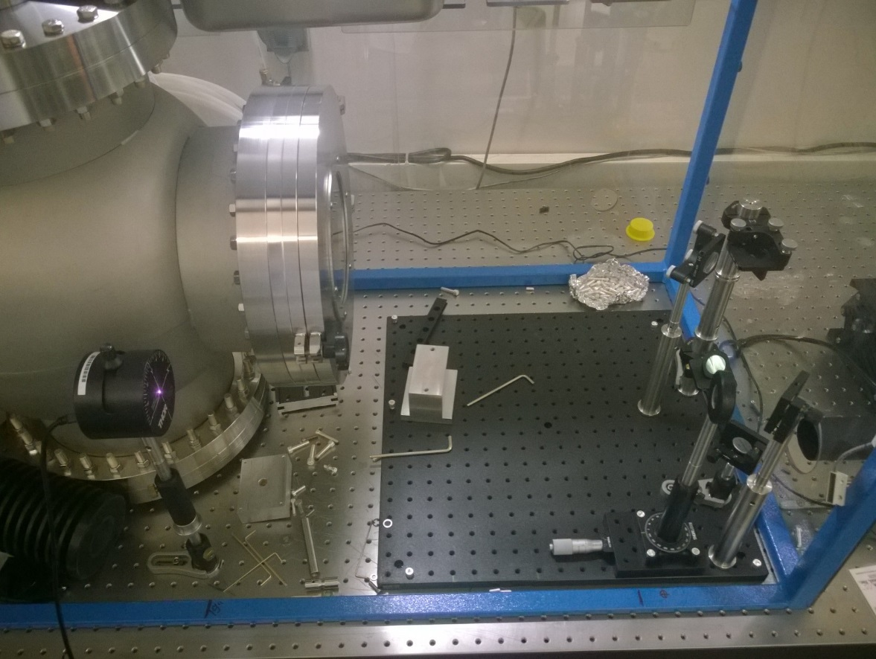
Focal distance was adjusted at the translation stage as: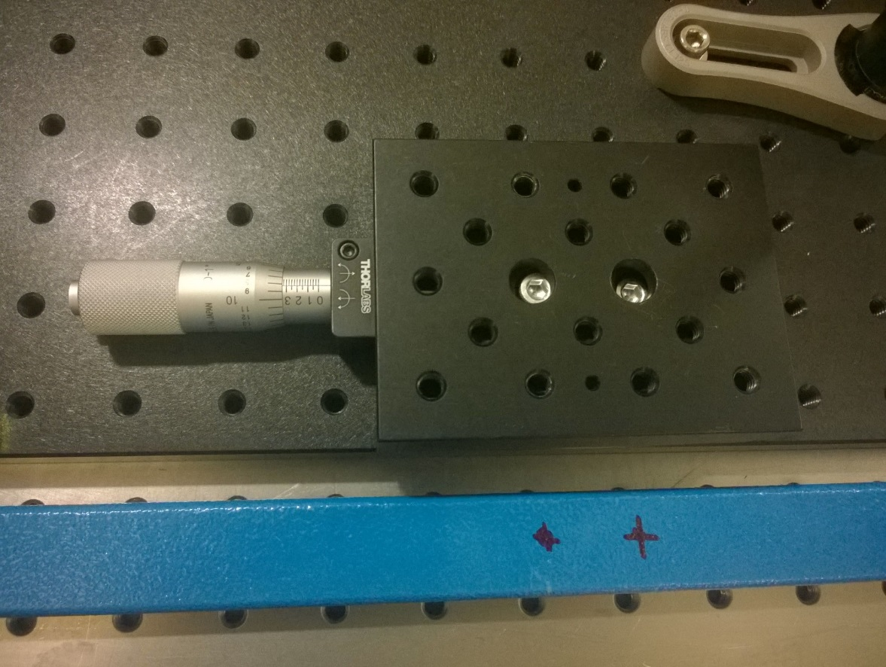

Beam profiler measured about 100 micron beam waist:
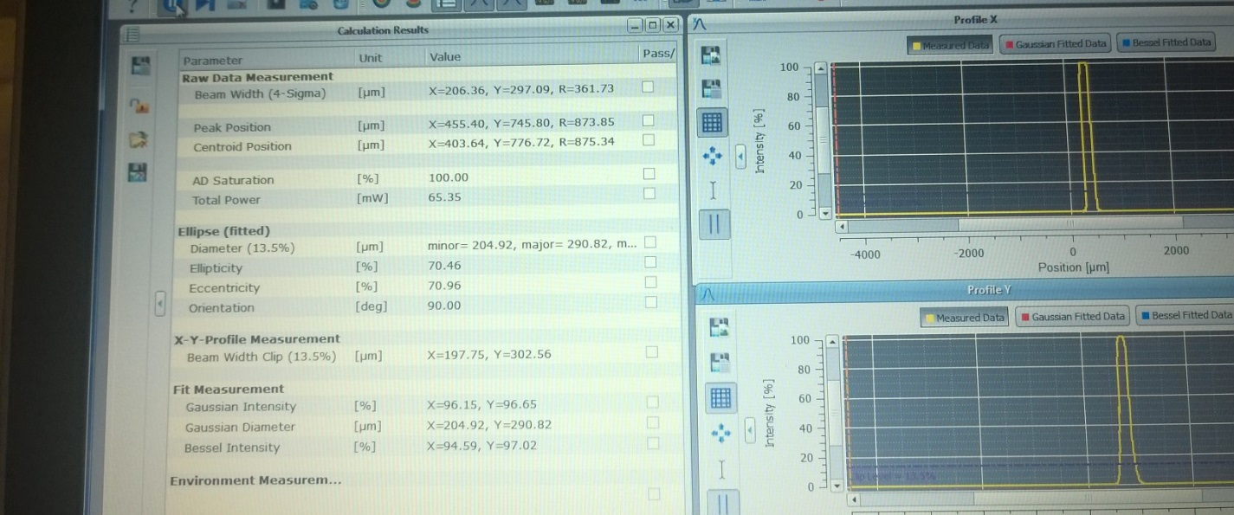
The translation stage with the focal lance has been moved next to the periscope keeping the same distance to the target.
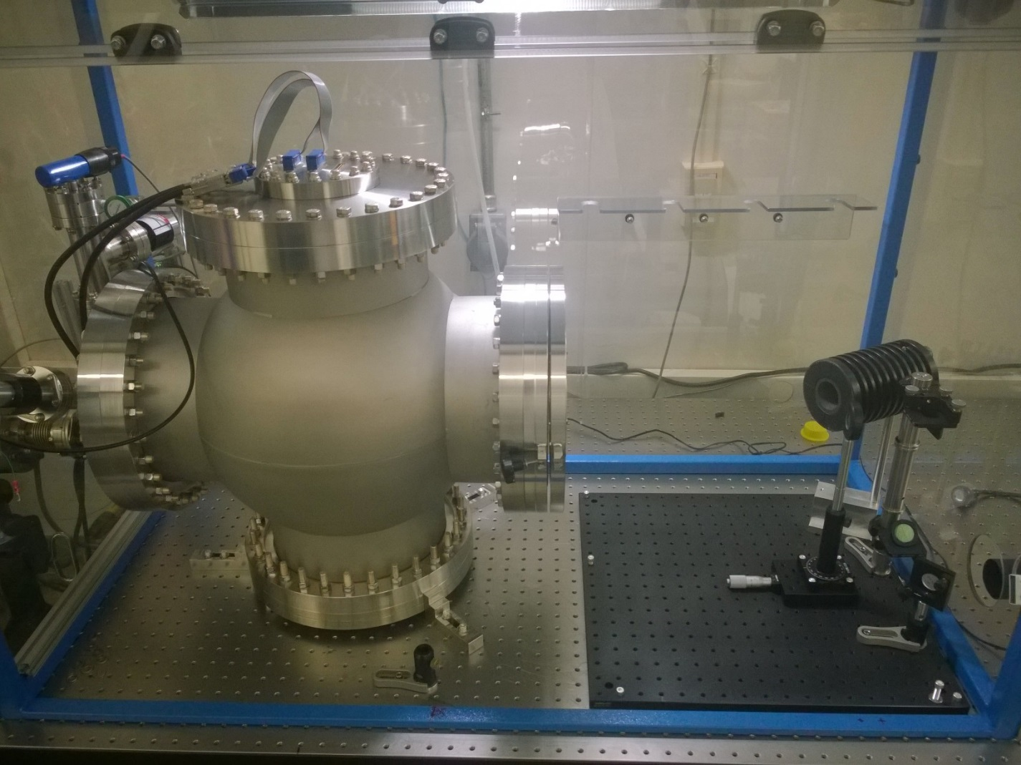

A phone camera could register the beam at the target:
