Alternative design approach for caging, sensing, and control next generation suspensions
G1601426-v3
Brett Shapiro
22 March 2017
Summary

Future generations of LIGO will potentially need larger and longer test mass suspensions, as well as higher performance control systems to meet their enhanced noise performance requirements. The total mass and performance of these suspensions could potentially be improved relative to the aLIGO design by choosing an alternative architecture.

Fig. 1 compares the aLIGO suspension and an alternative concept. The aLIGO architecture uses a reaction suspension directly behind the test mass suspension as a quiet reaction platform for the interferometer control actuators. This reaction suspension is nearly an exact copy of the test mass suspension. Both suspensions are surrounded by a single cage structure designed to protect them from large disturbances and mechanical failures. The cage also serves as an assembly platform, and a place to mount sensors, actuators, and other hardware. Because this cage structure is mounted to the active seismic isolation platform, its mechanical resonance frequencies are designed to be well above the platform’s control bandwidth.

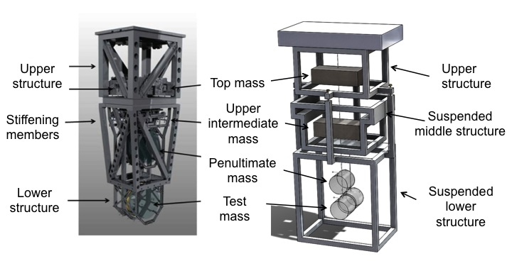
Fig. 1 Left: the aLIGO test mass suspension. Right: a concept for a future suspension with a suspended cage that doubles as the reaction chain. This alternative design might be simplified by doing away with the reaction mass behind the test mass and instead using an actuator similar to the photon calibrator. See text for further discussion. Image courtesy of Ian Gomez.
Utilizing the same design for both the test mass suspension and its reaction suspension is not necessarily the optimal choice since they serve different roles. A consequence of this choice is that the reaction suspension is only able to provide actuation for three out of six degrees of freedom at each stage of the test mass suspension. These three DOFs, length, yaw, and pitch keep the interferometer aligned, but the other DOFs show up in the interferometer as well, notably bounce and roll. Another consequence of the matched reaction chain is that it is quite massive, and that mass consumes part of the weight allowance for the seismic platform, constraining the mass and performance of the main suspension. A consequence of the cage’s resonant frequency requirement is that it is equipped with numerous and massive stiffening struts. These stiffeners limit access to the suspension, increase the assembly, aligning, and commissioning time, and consume the further weight capacity of the seismic isolation platform. If the length of the suspension is increased, maintaining these resonant frequencies will become more difficult.

In the alternative approach, the reaction suspension and the surrounding cage are merged. This ‘reaction cage’ then serves as a quiet actuation platform for the main chain and all the usual roles of suspension cage. Like the reaction chain suspension, the reaction cage is composed of suspended stages. However, each stage surrounds one or more of the test mass suspension stages, like the aLIGO cage. This change provides several advantages. First, more mass is available for the test mass suspension, allowing larger test masses. Rather than having the weight of a reaction chain plus a cage, the reaction cage merely weighs what the reaction suspension would have weighed on its own. Second, since the reaction cage surrounds the test mass suspension, it can serve as a quiet reaction platform for all the test mass suspension degrees of freedom. Third, since the cage is now suspended, its higher order resonances no longer couple well to the seismic isolation platform. Thus, the requirement of keeping their frequencies well above the isolation platform’s control bandwidth is reduced. As a result, the reaction cage can be designed to allow easy access to the suspension, potentially speeding up the assembly, aligning, and commissioning process. The more open structure will also provide more mounting locations for other hardware as needed. Additionally, this design will take up less space on the optics table.

This alternative design could potentially be simplified further by taking out the reaction mass that sits behind the test mass. In aLIGO, this reaction mass serves as the actuation platform for the electrostatic drive (ESD) used for the high frequency interferometer control forces. Instead we might be able to use an actuator similar to the photon calibrator (an idea suggested by Rana), which pushes on the test mass using the radiation pressure of an auxiliary laser located away from the suspension in some remote location. Assuming the maximum force of this ‘photon calibrator’ like actuator is small, it would only be used in observation mode. For lock acquisition, and for measuring test mass charge, an ESD would still be used, but it could be mounted directly to the cage, eliminating one of the reaction stages. This ESD could also be used as an auxiliary actuator during high seismic times such as earthquakes and windstorms to prevent lock loss.

Note 1: No modeling has yet been done for this design. It is merely a concept that merits further study.

Note 2: At this point the design is only compatible with room temperature suspensions. It should be investigated whether the design can be adapted for cryogenic suspensions.

Control scheme

As mentioned above, one of the advantages of this design is that it permits a quiet reaction platform for all 6 degrees of freedom for multiple stages. Also, since the cage’s resonant frequencies are less of a concern than in aLIGO, the cage will be more open and provide more locations to mount sensors and actuators at the lower stages. Consequently, all suspension DOFs of both the test mass chain and the reaction chain will be measured. One possible exception is the test mass itself, which cannot have sensors mounted to it (though there may be non-contacting sensors we can use).

Fig. 2 shows the sensing and actuation scheme. As in aLIGO, the main chain sensors are referenced to the cage and reaction platforms. The cage also has sensors and actuators at every suspended stage, referenced to the previous suspended cage stage. In this way, the position of every DOF of every stage can be sensed and controlled with the proper combination of signals. Note, Fig. 2 assumes OSEMs are the sensors and actuators, but this does not necessarily need to be the case.

Stage | Signals | Sensor Noise
Top mass | M0 | 1 * sensor noise
UIM | L1 + R1 | sqrt(2) * sensor noise
PUM | L2 + R2 + R1 | sqrt(3) * sensor noise
Middle cage | R1 | 1 * sensor noise
Lower cage | R2 + R1 | sqrt(2) * sensor noise
Reaction mass (if it exists) | R3 + R2 + R1 | sqrt(3) * sensor noise
Table 1: Reconstruction of the DOFs of each stage using the sensor/actuator scheme in Fig. 2.

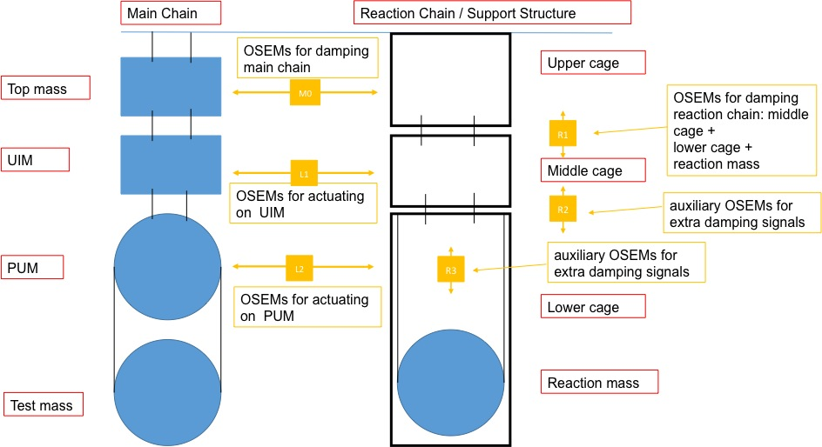
Fig. 2 The sensing and actuating scheme for the alternative design. Courtesy of Norna Robertson, adapted from the original.

To be studied

As mentioned previously, no modeling has yet been done for this design. Consequently, the design has several issues that remain to be resolved. First, assuming the impact of the cage resonances on the ISI is negligible, the impact on the interferometer may not be. Modeling is required to see how much of a requirement the interferometer may impose on these frequencies. If the frequencies need to be constrained, likely the stricter constraints will exist on the lower stages, which are closer to the interferometer. Second, suspending the cage may limit the amount of protection it provides to the test mass suspension since the EQ stops have many more DOFs. Modeling is required to determine how problematic this is, and if necessary, how to improve it. Third, the design as drawn has three suspended reaction stages rather than four. Modeling is required to determine if a three-stage reaction platform is sufficient. In the case where the reaction mass is removed, than there are two reaction stages, but this does not further degrade the actuation of the upper stages.

Acknowledgements

Brian Lantz and Norna Robertson have provided valuable feedback on this concept.

