ITM10 measurement, coated optic
1X data taken per the aLIGO procedure LIGO-E1101064
Cavity length noted as 84 mm in metropro 0 degree set, confirmed in ROC excel sheet.
ROC calculated at 1939.207 meters
Total range of values (m) 0.857
environmental uncertainty (m) -0.164
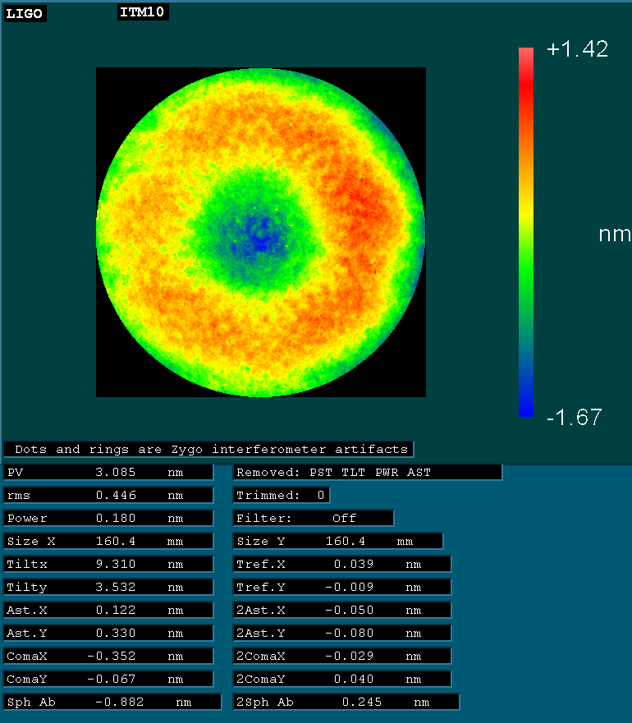
160 mm diameter
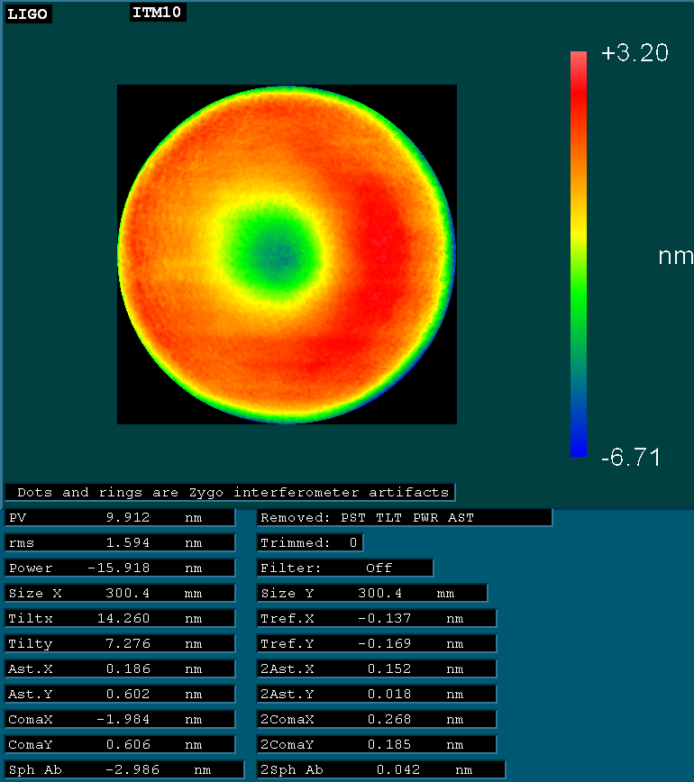
300 mm diameter

10x optic figure measurement strategy
See PSD analysis at G1700743-v1 for concept verification.
1. Fiducial average similar to the method used for large optics, only at 10x magnification.
Data from 8 angles are averaged in the camera reference frame, this is called the "reference file"
The reference file is subtracted from the data taken at each angle, creating a new file eg. 45-R. The new files are averaged in the reference frame of the optic using fiducial marks.
Center was found by rotating the optic and fitting the fiducials to a circle. The center of that circle is found at coordinates
Center: (0.09, 4.51) The Y coordinate being the most important.
Focus: 2.0417
Cavity length: 297 mm
For the first analysis – the center hot spike was removed from each (angle-R) measurement and, with spikes removed and data fill on the angles were averaged. The RMS of that measurement is 0.1 nm
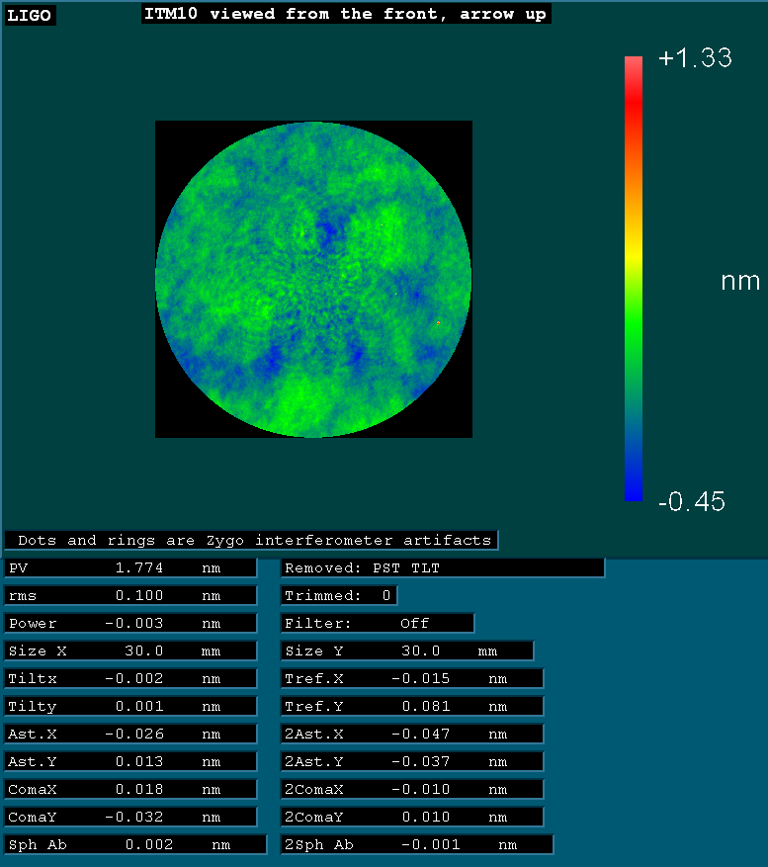
Odd-even normal = 0.07 nm rms in 30 mm
Odd-even spikes removed = 0.069 nm rms in 30 mm
Clearly – not much advantage to removing spikes and filling data.
For the normal analysis, no spikes removed:
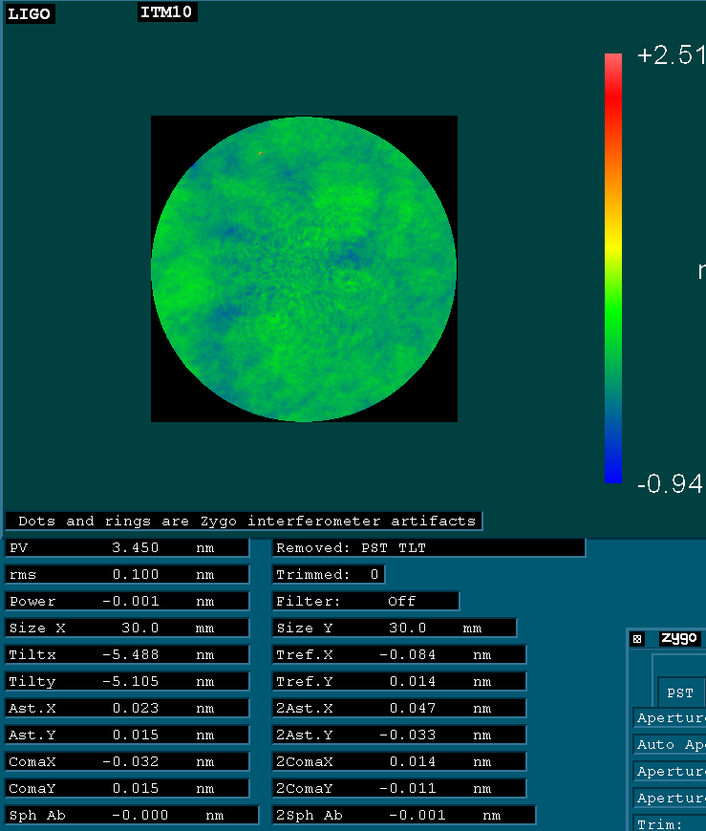
Result in 30 mm diameter (rms) for individual angles minus the composite reference.
Data set | Rms in 30 mm diameter (nm)
0 | 0.14
45 | 0.14
90 | 0.16
135 | 0.12
180 | 0.15
225 | 0.13
270 | 0.14
315 | 0.15

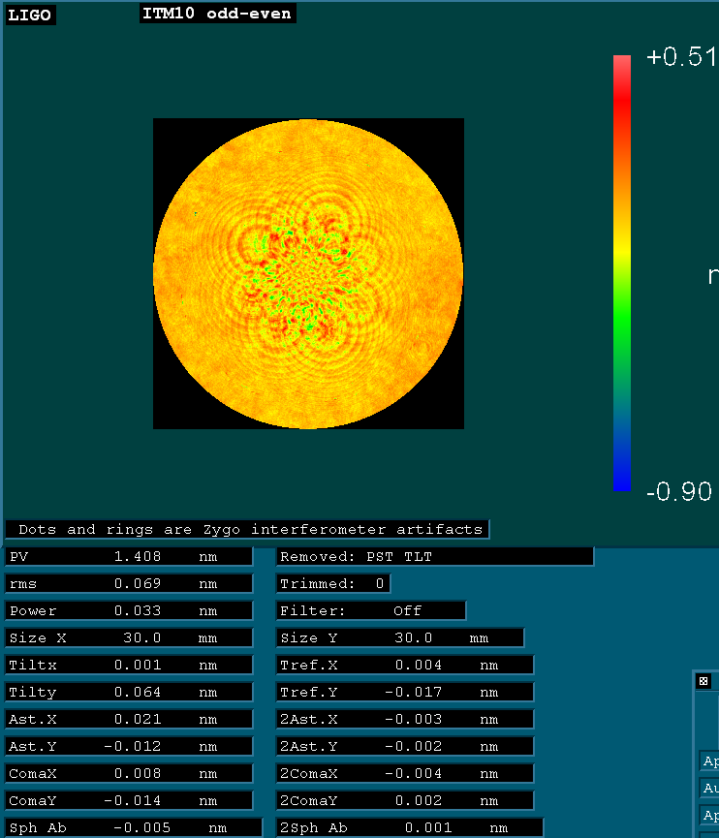
Figure 4 Odd-Even; an indication of the noise of the rotational average for the spikes removed case

Transmitted wavefront analyzed over 160 mm diameter
For zero degree orientation, consider the average of all clocking with no “null” or centered data:160 mm diameter power and astig removed from plot.
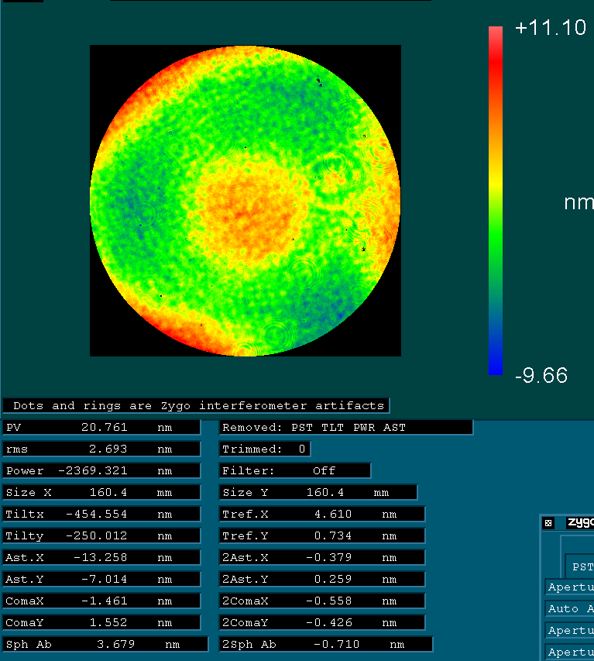

Next: Average of only the center data – no fringe repositioning
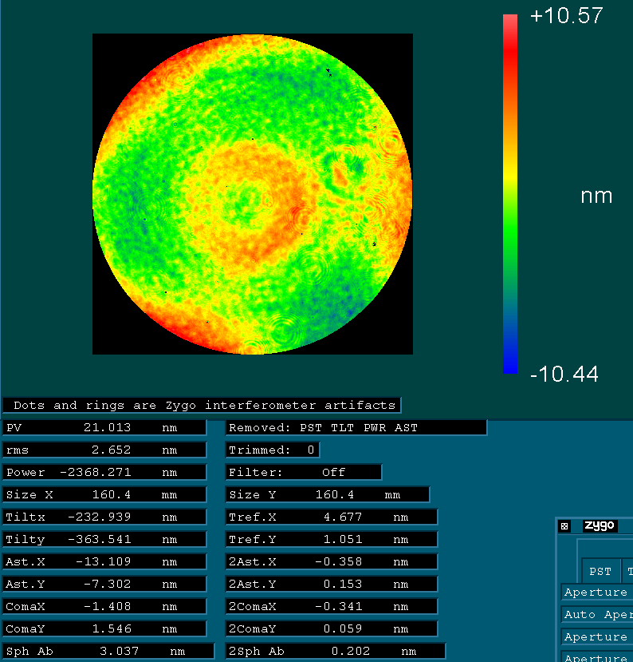

The difference in the two is the noticeable center dip (longer pathlength) in the center-only data: Subtract the two data sets….
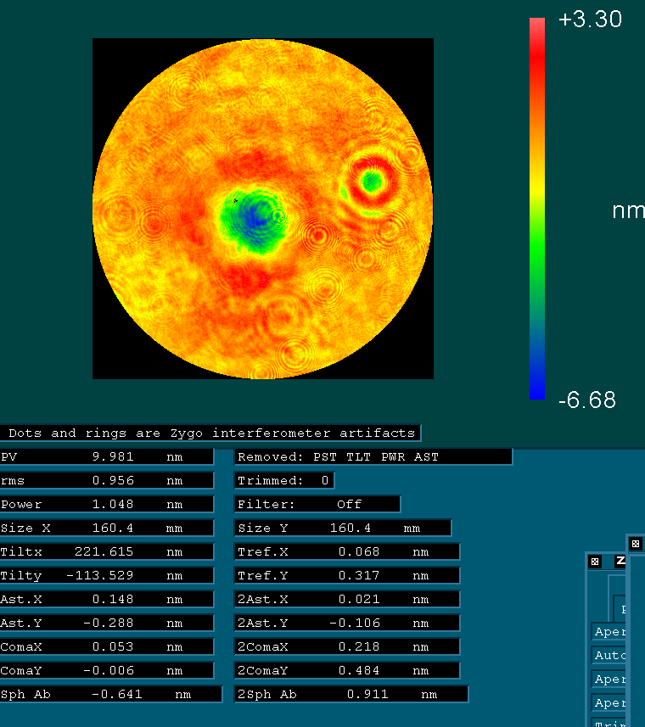
The cross sectional plot looks like:
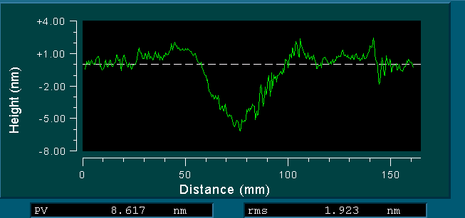
The fringe pattern for the center data was consistent through the center measurement at a mid-tone:
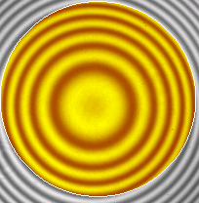
It appears that some sort of fringe movement is necessary to avoid this print-through. Let’s investigate the way the Zernike coefficients changed during the measurement. The sequence was:
Center – 6:00 – 7:30 – 9:00 – 10:30 – 12:00 – 1:30 – 3:00 – 4:30
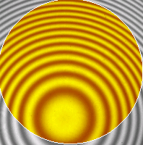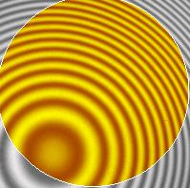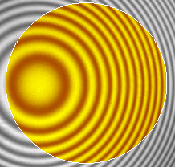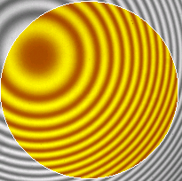
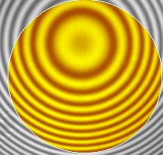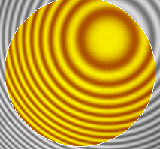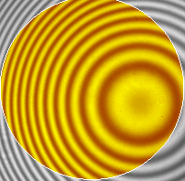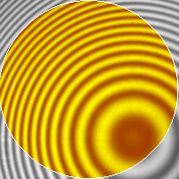

Above: Fringe positions and sequence for the data plotted below.
Below: Zernike plots and statistics for the zero degree data – 9 fringe positions
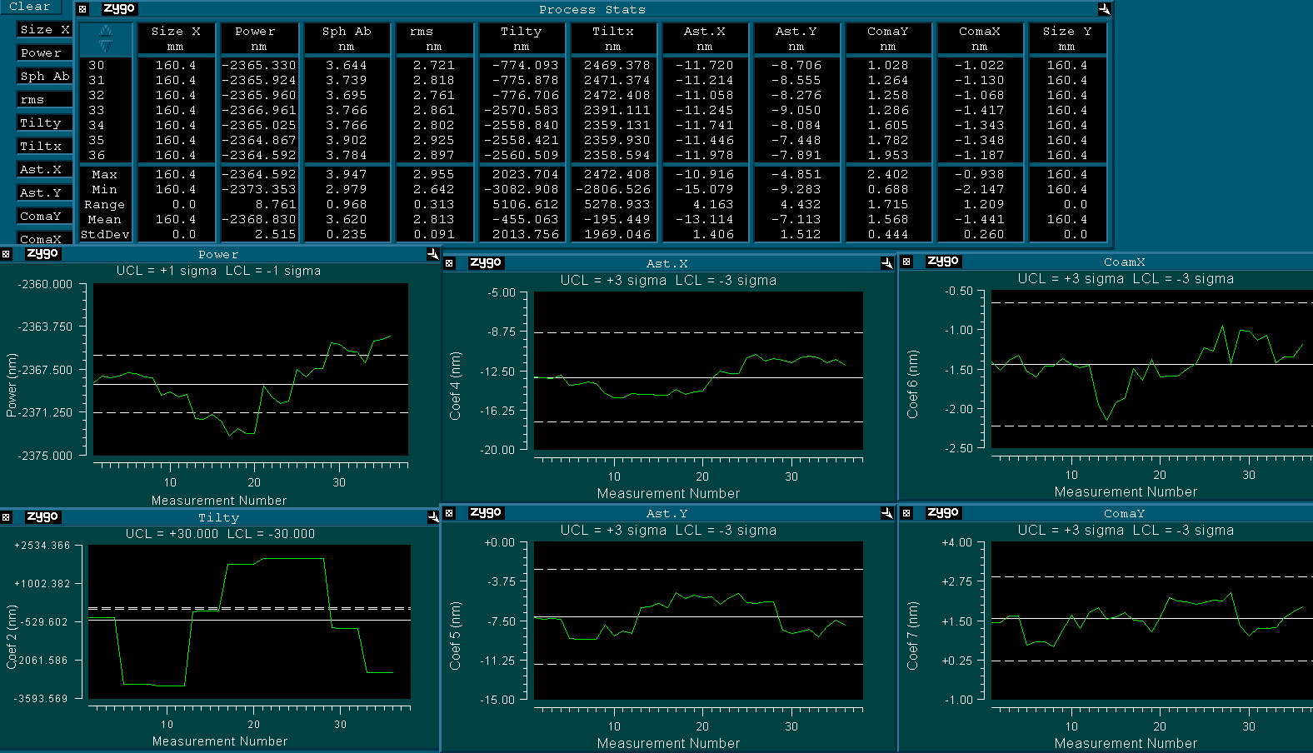

It is interesting to note that the power measured in the center position ends up being close to the average value (denoted by the solid white line). And after rotating the optic through four orientations (0,90,180,270) with 9 fringe positions each, we see that the average power remains the same as was measured at the 0 degree orientation.
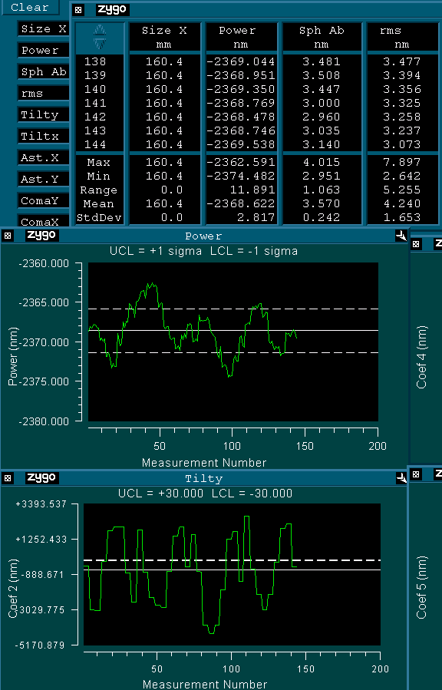
Final fiducial average of all transmitted wavefront measurements through the bulk, reflect off side one. The data heights are single pass, positive (red) is short path length, negative (blue) is long path length. Shown as viewed from the Beamsplitter.
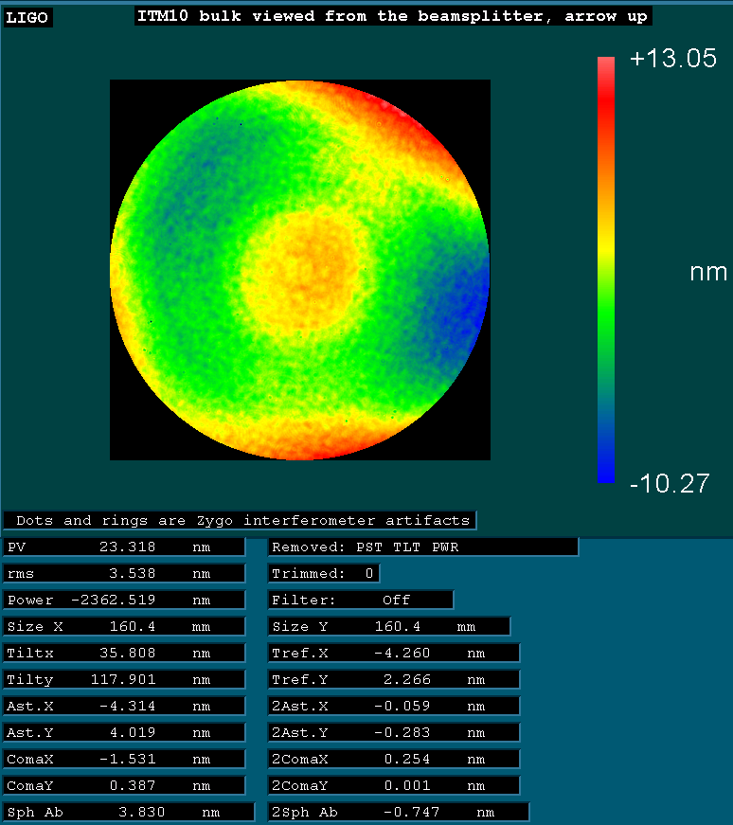

Flip and compare to the Zygo data at C1103714
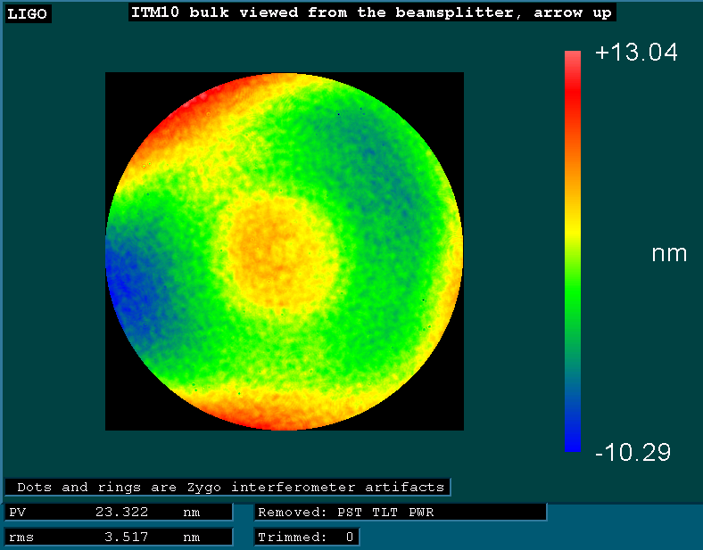

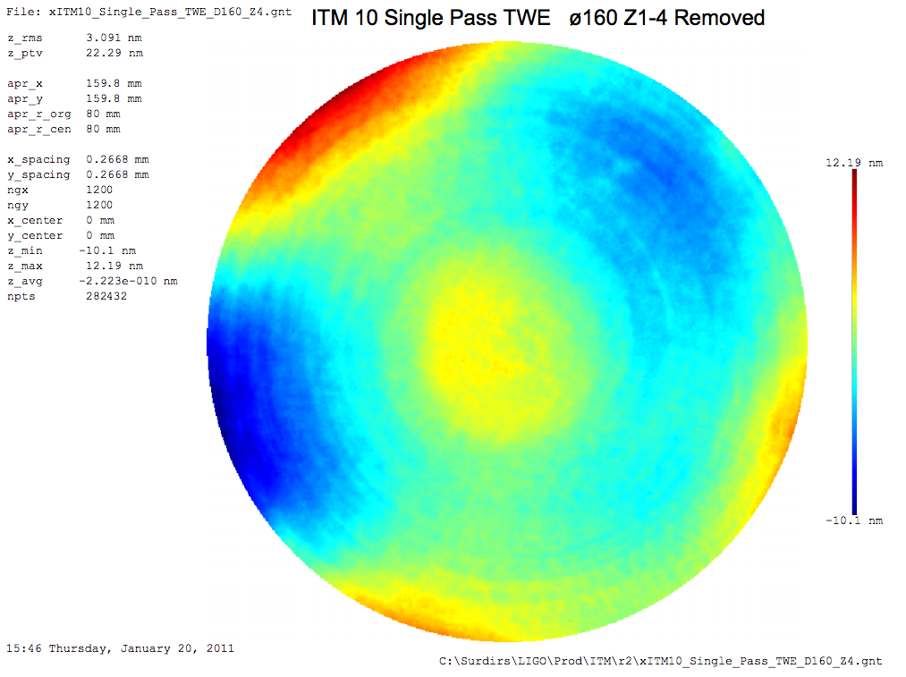
PV is 22.29 nm, ranging from -10.1 nm to +12.19 nm. rms is 3.091 nm

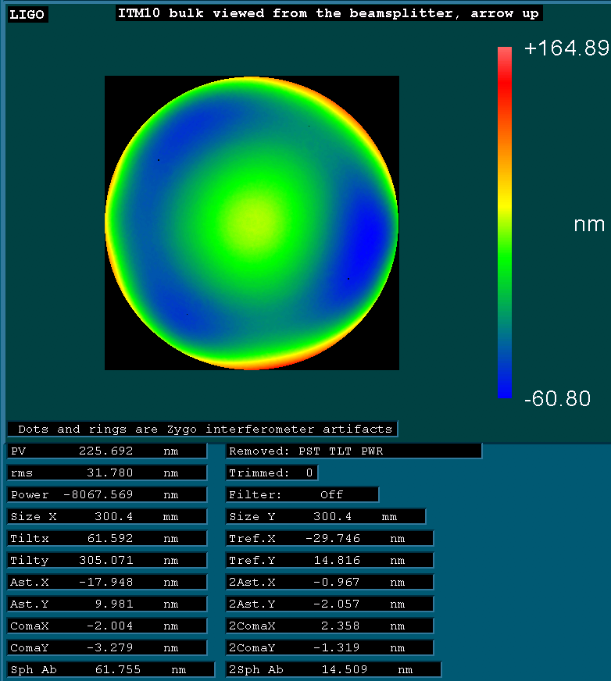

Transmitted wavefront Power
See ROC worksheet – excel document filed with this report.

