Test Date | Jun. 14-19, 2017
Author(S) | Liyuan Zhang, Stephen Appert, GariLynn Billingsley
Approval(s)
Specification Doc. | LIGO-E0900041 | Specification | 0.013-0.015
Procedure Doc. | LIGO-E1000863 | Mean ± Error* | 0.0138 ± 0.0003
Conclusion | Qualified.
*Error is the calibration error, which is ~2%.
Discussions and Comments:
Two scans were done over central 160 mm in diameter with the beam and step sizes of 1 mm and an incident angle of 1 and 2 deg respectively, as shown in Figs. 1 and 2, the arrow on barrel was at Y+ direction. The calibration is done by normalizing the transmitted signal to the signal without mirror and the variation of laser power during scan is monitored and corrected. The results are consistent.

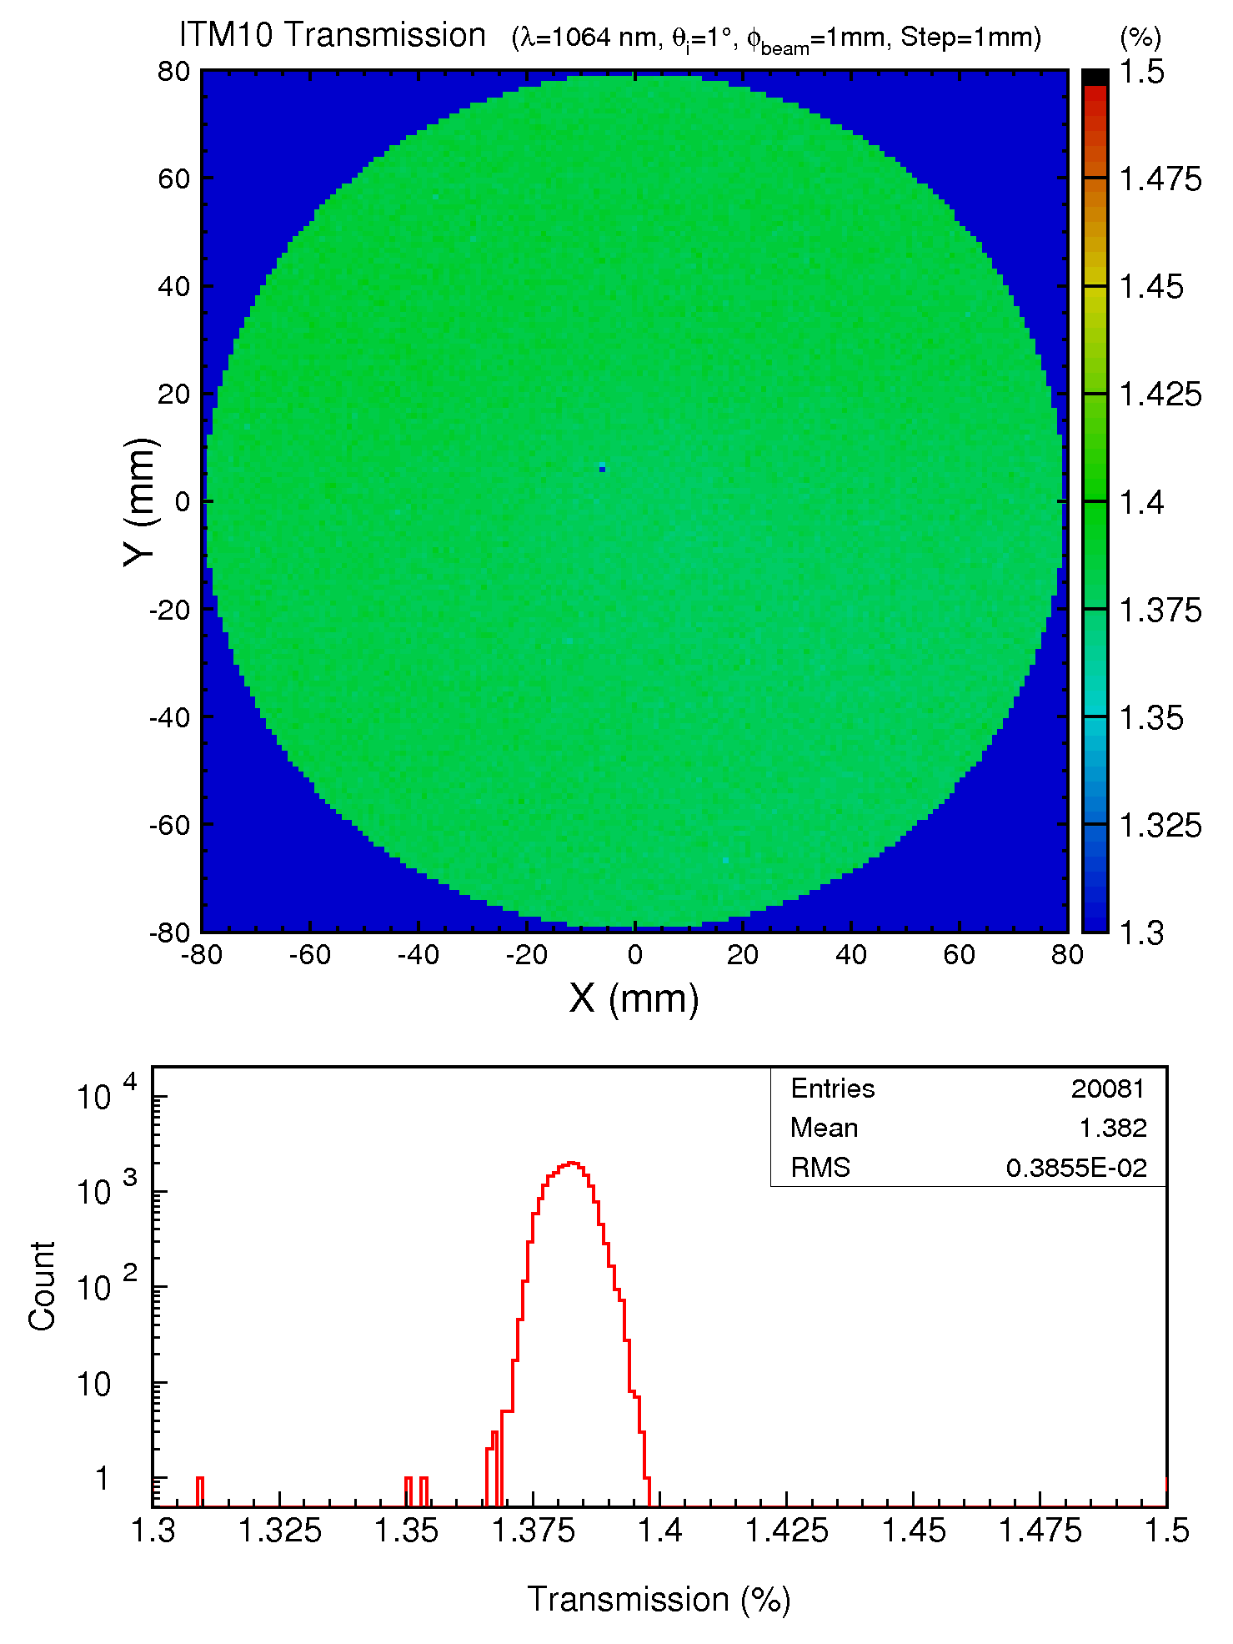
Fig. 1 ITM10 transmission over a 160 mm diameter aperture with the incident angle of 1 deg.

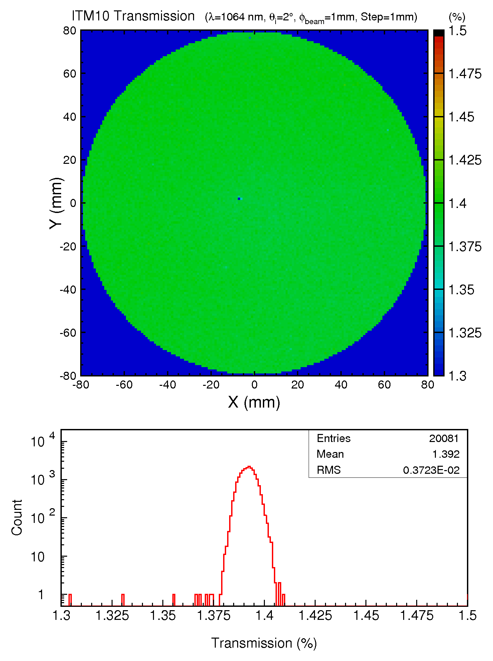
Fig. 2 ITM10 transmission over a 160 mm diameter aperture with the incident angle of 2 deg.

