LIGO HANFORD OBSERVATORY
PO BOX 159
RICHLAND WA 99352

TEL: 509.372.8106
FAX: 509.372.8137

MEMORANDUM

DATE: October 18, 2017

TO: | SQZ team
FROM: | Daniel Sigg, Marc Pirello
SUBJECT: | Modifications to the common mode boards
Refer to: | LIGO-E1700364-v1

This document lists the modifications to the 4th generation TTFSS, based on PCB D1700346-v1 and on schematics D1700077, D1700076 and D1700078.

Board modifications
Change 1:
U2 is missing the +15V rail. Add a jumper wire between the C5 pad towards U1 and the C46 pad towards U1 (D1700077, bottom).

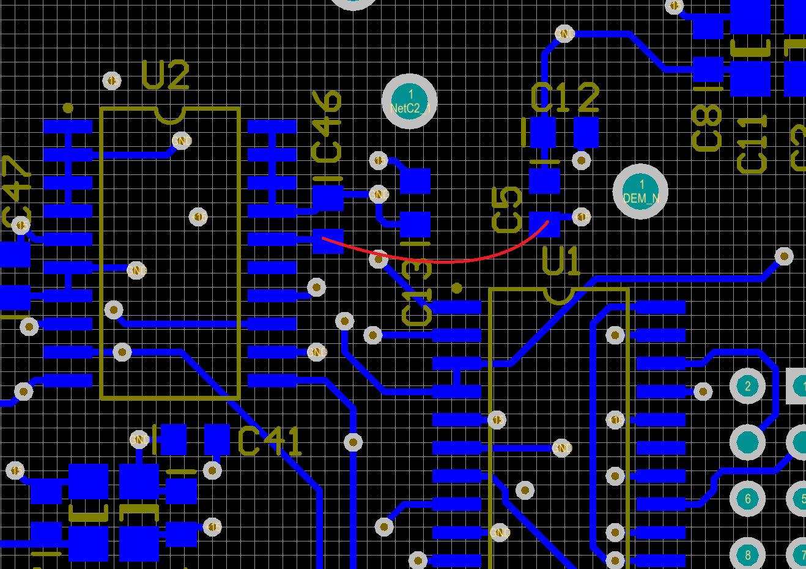

Change 2:
Input to U26 is floating when OPT4 is selected without an option board. Add a 10 kΩ resistor between pins 8 and 18 of header JP1 (D1700077, bottom).

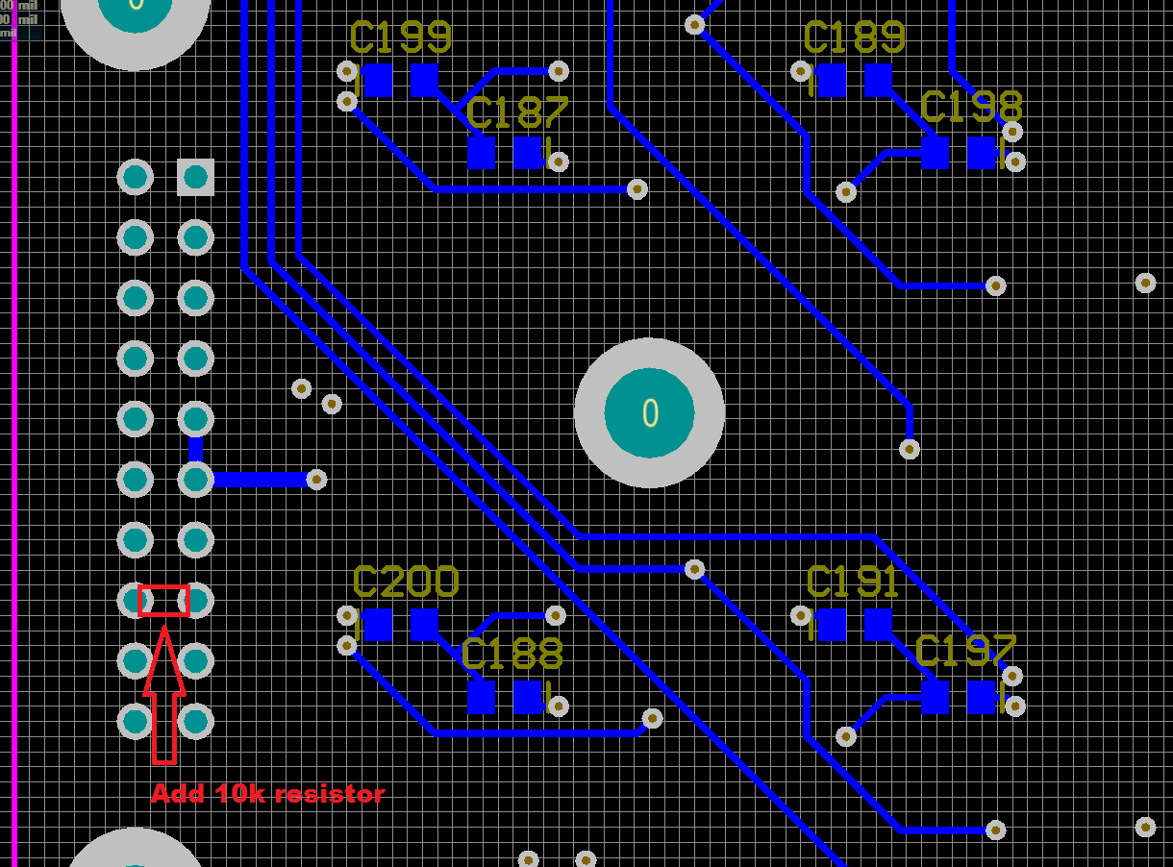

Part modifications:

Change 3:
A couple of AD829 operational amplifiers are missing a small capacitor in the feedback path to make them stable (D1700077, top).

C66 → 4.7 pF
C52 → 27 pF
C53 → 27 pF
C101 → 10 pF
C153 → 4.7 pF

Change 4:
The output of the EOM high voltage stage needs a higher output impedance to limit the maximum current drive (D1700076, top).

R99 → 470 Ω (350V)
C63 → 100 pF (500V)

BOM (for 6 units):
Qty | Item | Distributor | Description
10 | P10KDACT-ND | Digi-Key | Change 2; 10 kΩ
20 | 478-1300-1-ND | Digi-Key | C66,153; 4.7 pF
10 | 311-1099-1-ND | Digi-Key | C101; 10pF
20 | 311-1104-1-ND | Digi-Key | C52,53; 27pF
10 | 1135-1606-ND | Digi-Key | R99; 470 Ω
10 | 80-C1206C101FBG | Mouser | C63; 100 pF

