LIGO HANFORD OBSERVATORY
PO BOX 159
RICHLAND WA 99352

TEL: 509.372.8106
FAX: 509.372.8137

MEMORANDUM

DATE: February 22, 2018

TO: | SQZ team
FROM: | Daniel Sigg, Marc Pirello
SUBJECT: | Modifications to the Optical Fiber Switch
Refer to: | LIGO-E1700364-v2

This document lists the modifications to the Optical Fiber Switch based on v1 schematic located here D1700326.

Board modifications
Change 1:
Cut all four thermals on underside of PCB around pin 3, ensure they are not electrically connected to the GND plane. Also, remove solder mask next to pin 4 and bridge from pin 4 to the cleared solder mask (pad).

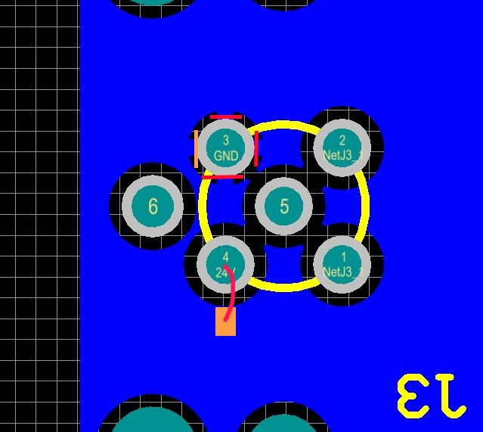

Change 2:
Cut 24V trace originating at J3 pin 4 as shown. Jump from J3 pin 3 to Cathode at D3.