LIGO Laboratory / LIGO Scientific Collaboration

LIGO-T1900258 LIGO A+ 09 May 2019

A+ Beam Splitter Optical Surface Deformation due to Gravity

Danielle Petterson

Distribution of this document:
LIGO Scientific Collaboration

This is an internal working note
of the LIGO Project.

California Institute of Technology  LIGO Project – MS 18-34  1200 E. California Blvd.  Pasadena, CA 91125  Phone (626) 395-2129  Fax (626) 304-9834  E-mail: info@ligo.caltech.edu | Massachusetts Institute of Technology  LIGO Project – NW17-161  175 Albany St  Cambridge, MA 02139  Phone (617) 253-4824  Fax (617) 253-7014  E-mail: info@ligo.mit.edu
LIGO Hanford Observatory  P.O. Box 1970  Mail Stop S9-02  Richland WA 99352  Phone 509-372-8106  Fax 509-372-8137 | LIGO Livingston Observatory  P.O. Box 940  Livingston, LA 70754  Phone 225-686-3100  Fax 225-686-7189
http://www.ligo.caltech.edu/

1 Introduction
The Beam Splitter Optic design currently in work in Advanced LIGO (d=370mm) needed to be redesigned for A+ with a larger diameter (d=450mm) and thus reanalyzed to observe its deformation under gravitational load (body force). In order to have some sort of control system to compare new results to, the Static Structural Analysis of the Advanced LIGO optic was replicated and reworked in ANSYS Workbench 2019 R1 with the goal being to get as close to the original analysis results (documented in D080233) as possible creating a baseline design before making any A+ changes. These results compared to the original results, as well as the analysis results for the larger A+ optic, are discussed in this document.

2 Model
The Beam Splitter Optic in all of these analysis is fused silica with a nominal thickness of 60 mm. The aLIGO optic and the A+ optic differences are their diameters of 370 mm and 450 mm respectively. All of the data inputs kept constant among all analyses is as follows:

- Mesh
  - Body sizing of entire optic (element size = 0.01 m)
  - Face sizing of just split lines and clocking line (element size 0.001 m)
- Boundary Conditions
  - Cylindrical Support on just split lines (radial: fixed, axial: fixed, tangential: free)
  - Displacement Support on clocking center line (X: 0, Y: free, Z: 0)
  - Standard Earth Gravity (-Y Direction)
- Suprasil 3001 Material Properties
  - Density = 2.2 g/cm³ = 2200 kg/m³
  - Young’s Modulus = 7.0x10⁴ N/mm² = 7x10¹⁰ Pa
  - Thermal Conductivity = 1.38 W/m·K = 1.38 W/m·°C
  - Specific Heat = 772 J/kg·K = 772 J/kg·°C
  - Tensile Yield Strength = 50 N/mm² = 5x10⁷ Pa
- Relevant Structural Steel Properties (from ANSYS Materials Library)
  - Density = 7850 kg/m³
  - Young’s Modulus = 2x10¹¹ Pa
  - Thermal Conductivity = 60.5 W/m·°C
  - Specific Heat = 434 J/kg·°C
  - Tensile Yield Strength = 2.5x10⁸ Pa
  - Tensile Ultimate Strength = 4.6x10⁸ Pa
- Solution
  - Directional Deformation in the Z Axis (for front and back faces)
    - Front face (S1) normal vector has the same direction as the global Z axis
  - Total Deformation in the Z Axis (for entire body)

The wire loops that support the suspended weight of the optic are modeled in this analysis as split lines distanced 10mm apart from each other centered about the geometric origin of the optic. It is important to note that this geometric center is not always be the same as the optic’s center of gravity. This greatly depends on the presence of a wedge angle and how that angle is modeled (1 of 3 wedge angle designs)

**See Figures 12-14 in Appendix 1 for the selections of the necessary Boundary Conditions

3 Advanced LIGO Optic Analysis Replication
The purpose of these replication ANSYS analyses is to try to get as close as possible to reproducing the findings from a previous ANSYS analysis done on this same optic a while ago (see LIGO-T080233). To make sure I ruled out all possible result affecting factors, I used 8 different geometries to narrow down which geometry fit the closest to the initial geometry used in the previous analysis.

The 6 geometries I tested are:
- Incorrect wedge and Structural Steel (SS) material
- No wedge and SS material
- Correct wedge and SS material
- Incorrect wedge and correct (Suprasil 3001) material
- No wedge and correct material
- Correct wedge and correct material
- Real Life Wedge and correct material
- Incorrect Wedge, correct material, and skewed split lines

I started my analyses with structural steel to see how large of a difference the material made on the overall results. Also, because the previous analysis that I was attempting to replicate didn’t have defined material properties. I had to later obtain these Suprasil 3001 properties from a different source.
The different wedge types listed are to cover an array of different wedge angles that were communicated to me in different ways. Although the previous analysis used an optic model without a wedge angle, I wanted to get a realistic view of how the wedge angle actually affected the analysis results. But in order to do this, I had to correctly model the optic with an angle. How the wedge angle was directly explained to me is what I deemed the “correct” wedge angle while the CAD model of the optic in the LIGO vault, which was modeled differently, I deemed the “incorrect” wedge angle. The third “real life wedge” angle is what I found upon further investigation of how the optics currently in use today were manufactured (See related documents in Q1100083 relevant to BS Fiducial Line Measurements). Figure 1 below gives a visual of how these wedge angles differ.

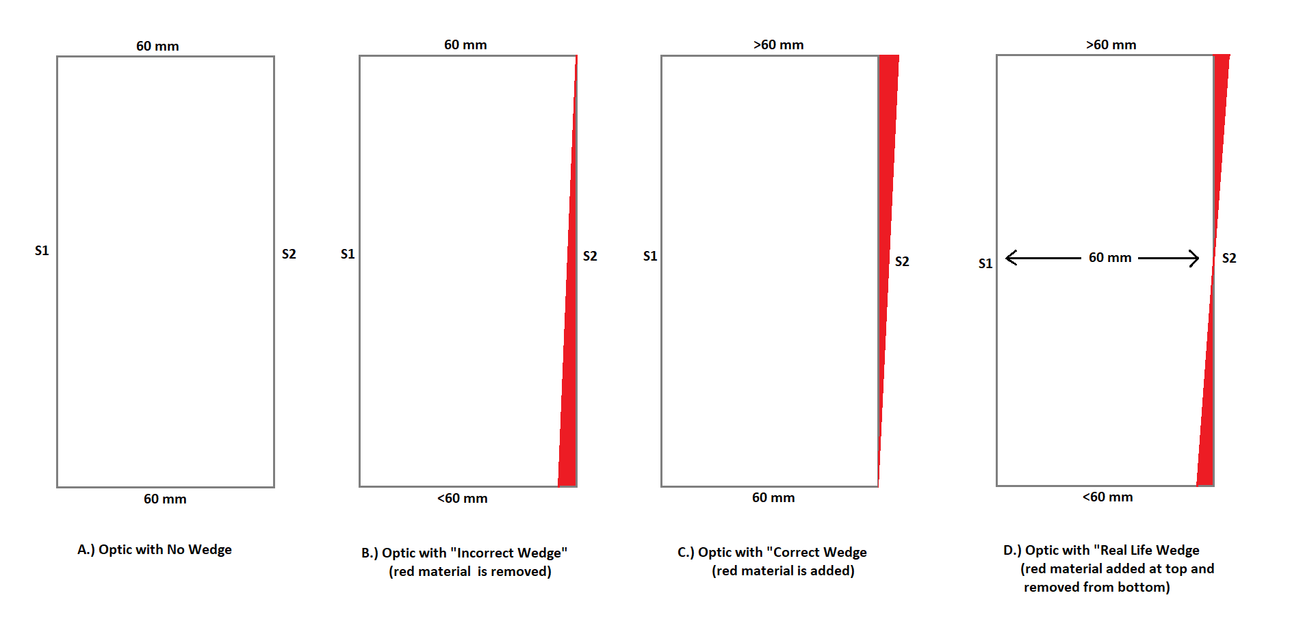
Figure 1: Wedge angle differences top view (wedge angles over exaggerated for reference)

For clarification, S1 is the front face of the optic while S2 is the back face. The “incorrect” wedge optic has a maximum thickness of 60mm, the “correct” wedge optic has a minimum thickness of 60mm, and the “real life” wedge has a central thickness of 60mm. So although one design was deemed as “correct” it may not be correct after all. This will take further investigation, but in the meantime, the no wedge angle optic is the one that most closely reproduced the analyses of before so that is the one that was used in the model of the larger diameter A+ optic (d=450mm) described further in a sections.

The results of all 8 models are described in Table 1 below. Note that case 8 was just an experiment to see if skewing the split lines boundary conditions (making each line parallel to the surface it was closest to instead of both parallel to S1) would reduce the pitching affect the wedge seemed to have on the optic. The results of these weren’t found to be that significantly different.

Table 1: ANSYS static structural analysis findings for the 370x60mm optic
370 x 60 mm Optic |  | Mesh |  | Directional Deformation Front Face (nm) |  |  | Directional Deformation Back Face (nm) |  |  | Directional Deformation Entire Body (nm)
Geometry Info | Weight (kg) | Nodes | Elements | Max | Min | Sag | Max | Min | Sag | Max | Min | Sag
Original Analysis (by Calum Torrie) | 14 | 100000 | 62000 | 1.9958 | -0.9114 | 2.9 | 0.93537 | -1.9908 | 2.9 | 2.1259 | -2.1021 | 4.2
1 - Incorrect Wedge + SS | 50.5 | 95,896 | 64,817 | 12.423 | 0 | 12.4 | 12.42 | -3.7437 | 16.2 | 12.42 | -3.7437 | 16.2
2 - No Wedge + SS | 50.6 | 95,854 | 64,846 | 4.3258 | -0.95961 | 5.3 | 0 | -4.445 | 4.4 | 4.3258 | -4.445 | 8.8
3 - Correct Wedge + SS | 50.8 | 95,656 | 64,678 | 3.7683 | -12.54 | 16.3 | 0 | -12.538 | 12.5 | 3.7653 | -12.54 | 16.3
4 - Incorrect Wedge + S3001 | 14.2 | 95,896 | 64,817 | 9.9229 | -1.2317 | 11.2 | 9.9238 | -1.9315 | 11.9 | 9.924 | -2.6567 | 12.6
5 - No Wedge + S3001 | 14.2 | 95,854 | 64,846 | 2.3946 | -1.2108 | 3.6 | 1.1975 | -2.4644 | 3.7 | 2.6367 | -2.6753 | 5.3
6 - Correct Wedge + S3001 | 14.2 | 95,656 | 64,678 | 1.9367 | -10.042 | 12 | 1.1945 | -10.041 | 11.2 | 2.665 | -1.004 | 3.7
7 - Real Life Wedge + S3001 | 14.2 | 96,264 | 65,093 | 2.4018 | -1.2051 | 3.6 | 1.1884 | -2.4575 | 3.6 | 2.6832 | -2.6818 | 5.4
8 - Incorrect Wedge + skewed split lines | 14.2 | 91,345 | 61,972 | 8.4949 | -1.2044 | 9.7 | 8.4958 | -1.9822 | 10.5 | 8.4961 | -2.626 | 11.1

Since case 5 produced the closest results to the original analysis (with case 7 being the second closest) this optic design was used to create and analyze the optic at the larger A+ diameter. The results from case 5 (no wedge and Suprasil 3001 material) are further revealed in Figures 2-6 below.

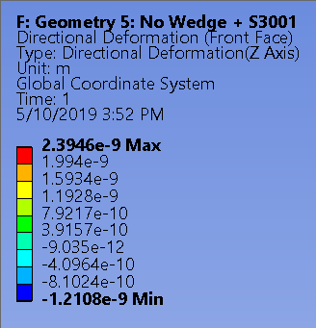
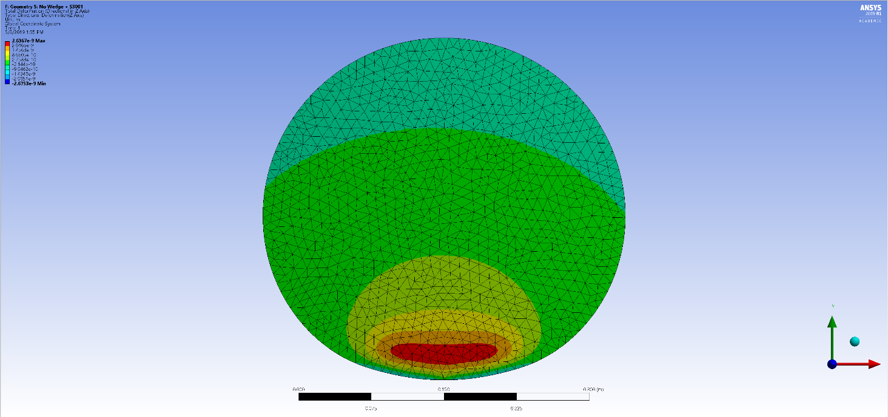
Figure 2: Front face normal displacement of replicated 370x60mm optic with no wedge

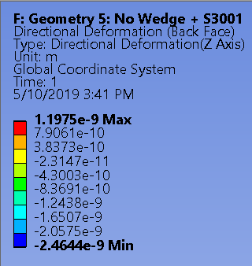
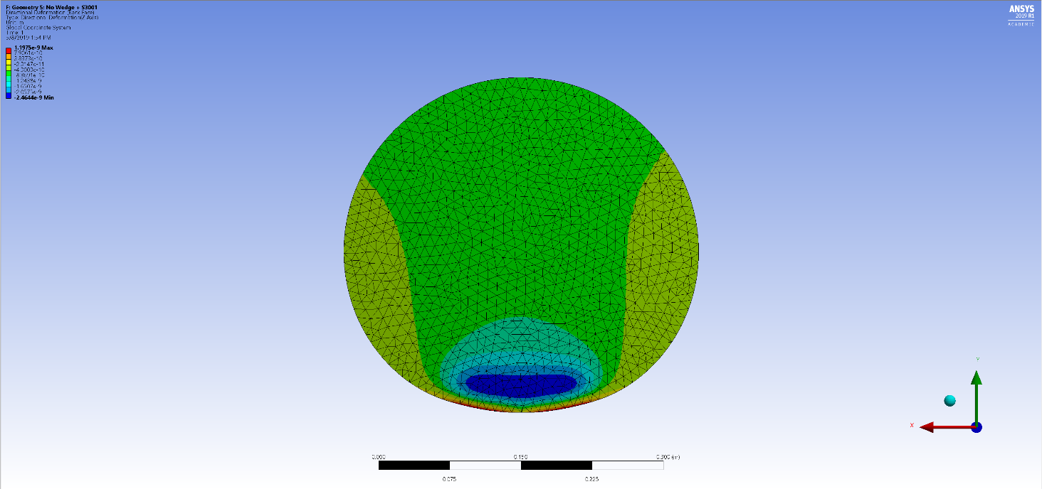
Figure 3: Back face normal displacement of replicated 370x60mm optic with no wedge

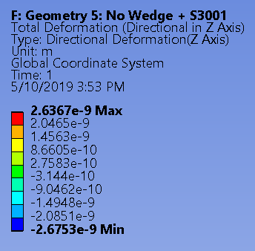
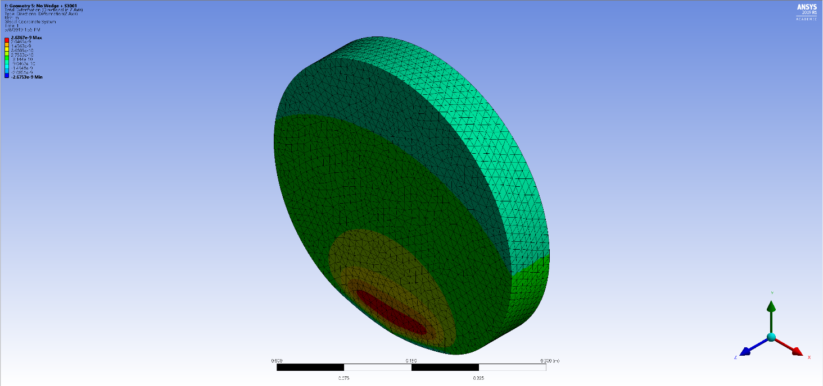
Figure 4: Isometric front view of replicated 370x60mm optic with no angle

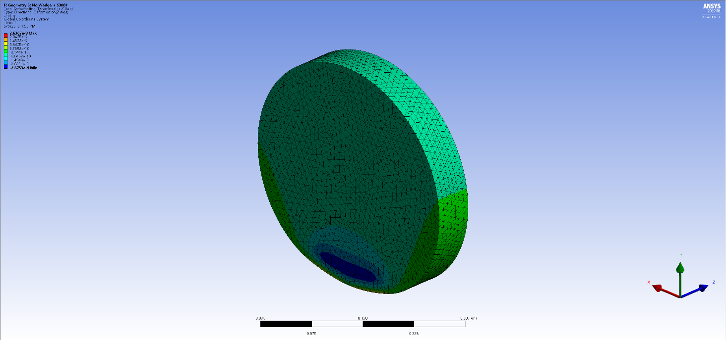
Figure 5: Isometric back view of replicated 370x60mm optic with no wedge

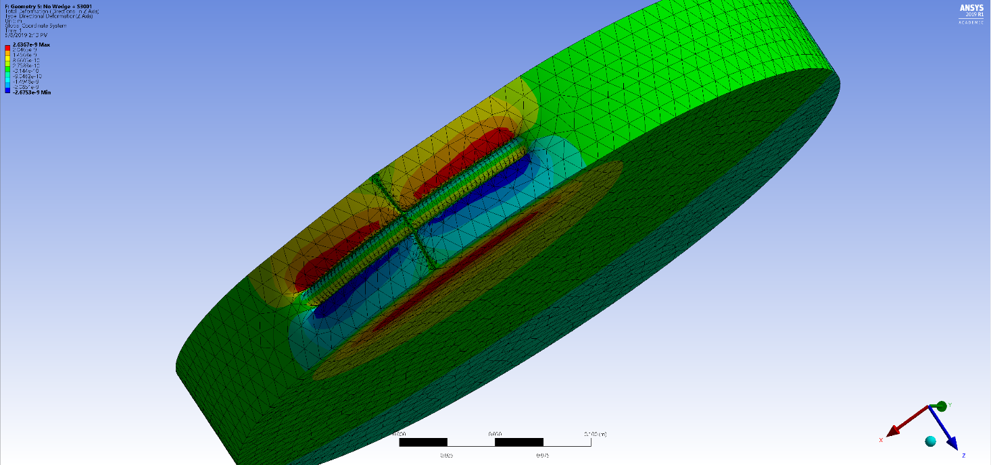
Figure 6: Location of wires on 370x60mm optic with no wedge

4 A+ Optic Analysis
As mentioned in the previous section, the analysis of the "real life wedge" optic, I found that the numbers weren't much different from the "no wedge" scenario because material was taken out of one side and added back to the other side of the optic symmetrically, which ended up pretty much canceling out the wedge entirely. So because of this and the fact that the “no wedge” optic results were slightly closer to the original results, I decided to use the no wedge design as my base for the larger diameter A+ optic. Analysis of the 450x60mm optic with no wedge is described in Table 2 and Figures 7-11 below.

Table 2: ANSYS static structural analysis findings for the 450x60mm optic
450 x 60 mm Optic |  | Mesh |  | Directional Deformation Front Face (nm) |  |  | Directional Deformation Back Face (nm) |  |  | Directional Deformation Entire Body (nm)
Geometry Info | Weight  (kg) | Nodes | Elements | Max | Min | Sag | Max | Min | Sag | Max | Min | Sag
9 - No Wedge + S3001 | 20.994 | 133877 | 91315 | 3.5294 | -1.7241 | 5.3 | 1.6775 | -3.4552 | 5.1 | 4.0205 | -4.0507 | 8.1

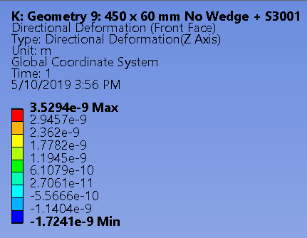
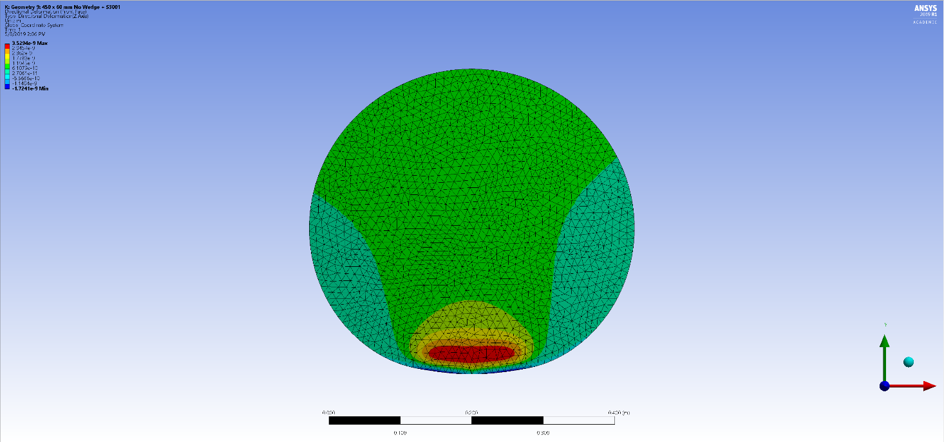
Figure 7: Front face normal displacement of A+ 450x60mm optic with no wedge

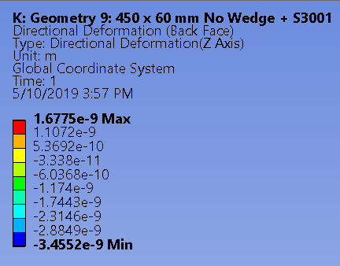
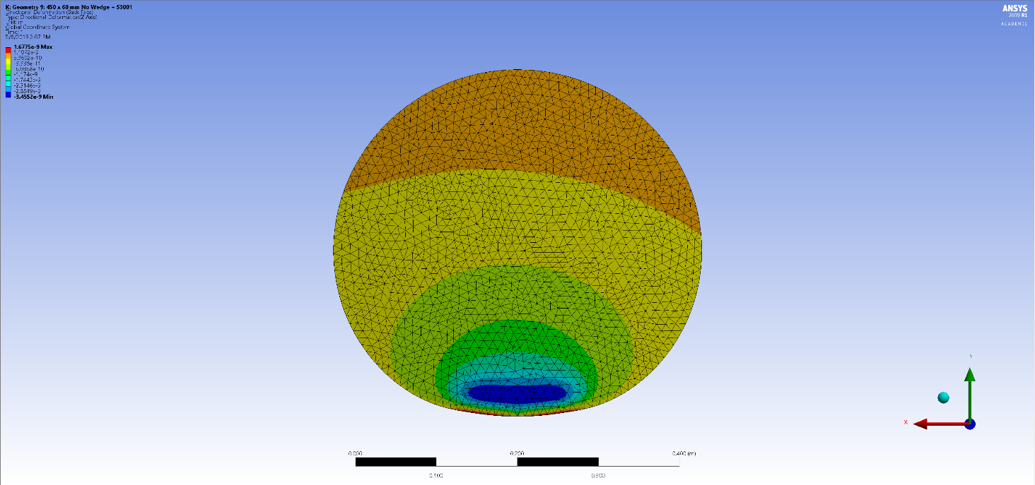
Figure 8: Back face normal displacement of A+ 450x60mm optic with no wedge
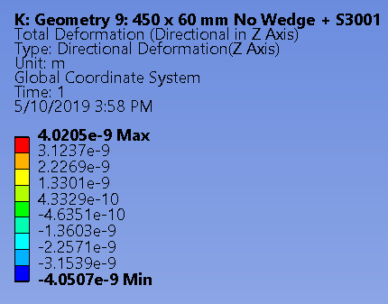
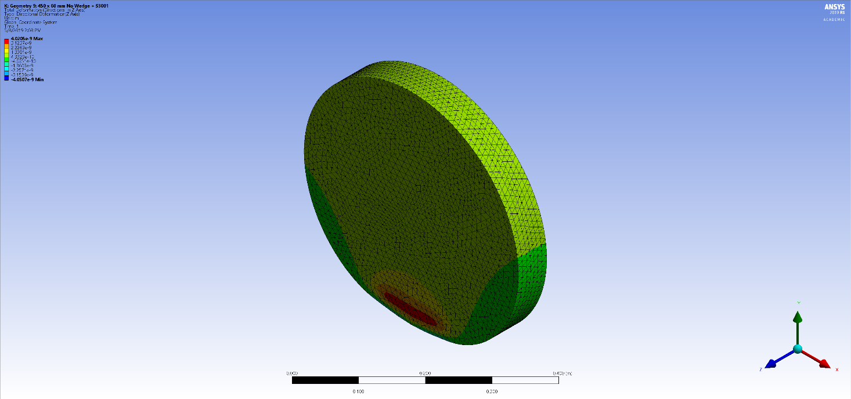
Figure 9: Front isometric view of A+ 450x60mm optic with no wedge

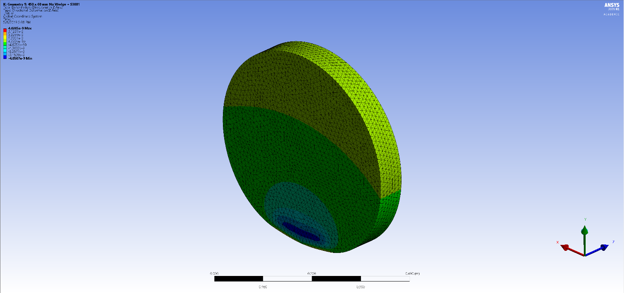
Figure 10: Back isometric view of A+ 450x60mm optic with no wedge
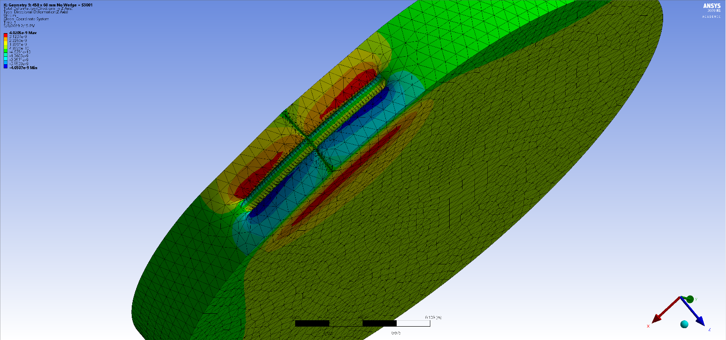
Figure 11: Location of wires on A+ 450x60mm optic with no wedge

5 Going Forward
After thorough static structural analysis of the optic and its many design options, we got close to the original analysis results but not an exact replication. There are many possible explanations for why we could not replicate these results exactly including issues with mesh sizing, the size and positions of the split lines, the upgrade differences between ANSYS Workbench version-11.1 to version 2019 R1, etc. The main thing to discuss now is whether these discrepancies are significant enough to be investigate further or minor enough to be considered a successful replication of results. Once that decision has been made, the larger optic design can be assessed and put into work for A+.

6 Appendices

Appendix 1

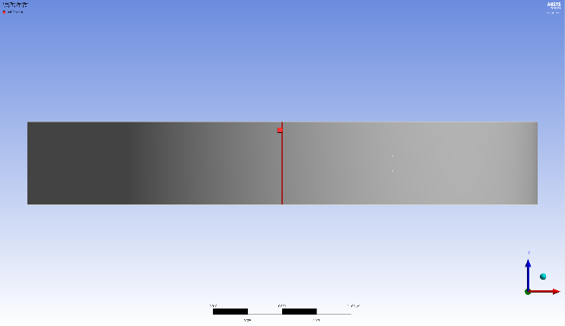
Figure 42: Clocking Line for Displacement Support
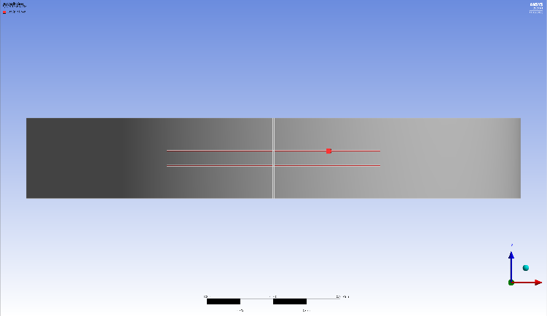
Figure 13: Split Lines for Cylindrical Support

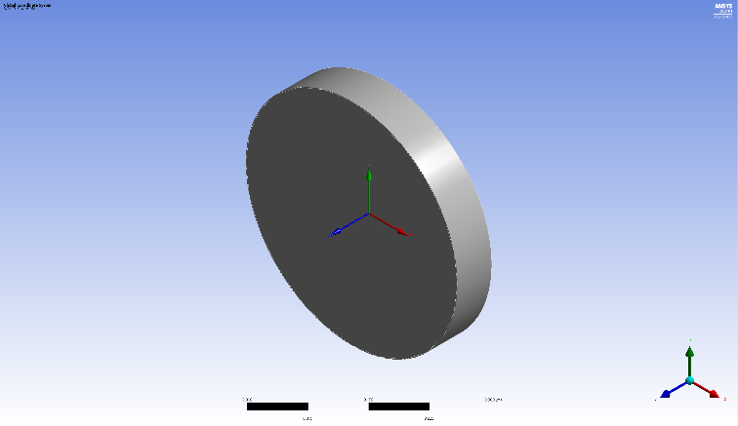
Figure 14: Global Coordinate System (Normal to S1)

