AUTHOR(S) | DATE | Document Change Notice, Release or Approval
Dennis Coyne, Stephen Appert | 9 Sep 2020 | see LIGO DCC record Status

Scope
The A+ Project scope includes the addition of a 300 m long Filter Cavity Tube (FCT) to extend the vacuum envelope at both of the LIGO Observatories. This specification pertains to the final design, fabrication and delivery of the pipe supports for the FCT. We seek companies to provide solutions from existing designs or components on a non-developmental time scale.
(All aspects of FCT installation will be performed by LIGO Laboratory.)

Types
The design of the FCT supports calls for two basic types of supports, fixed and guided (see Figure 1):
- Guided (G) Support: the tube is free to move axially.
- Fixed (F) Support: the tube is constrained in all degrees-of-freedom.
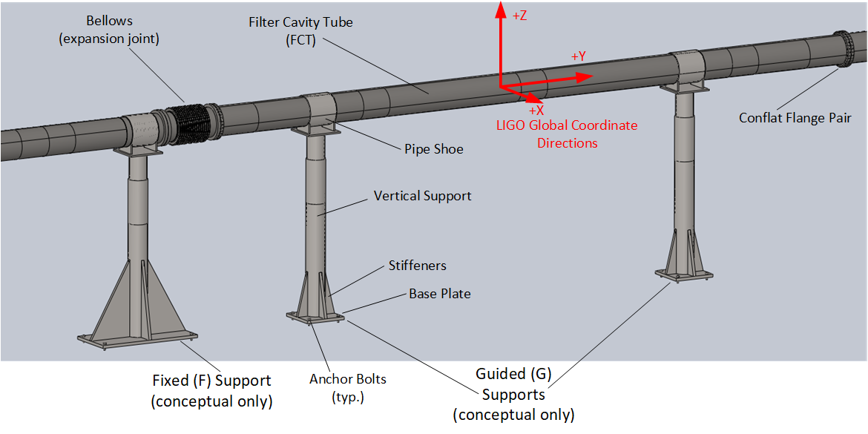
Figure 1 A representative section of the FCT (conceptual only)

Quantities
A total of 162 FCT supports are required. The quantities of each type of FCT support are given in the following table.
Type | @LLO | @LHO | Total
Fixed (F) | 16 | 16 | 32
Guided (G) | 65 | 65 | 130
Totals | 81 | 81 | 162

Requirements

Pipe size and interface
All supports shall include a pipe shoe that clamps around a nominal 10 inch outer diameter stainless steel (304) pipe. The shoe clamp material/design shall be compatible with the stainless steel pipe such that galvanic corrosion is not active.

Support Heights
The height of the FCT centerline relative to the floor varies between 46 and 70 inches over the ~300 meter span of the FCT.

Height Adjustment
A vertical height adjustment capability is required for each support with a range of ± 1 inches from its nominal height.

Support Base Plates
The loads imposed at the FCT centerline will be reacted by four (4), ½” diameter, anchors which are epoxy-bonded 4.5” deep into a 6” thick concrete slab. The support base dimensions are indicated in the Table below. Each base plate will have four (4) clearance holes for ½" floor anchors located 1.5” inches from each edge near each corner of the plate.
Table 3 Base Plate dimensions
Support Type | Base Plate Dimensions
Fixed (F) | 17” x 36”
Guided (G) | 14” x 14”

Loads on the Pipe Shoe
Table 2 Maximum Loads (lbf) imposed on Supports at Pipe Centerline
 | Fixed | Guided
Maximum Uplift | 0 | 0
Maximum Downward | 246 | 603
Dead Load | 176 | 431
Lateral | 122 | 215
Axial | 1700 | 193

Pipe Shoe lateral adjustment range
The Fixed (F) Supports shall be capable of lateral adjustment range of ± 0.5”.

Guided (G) Support Type Features
Guided (G) Supports shall allow sliding motion of the tube in a horizontal plane, principally in the axial direction.

Coefficient of Friction
The static coefficient of friction between the sliding surfaces of the Guided Support shall be no greater than 0.35. Hydrocarbon lubricants (oils, greases) are to be avoided if possible; low friction dry films or materials are preferred.

Axial range
The Guided Supports shall be capable of accommodating at least -3.4 to +1.0 inches, or a total range of 4.4 inches.

Pipe Shoe Lateral offset range
The Guided Supports shall be capable of accommodating a lateral offset from the top center of the Vertical Support of ± 1.4”.

Large motion vertical and lateral restraint
Vertical and lateral motion of more than approximately ± 0.5” shall be prevented by limit stops in the design of the guided pipe shoe.

