*LIGO Laboratory / LIGO Scientific Collaboration*

LIGO- T2000431-v4 *LIGO* 9 Sep 2020

Filter Cavity Tube (FCT) Support Loads

Dennis Coyne, Stephen Appert

Distribution of this document:

LIGO Scientific Collaboration

This is an internal working note

of the LIGO Laboratory.

|  |  |
| --- | --- |
| **California Institute of Technology**  **LIGO Project** | **Massachusetts Institute of Technology**  **LIGO Project** |
| **LIGO Hanford Observatory** | **LIGO Livingston Observatory** |

http://www.ligo.caltech.edu/

**Revision History**

|  |  |  |
| --- | --- | --- |
| **Version** | **Date** | **Changes** |
| v1 | 6 July 2020 | Initial Release |
| v2 | 13 July 2020 | corrected the BTE floor slab drawing to the final version |
| v3 | 24 July 2020 | 1. The use of "uncracked" concrete tables as assumed in –v1, for determining the strength of the anchors. The Hilti Anchor Fastening Technical Guide (ed. 19) states: "Both ACI 318 and the International Building Code conservatively assume cracked concrete as the baseline condition for the design of cast-in-place and post-installed anchors since the existence of cracks in the vicinity of the anchor can result in a reduced ultimate load capacity and increased displacement at ultimate load compared to uncracked concrete conditions. " The use of “cracked” concrete has been assumed in –v2 in order to calculate the factors of safety for the anchors. 2. The bellows (aka expansion joint) spring rate used in –v1 was from the conceptual design document, T2000002-v2: 17,162 N/m (98 lbf/in), axial 39,003 N/m, lateral 350,299 N/rad, torsional The manufacturer has recently provided a design with a reference axial spring rate of 191 lbf/in. The EJMA guidelines (6th ed. 1993) were used to calculate the following spring rates: 33,381 N/m (191 lbf/in), axial 125,979 N/m, lateral 425,782 N/rad, torsional The–v2 revision of this document uses these updated spring rates, but not with any tolerance for values in excess of these rates; If the exceedance is small it should be covered within the factor of safety (ASD) or load factor (LRFD). 3. The initial release of this document (-v1) used a seismic loading criteria consistent with the UBC and ASCE 7-88, the LIGO Beam Tube (BT) loading and the seismic load guidance in LIGO-E010613-v2. In the –v2 version of this document, the ASCE 7-16 standard (imposed by the IBC 2015 standard) has been used. The principal changes are (1) no reduction factor to account for the reduced response of high frequency (short period) structures, and (2) the inclusion of a vertical seismic component (not just horizontal). |
| v4 | 1 Sep 2020 | 1. LRFD load cases instead of ASD load cases 2. Correct minimum support height and FCT pitch angle in Figure 1 |

Table of Contents

1 Introduction 5

2 FCT Layout 5

3 Support types 5

4 Support description 6

5 FCTE slab interface requirements 7

6 Load analysis caveats 8

7 Load Calculation methodology 8

7.1 Requirements from ASCE 7-16 8

7.2 Load Combinations 9

7.2.1 LFRD versus ASD 9

7.2.2 LRFD load cases 11

7.3 Seismic Loads 12

7.3.1 UBC 1994 and ASCE 7-88 12

7.3.2 ASCE 7-16 13

7.4 Dead Weight Load 18

7.5 Vacuum Load 18

7.6 Expansion Joint forces 19

7.7 Settlement Loads 19

7.8 Horizontal Alignment 19

7.9 Embedded anchor strength 20

8 LRFD Loads 22

8.1 Design loads imposed at the Support Shoes 22

8.2 Floor anchor reactions 24

9 ASD load analysis 31

10 Beam Tube anchor and slab design for comparison 32

Tables

Table 1 Filter Cavity Tube Support Types by Building Location 6

Table 2 Load Cases 12

Table 3 Nonbuilding Structure Type applicable to the FCT 13

Table 4 LHO Seismic Mapped Parameters 15

Table 5 LLO Seismic Mapped Parameters 16

Table 6 Floor Anchor Resistance 21

Table 7 ASCE 7-16 LRFD Load Cases: Forces and Moments on Support Pipe Shoes @FCT Centerline 23

Table 8 Floor Anchor Bolt Loads 24

Figures

Figure 1 Height of FCT relative to the floor 5

Figure 2 A representative section of the FCT showing Fixed and Guided Supports 7

Figure 3 Comparison of ASCE 7-16 Seismic Response Coefficient and LIGO-E010613-v2 17

Figure 4 Vacuum equipment mounted on the 6-way cross 18

Figure 5 Stiffened support base results in improved load transfer to the anchor bolts 25

Figure 6 Simple beam representation of a typical, repeating module of FCT (section FCT-C) 26

Figure 7 An idealized, representative/typical section of the FCT (beam analysis) and the deformed geometry under gravity loading 27

Figure 8 FEM of a Support with a 36” by 17” base, welded stiffeners and 8 anchor bolts 28

Figure 9 FCT Support instances/types in the representative and repeating sub-assemblies of the FCT 29

Figure 10 Gravitational load and lateral seismic, static-equivalent load 30

Figure 11 Gravitational load and longitudinal seismic, static-equivalent load 30

Figure 12 Typical BT enclosure slip form slab 32

# Introduction

The Filter Cavity Tube (FCT) supports must be anchored to the floor slabs in the corner station, the FCT Enclosure (FCTE) and the FC End Station (FCES). The purpose of this document is to provide a calculation of the loads at the interface with the floor slabs and a design for embedded anchors capable of sustaining these loads.

# FCT Layout

The height of the FCT relative to the floor varies as shown in Figure 1. For this analysis the maximum height has been used (resulting in the largest moments at the interface with the floor).



Figure 1 Height of FCT relative to the floor

*Dimensions from the A+ vacuum equipment drawings (D1800238-v14 and D1800241-v11) and drawing D950148-v2.*

# Support types

The design of the FCT supports[1] calls for two basic types of supports, fixed and guided. Between each section of the FCT (see layout [LIGO-D1900456](https://dcc.ligo.org/LIGO-D1900456/public)) there are gate valves adjacent to fixed supports. These gate valves can be used to isolate the sections so that vacuum and atmospheric pressure can be applied to any section. Consequently from a load analysis point of view, there are three basic support types:

* Guided (G) Support: the tube is free to move axially and in rotations, but limited in lateral and vertical motion (i.e. slides on a horizontal plane with limit stops to prevent large lateral or upward motions in the event of an earthquake). During normal operational use, the Guided Supports would not apply any lateral loads to the FCT (only potentially an upward force).
* Fixed (F) Support: the tube is constrained in all degrees-of-freedom
* Fixed/Gated (F/G) Support: a fixed support adjacent to a closed gate valve. A closed gate valve can apply atmospheric loads to the fixed support in either axial (y) direction

A number of optical baffles are installed within the FCT. In order to limit the decentering error of the central aperture of these baffles, the FCT should ideally be straight. Given the tolerances of the FCT it may be necessary (or desirable) to limit the magnitude of FCT non-straightness. This can be accomplished by measuring each tube module and then selecting which to join together and at what rotation angle (‘clocking’). Alternatively, or additionally, one could require the guided support to not only prevent the tube from sagging downward, but also impose lateral or vertical forces to correct mis-alignment due to FCT tolerance build-up:

* Alternative Guided (AG) Support: the tube is free to move axially but is restricted from movement in the lateral and vertical directions (i.e. slides only in the axial direction with very little (if any) allowed motion horizontally and vertically). During normal operational use, the Alternative Guided Supports may impose static lateral and/or vertical forces to the FCT in order to straighten the FCT.

Depending on FCT production tolerances and the feasibility of an AG support design, either a G or AG support will be employed (one or the other, not both).

For details of the calculation, see the excel workbook uploaded with this document in the LIGO Document Control Center (DCC).

A breakdown of the types of supports by location is given in Table 1. The FCT within the FCTE is separated by gate valves into three sections (sections I, II and II of module FC-C in [LIGO-D1900456](https://dcc.ligo.org/LIGO-D1900456/public)-v7). The fixed, and potentially gated, supports at the beginning, and end, of module FC-C are on the BT termination slab, and the FCES slab, respectively. The FCES floor slab will likely be thicker than the FCTE floor slab which, for cost considerations, may be considerably thinner. In this memo the interface loads on the supports within the FCTE are presented, as well as an embedded anchor design and required FCTE floor slab thickness.

Table 1 Filter Cavity Tube Support Types by Building Location



# Support description

The support design concept[2] used in this load analysis is as indicated in Figure 2. For the tall supports (in the LVEA, FCTES and those on the FCTE slab near the FCTES) the tube loads imposed on the supports also impress high moments at the base of the supports, resulting in potentially high tension loads in the floor anchor bolts. Stiffening the base improves load transfer to the anchor bolts at the ends of the support plate to react against moments imposed by vacuum and axial earthquake loading, as depicted in Figure 5.



Figure 2 A representative section of the FCT showing Fixed and Guided Supports

*(The coordinate system shown in this figure is parallel to the LIGO global coordinate system,* [*LIGO-T980044*](https://dcc.ligo.org/LIGO-T980044/public)*.)*

The baseplate dimensions, anchor bolt hole spacing and number of anchor bolts was varied to minimize the bolt loading for a practical design and minimum floor slab depth. The recommended base plate sizes are:

* Fixed/Gated (F/G) Supports: 17” in the x-direction and 36” in the y-direction with anchors set back 1.5” from the plate edges at each corner (4 anchors total).
* Fixed (F) Supports, Guided (G) Supports and Alternative Guided (AG) Supports: 14” in the x-direction and 14” in the y-direction with anchors set back 1.5” from the plate edges at each corner (4 anchors total).

The recommended anchors are 1/2" diameter, Hilti HAS-B-105 (or similar) anchors embedded at least 4.5” and adhesively bonded. This arrangement is calculated to have adequate resistance to the loads using the ASCE 17-6 LRFD approach.

# FCTE slab interface requirements

The FCT supports are anchored to the FCTE floor slab, the FCES floor slab and the LVEA floor slab. The extant LVEA floor slab is 30” thick and heavily reinforced ([LIGO-D960917](https://dcc.ligo.org/LIGO-D960917)). The FCES floor slab will be 6” thick ([LIGO-M2000160](https://dcc.ligo.org/LIGO-M2000160)-v1 and detail 2 on drawing S301 in [LIGO-E2000380](https://dcc.ligo.org/LIGO-E2000380)-v1). The FCTE floor slab will be 8” thick (detail 4 on drawing S301 in [LIGO-E2000380](https://dcc.ligo.org/LIGO-E2000380)-v1).

The FCTE interface requirements on the floor slab are identical for the LHO and LLO installations, and are as follows:

1. Each filter cavity beamtube is supported along its length by supports which are anchored to the concrete floor by adhesively bonded anchors. Each support has a rectangular baseplate spanning 17” in X and 36” in Y, or 14” in X and in Y (LIGO global coordinates used throughout, [LIGO-T980044](https://dcc.ligo.org/LIGO-T980044/public)). Refer to [LIGO-T2000002](https://dcc.ligo.org/LIGO-T2000002) and [LIGO-T2000475](https://dcc.ligo.org/LIGO-T2000475) for design description.

2. The supports are variably spaced in Y at between 5’ and 15’ on-center, depending on local tube-mounted equipment.

2a. Y positions can typically be adjusted at installation time by up to ± 1.5 ’ in order to avoid, for example, expansion joints as-built or other local obstructions.

3. Each support baseplate will be anchored to the FCTE floor by four epoxy anchors placed near each baseplate corner at a distance of 1.5” from each edge, geometrically centered in X below the FC tube axis.

4. For 58 of the 60 instances mounted on the FCTE slab, 1/2” nominal diameter epoxy anchors (e.g. Hilti type HAS-B-105 or similar) with minimum embedment depth of 4.5” will suffice to provide adequate safety factor with respect to atmospheric, thermal expansion, and seismic (dynamic) loads under foreseeable conditions.

4b. The above presumes a reinforced concrete slab of 6” minimum thickness using 3,000 PSI nominal concrete.

4c. The slab reinforcement should have sufficient design margin that it will not be seriously compromised by occasional and incidental intersection of a drilled bolt hole with embedded reinforcement members.

*Note: In version v3 of this document the need for two locally enhanced regions of the slab (with 9” minimum thickness) was called out for the F/G Supports within the FCTE. This is no longer found to be necessary. A uniformly 6” thick FCTE slab is adequate.*

# Load analysis caveats

A few caveats and notes relating to this analysis:

* The FCT support final design will be determined by the contracted fabrication company in accordance with specification E2000429. If there are any significant changes from the support design assumed in this analysis the loads and anchor bolt reaction forces will need to be revisited.
* The Washington and Louisiana state amendments to the IBC 2015 standard have not been checked to see if they apply to this analysis as yet.
* The maximum allowable differential settlement for the FCT has not yet been established; the loads induced by settlement have not been included in this analysis.

# Load Calculation methodology

Comments on the methodology used to calculate the loads imposed on the floor slab by the FCT support interface, are defined in the following sub-sections. The accompanying Excel workbook captures the parameters, equations and documents sources for calculating the loads.

## Requirements from ASCE 7-16

The states of Washington and Louisiana have adopted the 2015 IBC (International Building Code) with amendments. According to IBC 2015 section 1613, “Earthquake Loads”: “Every structure, and portion thereof, including nonstructural components that are permanently attached to structures and their supports and attachments, shall be designed and constructed to resist the effects of earthquake motions in accordance with ASCE 7, excluding Chapter 14 and Appendix 11A. The seismic design category for a structure is permitted to be determined in accordance with Section 1613 or ASCE 7.”

In addition to seismic resistance, the following ASCE 7-16 requirements are relevant:

1. Loading factors and load combinations (see section 7.2)
2. Section 14.1.2.2.2: Structural steel elements designed to resist seismic forces in Seismic Design Category D must comply with AISC 341, except as permitted in Table 15.4-1.
3. Anchors in concrete shall be designed in accordance with ACI 318, Chapter 17.

## Load Combinations

### LFRD versus ASD

ASCE 7-16, section 2.1 requires using either Load and Resistance Factor Design (LRFD) or Allowable Stress Design (ASD), not both. Fundamentally these two design approaches are different ways at looking uncertainties and failure.

Load combinations (ASCE 7-16, sections 2.3.1, 2.3.6) for strength:

1. 1.4 D
2. 1.2 D + 1.6 L
3. 1.2 D + Ev + Eh + L
4. 0.9 D – Ev + Eh
5. 1.2 D + Ev + Emh + L
6. 0.9 D – Ev + Emh

or for allowable stress (ASCE 7-16, section 2.4.1 and 2.4.5):

1. D
2. D + L
3. D + 0.7 Ev + 0.7 Eh
4. D + 0.525 Ev + 0.525 Eh + 0.75 L
5. 0.6 D – 0.7 Ev + 0.7 Emh

where:

D = dead load[3]

L = Live Load[4] (for the FCT this is the vacuum/atmospheric pressure load and the bake-out thermal expansion induced load). Since the expansion joint force generated as a result of thermal expansion during a bake-out opposes the atmospheric pressure load it can be ignored in the determination of anchor loads. L = Lvac.

Ev = vertical seismic load

Eh = horizontal seismic load

Emh = horizontal seismic load with overstrength

The general form for ASD is:

$$\frac{R_{n}}{FS}≥Q_{d}+\sum_{i}{{γ_{ti}Q}_{ti}}$$

where

Rn = nominal resistance

Qd = nominal dead load effect

Qti = nominal effect due to the ith transient load effect

γti = load combination factor for the ith transient load effect

FS = Factor of Safety

The general form for LRFD is:

$$φR_{n}≥γ_{d}Q_{d}+\sum_{i}{γ_{ti}Q_{ti}}$$

where

φ = resistance factor

ASCE 7-16, section C2.1 (pg. 417) explains that “An indiscriminate mix of the LRFD and ASD methods may lead to unpredictable structural system performance because the reliability analyses and code calibrations leading to the LRFD load combinations were based on member rather than system limit states.” In the case of the FCT Support Structures, the Strength Design (SD) of the concrete embedded anchors, presented in Hilti’s simplified design tables, is based on ACI 318 and LRFD methodology[5]. The SD values in Hilti’s simplified design tables can be converted to ASD values as follows[6]:

where α = conversion factor calculated as a weighted average of the load factors for the controlling load combination. For example if the 2nd load combination listed above was the controlling load combination, then:

$$α_{ASD}=\frac{1.2 D+1.6 L}{D+L}$$

In essence $α_{ASD}$ is the minimum required Factor of Safety (FS) for each effect, for each load case. Calculation of this conversion factor is not easy for multi-axial loading situations. In order not to complicate the load case analysis with conversion to ASD, we will use LFRD.

### LRFD load cases

ASCE 7-16, section 12.4.2.1 defines the effect of horizontal seismic forces as:

$$E_{h}=ρQ_{E}$$

where

QE = effects of horizontal seismic forces from V

ρ = redundancy factor

ASCE 7-16, section 12.3.4.1 states that the redundancy factor, ρ = 1, for nonbuilding structures that are not similar to buildings.

Although the FCT is classified as a Seismic Design Category D, since there are no intersecting columns or walls of two or more seismic force-resisting systems (section 12.5.4), and there are no horizontal irregularities of the type defined in section 12.5.3, the design seismic forces are permitted to be applied independently in each of two orthogonal directions. We define these two orthogonal directions as axial, Ehy, and lateral, Ehx.

ASCE 7-16, section 12.4.2.2 defines the effect of vertical seismic forces as:

$$E_{v}=0.2 S_{DS} D=0.079 D$$

The alternative option to incorporate the effects of vertical seismic ground motions using the provisions of section 11.9 is not taken.

The horizontal seismic load effect including overstrength is defined (ASCE 7-16, section 12.4.3.1) as:

$$E_{mh}=Ω_{0} Q_{E}$$

So,

$$E_{mhx}=Ω_{0} Q_{Ex}$$

$$E_{mhy}=Ω_{0} Q_{Ey}$$

applied separately.

The load cases to consider are then shown in the Table below.

Table 2 Load Cases

|  |  |  |  |
| --- | --- | --- | --- |
| **#** | **ASCE 7-16 LRFD  Load Cases** | **Expansion** | **Comments w.r.t. anchor loads** |
| 1 | 1.4 D | 1.4 D | NA: all compressive |
| 2 | 1.2 D + 1.6 L | 1.2 D + 1.6 Lvac |  |
| 3a | 1.2 D + Ev + Eh + L | 1.279 D + Ehx + Lvac | NA: Case 5a exceeds case 3a |
| 3b | 1.279 D + Ehy + Lvac | NA: Case 5b exceeds case 3b |
| 4a | 0.9 D – Ev + Eh | 0.821 D + Ehx | NA: Case 6a exceeds case 4a |
| 4b | 0.821 D + Ehy | NA: Case 6b exceeds case 4b |
| 5a | 1.2 D + Ev + Emh + L | 1.279 D + 2 Ehx + Lvac | By symmetry reversing Ehx doesn’t increase the anchor loading |
| 5b | 1.279 D + 2 Ehy + Lvac | Ehy in the same direction as Lvac is the worst case direction |
| 6a | 0.9 D – Ev + Emh | 0.821 D + 2 Ehx | By symmetry reversing Ehx doesn’t increase the anchor loading |
| 6b | 0.821 D + 2 Ehy | By symmetry reversing Ehy doesn’t increase the anchor loading |

## Seismic Loads

### UBC 1994 and ASCE 7-88

The initial release of this document (-v1) essentially used the seismic requirements imposed on the design of the LIGO Beam Tube (BT). The requirements for structural resistance to seismic (earthquake) loading for the LIGO Beam Tube were based on the UBC 1994 edition[7] and the ASCE 7-88 codes. Seismic loading requirements for the LIGO Detector components are defined in section 8.2 of the “Generic Requirements and Standards for Detector Subsystems” ([LIGO-E010613](https://dcc.ligo.org/LIGO-E010613/public)-v2), which are in turn based on a static equivalent load methodology given in A. Chopra[8] and is consistent with the methodology of UBC 1994 and ASCE 7-88. These [LIGO-E010613](https://dcc.ligo.org/LIGO-E010613/public)-v2 requirements applied to the FCT are based on the lowest frequency of lateral motion which has been calculated to be 16 Hz (based on the dynamic analysis in [LIGO-T2000280](https://dcc.ligo.org/LIGO-T2000280/public)-v2) assuming a fixed support base at the interface with the ground. Using 16 Hz as the minimum frequency, the criteria are:

* Moderate earthquake: No damage (no stress exceeding the yield strength) shall occur for a simultaneous, static equivalent, load of 0.017 g vertical and 0.067 g horizontal (in the worst case horizontal direction).
* Severe earthquake: No catastrophic damage (no stress exceeding ultimate strength and no loss of integrity of the vacuum system) shall occur for a simultaneous, static equivalent, load of 0.062 g vertical and 0.25 g horizontal (in the worst case horizontal direction).

To be conservative (and to avoid the complexity of a materially nonlinear analysis), we took the no damage (no yield) criteria to apply for the severe earthquake load magnitude. The seismic static equivalent loads were applied in the lateral and axial (longitudinal) directions (separately), in combination with the dead load (weight), vacuum load and bake-out load, in a finite element analysis and the results given in –v1 of this document.

### ASCE 7-16

#### Structure Type

The ASCE 7-16 document defines “buildings” to be synonymous with “structures” but also defines another category called “other structures”: Structures, other than buildings, for which loads are specified in this standard.

ASCE 7-16, pg. 148, Table 15.4-2, “Seismic Coefficients for Nonbuilding Structures Not Similar to Buildings” lists a few nonbuilding structures types which seem potentially applicable to the FCT, which are given in Table 3.

Table 3 Nonbuilding Structure Type applicable to the FCT

|  |  |  |  |
| --- | --- | --- | --- |
| **nonbuilding structure type** | **R** | **Ω0** | **Cd** |
| Elevated tanks, vessels, bins, or hoppers: On symmetrically braced legs | 3 | 2 | 2.5 |
| Elevated tanks, vessels, bins, or hoppers: On unbraced legs or asymmetrically braced legs | 2 | 2 | 2.5 |
| Inverted pendulum type structures (except elevated tanks, vessels,  bins, and hoppers) | 2 | 2 | 2 |
| All other self-supporting structures, tanks, or vessels not covered  above or by reference standards | 1.25 | 2 | 2.5 |

Tanks, vessels, bins and hoppers are assumed to contain liquids or granules. If braced (stiffened) the FCT will not be symmetrically braced (for good reasons) and resembles an (elongated) inverted pendulum, so I think the appropriate parameters are:

* Response Modification Coefficient, R = 2
* Overstrength Factor, Ω0 = 2
* Deflection Amplification Factor, Cd = 2.5

#### Selected analysis procedure

ASCE 7-16, Subsection 15.1.3, “Structural analysis procedure selection” states: “Nonbuilding structures that are not similar to buildings shall be designed using the equivalent lateral force procedure in accordance with Section 12.8, the linear dynamic analysis procedures in accordance with Section 12.9, the nonlinear response history analysis procedure in accordance with Chapter 16, or the procedure prescribed in the specific reference document.” We have opted in this analysis to use the Equivalent Lateral Force (ELF) procedure.

The Equivalent Lateral Force (ELF) procedure for evaluating the response to seismic loading, is permitted by ASCE 7-16, section 12.6 for a Seismic Design Category D structure which has no structural irregularities and does not exceed 160 ft. in height.

#### Risk category

In ASCE 7-16, Table 1.5-1, Risk Category III is defined as: “Buildings and other structures, the failure of which could pose a substantial risk to human life”. Based on the possibility of collapse onto personnel in the vicinity of the FCT this seems an appropriate risk designation.

From Table 1.5-2, the Seismic Importance Factor, Ie = 1.25

#### Site classification

Based on the shear wave velocity of ${\overline{v}}_{s}$ = 890 fps reported for the surficial layer (13 to 20 ft thick) in section 4.3.3 of [LIGO-C930032-x0](https://dcc.ligo.org/LIGO-C930032/public), the LHO site classification is D (stiff soil) per Table 20.3-1 of standard ASCE 7-16. Based on the shear wave velocity of ${\overline{v}}_{s}$ = 700 fps on pg. 11 of [LIGO-C940056](https://dcc.ligo.org/LIGO-C940056/public), the LLO site classification is also D (stiff soil).

USGS web tool (<https://doi.org/10.5066/F7NK3C76>) was used to determine the mapped values for the LIGO Hanford Observatory (LHO) site (see Table 4) and the LIGO Livingston Observatory (LLO) site (see Table 5). Not unexpectedly the seismic design parameters are more severe for the Washington site and are used for the seismic load calculations and FCT design verification.

Table 4 LHO Seismic Mapped Parameters

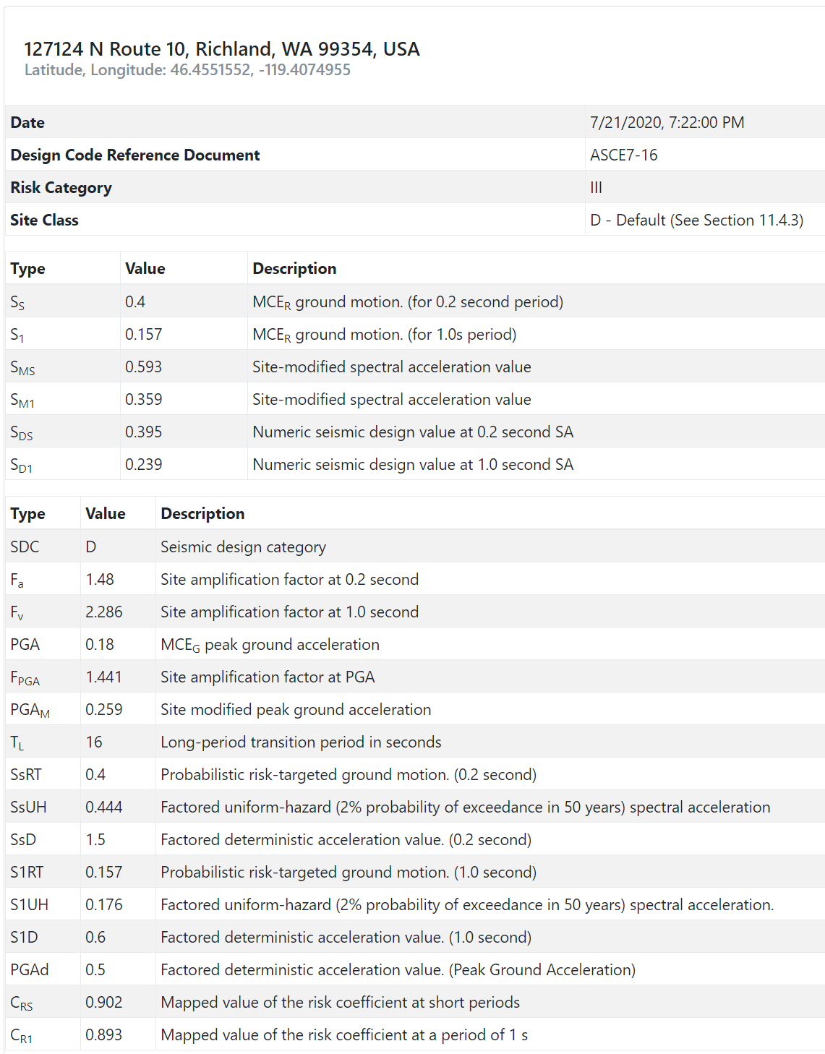

Table 5 LLO Seismic Mapped Parameters

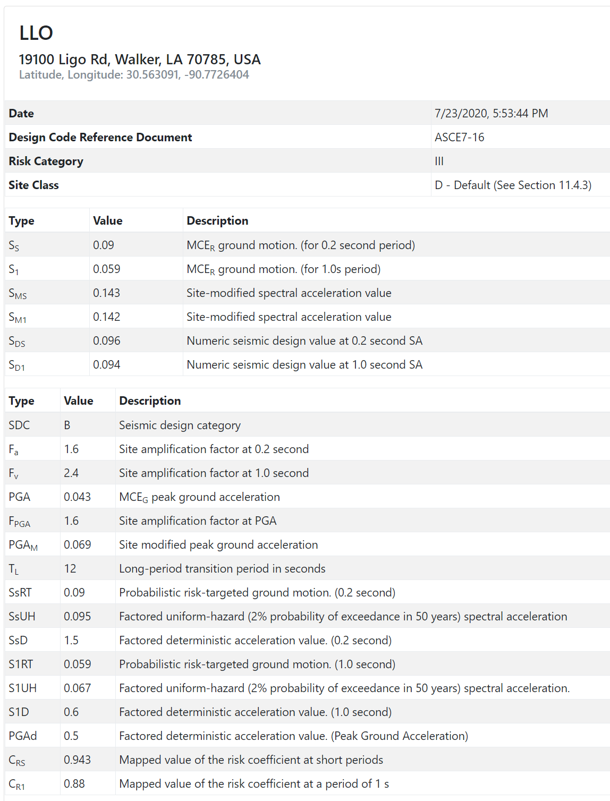

#### Seismic Design category

The “seismic design category” is assigned in accordance with ASCE 7-16 section 11.6 based on the “risk category” and the design spectral response acceleration parameters, SDS and SD1, from section 11.4.5 (and given in the USGS web tool output in the Table 4 above for LHO). Based on SDS and risk category III, the seismic design category would be C. However based on SD1 and risk category III, the seismic design category would be D. Per ASCE 7-16 section 11.6 the structure is assigned the more severe seismic design category, irrespective of the fundamental period of vibration of the structure. Consequently the FCT and supports are assigned a Seismic Design Category of D.

#### ELF

The Equivalent Lateral Force (ELF) procedure (ASCE 7-16, section 12.8) does not consider the reduced seismic response of structures with natural resonance periods shorter than the period range for which the response is a peak (as shown in Figure C12.8-1 of ASCE 7-16). The reason cited, for not reducing the response for short period structures, is that that simple reduction of the response spectrum by (1∕R) in the short-period region would exaggerate inelastic effects. The guidance given in the “Generic Requirements & Standards for Detector Subsystems” document (section 8.2.1.2, Figure 4 of LIGO-E010613-v2) includes this short period reduction but stipulates that R (or Rw per the old ASCE 7-88) is set equal to one.

|  |  |
| --- | --- |
| ASCE 7-16 Figure C12.8-1: Seismic Response Coefficient versus Period  (for LHO, T0 = 0.121 sec, TS = 0.605 sec) | LIGO-E010613-v2, Figure 4: Elastic Design Response Spectrum replotted vs period instead of frequency (for the FTC the fundamental period, Ta = 0.063 sec) |

Figure 3 Comparison of ASCE 7-16 Seismic Response Coefficient and LIGO-E010613-v2

The seismic base shear force, V, is given in ASCE 7-16, section 12.8, Eqn. 12.8-1 as:

$$V=C_{S}W$$

Where Cs = the seismic response coefficient and W is the effective seismic weight. For the FCT the effective seismic weight is equal to the dead load, or self weight. The seismic response coefficient is:

$$C_{S}=\frac{S_{DS}}{\left(R/{I_{e}}\right)}= 0.25$$

This value for Cs does not exceed limitations posed in ASCE 7-16, section 12.8.1. The horizontal seismic force is then 0.25 g.

## Dead Weight Load

An Ansys finite element analysis (see section 0) was performed to determine the dead weight reaction loads at the base plates of the support stands, which were defined to have a fixed boundary condition. The bellows (expansion joint) was modeled as a multi-degree-of-freedom spring between the conflats and cuffs of the bellows assembly. Discrete masses were added to the finite element model of the FCT and supports for the gate valve (51 kg), bellows convolutions (2.18 kg) and a fully loaded 6-way-cross (132.5 kg total mass; see Figure 4). See the spreadsheet filed at LIGO-T2000317-v1 for list of equipment attached to the 6-way cross.

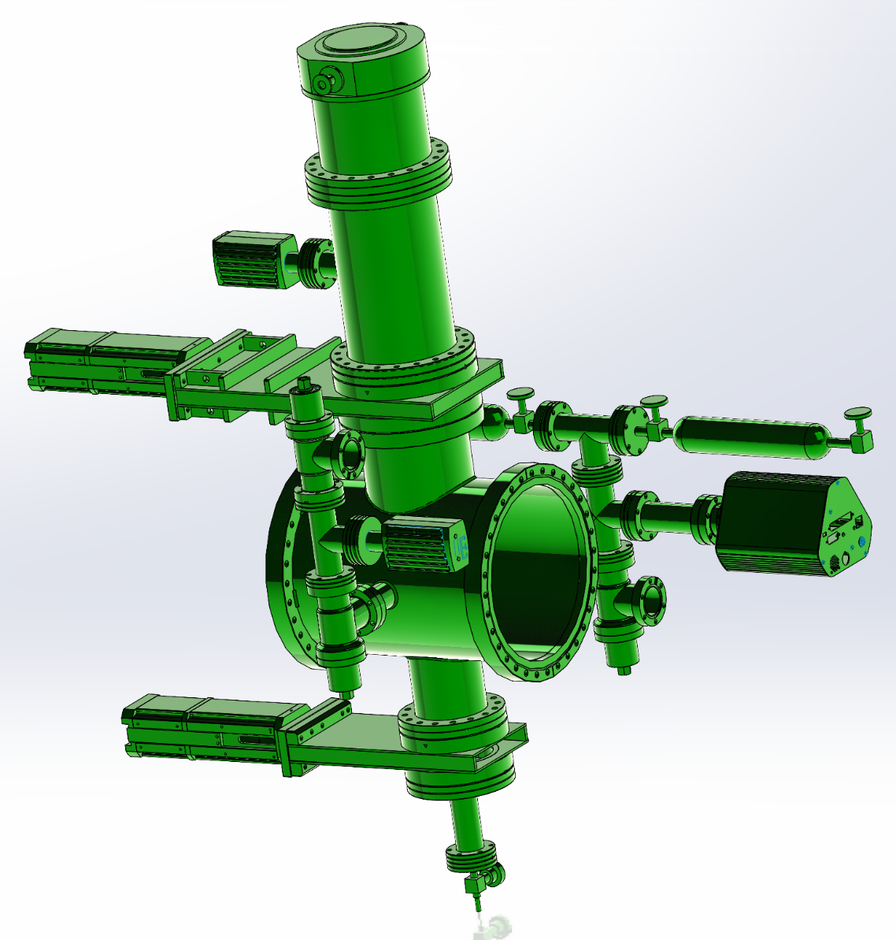

Figure 4 Vacuum equipment mounted on the 6-way cross

## Vacuum Load

There are a few gate valve positions defined along the length of the FCT in order to permit sections of the FCT to be vented and serviced if/as necessary. There are two of these gate valves within the FCT Enclosure (FCTE).These gate valves can be arbitrarily closed or opened with an atmospheric pressure difference in either direction.

The bakeout will only occur in a section which has been pumped down to a vacuum state.

The vacuum load is principally reacted by the fixed supports which have an adjacent gate valve. The fixed support load is simply equal to the tube interior area times the maximum atmospheric pressure. Due to the sliding (guided) boundary condition at each of the guided supports, a frictional force associated with the vacuum load can be imposed on the guided supports as well. The coefficient of friction for the sliding (or rolling) contact[9] of the Alternative Guided (AG) Supports is conservatively[10] assumed to be 0.35 for the load analysis. However, in order to minimize the magnitude of energy released in stick/slip motion due to diurnal temperature cycling we wish to minimize the coefficient of friction. Values as low as 0.15 are possible with graphite plates.

## Expansion Joint forces

The BT calculations in [T940074](https://dcc.ligo.org/LIGO-T940074) use a spring rate variation of 10%. While the FCT bellows may not have the same spread in spring rates, we could[11] assume they will until better information is available. However, the load factors used in the LRFD approach of ASCE 7-16 should cover the spring rate uncertainty.

The expansion joint manufacturer provided a design with a reference axial spring rate of 191 lbf/in. The EJMA guidelines (6th ed. 1993; see also LIGO-E2000002) were then used to calculate the following spring rates, which have been used in the load analysis:

33,381 N/m (191 lbf/in), axial; 125,979 N/m, lateral; 425,782 N/rad, torsional

## Settlement Loads

The maximum allowable differential settlement for the FCT has not yet been established; the loads induced by settlement have not been included in this analysis. For the BT the maximum allowed settlement was set by the maximum allowable compressive stress in the BT when under a thermal bake load (derived on page 145 of [C960366](https://dcc.ligo.org/LIGO-C960366)-x0 as 0.556 inches).

## Horizontal Alignment

The lateral or vertical force required to correct a FCT non-linearity at the bellows is included in the expansion joint load calculation. However the lateral or vertical force to make such alignment corrections at guided supports has not (yet) been included in the analysis. These loads are expected to be small.

## Embedded anchor strength

Anchors embedded in concrete should follow ACI 318 Chapter 17. The following is based on Hilti guidance and “simplified” design calculation tables[12] based on ACI 318. For complex anchor design, Hilti offers anchor design software[13]. These tables are as accurate as the anchor design software as long as interpolation isn’t used and the geometry is consistent with the tables.

A range of potential anchor bolt designs which might be considered is summarized in Table X. We have chosen to anchor the FCT Supports with four (4), ½” diameter, Hilti HAS-B-105 anchors (or similar) which are epoxy-bonded 4.5” deep into a 6” thick concrete slab with minimum separation of 11 inches. The resistance capability of each anchor is 11.8 kN in tension and 10.9 kN in shear.

Table 6 Floor Anchor Resistance



# LRFD Loads

## Design loads imposed at the Support Shoes

A simple beam model (Figure 6) without physical models of the supports, spanning one typical repeating module within the FCT enclosure was used to determine the loads imposed on the Supports at the Pipe Shoes. This model has discrete mass representation of the 6-way cross and associated equipment, and a multi-dimensional spring representation of the expansion joint (aka bellows). Ideal boundary conditions for each support were used. This model was also used to determine the loads on the Alternate Guided (AG) supports by imposing lateral displacements at each Guided (G) Support representative of worst case tolerance stack-up of the FCTs.

The steps for calculating the design loads at the Support Shoes are as follows:

1. Use the simple beam model to calculate the reaction forces at each boundary condition for each of the following 5 load cases:

* Dead Load (D)
* Vacuum load (atmospheric pressure), Lvac (for F/G Supports only)
* Alignment load including axial friction, Lalign
* Lateral earthquake load, Ehx
* Axial earthquake load, Ehy

1. Combine the results of step 1 per the 6 LRFD load cases in Table 2.

The calculations are in the accompanying Excel workbook uploaded to the LIGO DCC with this document ([LIGO-T2000431](https://dcc.ligo.org/LIGO-T2000431/public)) and the results are given in Table 7.

Table 7 ASCE 7-16 LRFD Load Cases: Forces and Moments on Support Pipe Shoes @FCT Centerline

Reaction forces are in Newtons (N), Moments are in Newton-meters (Nm).



## Floor anchor reactions

Several 3D representations of the supports were created in order to determine the transfer of loads imposed on the support shoe to the floor anchors with variations in the support base dimensions/design. An example model is shown in Figure 8. For each model, the response or transfer matrix (T) was calculated for unit forces (F) and moments (M) in each direction (Fx, Fy, Fz, Mx, My, Mz) applied to the support at the FCT centerline, to reaction forces (R) at each of the n floor anchor bolts (Rx1, Ry1, Rz1, Rx2, Ry2, …, Rxn, Ryn, Rzn):

$$\left\{\begin{aligned}Rx1 \\ Ry1 \\ Rz1 \\ Rx2 \\ Ry2 \\ Rz2 \\ … \\ Rxn \\ Ryn \\ Rzn\end{aligned}\right\}=\left[\begin{matrix}T1,1 & ⋯ & T16 \\ ⋮ & ⋱ & ⋮ \\ T3n,1 & ⋯ & T3n,6\end{matrix}\right]\left\{\begin{aligned}Fx \\ Fy \\ Fz \\ Mx \\ My \\ Mz\end{aligned}\right\}$$

For each of the 6 LRFD load cases in Table 7 the reaction forces on each floor anchor bolt are calculated. Then the maximum and minimum vertical (anchor bolt axial) and shear forces are calculated across all of the 6 LRFD load cases. The transfer matrices and the calculations are in the accompanying Excel workbook uploaded to the LIGO DCC with this document ([LIGO-T2000431](https://dcc.ligo.org/LIGO-T2000431/public)) and the results are given in Table 8.

Table 8 Floor Anchor Bolt Loads

|  |  |  |  |
| --- | --- | --- | --- |
| **Support Type** | **Base Plate* Dimensions** | **Max Anchor  Tension (kN)** | **Max Anchor  Shear (kN)** |
| Fixed/Gated (F/G) | 17” x 36” | 9.0 | 3.1 |
| Fixed (F) | 14” x 14” | 8.8 | 0.7 |
| Guided (G) | 14” x 14” | 2.0 | 0.5 |
| Alternative Guided (AG) | 14” x 14” | 9.8 | 1.2 |

*\*Anchor bolts are located 1.5” in from each edge near the 4 corners of the base plate.*

Since all of the cases in Table 8 involve only 4 bolts equidistant from the center of the support, the anchor reaction forces can be estimated by a simple moment balance to first order (i.e. the system is approximately determinant). However, when intermediate anchor bolt positions are added, such as shown in Figure 5 with 8 bolts, then the stiffness of the base determines the distribution of reaction forces. A thick base plate (1” thickness was used in the models) with triangular bracing (also 1” thick) was used in the model. This ensures that all floor anchor reaction forces were (approximately) in proportion to their distance from the support center.

The resistance (strength) of the concrete embedded anchors decreases as the separation between anchors decreases due to the potential for the concrete cracking between anchors. A separation distance of 11” is a practical limit. For this reason smaller baseplates with more anchor bolts is not a practical design alternative to the recommended baseplate design (see section 4).

|  |  |
| --- | --- |
| 1. *Stiffened against moments from an axial FCT load - displacement* |  |
| 1. *No stiffening – displacement under axial FCT load* |  |

Figure 5 Stiffened support base results in improved load transfer to the anchor bolts

*Stiffening the base improves load transfer to the bolts at the end of the support plate to react against moments imposed by vacuum and axial earthquake loading (reduces maximum anchor bolt tension from 17.2 kN to 5.7 kN). Stiffened but only corner bolts: max tension is 7.6 kN*



Figure 6 Simple beam representation of a typical, repeating module of FCT (section FCT-C)

Overall length is approximately 64 ft. The 20 ft. tube lengths ([LIGO-D1900443](https://dcc.ligo.org/LIGO-D1900443/public), type 01) are 10” OD, .12” thick walled AISI 304 tube.

CF = bolted Conflat flange pair joint; no mass or stiffness representation; the tube is assumed continuous (‘welded’) at CF joints.

The Gate Valve, which is installed in some modules between the expansion joint and the Fixed/Gated Supports, is not in this model. The Gate Valve adds just ~4 inches of length and ~51 kg of mass.

The expansion joint is represented as a spring with the following spring rates, as well as 2 kg of discrete mass for the missing convolutions:

Axial stiffness = 33,381 N/m (191 lbf/in)

Lateral (horizontal and vertical) stiffness = 125,979 N/m

Torsional stiffness = 425,782 N/rad

The 6-way cross, and attached vacuum equipment, is represented as a 10” OD tube of 14” length with 132.5 kg of discrete mass.

Fixed boundary conditions apply at the end adjacent to the expansion joint, as well as at the opposite end. These boundaries correspond to Fixed (F) or Fixed/Gated (F/G) Supports.

At each of the 4 Guided (G) Supports the displacement is only free in the axial direction.

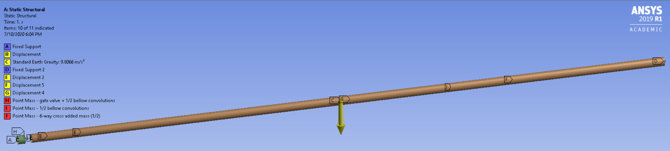

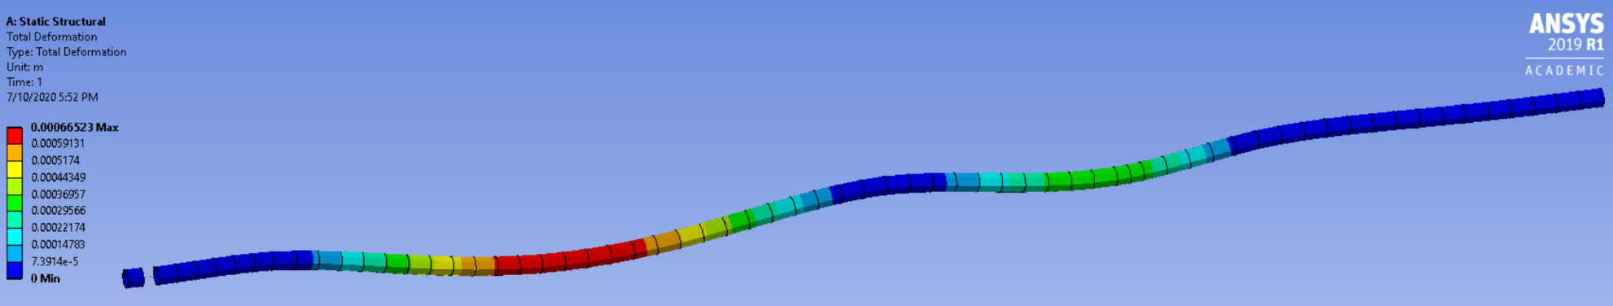

Figure 7 An idealized, representative/typical section of the FCT (beam analysis) and the deformed geometry under gravity loading

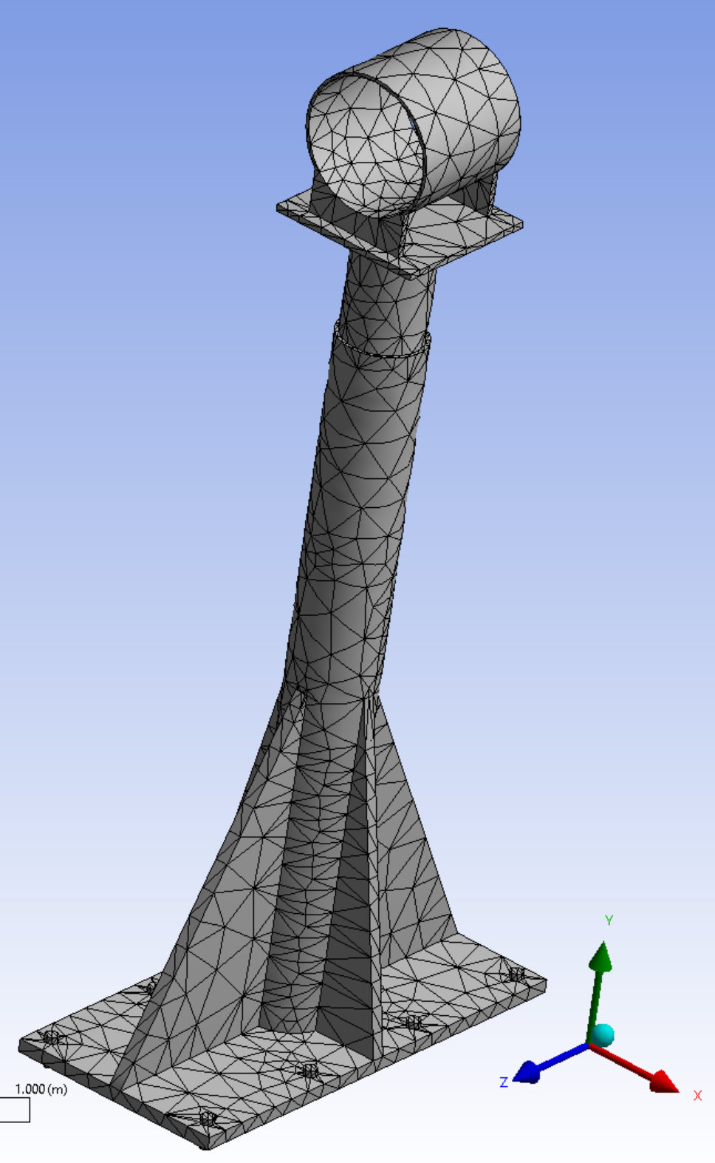

Figure 8 FEM of a Support with a 36” by 17” base, welded stiffeners and 8 anchor bolts

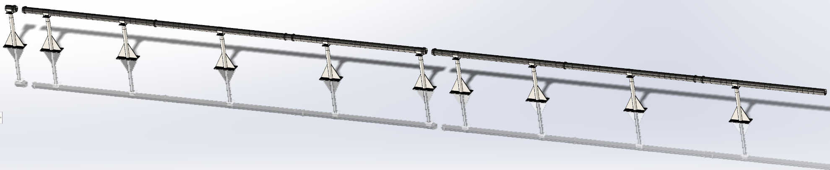

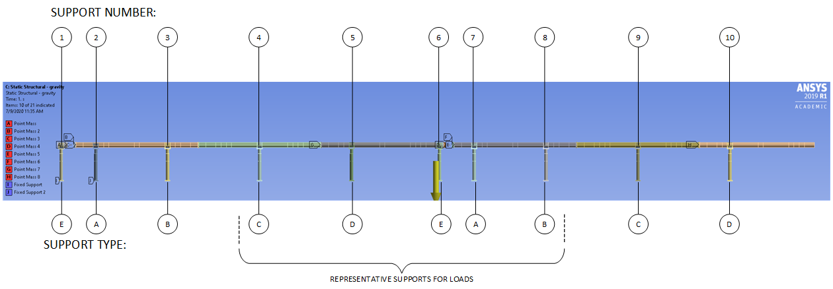

Figure 9 FCT Support instances/types in the representative and repeating sub-assemblies of the FCT

*Couldn’t get the “linear periodic” symmetry condition to work in Ansys, so using two sections between fixed end conditions. Based on Saint-Venant’s principle, the reaction loads for the supports distant from the ends should be representative.*

*A, B, C and D are Guided Supports. E is a Fixed Support. Only the reaction forces for the supports in the center of this model (distant from the end conditions) are used to evaluate loads on the anchors.*

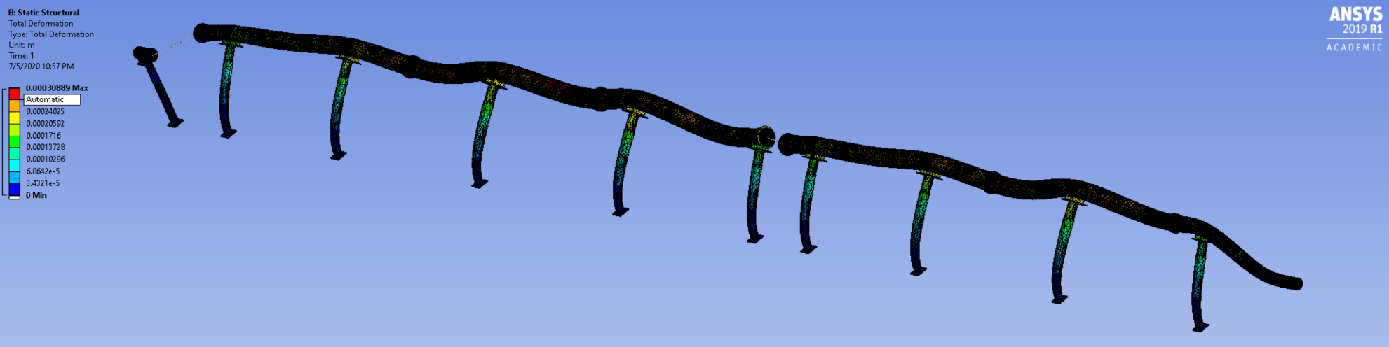

Figure 10 Gravitational load and lateral seismic, static-equivalent load

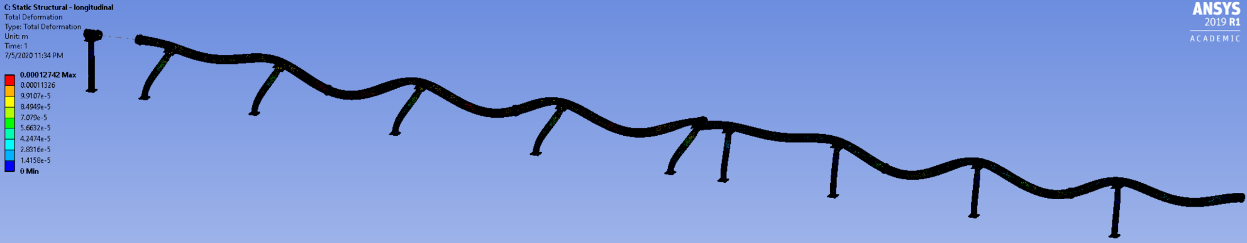

Figure 11 Gravitational load and longitudinal seismic, static-equivalent load

# ASD load analysis

The LFRD load analysis in the previous section is the best determination of loading and floor anchor resistance. An earlier ASD analysis was performed and presented in this section. The conclusions from this analysis in terms of baseplate size and floor anchor size are consistent with the LFRD analysis.

The following ASD load cases have been considered:

|  |  |
| --- | --- |
| G | ± gravitational load |
| LEQ | ± Lateral earthquake |
| AEQ | ± Axial earthquake |
| EJ | ± Expansion joint loads due to assembly tolerances, alignment and diurnal temperature range |
| V | atmospheric pressure loading when sections are under vacuum |
| BO | bake out at 200C induces expansion joint forces (occurs only when section is under vacuum) |

The following 12 load case combinations were considered:

* G ± LEQ ±EJ
* G ± LEQ ± EJ ± V
* G ± LEQ ± EJ ± (V-BO)
* G ± LEQ ±EJ
* G ± LEQ ± EJ ± V
* G ± LEQ ± EJ ± (V-BO)

Since the bakeout (BO) loads are less than the vacuum loads, and in the opposite direction, we can ignore the two combinations which include the bakeout, for the purpose of calculating maximum loads on the supports. (Of course the bake out must be taken into account in the design of the bellows motion range requirements.)

The 3D finite element model (Figure 9 ) starts with a representative/typical repeating section (as was used in the analysis of ground vibration transmission to the FCT baffles in [LIGO-T2000280](https://dcc.ligo.org/LIGO-T2000280)). Ideally a linear periodic symmetry condition would be used in the model, but I was not able to get this option to work in Ansys. As an alternative two representative sections were modeled between fixed boundary conditions. Based on Saint-Venant’s principle the loads on the bases of the FCT supports which are distant from the end conditions should not be significantly affected by this approximation.

The Guided Support (G) and Alternative Guided (AG) Support models approximate the sliding constraint at the interface of the cylinder with the pipe shoe, not at the base of the shoe.

Deformed geometry for lateral and axial seismic loading are shown in Figure 10 and Figure 11.

Results of the ASD analysis were provided in earlier versions of this document.

# Beam Tube anchor and slab design for comparison

The Beam Tube (BT) has fixed supports and guided supports along the BT slab. The termination supports are on special slabs within the corner and end station buildings. The fixed supports are anchored with eight, 5/8” diameter Hilti Kwik Bolt II expansion anchors with an embedment depth of 4”, according to section 3.2 of [E970033](https://dcc.ligo.org/LIGO-E970033)-B, “Fabrication/Installation Procedure – Beam Tube Interface with the Beam Tube Slab”. The guided supports are anchored with eight, 1/2" diameter Hilti HY-150 adhesive anchors with an embedment depth of 4.25”, according to section 4.2. These sections also define the minimum slab depth (6”), a requirement of 3,000 psi concrete and the maximum loads, as given in the table below:

|  |  |  |  |
| --- | --- | --- | --- |
|  | axial | lateral | vertical |
| Fixed | ± 8,128 lbf  at 838 mm below the BT centerline | ± 2,607  at the BT centerline | 8,948 lbf (downward only)  at the BT centerline |
| Guided | 0 | ± 1,625 lbf  at the BT centerline | 7,824 lbf (downward only)  at the BT centerline |

The most notable difference between the BT and the FCT is that the vertical forces are always downward for the BT fixed and guided supports, whereas for the FCT the vertical force can be upward

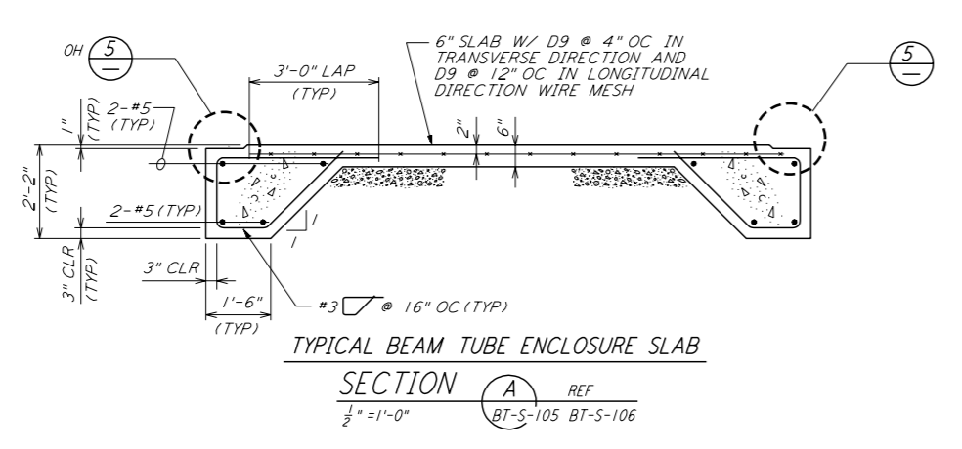

Figure 12 Typical BT enclosure slip form slab

*Excerpt from* [*LIGO-D961582-A*](https://dcc.ligo.org/LIGO-D961582-A)

Paragraph 2.6.A, “concrete-mix design”, in Section 02520, “Portland Cement Concrete Paving” of [C962994](https://dcc.ligo.org/LIGO-C962994), “Final Design Report, Beam Tube Enclosure Sitework and Fabrication, Vol. 1, Specifications”, calls for a minimum compressive strength of 3,000 psi at 28 days.

Although I did not find a procedure for CBI’s installation of anchors for the BT supports, I did find this PSI procedure for installation of adhesive anchors for the vacuum equipment: [LIGO-E1000712](https://dcc.ligo.org/LIGO-E1000712).

For a synopsis of the BT support load calculations see [T1900628](https://dcc.ligo.org/LIGO-T1900628) and the references therein.

1. [LIGO-T2000475](https://dcc.ligo.org/LIGO-T2000475/public) is the final design document. ([LIGO-T2000002](https://dcc.ligo.org/LIGO-T2000002/public) is the conceptual design document.)
2. A similar design concept is used in the analysis of ground vibration transmission to the FCT baffles ([LIGO-T2000280](https://dcc.ligo.org/LIGO-T2000280/public)).
3. ASCE 7-16, section 3.1.1 defines dead load as consisting of the weight of all materials of construction incorporated into the structure.
4. ASCE 7-16, section 4.1 defines Live Load as: “A load produced by the use and occupancy of the building or other structure that does not include construction or environmental loads, such as wind load, snow load, rain load, earthquake load, flood load, or dead load.” Since differential pressure (atmosphere/vacuum) loading is part of the construction/commissioning, or rarely leak hunting, of the FCT and not an often recurring load in operation/use it could be considered not a live load. Likewise bake-out is a construction, transient event as well. It is unclear how to account for these loads if not considered live loads, so we’ll (conservatively) consider them live loads in this analysis.
5. Section 3.1.6 of Hilti’s Anchor Fastening Technical Guide, Edition 19
6. Section 3.1.8 of Hilti’s Anchor Fastening Technical Guide, Edition 19
7. Uniform Building Code (UBC), Vol. 2, 1994. There have been a number of revisions to the UBC culminating in the 1997 version. The UBC is now superseded by the International Building Code (IBC).
8. A. Chopra, Dynamics of Structures: Theory and Applications to Earthquake Engineering, Prentice Hall, 1995, pg. 220-224.
9. According to the [START-PROF 4.84R3 User’s Guide](https://edu.truboprovod.ru/kbase/doc/start/WebHelp_en/index.htm#t=FrictionFactor.htm) normally 0.3 is assumed if otherwise not known or specified.
10. Coefficients of dry static friction for typical pipe support bearing surfaces are given in:  
    B.S. Antaal, et. al., “Considerations of the Restraint Introduced by Piping Support Friction in a Comprehensive ASME B31.3 Analysis”, Proceedings of ASME 2012 Pressure Vessels & Piping Division Confeence, PVP2012, July 15-19, 2012, Toronto, Ontario, Canada, PVP2012-78658.
11. However in the analyses included here only the nominal design spring rates from LIGO-T2000002-v2 have been used.
12. Excerpt from North American Product Technical Guide, Vol. 2: Anchor Fastening, Edition 16. <https://www.hilti.com/medias/sys_master/documents/hbf/9175927062558/Product_Technical_Guide_Excerpt_for_ACI_318_Chapter_17_Strength_Design_-_SD_LRFD_Technical_information_ASSET_DOC_LOC_5941017.pdf>
13. <https://www.hilti.com/content/hilti/W1/US/en/engineering/software/hilti-software/structural-engineering/profis-engineering-suite.html>