Title | OMC DCPD Signal Chain Analysis
Author | R. Abbott, Caltech
Date | 25 February 2021

Overview
Due to the redesign of the new in-vacuum preamplifiers (D2000592) certain aspects of the main Gravitational Wave (GW) readout chain needs to be re-examined. This note examines the following:
- A comparison of key new and old specifications for perspective.
- Functions supported by existing and proposed in-air interface chassis approach.
- The sensing capability of the new bias monitors.
- The calibration chain response.

In addition to the elements above, the transition to the in-vacuum preamplifier design has the following aspects worthy of note:
- New Design is Dual Channel - The old preamplifiers had a single transimpedance circuit per in-vacuum box resulting in the need for two preamplifiers boxes per OMC. The new preamplifiers are dual-channel designs, thus only one in-vacuum box is needed for a direct replacement. Upon the transition to BHD readout, a second dual in-vacuum preamplifier will be needed.
- Move Preamplifiers off the OMC Structure - The new dual preamplifier design uses a physically large enclosure that is considerably heavier than the old design. As a consequence, it would be beneficial to move the new preamplifier design off the OMC cage (which won’t even exist in 05) and onto the optical table. This will require a longer interface cable between the OMC breadboard and the preamplifier. The effects of this change must be carefully studied.
- Fix an Inadvertent Grounding Problem – In February of 2019, it was noted at LHO that the DCPD interface cable leading from the preamplifiers to the cable bracket on the OMC platform has an unwanted ground point as shown in the diagram below. As a new interface cable between the new dual preamplifier and the two DCPD heads is required, there is an opportunity to fix this problem (and perhaps create another). This is worth considering.

Product Perspective, Transfer Functions, and Noise Analysis
Figure 1
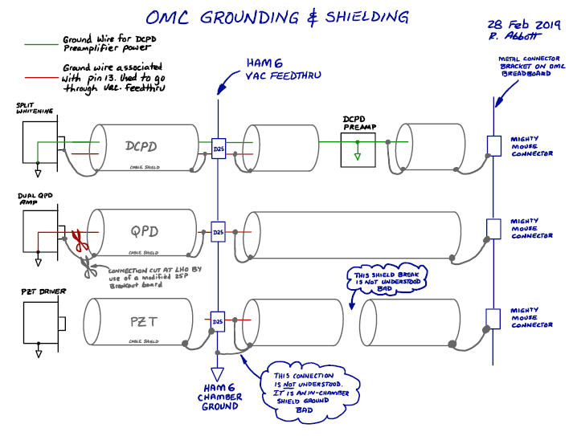

New vs. Old Features
Key specifications are compared below as perspective of the new and old approach to the in-vacuum preamplifier.

Parameter | Old Preamplifier | New Preamplifier
Input Transimpedance seen by photodiode | 100/400 Ω | 31 Ω
Overall Head DC Transimpedance | 200/800 Ω | 200 Ω
Overall Head Transimpedance at 50Hz | 28 kΩ | 102 kΩ
Overall Head Transimpedance at 1kHz | 96 kΩ | 99 kΩ
Gain at 3.125MHz | 840 Ω | 553 Ω
Transimpedance Selection | Selectable (100/400 Ω) | Fixed
Calibration Path | None | Relay switchable calibration function
Bias Voltage Monitor | None | Included

Product Perspective, Transfer Functions, and Noise Analysis

Figure 2 Overlay of New and Old In-vacuum Preamplifier Head Transfer Functions from Photocurrent to Differential Outputs (overall transimpedance)
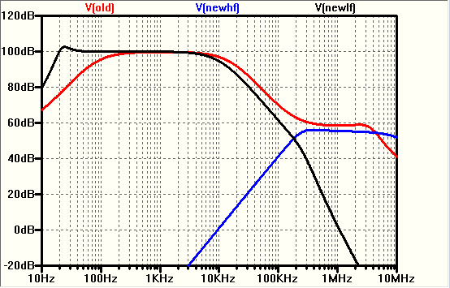

Figure 3 Old electronics chain transfer function from photocurrent to ADC input. Three filters can be switched in any combination. The first and last stages are Z=1Hz, P=10Hz. The second stage is P=50Hz, Z=500Hz.
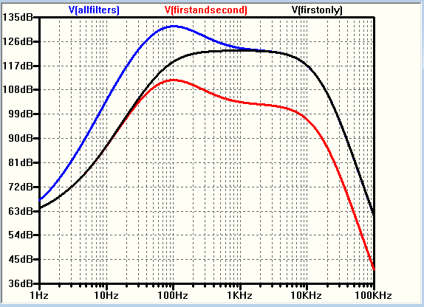

Figure 4 Predicted spectrum at input to ADC for existing (old) preamplifier design using all three available stages of in-air whitening. Red curve corresponds to the signal from 10mA of photocurrent. Blue curve is the dark noise of the entire signal chain. Y-axis is in units of Vrms/$√Hz$
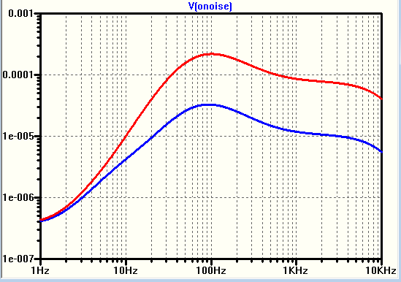

Figure 5 Predicted spectrum at differential output of new preamplifier design. From top to bottom are the predicted signal levels for 30mA, 20mA, 10mA, and dark noise (blue, bottom trace). Y-axis is in units of Vrms/$√Hz$
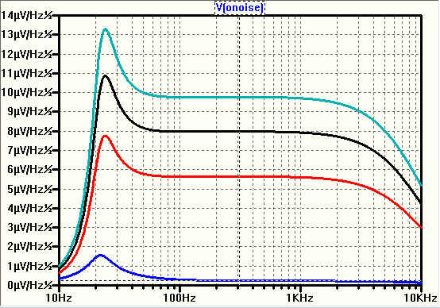

Figure 6 Bias monitor transfer function from PD to bias monitor differential output
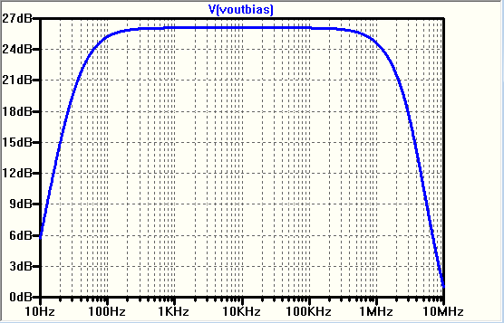
Figure 7 Approximate coupling transfer function from bias supply input to main preamplifier differential output. Useful for estimating allowable bias voltage noise.
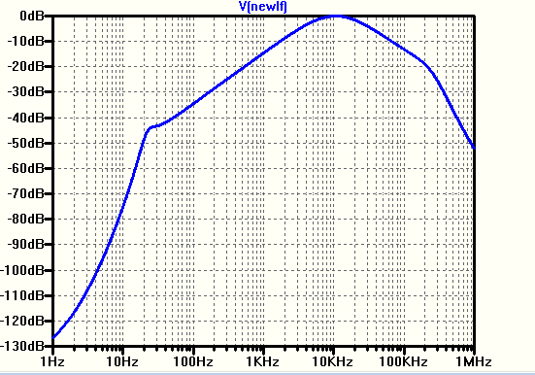

Figure 8. Bias monitor path input referred voltage noise.
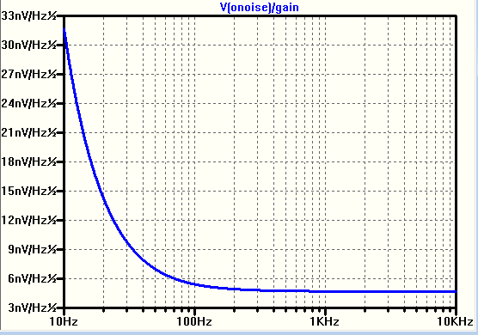

Figure 9 Calibration path transfer function assuming signal input to 100k resistor tied to PD anode, with the output taken differentially from the in-vacuum preamplifier head.
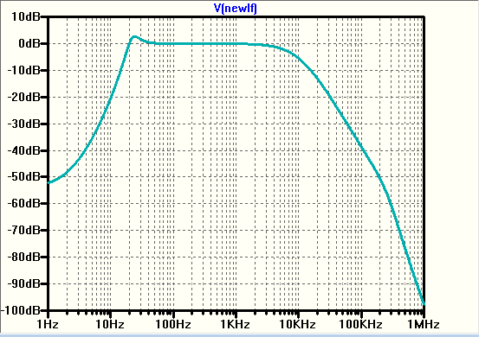

Required Functions for In-air Whitening and Interface Chassis

Item Number | Function
1 | Filtered and current-limited source of +/-15VDC power to two dual-channel in-vacuum preamplifier heads
2 | Independent on/off switch on front panel serving each in-vacuum preamplifier
3 | Sufficient remotely controllable switchable whitening to support lock acquisition and normal low-noise operation for main GW outputs
4 | Calibration relay on/off control (front panel and remote) with switch state readback
5 | Parametric Instability (PI) signal extraction to real-time ADCs
6 | Rear panel signal outputs to real-time ADC channels on Dsub connector (bias monitors, and GW output signals)
7 | 1U 19-inch rack mountable chassis operating on +/-18VDC raw power. Rear-panel chassis on/off switch with raw and regulated power indicating LEDs (regulated on front panel, raw on rear panel)
8 | Filtered and adjustable by circuit component value choice (< tbd V/√Hz) independent source of bias voltage for each preamplifier photodiode.
9 | Rear panel real-time DAC excitation input to inject calibration signals to either or both preamplifier heads. Pin-type 9-pin Dsub interface.

