To: Calum Torrie, Matt Heintze 05-04-2021

From: Vanessa Gomez, Jerami Mennella, Nicholas Heinz

Subject: LIGO-E 2100134-v4; HAM-7 Chemical Characterization of Contaminates

Background

HAM-7 chamber was sampled after being transported from LHO and LLO. Samples S1, S2, S7, S3, and S4 ( reference report ACL-VLG-042221-1) were originally analyzed and failed to meet the cleanliness requirement. Additional samples were submitted for further analysis to identify the contaminates via a series of chemical analyses, specifically FTIR, XRF, and Raman. Samples S8, S9, and S10 had visual debris present on the swab and were thus chosen for analysis. Cleanliness requirement for surfaces after an air bake is level A/50 or ≤ 0.02 micrograms/cm2 and ≤ 0.4 microgram/hole for through holes and ≤ 0.7 microgram/hole for blind holes (9).

Results and Discussion

- The molecular analysis results performed by FTIR can be seen in Table 1. Total amounts were reported as micrograms per centimeter squared. The samples failed met level R2E-2 or A/50 of IEST-STD-CC1246E.

- Elemental analysis was performed by XRF; the method provides qualitative identification of elements with an atomic number from Sodium (11) through Uranium (92). The results showed the presence of iron, nickel, and chromium in all three samples. The presence of these elements at their given mass percentage ratios are indicative of stainless steel. Silicon, aluminum, and calcium were present in sample S9; these elements are components of mixed silica/silicates (soil/dirt) (10).

- Raman analysis showed the presence of iron oxide in all three samples. Sample S8 contained microseal (Molybdenum Disulfide), which is typically used as a dry film lubricant. Metallic particulates were also observed.

- High resolution images of the contaminates collected on the swabs can be seen in Figure 1.

Table 1: FTIR Results for the Hexane Swab Samples
PARTS |  |  |  |  | SAMPLES |  |  |  | RESULTS
# | Part No. | SN | Description | PO # | Vial # | Type | Description | Amount | Chemical Functional Group | Total Amount | Pass/Fail
1 | S8 |  | On roof west of conflat | S491485-A+ | 1 | Surface | - | Area: 161.29 cm² | AHC, Ester | 0.15 μg/cm² | Fail
 |  |  |  |  |  | Holes | - | # of Holes: - | - | - | -
2 | S9 |  | Northeast corner of chamber | S491485-A+ | 2 | Surface | - | Area: 206.451 cm² | AHC, Ester | 0.07 μg/cm² | Fail
 |  |  |  |  |  | Holes | - | # of Holes: - | - | - | -
3 | S10 |  | Southeast corner of chamber | S491485-A+ | 3 | Surface | - | Area: 425.80 cm² | AHC, Ester | 0.06 μg/cm² | Fail
 |  |  |  |  |  | Holes | - | # of Holes: - | - | - | -

Terminology:
AHC: Aliphatic Hydrocarbons, base oil of lubricants, additives
Esters: common sources are from plasticizers and fingerprint
“-“ Not present
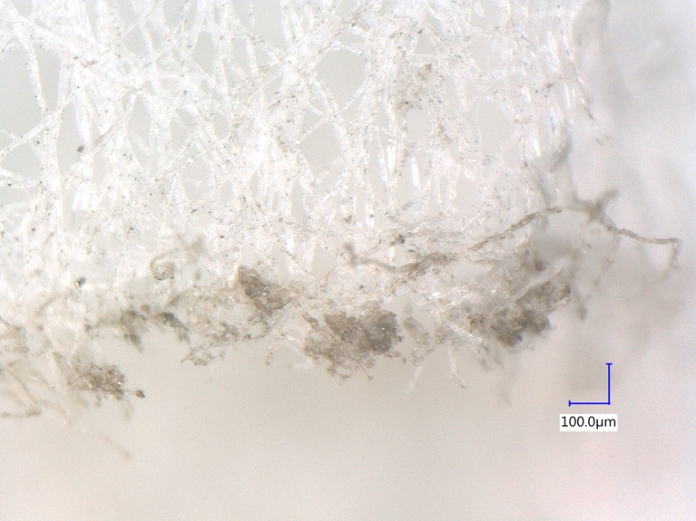
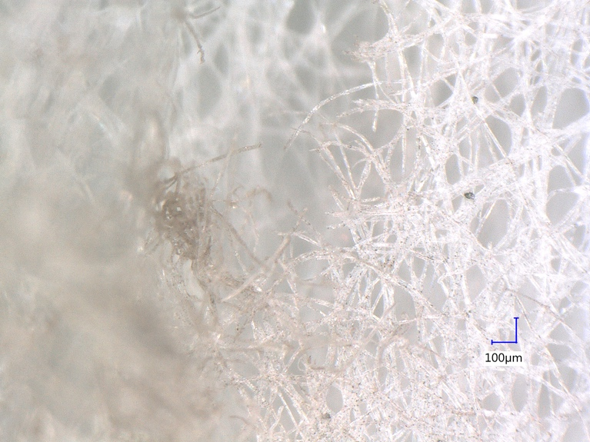

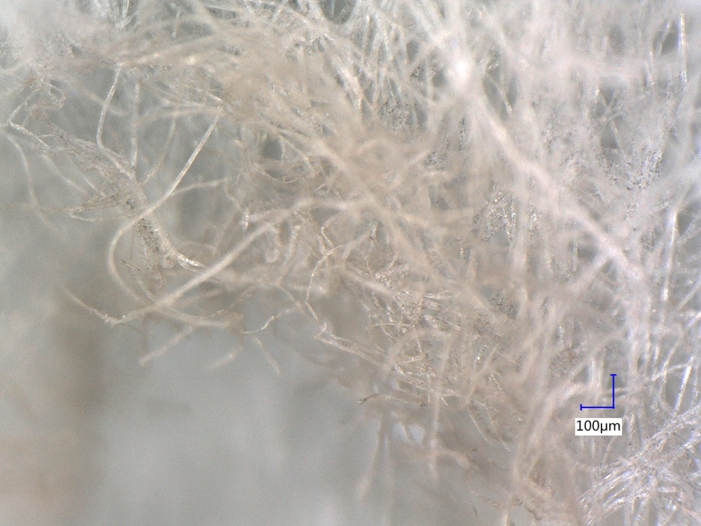

Figure 1: Images of Sample S8 (top left), S9 (top right) and S10 (bottom)

Method

A hexane (NVR) swab (Soxhlet extracted for 48hrs) was used to extract low volatile residues (LVR) on a surface. LVR dissolved into the hexane were analyzed using Diffuse Reflectance Infrared Fourier Transform (DRIFT) spectroscopy. FTIR provides chemical functional group information for qualitative and quantitative determination of materials. The analysis complies with IEST-STD-CC1246E and M2020 requirements (1-2), using a published methodology (3-7), and is sensitive to the stringent levels of molecular contamination (8).

The elemental analysis was performed using a Horiba Model XGT-7200 X-Ray Fluorescence Microscope (μXRF). This technique non-destructively excites the sample with high energy X-Rays and measures the energies and intensities of Fluorescence X-Rays emitted by the sample. The method provides qualitative identification of elements with an atomic number from Sodium (11) through Uranium (92). The method is typically used for qualitative and semi-quantitative analysis. Quantitative analysis is achieved using appropriate standards (11).

Raman spectroscopy is a molecular spectroscopy technique used to observe vibrational, rotational and other low frequency modes in a system. It that relies on inelastic scattering of monochromatic light. The interaction between the light and the molecular vibrations, phonons or other excitations in the system provides information about a material.

References and Notes

- The method conforms to the Institute of Environmental Science and Technology (IEST), Contamination Control Division Document IEST 1246E “Product Cleanliness Levels and Contamination Control Program”. The method is intended to conservatively bin the molecular contamination into cleanliness levels. The ACA M2020 limit is “Level R1E-1” (level A/10 of IEST-STD-CC1246E) and this is 0.1 microgram per square centimeter (μg/cm²) and this corresponds to an average film thickness of 10 angstroms (assuming a density of 1.0).
- M. S. Anderson, “The Chemical Analysis Plan for M2020 Sample Return Hardware”, IOM-3530-2018-043.
- Fuller, Michael P., and Peter R. Griffiths. "Infrared micro-sampling by diffuse reflectance Fourier transform spectrometry." Applied Spectroscopy 34, no. 5 (1980): 533-539.
- “Diffuse Reflection spectroscopy” Handbook of Vibrational Spectroscopy, Volume 2, page 1125-1175, J. C. Chalmers and P. R. Griffiths, eds., John Wiley & Sons, Chichester, UK, pp. 2263 (2002).
- Averett, Lacey A., and Peter R. Griffiths. "Method to improve linearity of diffuse reflection mid-infrared spectroscopy." Analytical chemistry 78, no. 23 (2006): 8165-8167.
- M. S. Anderson et al "Analysis of Semi-Volatile Residues Using Diffuse Reflectance Infrared Fourier Transform Spectroscopy" in Optical System Contamination: Effects, Measurements, and Control VII; July 2002, edited by Phillip T. C. Chen and O. Manuel Lee; Proceedings of the SPIE, Vol. 4774, pp. 251-261, (2002).
- Handbook of Vibrational Spectroscopy, Volume 3, J. C. Chalmers and P. R. Griffiths, eds., John Wiley & Sons, Chichester, UK, pp. 2263 (2002).
- Very clean surfaces, ≤0.02 μg/cm², with mono-molecular layers or less are more complex to describe when cleaning or analyzing. Carbon/hydrocarbon based substances are known to rapidly (within ~1 hour) accumulate on most, if not all, freshly exposed surfaces. This “adventitious” carbon is well documented in clean rooms and vacuum systems and compositionally varies by environment. Adventitious carbon is a discontinuous layer of approximately ~0.2 nanometers thick or ~0.02 µg/cm² up to 0.1 µg/cm² (for ρ = 1). The last mono-layer fractions may in some cases be strongly adsorbed to the surface as a “corrosion” layer. Therefore solvent based sampling methods may not remove these fractions, particularly if the surface is porous. When specifying cleanliness level to lower than A/10 IEST-STD-CC1246E (0.1 µg/cm²) these monolayer effects become more significant. See Anderson M. S., “Chemical Analysis and Mitigation of Adventitious Carbon Contamination”, 1/3/2017, Mars 2020 Project, JPL D-97858. See also: H. Piao and N. S. McIntyre, “Adventitious carbon growth on aluminum and gold–aluminum alloy surfaces”, Surface and Interface Analysis, 2002; 33: 591–594.
- Torrie, C., Coyne, D. “FTIR Testing to Qualify Parts for LIGO UHV Service,” Doc No. E0900480- Rev. v5., Oct. 2017.
https://dcc.ligo.org/public/0007/E0900480/005/E0900480-v5%20FTIR%20testing.pdf
- http://organiclifestyles.tamu.edu/soilbasics/soilchemical.html
- Haschke M. Special Requirements for μ-XRF, Laboratory Micro-X-Ray Fluorescence Spectroscopy 2014 (pp. 119-156). Springer, Cham.

