A+ BHD Final Design
LIGO T2200032-v3
Mark Barton, Angus Bell, Russell Jones, Ken Strain & Stephen Webster
September 2022

Contents
1. Contents 1
2. Introduction & references 2
3. Review process, structure, and contents of this document 4
Overview 4
4. PDR checklist & Status of Design work 6
Status of design work and plans for FDR updates or IRR. 7
5. Status of Engineering models 9
6. Septum window wedge mitigation 14
Statement – removal of septum windows in O4 and thereafter 14
Statement of the problem. 14
Steps toward a solution 15
Parallel-window solution 15
Performance Estimate 16
Additional septum window design requirements and options 18
7. OFI wedge mitigation 19
Statement of the problem. 19
Proposed solution 20
Consequences for the SRM and its suspension 21
Consequences for the OFI 21
8. Overview of the plan for management of stray light 21
Stray light control in HAMs 3, 4 and 5, and BSC2 (led by SYS) 22
Stray light control in HAM6, H1/L1 for O5 22
High priority – essential to review these at FDR 23
Medium priority – expected to review at FDR 23
Low priority – can be left until after FDR (if necessary) 23
High (see below for proposals) 23
Medium 23
Low 23
Ghost-beam analysis for a general survey of beams in HAM6, and to address at least the High and Medium categories above 23
Proposal for stray light control of the OMCs 24
Stray-light control related items between HAM3 and HAM6 that may require to be changed to accommodate BHD 26
Stray-light control related items affected by SRM rotation 26
9. Cable routing (introduction) 26
10. HAM6 table mass balance (continues after BHD FDR) 27
11. Preliminary plan for initial alignment of BHD-related optics 28
12. Known interfaces with BHSS 30
13. Outline schedules 30
14. RODAs and actions completed 31
15. Outline plan for safety and hazard analysis 31
HAM3, HAM4, HAM5, BSC2 31
HAM6 32

Introduction & references
Updates in v3
- At FDR it has been proposed that plane-parallel windows are installed in new septum plates to facilitate initial alignment see Section 11 where the required material is described in outline. A note on this topic has been added to Section 13 to indicate the need to complete design and procurement of new septum plates, windows and related hardware.
Updates in v2
- Checked/added cross-references relating to deferred areas of ISC - see ISC entry in table of Section 4
- Page numbers displayed
- New Section 11 on preliminary plan for initial alignment
- New Section 12 on known interfaces with BHSS
- Link to M2000048 for scope of UK/US deliverables (see table immediately below).
- Add note on baffles etc. that need to be revised for BHD and due to SRM rotation, see new subsections at end of Section 8.
- Add design task for beam dumps on WFS36 sled on HAM6 to SolidWorks task table in Section 5.
Documents other than this one to be reviewed as part of the BHD FDR, or which provide important reference material
https://dcc.ligo.org/LIGO-T2000581 | BHD Preliminary design (review of updates, see Section 4)
https://dcc.ligo.org/LIGO-T2000582 | BHSS Preliminary design (reference only)
https://dcc.ligo.org/LIGO-T2200104 | BHD stray light analysis (review, see also Zemax models)
https://dcc.ligo.org/LIGO-E2200271 | For reference: FMEA and related material (request initial review of plan, for follow up at IRR)
https://dcc.ligo.org/LIGO-E2200270 | For reference: BHD installation summary (request initial review of plan, for follow up at IRR)
https://dcc.ligo.org/LIGO-E2000608 | Zemax model HAM6 H1 (O5) (review from SYS layout and stray light perspective)
https://dcc.ligo.org/LIGO-E2100036 | Zemax model BHD H1 (O5) (review from SYS layout and stray light perspective)
https://dcc.ligo.org/LIGO-E2100244 | Zemax model HAM6 L1 (O5)* (reference)
https://dcc.ligo.org/LIGO-E2100207 | Zemax model BHD L1 (O5)* (reference)
https://dcc.ligo.org/LIGO-D2100601 | HAM6 H1 layout SW model (reference)
https://dcc.ligo.org/LIGO-D2100602 | HAM6 L1 layout SW model* (review from SYS perspective)
https://dcc.ligo.org/LIGO-T2200049 | Update on HAM6/O5 cable routing (review)
https://dcc.ligo.org/LIGO-M2000048  (viewable by LIGO Lab) | Informal document recording scope of equipment to be provided by UK/BHD team and LIGO, including plan for reuse of LIGO equipment (in development, pending SolidWorks BoMs).
* As presented, some updates that have been applied to the H1 models may not have been implemented in the L1 models, these are in all cases minor, typically placement of secondary optics etc. The models and resulting BoMs will be updated following the completion of detailing of cable brackets, cable clamps, dog clamps and optics “sleds”, at the time of writing all of which are being passed between the BHD team and Systems, concentrating on H1.
A major component of the BHD system is the BHSS, subject to separate review. See https://dcc.ligo.org/LIGO-T2100318 for the FDD, in preparation with the review due shortly after the BHD FDR. Several topics such as installation, stray light control, etc., overlap the two reviews and we attempt to include relevant material in both. Engineering detail of the BHSS is not, however, included in the documents for the BHD FDR.
A list of the following topics that are deferred until an FDR update closer to installation was provided to the review chair and systems prior to commencement of the review. The following topics, normally part of an FDR are not included at this stage, for the reasons given below. In all cases we expect these to be revisited at an FDR update.
- subsystem block and functional diagrams, in particular CDS wiring diagrams – the BHD team does not have the expertise to produce these, to allocate racks, etc. Note that in-vacuum wiring within HAM6 is introduced in Section 9.
- hardware test/characterization plan(s) are available for many components such as suspensions and will be provided for the BHSS. Additional plans for the BHD subsystem as a whole requires input from commissioners. This includes the plan for initial alignment and commissioning of the BHD system.
The following documents specify components/assemblies of the BHD and were introduced or modified after PDR (with DCNs where appropriate):
https://dcc.ligo.org/LIGO-E2200138 | BHD secondary optics HAM6 high-refl
https://dcc.ligo.org/LIGO-E2200139 | BHD secondary optics HAM6 beamsplitters
https://dcc.ligo.org/LIGO-E2200140 | BHD secondary optics HAM lenses
https://dcc.ligo.org/LIGO-E2200141 | DCN for above
https://dcc.ligo.org/LIGO-G2200865 | New concept for OMC mounting (see below)
https://dcc.ligo.org/LIGO-E2100308 | DCN for all 3” BHD optics (see DCN for links to relevant specifications and drawings)
https://dcc.ligo.org/LIGO-E2100342  https://dcc.ligo.org/LIGO-E2100311  https://dcc.ligo.org/LIGO-E2100310  https://dcc.ligo.org/LIGO-E2100309 | DCNs for 2” and 50mm BHD optics (see DCNs for links to relevant specifications and drawings)
https://dcc.ligo.org/LIGO-T2100078 | OMC FDR update, mainly relates to BHSS FDR but should be noted here

Review process, structure, and contents of this document

Overview
The BHD subsystem consists of an optical design with suspended optics in HAM3, BSC2, HAM5, and HAM6, non-suspended optics, shutters, beam-dumps etc., in HAM6, with associated cabling and stray-light baffles. The design requirements https://dcc.ligo.org/LIGO-E2000072 and linked documents such as https://dcc.ligo.org/LIGO-T1800413 were updated and reviewed at PDR and have not changed since.
The CDD https://dcc.ligo.org/LIGO-E1900377 is effectively obsolete, as all relevant information was included in the PDD https://dcc.ligo.org/LIGO-T2000581
Material from the PDD is relevant to this review, and is referenced below, including aspects amended in the closing stages of the PDR.
The PDD was updated to -v2 during the PDR, to -v3 with the “final” version of the preliminary optical layout for HAM6, and -v4 with a minor correction to the value of BHDL1 RoC, for consistency with the part specification. A few PDR actions relating to work required at the systems level were not completed in the PDR phase, and are listed here:
- Check of revised LO beam path from HAM3 to HAM5, reflecting horizontal wedge on BHDBS1, confirmation of coordinates for BHDM1 (these form part of the systems layout and stray light baffle design checks, now underway SYS may comment)
- Check of interference of LO beam path with any baffles in HAM4/HAM5 and the HAM45 beam tube (as above),
- Check of clearance of the proposed LO beam path through the SR2 structure (as built). Believe plan was for SYS to look at this with updated layout, status TBC.
The BHD subsystem relies on availability of HRTS, HXDS, BHSS, HTTS suspensions. All have passed FDR except for the BHSS whose FDR process is expected to occur around the same time as this BHD FDR. See https://dcc.ligo.org/LIGO-T2100318 for the BHSS final design. Only outline aspects of the BHSS are discussed here, mainly concerning performance requirements.
The BHD subsystem design affects details of the following items that have otherwise passed FDR:
- HRTS: spacer heights for HAM mounted HRTS, bracket details for BSC mounted HRTS; optics to be suspended on all HRTS – details included in Section 19 of https://dcc.ligo.org/LIGO-T2000581 dimensions are included in the proposed BHD layout SolidWorks models (per site).
- HXDS: requirement of HXDS variants in HAM6 (only) see https://dcc.ligo.org/LIGO-D1800027 version 26 or later, spacer heights for these HXDS; optics to be fitted to each HXDS – details included in Section 19 of https://dcc.ligo.org/LIGO-T2000581 and as shown in the layout models.
- HTTS: requirement for application of modified ECD bracket https://dcc.ligo.org/LIGO-E1800098 optics to be fitted to each HTTS (requirement first stated here).
- BHSS: the optical interfaces are the in- and out-going beam vectors, and the points of location on the HAM-6 table. An important aspect of this is the (interface) specification of stray light control for the BHSS. This is described in outline below, with full detail to be shown in the BHSS final design.
The process includes:
- review of this document BHD subsystem
- review of the BHSS (FDR)
- sometime later, an IRR for BHD subsystem based on as-built suspensions, final optical design etc. to check provided hardware and that installation procedures are clear.
Clearance to move ahead with the procurement of suspended BHD optics was given at PDR. Section 19 of https://dcc.ligo.org/LIGO-T2000581 was updated to reflect this. Minor changes in optical specifications were carried out during their individual approval processes according to the following DCNs.
The resulting specifications cover substrate material, substrate shaping and finishing, and coatings. They were reviewed and released by DCN (https://dcc.ligo.org/LIGO-E2100308 (3 inch optics); https://dcc.ligo.org/LIGO-E2100309 (SAMS mirrors), https://dcc.ligo.org/LIGO-E2100310 (BHDL0); https://dcc.ligo.org/LIGO-E2100311 (LOPO) and https://dcc.ligo.org/LIGO-E2100342 (HDDS mirrors).
The following specifications and drawings were created:
Item | Specification | Drawing | Note
Plane 3” optics (BHD BS1, M1, BS2; OM0) | E2100052 | D2100495 | 4 sub-types
3” lens BHDL1 | E2100215 | D2100496
50 mm lens BHDL0 | E2100214 | n/a
50 mm mirror LOPO | E2100113 | n/a
50 mm SAMS mirrors | E2100053 | n/a | 4 sub-types
2” HDDS mirror | E2100335 | n/a
Table 1: BHD optics: specification of items requiring early procurement (underway)
Item | Specification | Drawing | Note
lenses | E2200140 | n/a
high reflectors | E2200138 | n/a
beam splitters | E2200139 | n/a
Table 2: BHD optics: additional 1 and 2” optics for HAM6 (procurement underway)
Due to delays to this FDR, it has become necessary to procure at least the substrates of all other BHD-related optics, i.e., 1” and 2” mirrors required for HAM6. These parts were specified and reviewed according to the above table with DCN https://dcc.ligo.org/LIGO-E2200141 The 1” optics required for the BHSS are included in the above list.

PDR checklist & Status of Design work
Points recorded for action in https://dcc.ligo.org/LIGO-L2100047 were addressed in Section 6 of https://dcc.ligo.org/LIGO-T2000581 refer to that section for additional detail.
The following reports on the action items from L2100047:
- Ken, Stephen, Russell, Calum: Due date June 2021 (-v2 of PDD): All items related to the getting a full SolidWorks model of the BHD HAM6 layout (Issue # 3, 5, 6, 26, 27, 34, 44)
  - these were addressed by the BHD team in updates of T2000581 and later by providing Zemax models for the IFOs and HAM6 SolidWorks (SW) layouts. In detail: #3 – additional diagrams added; #5 – LO beam path incorporated in Zemax and SW; #6 –fully-detailed Zemax and SW models for HAM6; #26 – OMC beam dumps added, under revision given new OMC cover; #27 – see Zemax/SW models for HAM6/BHSS; #34 – discussed with SYS, baffle design in progress based on Zemax layout provided; #44 – Zemax layout provided.
- BHD Team and SYS: Due date for discussion, 14-June-2021: how to address the phase noise issue from the septum window. Options are removal of window, getting a plane-parallel septum window, moving some of the BHD optics into HAM5 (issue #4, #35)
  - See Section 5 (moot, assuming removal of windows)
- Lisa Barsotti. Last week of May 2021. BHD trade study document. (issue #24, #43). This is not required for BHD PDR to be accepted.
  - Done, see https://dcc.ligo.org/LIGO-T2100199
- Alena Ananyeva. Due date: FDR (could also be provided later in O4 commissioning). Update and sign OFI RODA
  - https://dcc.ligo.org/LIGO-M1900173 still needs to be updated. Managed meantime by exchange of compatible Zemax models. With window removal, path through septum less critical, but path to HAM6 remains significant. See also Section 7
- BHD Team: Due date: FDR: Miscellaneous (issues #39, #40, #41)
  - #39 – track down ghost beams, see Section 8; #40 – parking of LO beam, resolved by pitching BHDM1 and directing LO to baffle (see PDD); #41 – beam dumps were added as shown on HAM6 layouts. Baffles in HAM3, HAM4, HAM5 and BSC2 remain in design (SYS).
Other updates to https://dcc.ligo.org/LIGO-T2000581 were made in response to PDR: #11 (SAMS), #13 (AWC noise), #14 (SAMS actuator table), #25 (OM0 transmission), #42 (LO power), #22 and #46 relating to fast shutters. These items were closed prior to PDR sign-off. We are holding open the selection of types of fast shutter and have confirmed space provision, optical and electrical compatibility of the alternatives.
Later, it was realized that the OFI is also wedged and could introduce phase noise, see Section 7, below.

Status of design work and plans for FDR updates or IRR.
Subsystem/item | Status | Plan
CDS – in-vacuum wiring diagrams & feedthrough allocations | Proposal presented for HAM6 for review, details for HAM3 (1 sus), HAM5 (1 sus), BSc2 (2 sus) TBC.  See Section 9 | Incorporate into SW layouts (2022). Likely review separately to allow procurement of cables (US) and cable brackets (UK), expect during 2022.
CDS – in-air wiring diagrams, racks, power allocations, etc. | Information available to SYS reference T2000581 | Review at time required for procurement of cables etc.
ISC | Reference T2000581, further work needed  - Review/revise carrier/RF spectra at all sensors (other than DCPDs) – based on O4 commissioning, update SNR calculations and fix dither amplitudes, aux loop bandwidths, etc.  - Review SAMS optics and initial preload against new information that may be obtained during O4 commissioning.  - Move from notional (T2000581) to final loop filters for aux loops such as OMxx alignment (follows i.)  This may benefit from additional measurements of corner station motion during O4 commissioning. | These have little or no impact on hardware but do require control system design work, likely during O4.  Review at IRR (late in O4?)
ISC HAM6 equipment US scope | Requirements: see T2000581, other than reused equipment: 2nd Fast shutter (design TBC) and WFS/RF sensing. | IRR
SUS (actuators) | Reference T2000581, only uncertain requirement is for OM0 dither/actuation at M3. Follows from ISC review above. | All hardware required already included at PDR. Review possible changes to OM0 dither, actuation at IRR (circuit mod).
SUS: BHSS | Separate review due soon (Summer 2022) | BHSS FDR
SYS: Table balance (HAM6) | See Section 10 – we are assured that, due to relatively light payload, risk of problems is low. Finalize when all details that may affect payload mass are fixed, i.e., cable routing, brackets, guards, stray light baffles, dog clamps and small optics sleds. | IRR
SYS: Stray light | Design work underway, see Section 8 for introduction. | Possibly FDR update for stray light baffles (2023?), otherwise IRR.
SYS: installation | See https://dcc.ligo.org/LIGO-E2200270 | Review initial plan for follow up at IRR
SYS: global IFO alignment | Deferred – requires joint planning with SYS/commissioners. | IRR
Safety | Hazard analysis: Section 15 | Outline only, LIGO to provide formal plan meeting legal requirements
Risk management | FMEA / characterization & test plans see https://dcc.ligo.org/LIGO-E2200271 | Review initial plan for follow up at IRR
Engineering model SW/drawings  https://dcc.ligo.org/LIGO-D2100601  https://dcc.ligo.org/LIGO-D2100602 | For HAM6 (UK led) See also Section 5  Note that H1 is regarded as the “master” with L1 updated to follow, based on the known differences. | Under iterative development with SYS / IRR  The L1 version is slightly behind with respect to small optics including on the BHSS. See the note for Zemax, these will soon be brought up to date.
Zemax models & associated optics specifications  https://dcc.ligo.org/LIGO-E2000608  https://dcc.ligo.org/LIGO-E2100036  https://dcc.ligo.org/LIGO-E2100244  https://dcc.ligo.org/LIGO-E2100207 | Presented for review for H1 (top two references) complete in all detail, for L1  Review of these documents is requested.  See also Section 5 | Under iterative development with SYS / IRR  (E2100207 needs a minor/trivial update to one optic.  E2100244 is one version behind E2000608 as regards BHSS optics & realistic positions for OMC optics.)
OFI wedge mitigation | See Section 7 note that the design details, i.e., final position of OFI per site, drawing for BHDL0 holder, and stray light configuration at OFIs should be reviewed with final O4 geometry (mm-level changes from PDR design) | IRR, possibly also review prior to production of BHDL0 holder (late 2022, if possible).
Septum window mitigation | See Section 6, essentially on hold on the assumption that septa are to be removed at both sites.  Note that at FDR it has been proposed that plane-parallel windows are installed in new septum plates to facilitate initial alignment see Section11 | VRBs / FDR update if needed.
Schedules | UK hardware procurements see Section 13
RODAs and actions complete | See immediately above and Section 14

Status of Engineering models
The Zemax system layout for H1 https://dcc.ligo.org/LIGO-E2100036 is at the top of the hierarchy of engineering models. The HAM6 Zemax model for H1 https://dcc.ligo.org/LIGO-E2000608
is consistent with it and provides a more convenient scale to consider beams in and around HAM6. The corresponding L1 models (https://dcc.ligo.org/LIGO-E2100207, https://dcc.ligo.org/LIGO-E2100244 ) are less frequently updated with the minimum changes to cope with the different beam paths in the output side of the IFOs.
The Zemax models are carefully updated to reflect changes in the optics specifications that emerged during procurement. Examples include small changes to RoCs requested by substrate manufacturers that could be accepted, sometimes with adjustments to the layout. The RoC changes were managed by DCN to the specifications listed above and at the same time the models were updated. The H1 HAM6 model was then used to trace the beam paths in the matching SolidWorks (SW) model, with a similar hierarchy of updates to systems and L1 models, except that the systems models are not practically accessible to the UK group. This explains many of the version updates – the underlying layout has not changed markedly since PDR sign-off.
SolidWorks (SW) models of HAM6 are provided by the UK for incorporation into the system model. As with the Zemax models, while both L1 (https://dcc.ligo.org/LIGO-D2100602) and H1 (https://dcc.ligo.org/LIGO-D2100601) models exist, the latter takes primacy.
Note that these assemblies are on the SW vault, with snapshots of recent versions given below.
Work that remains is summarized as follows (SW work presented in time order):
Item | Status | Plan
Zemax: stray light baffles | HAM6: UK led work to place baffles, with SYS advice  Other: SYS work to place baffles with UK advice  See also OFI wedge mitigation | Iterative updates
SolidWorks: cable brackets | HAM6 – SYS proposal for cable routing leads to positions for cable brackets to be added to SW models (in progress) | Fix cable bracket types and positions, procure additional parts where needed (for all BHD suspensions)
SolidWorks: WFS36 beam dumps | HAM6 – beam dumps currently shown on the WFS36 sled are too large | Need to develop more compact (Super8/DLC) “V” beam dump for this location (part of joint stray light work)
SolidWorks: cable guards (HAM6) | Immediately following from above, consider where guards may need to be added in crowded areas to prevent cables moving into beams. | Plan for Fall 2022, procure necessary material. Mini-review with previous item?
SolidWorks: small optics sleds and dog-clamps | Work with SYS to define clamps for all parts and to design common “sled” mounts for small optics in high-density area (in progress). | Plan for Fall 2022, procure sleds during 2022 (most clamps are part of SUS).
SolidWorks: stray light control | Implement updates to beam-dumps and baffles emerging from Zemax work (future) | Expect late 2022 I to 2023 (TBC)
SolidWorks: HAM6 table balance | On completion of above, the payload mass is essentially fixed. | Expect table balance review in 2023

Renderings from https://dcc.ligo.org/LIGO-D2100601
Notes:
- Beam paths from E2000608-v18 beam paths are shown later versions of the layout show minor changes to beam paths around small optics on the HAM6 table and on the BHSS.
- Suspension spacers are not yet included in the suspension models used within this assembly. These are part of the suspensions and should be updated in due course (HRTS by UK/RAL, HXDS by LIGO).
- It is planned to place LOPO and associated optics on a sled, not yet shown. The same may apply to other collections of small optics where they are not well aligned to the table grid. In all cases the optics/mounts are shown in their final location however.
- The LO-QPD and ID-QPD assemblies remain to be properly specified as assemblies. These consist of a standard in-vacuum QPD on a standard mount but the whole assembly does not appear to exist as a model.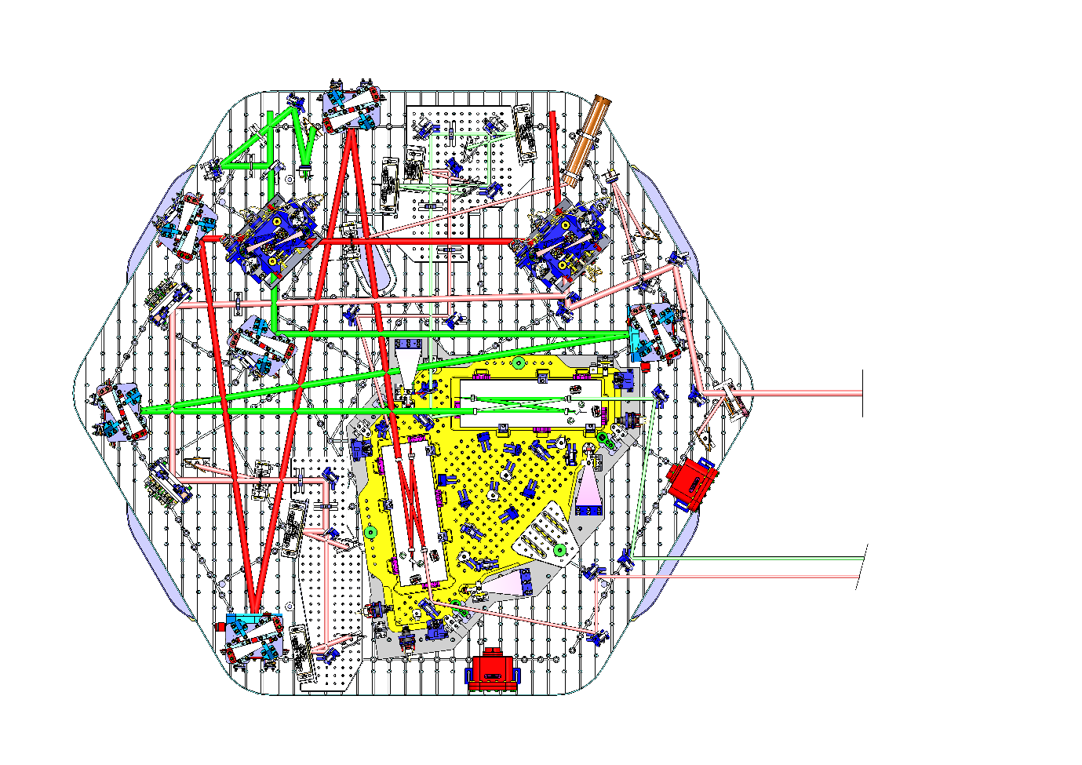
Figure 1: Plan view of O5 HAM6-H1, see D2100601. The view for HAM6-L1 would look similar.
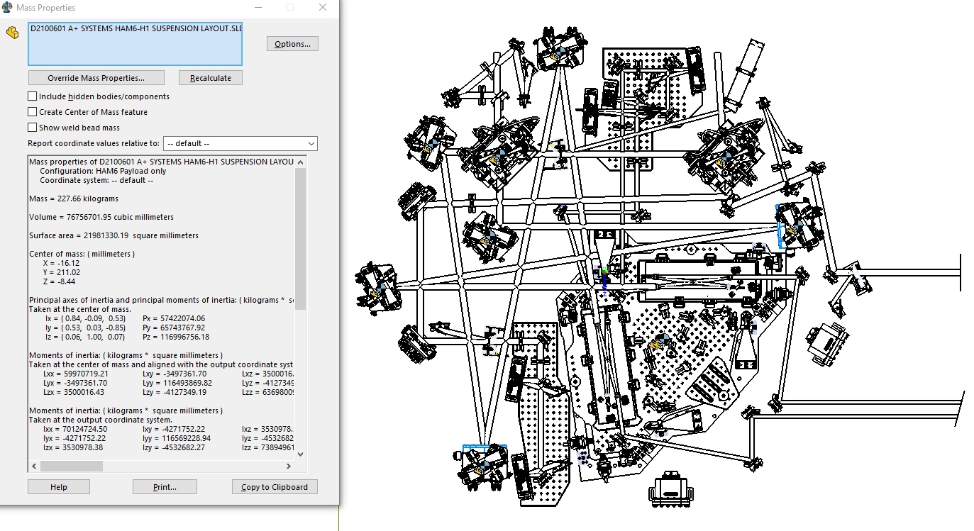
Figure 2: HAM6-H1 payload, showing CoM coordinates roughly centered in local X, Y, and 13cm above the table, to be refined when items such as, HXDS spacers, cable brackets, cables, sleds for some optics and dog clamps are added – see Section 10. Beams external to the BHSS are shown as tubes of 20w width/diameter. CoM in Local coordinates is 300 mm − 211.99 mm = 88mm below the Local CS zero, this is 132mm above the table surface.
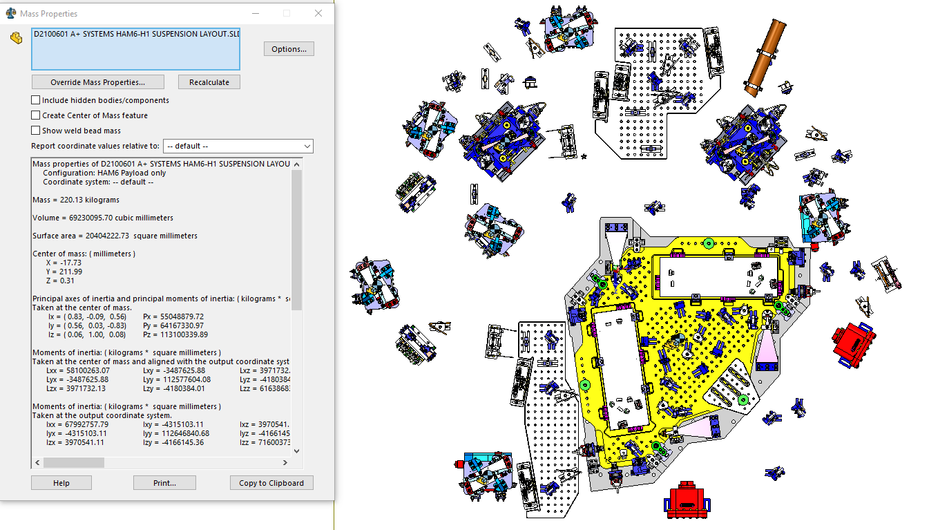
Figure 3: placement of components showing access. Several small optics on the HAM table, in those cases where components are not well aligned to the table grid, may be combined on to sled(s) for ease of mounting/clamping.
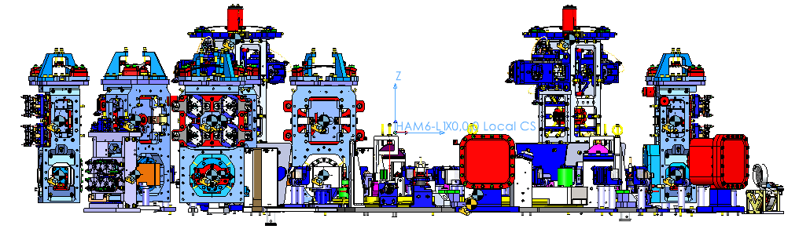
Figure 4: view from −Y side of table showing payload.
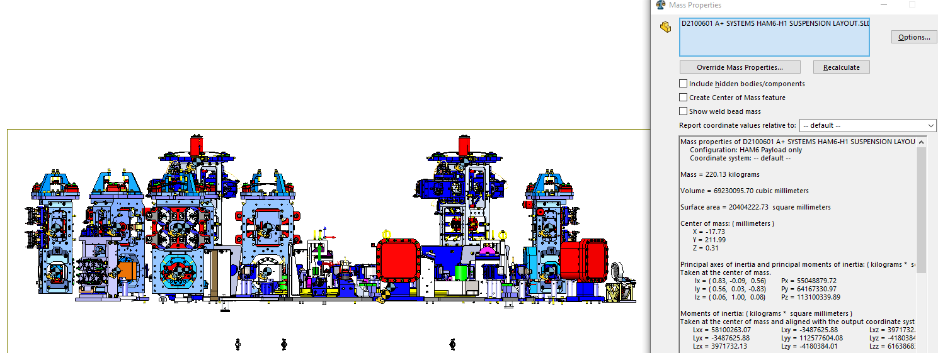
Figure 5: as above, showing CoM location in side elevation
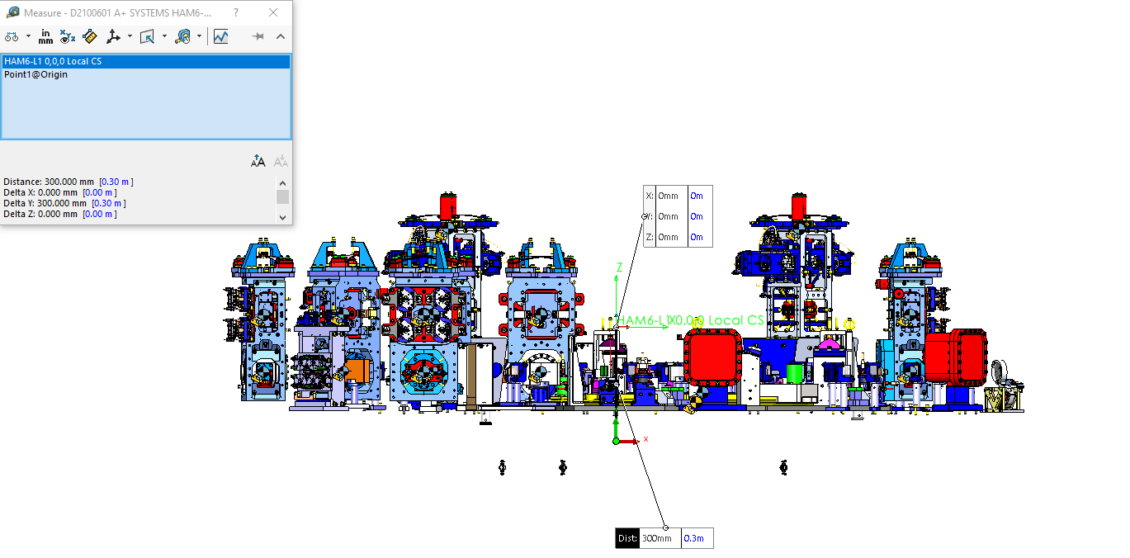
Figure 6: clarification of various coordinate systems (local zero in green, vs. automatic CAD system). These coordinate systems are offset by 300mm, and swap Y and Z.

Septum window wedge mitigation

Statement – removal of septum windows in O4 and thereafter
Following problems during O4 commissioning, a plan was put forth to remove the existing output septum windows (confirmed for LLO, pending if not already confirmed for LHO). It is therefore expected that the remainder of this section is moot as no new windows are required, and may be excluded from review, - the relevant sections are shown in italics. The material is left in place in case the situation changes. Also, the arguments are helpful for the following section where OFI wedges are considered. Note that at FDR it has been proposed that plane-parallel windows are installed in new septum plates to facilitate initial alignment see Section 11

Statement of the problem.
At the BHD PDR the effect of wedged optics on BHD phase noise was raised. It was realized that the proposed HAM5/6 septum windows (hereafter septum windows) are wedged, and that this, together with the expected level of transverse-horizontal and vertical motion of the septum plate would lead to phase noise above the single optic requirement for the BHD path.
The single optic path length or equivalently phase noise requirement for the BHD paths, including the usual factor of ten margin below equivalent DARM noise, and a further factor of the square root of the number of contributing components, is shown as Figure 4 of https://dcc.ligo.org/LIGO-T2000581. The same (displacement) curve appears in several figures referenced or presented below. Note that at some frequencies the septum windows may be the dominant contributor to path length noise, in which case the requirement is modestly more stringent that in need be.
The first step taken was to request accelerometer data representing vertical and transverse horizontal motion of the septum plate. This is available for LLO, directly from the triaxial PEM accelerometer mounted on the plate. As recorded in Section 5.3.1 of T2000581, data and analysis code were provided by Anamaria Effler. The data were recorded at LLO in February 2021 and represent calibrated output from the 3-axis in-vacuum accelerometer attached to the HAM5–HAM6 septum. The MATLAB script was modified (in minor ways) to yield the required output plots.
Original data are at: https://llocds.ligo-la.caltech.edu/data/anamaria.effler/PEM/forKen/
The data come from L1:PEM-CS_ACC_HAM6VAC_SEPTUM_Z which is actually a tri-axial accelerometer that provides calibrated output with noise level corresponding to essentially ${10}^{-5}\text{m}{\text{s}}^{\text{-2}}$ (slightly worse below about 20 Hz). This accelerometer is a good witness for all the important vibrations of the septum. As the concern is mostly with motion around 20 Hz, and to a lesser extent in the band 40 to 60 Hz, the septum can be assumed to be rigid. The resulting spectra are shown on figures referenced or presented below.

Steps toward a solution
Several ideas were raised at the PDR:
- Extremely-uniform, plane-parallel septum windows – i.e., windows that deflect the beam by < 0.01 arc-seconds. A pair of such windows, installed in any orientations, would ensure negligible coupling. Unfortunately, such windows cannot reliably be fabricated due to refractive index inhomogeneity on length scales comparable to the beam size (radius 2mm) that cannot be corrected using known technology. Following the PDR, a more practical compromise solution was sought, and this has yielded the proposal presented below.
- Differential pumping with ducts linking across the septum. The ducts would require to be about 2” ID to accommodate the beams and allow baffles of reasonable aperture diameter, and about 1’ long. Two ducts represent a leak rate of about 125l/s for water. As there are unidentified contaminants in HAM6, however, it is hard to evaluate the risk of such conductance between HAM6 and the rest of the vertex vacuum. Due to the high cost of potential contamination, the risk is perceived as too high. If this perception changes, the omission of septum windows would have almost no consequences for the HAM6 layout. It was noted that if 2” gate valves can be obtained whose valve bodies are permitted in HAM6, the ducts could be closed to allow HAM6 to be vented on its own, offsetting at least part of the inconvenience.
- Relocating BHD optics to HAM5. If OM0, BHDBS2 and OMAS were moved to HAM5, and the proposed LO septum window replaced by two smaller windows, it would be possible to send the recombined beams in parallel into HAM6. See https://dcc.ligo.org/LIGO-G2101113 for an overview. At first this proposal looked attractive, but it was soon understood that it would be a substantial engineering task to evaluate it. To keep most of the HAM6 layout and BHSS design valid, taken as a necessary condition, requires placing the transferred optics in a row along the -Y edge of the HAM5 table. The location of the OFI enclosure and other constraints force the three suspensions to sit wholly or in part off the table, i.e., on extensions. When the mass of table extensions and suspensions is considered, it appears probable that the ISI/table could not be balanced. This option is therefore disregarded until others are ruled out.

Parallel-window solution
Solution 1, above, has been developed into a practicable solution, should such windows be required. There are three considerations that, when properly balanced, indicate that an acceptable solution exists:
- It is observed (see Figure below) that the spectrum of the septum window motion is dominated by a few peaks. Further, the triaxial PEM accelerometer at LLO is believed to be a reliable witness for the coupling to DARM, linear and of low enough noise to allow a modest degree of subtraction at the peaks.
- Septum windows can be prepared, using state of the art (e.g., IBF) polishing, to a requirement of 0.1 arcseconds wedge. At this level it should be possible to pair-match windows to avoid the worst possible combination of absolute and relative wedge orientations (even random orientation is unlikely to lead to opposed horizontal wedges, which is the worst case). This gains back a factor of 2-3 relative to the 0.01 arcsecond wedges originally proposed which are probably not practical to procure.
- Considering w= 2mm beams within a few cm of the center of a window, fused silica is available with refractive index inhomogeneity that leads to deflection of the transmitted wavefront by much less than 0.1 arcseconds, though possibly more than 0.01 arcseconds. GariLynn Billingsley examined several samples of transmission data from high quality optics. Examples and summary information is found in https://dcc.ligo.org/LIGO-G2101462 Consistently, Heraeus Suprasil in the best homogeneity grades (i.e., compensator plates or beam-splitters) was seen to conform to the requirement both in terms of low-order aberrations (primarily power) and higher spatial frequency inhomogeneity, down to the scale of the beam size at the septum window ($2w=4\text{mm}$). The situation was less clear with Corning 7980 material for two reasons: i) there were fewer measurements where power could be convincingly subtracted or measured, ii) all available samples showed many localized defects, of approximately the same size as the LO or signal beams – likely the worst case. It was concluded a) that Suprasil, in suitable grades such as 3001, 312, or 311, can be expected to perform at the level needed to lead to less than 0.1 arcsecond deviation of the beam by each septum window and b) that this may also be possible with 7980, but each part would require to be inspected for small-scale defects and the windows oriented accordingly to keep these at least several mm away from the beams. This also rules out beams passing through the center of rotation of the window.
Taking the above into consideration and sa material cost or availability is not likely to be a driver, it was decided to concentrate on the development of a Suprasil window with a 0.1 arcsecond parallelism requirement. Remaining design considerations are summarized below, following an estimate of the performance that may be achieved.

Performance Estimate
A MATLAB script was prepared to represent the expected BHD path length noise from pairs of 0.1 arcsecond windows in various relative and absolute orientations.
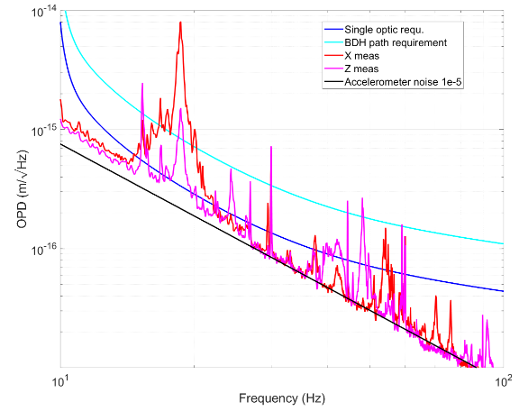
Figure 7: taken from Figure 7 of T2000581-v3, the blue curve is the BHD single optic path length noise requirement; the cyan curve is the total path length requirement, 10x below the equivalent coupling to DARM. The red curve shows the projected septum window noise resulting from two horizontally wedged 0.1 arcsecond windows in optimally bad alignment. The magenta curve shows the equivalent vertical coupling with the windows rotated to show worst-case in that direction. With the worst-case coupling, accelerometer noise is approximated by the black line, though there is some excess apparent at low frequency. See text for additional consideration, taking the horizontal case as an example as vertical only exceeds the requirement significantly at a few narrow lines even in the worst case orientation which should be avoidable.
The worst-case orientation of a pair of windows, at the limit of the requirement leads to the 18Hz peak shown, and this would be unacceptable without mitigation. If, however, worst case is avoided, perhaps one window has much less deflection than the other, which would give about half the coupling, the situation is closer to being tolerable. In that situation, only the 18Hz peak would disturb DARM significantly (reaching about 10 dB below the design curve) and the PEM accelerometer should be able to allow subtraction of the noise to well below the BHD single optic requirement (26 dB below DARM). Further if seismic excitation increases the accelerometers should remain able to provide a subtraction signal down to a similar level, as there appears to be sufficient dynamic range and no indication of significant non-linearity of their response.
With a reasonable number of windows to pair match (at least six, from which to select two pairs and keep two spares) it should be possible to match even better than this: it is likely to require careful metrology to ensure reliable measurement of “slope”.
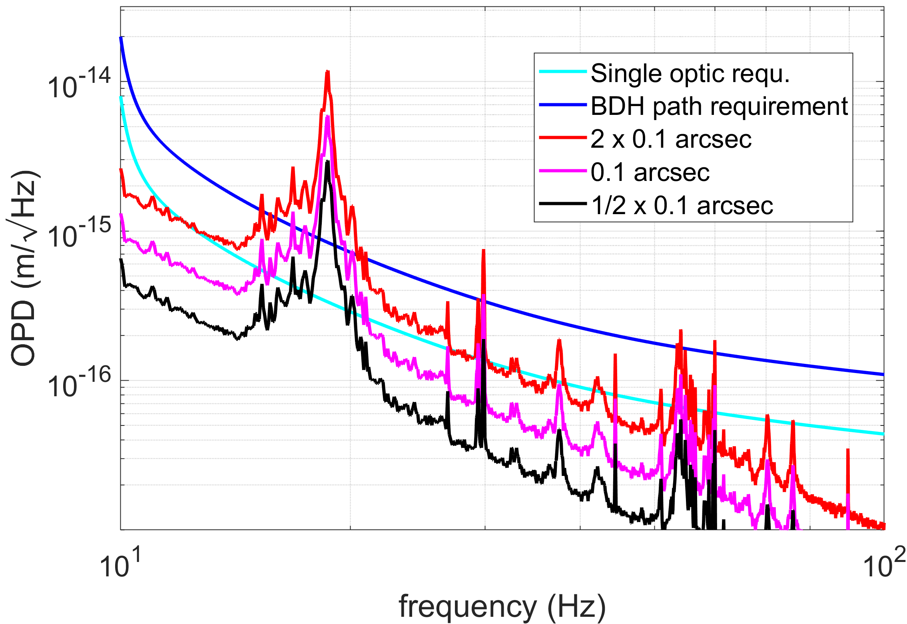
Figure 8: examples of horizontal coupling spectra due to several combinations of septum windows made to 0.1 arcsecond wedge requirements. The blue and cyan curves are swapped relative to Figure 1. The red curves match. The magenta curve shows the case of combining one window at the limit of the requirement and one that has almost no horizontal wedge as installed. This is about what would be expected from random selection of windows within specification. If the metrology can be made reliable, it may be possible to at least partly cancel the wedge on pairs of windows to reach closer to the black curve.

Additional septum window design requirements and options
The windows should be approximately the same size as existing septum windows, to fit in similar holders. Slightly windows may allow additional options for IBF finishing, potentially reducing cost and accelerating delivery.
Altered window dimensions would require parts for the septum window assembly https://dcc.ligo.org/LIGO-D1101092 excluding the o-ring and fasteners to attach to the septum port which should remain unchanged. Need to check detail for D1003207 (not LSC viewable).
Polish and coating requirements for septum windows specification TO BE COMPLETED based on information collected in https://dcc.ligo.org/LIGO-G2101462 only if it is expected that such windows will be needed. Note that omission of windows has only a minor effect on the beams approaching OM0 and BHDBS2. The windows were intended to be ~20mm thick and tilted at about four degrees, shifting the beams laterally by about 1mm. This can be corrected by 1mm shifts of the optics, a small effect compared to those discussed in the following section.

OFI wedge mitigation
References for this section (in addition to T2000581):
- https://dcc.ligo.org/LIGO-G2101284 presentation: A+ BHD: SRM wedge and beam path through OFI
- https://dcc.ligo.org/LIGO-E2100036 (v12 or greater, for LHO) and https://dcc.ligo.org/LIGO-E2100207 (v3 or greater, for LLO): Zemax models showing path of LO beam
- https://dcc.ligo.org/LIGO-E2000608 (v11 or greater, for LHO) and https://dcc.ligo.org/LIGO-E2100244 (v2 or greater, for LLO): Zemax models of HAM6
- https://dcc.ligo.org/D1900487 and https://dcc.ligo.org/D2000330 OFI models from LHO and LLO (see versions incorporated into BHD Zemax models)

Statement of the problem.
Following from the BHD PDR at which the effect of wedged optics on BHD phase noise was raised, it was realized that the OFIs are wedged, and that this, together with the expected level of transverse-horizontal and vertical motion of the suspended OFI problem, may lead to excess phase noise coupling.
https://dcc.ligo.org/LIGO-T1000109 was consulted as the best available estimate of OFIS transmissibility. High damping gain was assumed.
The expected motion was then obtained by multiplying the above transmissibility factors by the appropriate HAM table motion spectra from https://dcc.ligo.org/LIGO-T1800066 noting that allowance must be made for increased excitation during noisy seismic conditions.
The Zemax models for the OFIs were consulted to determine the beam deflection angles in both significant degrees of freedom. It was noted that the two OFIs are almost identical and need not be distinguished in the following. This deflection angle is numerically equal to the relevant coupling due to the overall optical “wedge” of the OFI.
The result of the above estimate was compared to the single optic motion allowed for each item on the BHD LO or signal paths – shown in Figure 8 of the PDD, and reproduced below as Figure 9
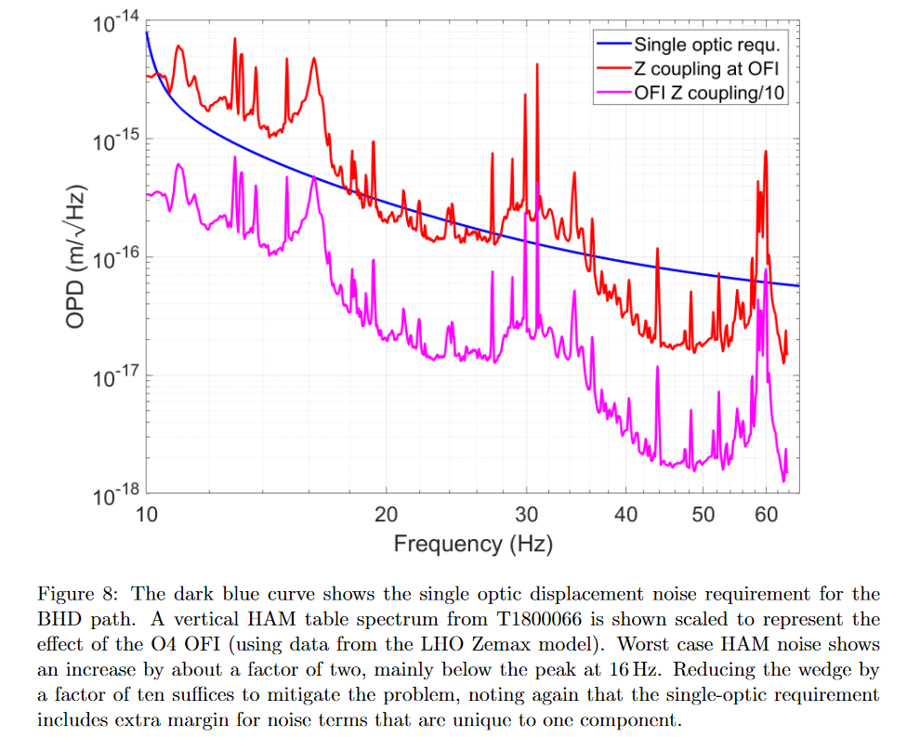
Figure 9: figure 8 from the PDD, see original caption, note that the requirements in the transverse-horizontal direction are slightly less demanding, as the corresponding OFIS transmissibility is less.
This suggests that reducing the OFI coupling (wedge) by about an order of magnitude is required. It is proposed to require the vertical component of the deflection due to the wedge be ≤ 0.8 mrad and the horizontal component of the deflection due to the wedge of be ≤ 1.6 mrad.
This has consequences for the path of the signal beam into HAM6 and leads to the solution summarized as follows.

Proposed solution
Presentation https://dcc.ligo.org/LIGO-G2101284 describes the development of the proposal set out below in more detail.
Step 1: approximately cancel deflection of the beam transmitted through the OFI. The path from SRM to HAM7 via the OFI should be affected to the minimum extent possible, therefore the wedge is corrected by including a compensating wedge in BHDL0 which is downstream of the “output” polarizer of the OFI. As noted in Sections 5.7 and 19 of https://dcc.ligo.org/LIGO-T2000581 a compromise wedge angle of 1.187±0.015º for BHDL0 allows cancellation of the total wedge to within 0.3 mrad, meeting the requirement with considerable margin.
Step 2: the current (O4) SRM has a 1 º wedge angle (thick at bottom) which deflects the signal beam downward into HAM6, via the OFI. The current OFI deflects the beam so that it becomes almost level from the OFI to OM0 in HAM6. The proposed (O5) OFI does not deflect the beam, which is then inconveniently low in HAM6, i.e., >1cm below the 4” design height for HAM6 optics. There are requirements on the pitch angles of OM0 and BHDBS2 that mean that the LO beam and OMAS would also have to be below the design height shown in the preliminary BHD layout, so this is an unsatisfactory state.
Step 3: rotate SRM in roll such that its wedge is horizontal. This leads to a more gently sloping beam, allowing OM0, BHDBS2 and OMAS to be raised to have their centers a few mm above the nominal beam height, achieved by specifying suitable spacers. The details differ slightly between the sites, see the presentation and above models/drawings for the exact numbers, these details are easily dealt with as part of the BHD/O5 HAM6 layout presented elsewhere in this document. The consequences for the OFI are also set out below. The preferred orientation of the SRM wedge is with the thick end facing +X (thin end with its identifying arrow therefore on the −X side). This allows slightly easier re-alignment of the OFI and downstream components than would be the case with the alternative orientation of SRM.

Consequences for the SRM and its suspension
The installed SRMs and spares all have close to 1 º wedge angle. Therefore, there is no loss of flexibility in terms of future replacements. The suspension would require to be adjusted, but no difficulty was seen in doing this given the relatively small wedge angle, and general details of the HSTS. The BHD team has not developed a procedure for this change. See https://dcc.ligo.org/LIGO-T2100504 for discussion of the implications for the HSTS carrying SRM.

Consequences for the OFI
The details of the OFI and associated optics differ by a fraction of a mm between sites. Coordinates listed below represent the required changes in the LIGO global coordinate basis (X, Y, Z), not the Zemax basis, and are based on the information available in late 2021. The details must be reviewed following O4 commissioning, to ensure the correct changes are made between O4 and O5 (affecting procedures and detail of the location of OM0 at the mm level, but not affecting the specification of associated parts).
At LHO the OFI must move +4.7 mm in X (i.e., away from SR3), +0.5 mm in Y (toward SRM), and 4.8 mm vertically up. The OFI also needs to be rotated 0.45º counterclockwise as viewed from above.
At LLO the OFI must move +4.2 mm in X (i.e., away from SR3), +0.2 mm in Y (toward SRM), and 4.2 mm vertically up. The movement in Y may be negligible. The OFI also needs to be rotated counterclockwise by 0.44 º.
The BHD team has not checked what is the best method of raising the OFI platform by the required few mm, according to HAM5 drawings and photographs, there appears to be space to allow the horizontal and yaw movements.
We recommend that an installation readiness review consider the details of the above in case of late OFI changes during commissioning for O4. The location of the OFIs and the design of holders for BHSL0 should be revisited when the risk of changes is low (late 2022?). The dumping of reflections from BHDL0 may also require modifications to the OFI baffles – see following section.

Overview of the plan for management of stray light
Joint work between Systems and the UK team is underway to check that there are no exceptional problems created by the design of the BHD optics. This is being investigated under two headings:
- for other than HAM6, led by Systems
- for HAM6 H1 and, L1, where all installed optics are related to BHD, led by the UK team,
in both cases with cross-checking. A summary of considerations for HAM6 is given following a brief overview of the situation in HAM3, HAM4, HAM5 and BSC2, which have respectively 1, 0, 2, and 1 new optics for BHD. The work is based on Zemax models and analysis presented in https://dcc.ligo.org/LIGO-T2200104 and in presentation https://dcc.ligo.org/LIGO-G2200627

Stray light control in HAMs 3, 4 and 5, and BSC2 (led by SYS)
The BHD Zemax layouts (for H1 and L1) are built in the context of the overall system Zemax models, and therefore correctly show ghost beams from all components in a consistent way.
In HAM3 the changes are required with respect to baffles associated with HRTS BHDBS1. Minor reconfiguration of the beam reflected from BHDBS1 (that came previously from the fixed mirror in almost the same location), is not expected to require major changes. The forward-going (secondary) ghost beam from BHDBS1 is dealt with in HAM5.
In HAM4 and/or the HAM4-5 tube, new baffles may be required to allow the LO to pass, and possibly to catch ghost beams generated in HAM6 (or elsewhere), that only become sufficiently separated from primary beams in HAM4. The former case is assumed to be low-risk and the latter case is considered in the context of HAM6 (or as appropriate), where these ghost beams are generated. The change to SRM rotation, described in the previous section on the OFI wedge is expected to require new baffle(s) in HAM4.
In HAM5 it is expected that the largest changes may be baffles associated with HRTS BHDL1. The ghost beams generated by BHDL1 should be directed to appropriate positions in HAM4 and HAM6. Also, in HAM5, BHDL0, retrofitted to the OFI requires to be considered, and its ghost beams dumped. The changes to SRM and the OFI may have minor implications for associated baffles. Finally, in HAM5, a dump is required to absorb the unwanted LO beam when this is deliberately mis-aligned using BHDM1.
In BSC2, consideration of ghost beams was made when HRTS BHDM1 was positioned, and its baffles designed (in outline) for the HRTS FDR, so it is expected that completing/reviewing the design should be straightforward (this is under review at the time of writing, following the BBSS FDR update – see https://dcc.ligo.org/LIGO-E2200232 ).

Stray light control in HAM6, H1/L1 for O5
The following section describes work carried out, in part, following “pre-FDR” discussions to determine what steps required to be taken before FDR and what design details could be safely left until after FDR. In each section below, we aim to make clear what work remains to be completed and attempt to provide an assessment of risk that may be associated with this work.
We appreciate that the design task for stray light control in HAM6 has two main elements:
- To prevent stray light from reaching the DCPDs after having taken a path in which it has reflected from an object with significant motion relative to the suspended HAM table and/or BHSS
- To prevent stray returning to the interferometer (via HAM5, HAM4, etc.)
Following the pre-FDR discussions, the problems were categorized as high, medium, or low priority to be considered (as proposed by review chair, Aidan Brooks)

High priority – essential to review these at FDR
- Stray light scattered from OMC optics: “isolation” of this bright source of diffuse scatter and prevention of light from the vacuum enclosure or other moving sources from reaching the DCPDs or into the interferometer.

Medium priority – expected to review at FDR
- Ghost beams generated by primary optics (HRTS and HXDS) on HAM6 platform and their implications for baffle design.
- Dumping of critical high-power beams.

Low priority – can be left until after FDR (if necessary)
- Ghost beams generated by secondary optics (i.e., table-mounted 1’’ or 2’’ optics that carry primary beams ranging from some mW to a significant fraction of a W of power.
- Dumping of known low-power beams, such as reflections from photodetectors or beams created where beam-splitters are used to reduce power on the path to a photodetector.

The agreed plan in mitigation of the above problems is being carried out as follows:

High (see below for proposals)
- For OMCs: design a shroud or cover to surround the OMCs as completely as practicable. Integrate this on to the BHSS platform, with formal approval at BHSS FDR, and with sufficient detail to assess the design presented at the BHD FDR.
- For HRTS/HXDS, check integration of suitable baffles on suspensions on the HAM6 table.

Medium
- Identify significant ghost beams generated from primary optics, i.e., within the main, high-power beam path. Establish whether beam separation is adequate for termination with beam blocks or existing baffles.
- Identify critical high-power beams and means by which they are dumped.

Low
- Identify significant ghost beams generated by secondary optics, i.e., outside of the main, high-power beam path. Establish means for their termination with beam blocks or existing baffles.
- Identify known un-wanted low power beams and means by which they are dumped. This includes ensuring that beam dumps, whether V-shaped or plates behind steering mirrors to block residual transmission, are shown using the most recent designs and part numbers, in particular showing the use of DLC plates rather than black glass, in cases except where AR-coated black glass may be needed.

Ghost-beam analysis for a general survey of beams in HAM6, and to address at least the High and Medium categories above
As Zemax allows the calculation of an impractically large set of ghost beams, we chose to consider the obvious secondary and tertiary beams in all cases and pay careful attention to those and all ghost beams exceeding $\sim 1×{10}^{-8}$ power relative to the primary beam. This figure is based on input from commissioners (we had started by checking beams of absolute power exceeding 1nW).
The following categories of ghost beams merit investigation and in each case an approach to trace and deal with ghost beams has been applied:
- Retro-reflected from HAM6, and travelling back towards the interferometer, too close to the SIG or LO beams to be blocked by baffles on HAM6. Identify:
  - Locations in HAM4, HAM5, BSC2 or HAM3 where these can be terminated (see comments in previous section regarding the tracing of these beams from HAM6)
- Forward-going, travelling towards the OMCs, too close to the combined SIG/LO beam to be blocked by baffles on HAM6. Identify:
  - Locations on HAM6 where these can be terminated;
  - If the beams strike the edge of an optic at any point;
  - If the beams are incident upon the active area of photo-diodes;
  - If the beams enter the OMC and, if so, whether they continue on to the active area of the DCPDs.
Due to the level of detail involved and many associated Zemax diagrams, a separate working document has been prepared to detail the analysis carried out thus far. A short summary of the main points and outcomes is recorded below. A detailed summary of results for each optic in the BHD subsystem is found https://dcc.ligo.org/LIGO-T2200104 and in presentation https://dcc.ligo.org/LIGO-G2200627. The material of T2200104 is intended to be part of the BHD FDR and is not repeated here.
The approach taken was to allow Zemax to generate ghost beams at all optics and to study the results to find at least the generic problems – where retro-reflected or forward going beams are generated, and what other circumstances may exist that require measures to block beams. Due to the meter-scale distances and zero or small wedge angles and, at for 45º AoI small part thickness involved, most of the ghost beams fall into one or other of these categories. The forward-going cases end up at dumps, on photodetectors (WFS etc.) or at the input coupler of an OMC. We therefore pay attention to all of these cases. Most of the optical power entering HAM6 is in RF sidebands, but for the purpose of this analysis, we assume the significance of a ghost beam is determined by its power (or the square root thereof) and don’t distinguish RF content.

Proposal for stray light control of the OMCs
Context: the OMCs are in a low-vibration environment. To the extent that the OMC enclosure is a rigid box, there is no relative motion between the OMC and its enclosure that could lead to noise from optical path changes within the box. The enclosure is expected to have modes in the range of a few hundred Hz. The BHSS provides filtering of HAM table motion above ≤4 Hz, reaching ≥40dB in the frequency range above 100 Hz and yielding motion of the BHSS platform of order 10 ^{–14}m/ Hz, possibly with some resonances exceeding this level.
On the inside of such an enclosure, in a low-vibration environment, it is not expected that stray light reaching a DCPD would typically contain a strong phase signature.
After initial consideration, the following objectives were set for a cover to enclose the OMCs – the underside being occluded by parts of the BHSS platform:
- to block, as completely as practicable, stray light travelling in HAM6 from reaching the DCPDs
- to block diffuse scatter originating from the OMC components
- to present a black and where possible non-vertical outer surface to any stray light crossing that region of HAM6, especially around the aperture where the intended beam enters the OMC enclosure
- to present an absorbing environment around the OMC to modestly reduce the amplitude of diffuse scatter reaching the DCPDs. A reasonably smooth and black interior surface helps to reduce the light reaching the DCPDs through secondary scatter and/or after multiple reflections.
- consider whether a separate compartment for the DCPDs could bring advantages by separating the detectors from the relatively bright diffuse scatter from the OMCs.
The above requirements can be met if the OMC is almost completely surrounded in a DLC coated metal box. Since the material is relatively absorbing, multi-reflection processes are attenuated.
The total diffuse light from an OMC is of order 1mW (i.e., 2% loss with 50mW throughput). As the DCPDs constitute about 0.01% of the internal surface area (and as most light is absorbed in each interaction with the black material), a rough estimate for the largest power reaching the DCPDs is 10nW. Considering the geometry, including obstructions around the DCPDs, angles for scattering etc., suggests that the stray light reaching each DCPD is probably closer to 1nW, or about 10⁻⁸ of the LO power. Sensitivity to the phase of these beats should be four orders of magnitude poorer than the LO shot noise), or a phase sensitivity of ${10}^{-5}/\sqrt{\text{Hz}}$ or ${\sim 10}^{-12}m/\sqrt{\text{Hz}}$ – an extra factor of 10 being allowed as margin.
The proposal is set out in more detail in https://dcc.ligo.org/LIGO-G2200865 This was presented in conceptual form to interested parties on May 26th and feedback received at that meeting incorporated into the proposed design (to appear in full detail in the BHSS FDD). Subsequent discussions have covered materials methods for production of suitable covers and inform the remainder of this section.
The OMC covers may be made of one formed piece formed from a sheet or possibly with separate ends the ends shall be inclined to send external-incident beams downward. The ends shall have apertures, each approximately 10mm diameter. One of these admits the LO and signal beams and allow the reflected light to leave to QPDs, WFS, etc. It is likely that apertures will be provided for both transmitted beams, though the unused one may also be dumped within the enclosure (TBC). If the end plates and main cover are separate, they could be of different material. Standard methods of attachment are planned, incorporating Fluorel damping inserts and with oversized holes to allow adjustment.
The external surface of the enclosure should follow guidelines for baffles – i.e., likely DLC coated super 8 stainless steel, otherwise the usual aluminum sheet used for baffles, with black-nickel as a fall back if for some reason DLC is impractical on these parts.
Our mass budget is about 1kg per enclosure including accessories. This requires the enclosure to be made from thinner sheet than usual (we believe that sheet is available in 0.46mm and 0.61mm), or otherwise aluminum up to around 1.5 or 2.0 mm thick. The exterior finish should conform to the normal specification for baffles.
The requirements for the internal finish have been considered. To prevent multiple reflections and absorb background scatter, the interior should be black, likely DLC. In searching for requirements for the interior finish, we have been able to trace a path such that an individual backscatter would be of concern, i.e., allowing an upper limit on BDRF to be specified.
Higher-order beams have been traced in Zemax for all BHD related optics including the OMC mirrors. See https://dcc.ligo.org/LIGO-T2200104 with further illustration in the pdf at https://dcc.ligo.org/LIGO-G2200627-v4 from which the following page references are taken.
The stronger reflections from the AR surface of the input and output couplers (p73 to p87) leave through the baffle aperture for incoming/reflected light or reach the DCPD mount (as in aLIGO). Only weak higher-order reflections may reach the interior of the enclosure. Direct backscatter from there does not enter the forward-going OMC path however, requiring additional scatter processes to enter the forward-going OMC path.
Reflections from the AR surfaces of the curved mirrors (p88 to p95) are extremely weak – in part due to the lower transmission specified for these mirrors than in aLIGO. Again, backscatter would couple to the reverse direction within the OMC cavity.
The only beams we have identified as being of concern were they to reach the interior surface are those transmitted by the curved mirrors, and these shall not be permitted to encounter the enclosure.
That leaves the general large-angle scatter at the mirrors as a concern. This may also scatter directly back from the interior surface of the cover, and re-enter the forward-going OMC beam by a second scatter process. As the mirrors are low-scatter, the geometry is complex and we have not evaluated this effect.
Our interim conclusion, to be tested in further Zemax modelling, is that there are no obvious especially stringent requirements on the BDRF of the interior surface of the enclosure. We expect to employ one of the established materials and finishes. It is proposed to provide an update on selection of materials, finish and manufacturing detail at the BHSS.

Stray-light control related items between HAM3 and HAM6 that may require to be changed to accommodate BHD
List provided by Alena Ananyeva:
- MC tube baffle between HAM4 and HAM5
- SR2 scraper baffle
- Potentially SR3 baffles

Stray-light control related items affected by SRM rotation
List provided by Alena Ananyeva:
- All OFI baffles wich have apertures (likely will need to increase the apertures on the vertical axis to avoid clipping of the OFI ghost beams reflected by SRM AR)
- SRM AR and HR baffles (likely will need to increase the apertures on the vertical axis to avoid clipping of the OFI ghost beams reflected by SRM AR)

Cable routing (introduction)
Other than in HAM6, cable routing is straightforward – essentially at most one suspension per chamber for BHD. The situation in HAM6 is more complicated and the following plan has been put in place and is in implementation.
To start the process, a rough “map” was sketched of items requiring cables in HAM6 (suspensions, actuators, sensor-PDs, etc.). This was passed to systems for refinement, including cable part numbers and allocation to feedthroughs. The result of this is given in https://dcc.ligo.org/LIGO-T2200049, the plan to refine the cable design is as follows
- Sketch requirements (UK team, complete, see live documents linked from T2200049-x0)
- Led by Systems team: review requirements and implement detail. See T2200049 (both live documents and main document). This is in progress, largely complete. It includes proposals for flange/feedthrough allocation, cable types and cable bracket locations.
- Review design proposals from Step 2 and fix any minor problems/missing details, where required. This is in progress. A first pass has been completed to check for obvious problems and we believe we can accept the proposal with no important changes (it is possible that cable brackets with 3 or 4 connectors will be split into 2 connector versions that are safely below beam height).
- Finally, when approved, feed into a new version of https://dcc.ligo.org/LIGO-D1300122
Following Step 2, the requirements for cable brackets should be clear enough to decide if there is a shortfall of any variants that are required – this information is needed by mid-2022 to allow the team to procure parts to make up any shortfall. It is, however, believed that most brackets can come from existing inventory, including installed parts and spares/reserve.
The activity of Step 3 runs in parallel with Step 2. The proposed location of cable brackets on the HAM6 table is being checked for potential interference with hardware or beams, and to ensure that space is left for tool or manual access. We note that the types of bracket are described in https://dcc.ligo.org/LIGO-D2000492
Proposed cable routes, where they cross the HAM table or pass close to beams near the edge of the table, are being considered to check for potential interference, including as a result of sagging or accidental disturbance. Where there is such a risk, parts are being designed to keep the cables away from beams. The beams at risk have power of no more than a few mW so the risk is inconvenience rather than thermal damage.
Cable routing internal to the BHSS platform is dealt with separately (see also two paragraphs below).
We believe that sufficient work has been done on steps 1 and 2 above to reduce the risk of conflict between cable brackets, cables, stray light baffles and other hardware on HAM6. It is expected that, in the case of cables, if a problem has been missed, it can be solved through a minor reconfiguration of cable and bracket (such as splitting 4-connector brackets into two 2-connector brackets which fit below underneath beams with plenty of clearance).
BHSS/OMC wiring: following the OMC FDR update, the OMC cables for DCPDs and PZTs and the cables for the separately mounted QPDs are being updated. The plan is (probably) to standardize on PEEK-bodied sub-D connectors and Kapton-insulated wiring. The details of this wiring, integral to the BHSS, are to be given in the BHSS final design document (if provided on time).
Summary: cable routing is in progress at the time of the review, although incomplete, there are no major risks, and the UK team plans to adopt the proposal presented in T2200049 and build it into the HAM6 model without significant change.

HAM6 table mass balance (continues after BHD FDR)
The mass of the payload, minus cables, cable brackets, stray light baffles and similar small parts is estimated at 220 kg per HAM6, though this will increase by ~20kg when parts listed above are added (spacers, cables and brackets, etc.). The center of mass of the payload is close to the center and at a height of 13 cm above the table. Adding the accessories is expected to result in what Systems experts judge to be a benign load for a HAM ISI.
Mass balance calculations will require to be updated/reviewed following completion of work on cable routing, cable brackets, and perhaps to the greatest extent depending on the strategy adopted for addition of stray light baffles.

Preliminary plan for initial alignment of BHD-related optics
During the FDR it was requested that this section be added. This is a placeholder for a plan that will need to be developed as part of an update to the FDR.
During the first FDR meeting (see https://dcc.ligo.org/LIGO-M2200192 ), it was observed that the complexity of alignment of the HAM6 optics, especially, would depend on the presence or otherwise of the output septum plate. If HAM6 can be vented with the rest of the vertex under vacuum, i.e., if there are septum windows available, even if only for use during the alignment process, it is much easier to formulate a plan. As noted in Section 6, the septum windows will likely require to be removed during high-sensitivity operation, unless extremely high quality windows can be procured, and even then carrying risk of problems.
The BHD team supports the suggestion to plan on the basis of keeping the septum and fitting conventionally polished (plane parallel) windows to ease the process of alignment. This is attractive at least to give a baseline plan for alignment that relies only minimally on untried methods. We therefore present the steps needed to align the BHD system on the assumption that the initial alignment can take place with HAM6 vented but the system otherwise evacuated. In a second step we attempt to identify additional challenges should this not be possible.
What is included in BHD alignment? Operation of BHD requires bringing the signal and LO beams together at BHDBS2 such that they overlap and travel to the two OMCs. Other aspects of the interferometer affected by inclusion of BHD include:
- In HAM3: re-establish alignment of the POP beam following installation of BHDBS1
- In BSC2: correctly locate BHDM1
- In HAM5: re-establish alignment of the squeeze beam following SRM rotation and consequent changes to the OFI alignment
Step 0: components that can be aligned with the existing readout optics in HAM6
- Before disrupting the interferometer, i.e., while it is possible to lock the system with minimal effort, it makes sense to install BHDBS1 in HAM3 and re-align the POP beam. The new mirror is intended to reproduce the existing POP beam path, so the change should be minor. (Detail steps TBD)
- The next step would be to complete work in BSC2, with the new BBSS and BHDM1 installed as a unit, and the interferometer aligned with its new BBS. As BHDM1 should be accurately centered on the LO beam, it may be necessary to install a tracer beam for the purpose, i.e., a beam travelling in the reverse direction of the POP beam. This tracer beam should also allow BHDM1 to be aligned to direct the beam to the correct place in HAM5. (Detail steps TBD)
Step 1: SRM rotation, alignment in HAM5, requires at least minor changes in HAM6
- Changes to signal beam path from SRM to OFI and OFI to HAM6
- Changes to squeeze beam path (minor adjustments to steering optics following relocation of the OFI by a few mm)
- Positioning BHDL1 (LO beam): initial positioning of this lens couples with the alignment of BHDM1 to determine the entry of the LO beam into HAM6.
One point to be decided is, is it worth re-establishing readout in HAM6 to lock the interferometer and re-align squeezing following SRM rotation but before the major changes in HAM6? This extra step is likely worthwhile. Note that the changes to the OFI include inserting BHDL0 and it has not been checked what steps may be needed to relock using the existing HAM6 optics with this lens in place (we think RF lock should be possible and sufficient to check alignment).

Step 2: re-alignment of signal beam in HAM6 with new optics installed
The detail has not been worked out, but the alignment of the signal beam into HAM6, established in step 1 would form the basis of the initial alignment of OM0, BHDBS2 and the optics leading to the OMCs. The components would be installed as introduced in https://dcc.ligo.org/LIGO-E2200270 and for the BHSS in https://dcc.ligo.org/LIGO-E2100328 (in development at time of writing). Note that it should be possible to use the RF/heterodyne locking prior to alignment of the LO beam, and that provides the opportunity to have a bright LO beam for the next step. The incoming beam is partly transmitted by OM0 and can be aligned to the associated QPD (if that is suitably set up, detail TBC).
Step 3: alignment of the LO beam
Following from the above, and assuming correct alignment of BHDM1 and adequate alignment of BHDL1, the LO beam should enter HAM6 and be directed to the by LOPO to the associated QPD. This suggests that an auxiliary laser should be used to link the QPD alignment to the required location and angle on BHDBS2. (Detail TBC).
Challenges if the output septum plate is removed.
Steps 2 and 3 are expected to become much more challenging if the septum plate is removed, particularly with respect to LO beam alignment as this would require to be done without locking the interferometer. It is hard to conceive that this can be done with the whole corner vented, as the motion of the ITMs is likely to make it hard to trace the LO beam which would be unstable in power and position. This point should be weighed up when considering whether or not to provide septum plates for O5.
Given the above, at FDR it has been recommended that plane-parallel windows are installed in new septum plates to facilitate initial alignment. This is therefore adopted as the plan. Plane parallel windows similar to https://dcc.ligo.org/LIGO-D1101006 / https://dcc.ligo.org/LIGO-E1100267 are 0.75 inch 19.05mm thick and if mounted with AoI no greater than 5 degrees gives a tolerable 0.5mm shift in the beams at OM0 and BHDBS1 on their removal. The final choice of angle to control ghost beams etc., within a 5 degree limit is TBC but should be agreed as part of the on-going stray-light/BHD layout work. Such windows require mounting hardware similar to or developed from e.g., https://dcc.ligo.org/LIGO-D1101535 . This gives an idea of is what is meant by the septum windows and hardware in Section 13.

Known interfaces with BHSS
The approach taken is to keep the interfaces between the BHSS and the remainder of the BHD system as simple as possible. The electro-optical requirements were dealt with by ensuring that the OMCs, which largely operate independently (other than static alignment) are compatible with BHD. See the OMC FDR update https://dcc.ligo.org/LIGO-T2100078. Therefore, for the BHSS, the electrical interfaces are those of a pair of OMCs, with no new features, and the six AOSEMs damping of the platform (not intended to be used for static alignment). Alignment of incoming beams is intended to be achieved using the OMx1 and OMx2 mirrors (x = A or B), therefore the BHSS is passive in this regard. This also establishes the outgoing alignment, as determined by each OMC. Implications for ISC regarding the operation of two OMCs have not been considered in detail but are not expected to be complicated.
The following requirements must be met for the BHSS:
- The isolation and noise performance goals were set out in the BHD DRD https://dcc.ligo.org/LIGO-E2000072.
- Relative and absolute position and alignment of OMCA and OMCB must present axes for alignment of the two input beams (from OMA2 and OMB2, respectively) and must comply with the HAM6 table layout for these items. This is intended to be achieved by setting the BHSS up in a jig, resembling the standard setup used for OMC assembly. See the BHSS FDD https://dcc.ligo.org/LIGO-T2100318 for detail.
- As noted, OMC operation should be checked (at least one at a time, if not simultaneously) to establish correct electro-optical operation. This is planned to be done at the same time as the BHSS alignment process. Setting null alignment for the QPDs and setting the related steering optics would be done at the same time.
- The BHSS must be installed with sufficient accuracy on HAM6, this is planned to be done using a “cookie-cutter” method. Alignment of downstream optics will require to be adapted to the individual OMCs. This has not been considered in detail, pending a full installation plan for HAM6 optics (includes OMC transmission beams to external cameras, etc.).
- The large size of the BHSS requires that it be installed on the HAM6 table at a relatively early stage in the installation process.
- The handling of stray light involves the BHSS, as described in Section 8. This is primarily dealt with through the application of the OMC covers.

Outline schedules
The schedule for completion of BHD design detail including stray light control, ISC and other elements deferred at FDR is expected to extend beyond 2023. The following schedule/milestone information relates to significant procurements and completion of UK-driven design work.
Item | Status | Delivery/completion
BHD optics HRTS/HXDS | In production | Q4 2022/Q1 2023
HRTS | Procurement | Q4 2022
BHD optics HAM6 table etc. | Substrates (in production),  Coatings (TBC) | Q4 2022  Q4 2022
BHSS (see also BHSS FDR) | Blade springs in production  Other parts following FDR | Q3 2022  Q4 2022/Q1 2023
P-SAMS PZTs | On order | Q2 2022 (late)
OMC wiring | Design revision in progress | Q3/Q4 2022
Other hardware and installation tooling (designs and/or hardware as appropriate) | TBC | Q4 2022/Q1 2023
OMC assembly | Pending wiring revision | TBC (expect 2022)
BHSS assembly | (following fit-checks in Glasgow) | TBC (expect early 2023)
Septum windows for initial alignment (with SYS)  (See end of Section 11 for more detail.) | Design work to choose the angle for windows and finalize septum plate and mounting hardware. | TBC (expect 2023)

RODAs and actions completed
There are no new RODAs within the BHD scope. The actions emerging from the PDR are noted in Section 4 above. An updated OFI RODA is due when the situation is regarded as stable, meantime information has been exchanged in the form of Zemax models.
We were asked to note certain information relating to the naming of DCPDs in the wiring chain, in particular for the BHSS interface. The DCPDs on an individual OMC are called DCPD1 and DCPD2 (see OMC assembly documentation), but when installed into a complete BHSS, specific instances of OMCs/DCPDs are to be referred to as set out in the O5 section of https://dcc.ligo.org/LIGO-D2100716 BHSS documentation should be compiled in compliance with this requirement, to be actioned in BHSS FDD. The naming of DCPD signal connectors on the BHSS should comply with the referenced document.

Outline plan for safety and hazard analysis
Review of items involved in the BHD subsystem, identification and appropriate hazard and safety analysis. The final hazard analysis should be completed by qualified LIGO staff.

HAM3, HAM4, HAM5, BSC2
In these chambers, the BHD subsystem requires installation of suspensions (HRTS, with associated low-voltage cabling, no voltages exceeding 40 V with respect to ground are involved), baffles, and beam dumps. The BHD system creates a new beam (the LO beam) of up to about 1W and with Gaussian radius $w\sim 1.8\text{mm}$.
The LO beam is only present with significant power when the PRC is locked which requires the corner station (possibly excepting HAM6, see below) to be evacuated. Therefore, this beam does not create a direct hazard provided its reflections are controlled. There are similarly intense beams present in the same chambers, so there is no new class of laser safety hazard introduced by the LO beam.
The LO beam has two alignment states, either passing through BHDL1 in HAM5, to reach HAM6 via the septum window, or hitting a defined beam dump/baffle on the BHDL1 suspension.
The two strongest ghost beams associated with the LO are at the mW level. These require to be dumped: one in BSC2 and one in HAM5.
Hazards associated with the HRTS are described in https://dcc.ligo.org/LIGO-T2000670
There is no other hazard or hazardous technique in the installation, commissioning, or operation of the BHD subsystem in these chambers, that is not already present from installed equipment.

HAM6
The analysis for HAM3-HAM5 applies, with the following additional points.
- The LO beam focusses down to the OMC waist. Other than within the OMC, the beam radius ranges from 0.5 to 1.5mm.
- If it proves possible to lock the PRC with HAM6 at atmospheric pressure, and with optics other than in final alignment, precautions must be taken to ensure appropriate eye and skin safety from exposure to laser beams. This scenario is not, however, expected to be possible.
- There are new components to be installed. The following items have moving parts with stored energy, and require their own hazard analysis and safety procedures:
  - HRTS (see above)
  - HXDS https://dcc.ligo.org/LIGO-E2000574
  - BHSS https://dcc.ligo.org/LIGO-E2100307 this includes hazards associated with OMCs and other BHSS payload components, it is in development and covers assembly, installation, and operations
  - HTTS https://dcc.ligo.org/LIGO-E1300862
  - Fast shutter https://dcc.ligo.org/LIGO-E1400177 - note that there may be updates affecting one or both fast shutters required in each HAM6.
Additionally, high energy laser pulses may be present between the HAM5/6 signal septum window and the optical path to the fast shutter and in its “closed” state to the associated high power beam dump. This reproduces the situation present in HAM6 during O3 and O4, but with a new optical layout and potentially higher pulse energy. A sample of the signal beam, not interrupted by a shutter, is directed out through a viewport on the +X side of HAM6. This represents a hazard if not blocked, as it could be as much as ~100 mJ pulse energy. Note that its exit from HAM6 is controlled by a beam diverter (bDiv).
There are two OMC transmission beam provided at the +X side of HAM6, but these are low power (<0.1mW average) and do not show high pulse energy provided the OMC protection (shutter function) operates correctly. In any case, these beams should be properly dumped or directed onto cameras, prior to operation.
Laser safety procedures should be reviewed to ensure these points are considered where necessary, particularly with respect to commissioning where the bDiv may be opened to allow analysis of the signal beam.
There are no high voltage hazards, other than those associated with the OMC PZT actuators and the fast shutters, covered in the relevant hazard analyses for these components (and already present in O3/O4).

Suprasil 312 blanks suitable for the fabrication of six windows have been procured and will be provided to LIGO to be held in reserve in case of later need.

