Calibrating the global network of gravitational wave observatories via laser power calibration at NIST and PTB.
D. Bhattacharjee¹, R. L. Savage², S. Karki³, A. Sanchez², F. Llamas⁴, J. Betzwieser⁵, J. Lehman⁶, M. Spidell⁶, M. Stephens⁶, S. Kück⁷, H. Lecher⁷, M. López⁷, L. Rolland⁸, P. Lagabbe⁸, D. Chen⁹, R. Bajpai⁹, and S. Fujii¹⁰
¹Kenyon College, Gambier, USA, ²LIGO Hanford Observatory, Richland, USA, ³Missouri University of Science and Technology, Rolla, USA, ⁴University of Texas Rio Grande Valley, Brownsville, USA, ⁵LIGO Livingston Observatory, Livingston, USA, ⁶National Institute of Standards and Technology, Boulder, USA, ⁷Physikalisch-Technische Bundesanstalt (PTB), Braunschweig, Germany, ⁸Laboratoire d’Annecy de Physique des Particules, Annecy, France, ⁹National Astronomical Observatory of Japan, Mitaka, Japan, ¹⁰Institute for Cosmic Ray Research, Kashiwa, Japan
Corresponding e-mail address: bhattacharjee1@kenyon.edu

Gravitational wave observatories use laser radiation pressure to generate calibrated displacement fiducials used to calibrate the detector output signals. Reducing calibration uncertainty enables maximizing extraction of astrophysical information from detected signals – source distance, masses, spins, orbital parameters, etc. The global detector network is employing a new calibration scheme with transfer standards calibrated at both NIST and PTB. We report the results of a bilateral comparison between NIST and PTB with significantly lower uncertainty than previous studies and details of the implementation of gravitational wave detector displacement fiducials with less than 0.6 % uncertainty (k = 2 or 2-σ values are used throughout this document).

INTRODUCTION AND GLOBAL PLAN

The LIGO, Virgo, and KAGRA gravitational wave (GW) observatories will start their fourth observing run (O4) in May 2023. Though nearly 100 GW events have been detected since the first in 2015, improved detector sensitivities for O4 suggest significantly higher event rates. As signal-to-noise ratios increase, reduction of calibration uncertainties becomes increasingly important for optimally extracting the astrophysical information encoded in the GW signals [1].
To improve calibration accuracy, the global network of GW observatories and the NIST and PTB national metrology institutes (NMI) have implemented a novel calibration scheme [2]. The observatories employ systems known as photon calibrators (Pcal) [3] to generate displacement fiducials, calibrated periodic displacements of the interferometer mirrors at discrete frequencies across the 20 Hz to 2 kHz detection band, at the 1x10⁻¹⁷ m level via radiation pressure. These systems rely on calibrated laser power sensors to enable accurate and precise displacement calibration. The new scheme includes two integrating-sphere-based transfer standards (TS), similar to the power sensors employed at the observatories, that travel between the NIST and PTB NMIs and the observatories as shown in Fig. 1. The two standards will complete the calibration loop once per year, with a relative delay of six months. Thus, each participating observatory will receive a calibrated TS approximately once every six months. LIGO and Virgo will participate in this scheme from the beginning of the run, with KAGRA joining later in 2023 and the LIGO India project joining several years later.
Figure 1. Schematic diagram of the global calibration scheme for the O4 observing run with transfer standards TSA and TSB circulating between observatories and NMIs once per year with a relative delay of six months.

NIST/PTB BILATERAL COMPARISON

Partly to support the GW community, NIST has commissioned a new primary radiant power calibration standard [4] with expanded uncertainty of 0.15 %, comparable to the PTB calibration uncertainty. NIST and PTB are conducting a bilateral comparison using the two transfer standards, TSA and TSB. After completing the first steps in the comparison, the relative uncertainties of the consensus values for the two standards are 0.15 %. The bilateral degree of equivalence (DoE) for this comparison is 0.23 %, with an expanded uncertainty of 0.25 %. This is a factor of more than three smaller than for the previous NIST/PTB bilateral comparison using a LIGO TS [5]. The smaller calibration uncertainties reduce the uncertainties of the displacement fiducials generated by the Pcal systems and the reduced DoE uncertainty increases confidence in their accuracy.

DISPLACEMENT FIDUCIALS FOR O4

The modulated displacement induced by a Pcal system is given by
where 𝜃 is the angle of incidence of the Pcal beams on the mirror surface, M is the mass of the mirror, c is the speed of light, and P(𝜔) is the reflected modulated laser power. 𝜌_{R} is the calibration coefficient for the power sensor at the end station in digital counts per watt, 𝜂_{R} is the optical efficiency for the path between the end mirror and the sensor, and d_{R} is the power sensor output in digital counts.
In preparation for the O4 observing run, Pcal power sensors were upgraded to incorporate detector spacers that reduce the temperature dependence of the responsivity. The transfer standard that was previously calibrated by NIST and PTB during the earlier bilateral comparison [5] was used to calibrate the end station sensors at the LIGO Hanford Observatory (LHO). First its calibration was transferred to a gold standard that is maintained in a laboratory at LHO, then from the gold standard to a working standard that is transported to the interferometer end stations to calibrate the Pcal sensors that receive the light reflected from the end mirrors. This process is shown schematically in Fig. 2. The measurements were repeated five or more times at each step in the transfer process.
The expanded, composite, relative calibration uncertainty for the TS is 0.20 %. Transferring it to the end station sensors, the resulting calibration uncertainty is 0.21 % for the X-end sensor and 0.22 % for the Y-end sensor. The relative uncertainty in 𝜂_{R} is 0.20 % and 0.44 % for the X-end and Y-end, respectively. The relative uncertainty in the masses of the suspended end mirrors is 0.02 %. The resulting uncertainties in the displacement fiducials given by Eq. 1 are 0.30 % and 0.50 %. However, the simplified treatment presented here ignores two important effects that are discussed in detail in [6]: 1) a dominant uncertainty introduced by unintended rotation of the mirror induced by Pcal beam location errors and 2) reduction of uncertainties that are not common to both end stations by using the interferometer output signal to compare the two Pcal end station calibrations. Taking both into account, the expanded uncertainties in the displacement fiducials for the O4 observing run for both end stations are 0.56 %. These are less than the 0.82 % uncertainties for the O3 observing run. Most of the improvement is due to the reduced TS calibration uncertainty from the earlier NIST/PTB bilateral comparison, 0.20 % vs. 0.63 % for the O3 run [6].
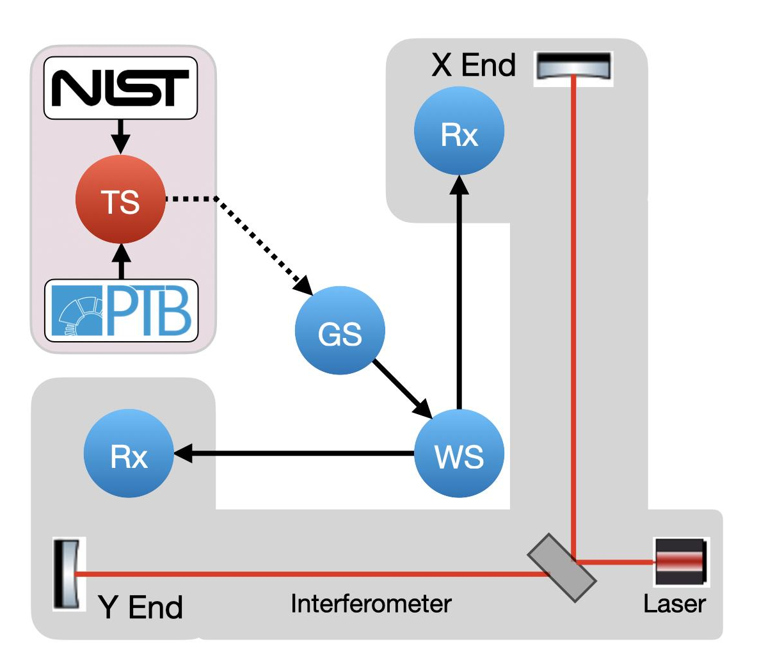Figure 2: Schematic of propagation of calibration from NIST/PTB to the transfer standards, then to gold standards for each project, then to working standards that are taken to the interferometer end stations to calibrate the receiver-side (Rx) power sensors.

REFERENCES

1. R. Essick, Calibration uncertainty’s impact on gravita-tional-wave observations, Phys. Rev. D 105, 082002, 2022.
2. S. Karki, et. al., Toward calibration of the global network of gravitational wave detectors with sub-percent absolute and relative accuracy, Galaxies, 10, 42, 2022.
3. S. Karki, et al., The Advanced LIGO photon calibrators, Rev. Sci. Instrum., 87, 114503, 2016.
4. A. Vaskuri, et al., High-accuracy room temperature planar absolute radiometer based on vertically aligned carbon nanotubes, Opt. Express, 29, 22533, 2021.
5. M. Spidell et al., A bilateral comparison of NIST and PTB laser power standards for scale realization confidence by gravitational wave observatories, Metrologia , 58, 055011, 2022.
6. D. Bhattacharjee, et al., Fiducial displacements with improved accuracy for the global network of gravitational wave detectors, Class. Quantum Grav., 38, 015009, 2021.

